Springfield Primary School.
Year 3
Term: Summer1 2026 | Theme: Growing
Key Questions  Where does rice come from?  Are all families like mine? | Stimulus: (Book/ Visit/ etc) Western Park Museum, Botanical gardens Text: My rice is best by Selina Brown 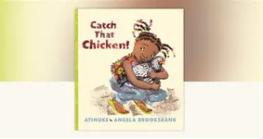 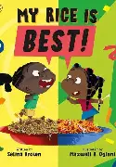  Catch the chicken by Atinuke
Narratives  Persuasive writing
  As writers we will:
  Be writing to entertain by writing
  Playscripts.
  In Religious Education we will:
  How do people’s beliefs about God, the world and others impact on their life.
  In computing we will:
  Use desktop publishing software and consider choices of font size, colour and type to edit and improve our work.
 | As designers we will:  Know what a greenhouse is used for and how it helps plants to grow.
  As mathematicians we will:
  Learn to identify the value of coins and notes.
  Convert, add and subtract money.
  Find change.
  Learn how to tell the time.
  Tell the time to the nearest 5minutes and 1 minute.
  Read time on a digital clock. Be able to tell the difference between am and pm
  As Geographers we will:
  Look at how and why our local area is changing.
 | As Historians we will  Not covered this half term
  As musicians we will:
  Practise our skills in playing the violin
  Learn to sing The ink is black.
 | In RSHE we will:  Learn about what makes a family and do families always stay the same. |  | Learn the rules of Tennis. We will understand the aim of the game and we will use basic racquet skills.
  As scientists we will:
  Identify and describe the functions of different flowering plants.
  As artists we will:
  Not covered
  this half term
  In PE we will:

