Homework Grid Year 1 Summer 1

We would like you to choose some of the homework ideas from this grid to do at home over the 6 week term. We will have time in school to talk about the homework we have done that week. You can bring your homework to school, or a photo of you doing an activity from the grid.


Weekly Homework
Reading 5x per week (school book or Bug Club)
Maths practise on SumDog
Spellings and key words www.sumdog.com/user/sign_in www.activelearnprimary.co.uk/login
Literacy  Speaking and Listening | Imagine you are a famous explorer. Write a list of all the things you will need on your journey. | 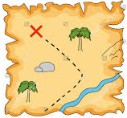  Draw a map of a jungle. Can you write instructions on how to get to each place on your map? | Choose your favourite book to read at home. Can you write a letter to someone explaining why they should read it too? | 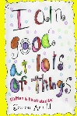  Look out your bedroom window and write a list of all the things you can see. Are they human or physical geographical features?
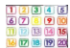  Maths and problem solving | In maths, we will be learning our 2, 5 and 10 times tables. Can you practise them? | Get all the soft toys in your bedroom and sort them into equally between your family members. How many does each person have? How many toys are left over? |   When you eat your dinner, see if you can eat one quarter of it, then half of it, then the whole thing. | How many number doubles can you make between 1 and 50?
Science and  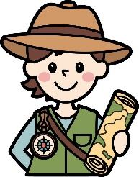  Topic | 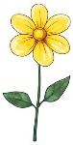  Draw a picture of two different plants. What is the same? What is different? Can you label the parts of the plant? | In your garden or at the park, see how long you can run for. How does your body feel after you run? Can you beat your best time? |   Think about the communities you are part of. Can you explain why your faith community or your family are special to you? | Can you make a list of all the things you do to keep your body healthy?

