
Pleas
SHERWOOD PRIMARY SCHOOL
YEAR 4 HOMEWORK
Summer Term 2026 – First Half
READING WITH YOUR CHILD
Please continue to hear your child read, and to discuss the text and new vocabulary with them, to further deepen their comprehension skills. For Top Tips on Reading and further information on the Reading Pathways please see our page on the website.
Click here for the We are Reading page on our website
KEY MENTAL MATHS SKILLS TO REHEARSE ORALLY THIS HALF TERM
By the end of Year 4, You will be expected to know your times tables up to 12 x and their corresponding division facts. For more information Click here for the Sherwood Primary School Multiplication Challenge!

Week | Core Task 1 Maths | Core Task 2 English | Reading Focus | Deadline for completion
17.4.26 | This week, we have been looking at rounding of whole and decimal numbers along with ordering decimal numbers  Please complete:  - Page 42 – Rounding Decimals  - Page 43 – Comparing Decimals | In Spelling, we have been practising adding the prefixes -sub and -super to root words.  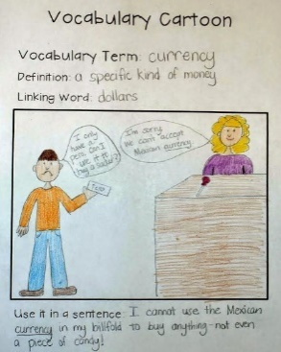  - Create a cartoon in your Homework book to illustrate and show the meaning of the word, just like we did in our spelling sessions in class. Use the template provided.  - Please logon to Spelling Frame and complete the test assigned through your Dashboard. Click the link – your login details are in your diary.  SpellingFrame | This week as you are reading, look for words that begin with the prefixes sub and super. List the words you find in your diary. | Wednesday 22nd April
24.4.26 | This week, we have been looking at strategies for mentally calculating solutions to a variety of whole and decimal number problems. Using, and clearly showing the strategies worked on this week, complete the questions found in your homework books. | 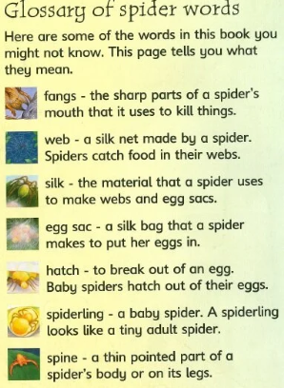  In Geography, we have been exploring the journey of a river from its source to its mouth. We would like you to create a glossary for rivers using the key vocabulary that we have learnt. Your glossary should have the title: Rivers Glossary. It needs to be in alphabetical order, and It should have the word in bold, followed by the definition. You can add decorations and colour to make your glossary stand out. Please see the example and the vocabulary list in your Homework Book. | This week as you are reading, see if you can spot birds in your book. Which birds are mentioned and described? Write the birds you find in your diary. | Wednesday 29th April
1.5.26 | This week we have been using our understanding of multiplying by 10 and 100 to convert decimal numbers into whole numbers to help us put them in order and find sequences. We would like you to complete pages 40 and 41 of your CGP booklets.  - Dividing by 10 and 100 pages 40 and 41. | This week, we would like you to practise spelling words linked to our Science topic. Please logon to Spelling Frame click here and go to your Dashboard to complete the practice activities and test.  Topic Words – Science – Y4 Living things and their habitats | This week as you are reading, see if you can spot birds again in your book. Which birds are mentioned and described? Write the birds you find in your diary. | Wednesday 6th May
8.05.26 | This week we have revisited the strategies for mental multiplication and division. We have used partitioning, factorisation and compensation methods. We would like you to complete the questions in your Homework books showing the method you use, clearly. | This week, linked to our class novel ‘Twitch’, we would like you to create fact files about two birds of your choice on the sheet in your Homework Book.  In the blank box, make sure you include a clear and detailed drawing of the bird showing the colour of its plumage (feathers). | This week as you are reading, look for words that have the ‘g’ sound spelt gue (e.g. plague) and the ‘k’ sound spelt que (e.g. mosque). | Wednesday 13th May
15.05.26 | This week we have been extending our learning looking at multiplication of a three-digit number by a one-digit number. We would like you to complete page 29 of your CGP books – Written multiplication. Show your working using the Grid method. | This week, we would like you to practise spelling words linked to our work this week. We have been investigating the prefixes anti and inter. Please logon to Spelling Frame click here and go to your Dashboard to complete the practice activities and test.  Choose five of the words and write them in sentences in your books, showing the meaning of the word. | This week as you are reading, look for words that have the inter or anti prefix.  Make a note of them in your home school diary. | Wednesday 20th May

