Write a book review and be creative in your presentation. | Explore 5 different marine animals that would be at risk from fishing nets. | Create a fact file for a whale.  Include: Species name; size; fins; diet; habitat.
Create your own front cover for the book. | 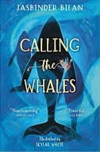  Book Drop Bingo | Write a poem about a whale.
Wearing protective gloves, pick up at least 5 pieces of rubbish from an area near you. Upload a photo to Seesaw. | Create a 10 question quiz about the story and characters. | Draw, sketch or paint a picture of a scene from the story.

Name:____________________

