
LONGTON LANE PRIMARY SCHOOL
‘Believe and Achieve’
Amendments made since last review
Teachers have gone through the policy for their year group checking and crossing out any methods that are not taught in school.

Policy agreed / reviewed 19th March 2024 | Next review due Spring 2026
Signed on behalf of the Governing Body | Signed by headteacher

Progression in Calculation Policy

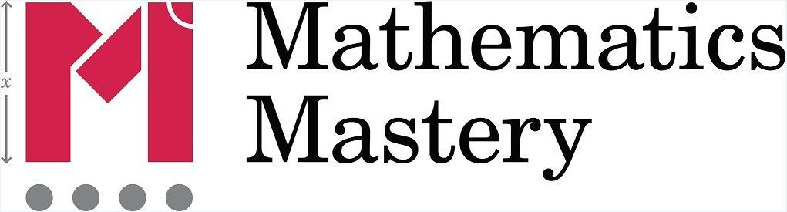

September 2017

NB. Users should familiarise themselves with the introduction (pp 2-10) to this document before referring to individual year group guidance.

1

Introduction

At the centre of the mastery approach to the teaching of mathematics is the belief that all pupils have the potential to succeed. They should have access to the same curriculum content and, rather than being extended with new learning, they should deepen their conceptual understanding by tackling challenging and varied problems. Similarly, with calculation strategies, pupils must not simply rote learn procedures but demonstrate their understanding of these procedures through the use of concrete materials and pictorial representations. This document outlines the different calculation strategies that should be taught and used in Years 1 to 6, in line with the requirements of the 2014 Primary National Curriculum.

Background

The 2014 Primary National Curriculum for mathematics differs from its predecessor in many ways. Alongside the end of Key Stage year expectations, there are suggested goals for each year; there is also an emphasis on depth before breadth and a greater expectation of what pupils should achieve.

One of the key differences is the level of detail included, indicating what pupils should be learning and when. This is suggested content for each year group, but schools have been given autonomy to introduce content earlier or later, with the expectation that by the end of each key stage the required content has been covered.

For example, in Year 2, it is suggested that pupils should be able to ‘add and subtract one-digit and two-digit numbers to 20, including zero’ and a few years later in Year 5, they should be able to ‘add and subtract whole numbers with more than four digits, including using formal written methods

(columnar addition and subtraction)’.

In many ways, these specific objectives make it easier for teachers to plan a coherent approach to the development of pupils’ calculation skills, and the expectations of using formal methods is rightly coupled with the explicit requirement for pupils to use multiple representations, including concrete manipulatives and images or diagrams –a key component of the mastery approach.

Purpose

The purpose of this document is threefold. Firstly, in this introduction, it outlines the structures for calculations, which enable teachers to systematically plan problem contexts for calculations to ensure pupils are exposed to both standard and non-standard problems. Secondly, it makes teachers aware of the strategies that pupils are formally taught within each year group, which will support them to perform mental and written calculations. Finally, it supports teachers in identifying appropriate pictorial representations and concrete materials to help develop understanding.

The policy only details the strategies; teachers must plan opportunities for pupils to apply these, for example, when solving problems, or where opportunities emerge elsewhere in the curriculum.

How to use the document

For each of the four rules of number, different strategies are laid out, together with examples of what concrete materials can be used and how, along with suggested pictorial representations. Please note that the concrete and pictorial representation examples are not exhaustive, and teachers and pupils may well come up with alternatives. The purpose of using multiple representations is to give pupils a deep understanding of a mathematical concept and they should be able to work with and explain concrete, pictorial and abstract representations, and explain the links between different representations. Depth of understanding is achieved by moving between these representations. For example, if a child has started to use a pictorial representation, it does not mean that the concrete

Copyright © 2017 Mathematics Mastery. This can be printed out and photocopied by Mathematics Mastery toolkit registered users only. For further information, please see our terms and conditions at www.mathematicsmastery.org/terms-and-conditions

2

cannot be used alongside the pictorial. If a child is working in the abstract, depth can be evidenced by asking them to exemplify their abstract working using a concrete or pictorial representation and to explain what they have done using the correct mathematical vocabulary; language is, of course, one abstract representation but is given particular significance in the national curriculum.

Mathematical language

The 2014 National Curriculum is explicit in articulating the importance of pupils using the correct mathematical language as a central part of their learning. Indeed, in certain year groups, the non-statutory guidance highlights the requirement for pupils to extend their language around certain concepts.

“The quality and variety of language that pupils hear and speak are key factors in developing their mathematical vocabulary and presenting a mathematical justification, argument or proof.”

2014 Maths Programme of Study

Suggested language structures accompany each strategy | ✓ | ✗
outlined in this document. These build on one another | ones | units
systematically, which supports pupils in making links between | is equal to | equals / makes
and across strategies as they progress through primary school. | zero | oh (the letter O)

New vocabulary should be introduced in a suitable context (for example, with relevant real objects, manipulatives, pictures or diagrams) and explained precisely. High expectations of the mathematical language used are essential, with teachers modelling accurate mathematical vocabulary and expecting pupils’ responses to include it infullsentences.

Presentation of calculations

You will see that throughout this document, calculations are presented in a variety of ways. It is important for pupils’ mathematical understanding to experience and work with calculations and missing numbers in different positions relative to the = symbol. Examples used in classwork and

independent work should reflect this.

Estimation

Pupils are expected to use their developing number sense from Year 1 to make predictions about the answers to their calculations. As their range of mental strategies increases, these predictions and, later, estimates should become increasingly sophisticated and accurate. All teaching of calculation should emphasise the importance of making and using these estimates to check, first, the sense and, later, the accuracy of their calculations.

Developing number sense

Fluency in arithmetic is underpinned by a good sense of number and an ability to understand numbers as both a concept (e.g. 7 is the value assigned to a set of seven objects) and as something resulting from a process (three beads and four more beads gives seven beads altogether or 3 + 4 = 7). Understanding that a number can be partitioned in many ways (e.g. 7 = 4 + 3; 5 + 2 = 7; 1 + 6 = 7) is key to being able to use numbers flexibly in calculating strategies. The part-whole model and, later, bar models, are particularly useful for developing a relational understanding of number. Pupils who
are fluent in number bonds (initially within ten and then within twenty) will be able to use the ‘Make ten’ strategy efficiently, enabling them to move away from laborious and unreliable counting strategies, such as ‘counting all’ and ‘counting on’. Increasing fluency in inefficient strategies will allow pupils to develop flexible and interlinked approaches to addition and subtraction. At a later stage,
applying multiplication and division facts, rather than relying on skip-counting, will continue to develop flexibility with number.

Copyright © 2017 Mathematics Mastery. This can be printed out and photocopied by Mathematics Mastery toolkit registered users only. For further information, please see our terms and conditions at www.mathematicsmastery.org/terms-and-conditions

3

Derek Haylock (2014); Mathematics Explained for Primary Teachers, p.56

“In a technological age, in which most calculations are done on machines, it surely cannot be disputed that knowing which calculation to do is more important than being able to do the calculation.”

Structures and contexts for calculations

There are multiple contexts (the word problem or real-life situation, within which a calculation is required) for each mathematical operation (i.e. addition) and, as well as becoming fluent with efficient calculating strategies, pupils also need to become fluent in identifying which operations are required. If they are not regularly exposed to a range of different contexts, pupils will find it difficult to
apply their understanding of the four operations. For each operation, a range of contexts can be
identified as belonging to one of the conceptual ‘structures’ defined below.

The structure is distinct from both the operation required in a given problem and the strategy that may be used to solve the calculation. In order to develop good number sense and flexibility when calculating, children need to understand that many strategies (preferably the most efficient one for them!) can be used to solve a calculation, once the correct operation has been identified. There is often an implied link between the given structure of a problem context and a specific calculating strategy. Consider the following question: A chocolate bar company is giving out free samples of their chocolate on the street. They began the day with 256 bars and have given away 197. How many do they have
remaining? The reduction context implicitly suggests the action of ‘taking away’ and might lead to a
pupil, for example, counting back or using a formal algorithm to subtract 197 from 256 (seeing the
question as 256 –197 = ?). However, it is much easier to find the difference between 197 and 256 by adding on (seeing the question as 197 + ?= 256). Pupils with well-developed number sense and a clear understanding of the inverse relationship between addition and subtraction will be confident in manipulating numbers in this way.

Every effort is made to include multiple contexts for calculation in the Mathematics Mastery materials but, when teachers adapt the materials (which is absolutely encouraged), having an awareness of the different structures and being sure to include a range of appropriate contexts, will ensure that pupils continue to develop their understanding of each operation. The following list should not be considered to be exhaustive but defines the structures (and some suggested contexts) that are specifically included in the statutory objectives and the non-statutory guidance of the national curriculum. Specific structures and contexts are introduced in the Mathematics Mastery materials at the appropriate time, according to this guidance.

Importance of knowns vs unknowns and using part-whole understanding

One of the key strategies that pupils should use to identify the correct operation(s) to solve a given problem (in day-to-day life and in word problems) is to clarify the known and unknown quantities and identify the relationships between them. Owing to the inverse relationship between addition and
subtraction, it is better to consider them together as ‘additive reasoning’, since changing which information is unknown can lead to either addition or subtraction being more suitable to calculate a

solution for the same context. For the same reason, multiplication and division are referred to as
‘multiplicative reasoning’. Traditionally, approaches involving key vocabulary have been the main strategy used to identify suitable operations but owing to the shared underlying structures, key words

alone can be ambiguous and lead to misinterpretation (see for example the question below about
Samir and Lena, where the key word ‘less’ might be identified, but addition is required to solve the problem).

A more effective strategy is to encourage pupils to establish what they know about the relationship between the known and unknown values and if they represent a part or the whole in the problem, supported through the use of part-whole models and/or bar models. In the structures exemplified

Copyright © 2017 Mathematics Mastery. This can be printed out and photocopied by Mathematics Mastery toolkit registered users only. For further information, please see our terms and conditions at www.mathematicsmastery.org/terms-and-conditions

4

below, the knowns and unknowns have been highlighted. Where appropriate, the part-whole relationships have also been identified. Pupils should always be given opportunities to identify and discuss these, both when calculating and when problem-solving.

Standard and non-standard contexts

Using key vocabulary as a means of interpreting problems is only useful in what are in this document

defined as ‘standard’ contexts, i.e. those where the language is aligned with the operation used to solve the problem. Take the following example:

First there were 12 people on the bus. Then three more people got on. How many people are on the bus now?

Pupils would typically identify the word ‘more’ and assume from this that they need to add the values together, which in this case would be the correct action. However, in non-standard contexts,

identifying key vocabulary is unhelpful in identifying a suitable operation. Consider this question:

First there were 12 people on the bus and then some more people got on at the school. Now there are 15 people on the bus. How many people got on at the school?

Again the word ‘more’ would be identified, and a pupil may then erroneously add together 12 and 15.

It is therefore much more helpful to consider known and unknown values and the relations between them.

Overexposure to standard contexts and lack of exposure to non-standard contexts will mean pupils are more likely to rely on ‘key vocabulary’ strategies, as they see that this works in most of the cases they encounter. It is therefore important, when adapting lesson materials, that non-standards contexts are used systematically, alongside standard contexts.

Copyright © 2017 Mathematics Mastery. This can be printed out and photocopied by Mathematics Mastery toolkit registered users only. For further information, please see our terms and conditions at www.mathematicsmastery.org/terms-and-conditions

5

Additive reasoning

Change structures

augmentation (increasing) |  | reduction (decreasing)
where an existing value has been added to |  | where an existing value has been reduced
Standard |  | Standard
First there were 12 people on the |  | First Kieran had six plates in his
bus. Then three more people got on. |  | cupboard. Then he took two plates
How many people are on the bus |  | out to use for dinner. How many
now? |  | plates are in the cupboard now?
“I know both parts. My first part is twelve and my |  | “I know the whole is six. I know one of the part that has
second part is three. I don’t know the whole. I need to |  | been taken away is two. I don’t know the other part. I
add the parts of twelve and three to find the whole.” |  | need to subtract the known part, two, from the whole,
12 + 3 = ? |  | six, to find the remaining part.”
 |  | 6 –2 = ? | 2 + ? = 6
Non-standard
First there were 12 people on the |  | Non-standard
bus and then some more people got |  | First there were six plates in the
on at the school. Now there are 15 |  | cupboard. Then Kieran took some
people on the bus. How many |  | out for dinner. There are now four
people got on at the school? |  | plates left in the cupboard. How
“I know my first part is twelve and I know the whole is |  | many did Kieran take out?
15. I don’t know the value of the second part. To find |  | “I know the whole is six and the remaining part is four. I
the second part, I could add on from 12 to make 15 or I
 |  | don’t know the part that was taken away. To find the
could subtract 12 from 15.”
could subtract 12 from 15.” |  | part that was taken away I can add on from four to
12 + ? = 15 | 15 –12 = ?
12 + ? = 15 | 15 –12 = ? | make six or I could subtract four from six”
Non-standard |  | 6 –? = 4 | 6 –4 = ?
First there were some people on the
bus then it stopped to pick up three |  | Non-standard
more passengers at the bank. |  | First there were some plates in the
Altogether now there are 15 people |  | cupboard. Then Kieran took two out
on the bus. How many were people |  | for dinner. Now there are four left.
were on the bus before it stopped at |  | How many plates were in the
the bank? |  | cupboard to start with?
“I know the value of the second part is three and that |  | “I know the part that has been taken away is two and
the whole is 15. I don’t know the value of the first part. |  | the part that is left is four. I don’t know the whole. I can
To find the first part, I could add on from three to make |  | find the whole by adding the parts of four and two”
15 or I could subtract three from 15” |  | ? –2 = 4 | 2 + 4 = ?
? + 3 = 15 | 15 –3 = ?

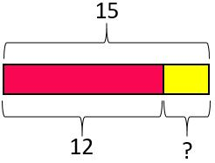

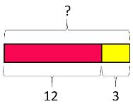

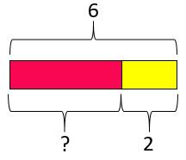

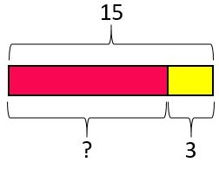

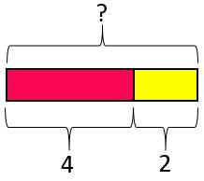

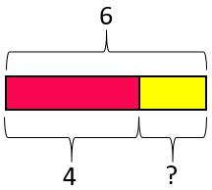
Note: the ‘first… then… now’ structure is used heavily in KS1 to scaffold pupils’ understanding of change structures. Once pupils are confident with the structures, such linguistic scaffolding can be
removed, and question construction can be changed to expose pupils to a greater range of nuance in interpreting problems. For example, the second and third reduction problems could be reworded as follows:

Kieran took two plates out of his cupboard for dinner. There were four left. How many plates were in the cupboard to begin with?

There were six plates in the cupboard before Kieran took some out for dinner. If there were four plates left in the cupboard, how many did Kieran take out?

Copyright © 2017 Mathematics Mastery. This can be printed out and photocopied by Mathematics Mastery toolkit registered users only. For further information, please see our terms and conditions at www.mathematicsmastery.org/terms-and-conditions

6

These present the same knowns and unknowns, and therefore the same bar models and resulting equations to solve the problems; however, the change in wording makes them more challenging to

pupils who have only worked with a ‘first… then… now’ structure so far.

Part-whole structures

Combination (aggregation)/partitioning
combining two or more discrete quantities/splitting one quantity into two or more sub-quantities

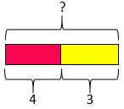
Hakan and Sally have made a stack of their favourite books. Four books belong to Hakan, three to Sally. How many books are in the stack altogether?
“I know both parts. One part is four and the other part is three. I don’t know the whole.

I need to add the parts of three and four to find the whole.”

4 + 3 = ? 3 + 4 = ?

(Only one problem has been written for combination as, owing to the commutativity of addition, the only change in question wording would be to swap Hakan and Sally’s names. The resulting bar model and calculation would be identical.)
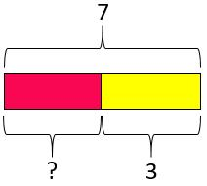

Sally and Hakan have made a stack of their favourite books. There are seven books altogether.

If three of them are Sally’s, how many belong to Hakan?
“I know the whole is seven and that one of the parts is three. I don’t know the other part. I need to
add on from three to make seven or subtract three from seven to find the other part.

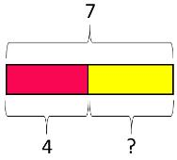
3 + ? = 7 7 –3 = ?

Sally and Hakan have made a stack of their favourite books. There are seven books altogether.
If four of them are Hakan’s, how many belong to Sally?
“I know the whole is seven and that one of the parts is four. I don’t know the other part. I need
to add on from four to make seven or subtract four from seven to find the other part.”

4 + ? = 7 7 –4 = ?

Note: all part-whole contexts are considered to be ‘standard’, as the language of part-whole is unambiguous.

Copyright © 2017 Mathematics Mastery. This can be printed out and photocopied by Mathematics Mastery toolkit registered users only. For further information, please see our terms and conditions at www.mathematicsmastery.org/terms-and-conditions

7



Comparison structures

Comparison structures involve a relationship between two quantities; their relationship is expressed as a difference. The structures vary by which of the values are known/unknown (the larger quantity, the smaller quantity and/or their difference). Part-whole language is not used here because the context contains not one single ‘whole’, but instead two separate quantities and it is the relationship between them being considered. Comparison bar models are therefore used to model these structures, which are known to be the most challenging for pupils to interpret.

Smaller quantity and larger quantity are known (comparative difference)

Standard

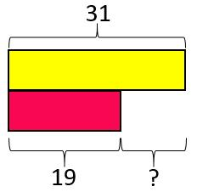
Navin has saved £19 from his pocket money. Sara has saved £31 from her pocket money. How much more has Sara saved than Navin? or How much less has Navin saved than Sara?

“I know one quantity is 19 and the other quantity is 31. I don’t know the difference. To find the
Difference I could add on from 19 to make 31 or I could subtract 19 from 31.”

19 + ? = 31 31 –19 = ?
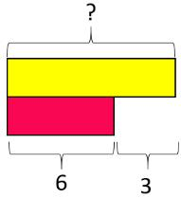
Smaller quantity and difference are known (comparative addition)

Standard

Ella has six marbles. Robin has three more than Ella. How many marbles does Robin have?

“I know the smaller quantity is six. I know the difference is three. I don’t know the larger
quantity. To find the larger quantity I need to add three to six.”

6 + 3 = ?

Non-standard

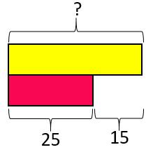
Samir and Lena are baking shortbread but Lena’s recipe uses 15g less butter than Samir’s. If
Lena needs to use 25g of butter, how much does Samir need?
“I know the smaller quantity is 25. I know the difference between the quantities is 15. I don’t
know the larger quantity. To find the larger quantity I need to add 15 to 25.”

? - 15 = 25 25 + 15 = ?

Larger quantity and difference are known (comparative subtraction)

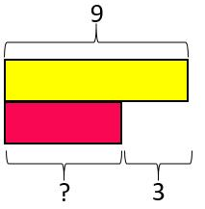
Non-standard

Ella has some marbles. Robin has three more than Ella and he has nine marbles in total. How many marbles does Ella have?

“I know the larger quantity is nine. I know the difference between the quantities is three. I don’t know the smaller quantity. To find the smaller quantity I need to add on from three to make nine or subtract three from nine.”
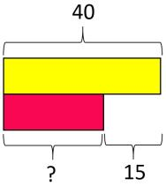
? + 3 = 9 9 –3 = ?
Standard

Samir’s shortbread recipe uses 40g of butter. Lena’s recipe uses 15g less butter. How much
butter does Lena need?
“I know one quantity is 40. I know the difference between the quantities is 15. I don’t know the
smaller quantity but I know it is 15 less than 40. To find the smaller quantity, I need to subtract
15 from 40.”

40 –15 = ? ? + 15 = 40

Copyright © 2017 Mathematics Mastery. This can be printed out and photocopied by Mathematics Mastery toolkit registered users only. For further information, please see our terms and conditions at www.mathematicsmastery.org/terms-and-conditions

8

Multiplicative reasoning

Repeated grouping structures

repeated addition

groups (sets) of equal value are combined or repeatedly added

There are four packs of pencils. Each contains five pencils. How many pencils are there?

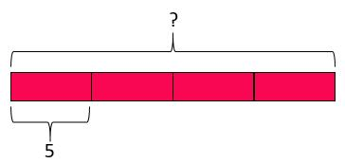

“I know there are four equal parts and that each part has a value of five. I don’t know the value of the whole. To find the whole, I need to multiply four and five.”

5 + 5 + 5 + 5 = ?

5 × 4 = ?

repeated subtraction (grouping)

groups (sets) of equal value are partitioned from the whole or repeatedly subtracted

There are 12 counters. If each child needs three counters to play the game, how many children can play?

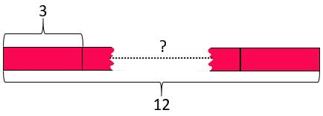

“I know the whole is twelve and that the value of each equal part is three. To find the number of equal parts, I need to know how many threes are in twelve.”

3 × ? = 12 12 ÷ 3 = ?

sharing (into equal groups)

the whole is shared into a known number (must be a positive integer) of equal groups (sets)

Share twelve counters equally between three children. How many counters does each child get?

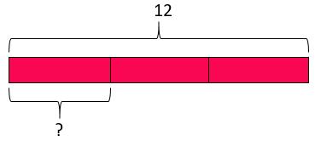

“I know the whole is twelve and the number of equal parts is three. I don’t know the value of each part. To find the value of each part, I need to know what goes into twelve three times.”

? × 3 = 12 12 ÷ 3 = ?

Cartesian product of two measures
correspondence

calculating the number of unique combinations that can be created from two (or more) sets

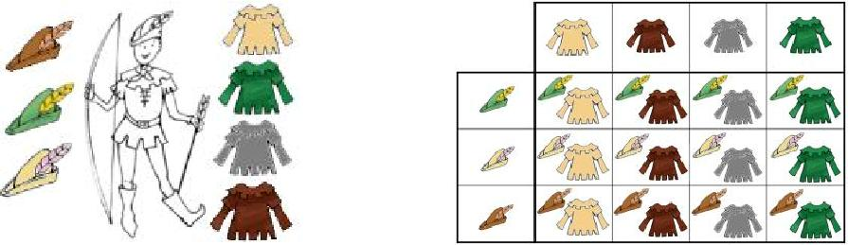

Robin has three different hats and four different tops. How many different outfits can he create, that combine one hat and one top?

“I know how many hats there are and I know how many tops there are. I don’t know the different number of outfits that can be created. To find the number of outfits, I need to find how many different tops can be worn with each hat or how many different hats can be worn with each top.”

4 × 3 = ? 3 × 4 = ?

Copyright © 2017 Mathematics Mastery. This can be printed out and photocopied by Mathematics Mastery toolkit registered users only. For further information, please see our terms and conditions at www.mathematicsmastery.org/terms-and-conditions

9


Scaling structures

scaling up | scaling down
(‘times greater / times as much’) | (‘times smaller/times less’)
the original value is increased by a given scale | the original value is reduced by a given scale factor
factor | The house in my model village needs to be
Rita receives £2 pocket money every week. Sim earns | half the height of the church. If the church is 8 cm tall,
ten times as much money for her paper round. How | how tall does the house need to be?
much money does Sim earn?
“I know one value is two and I know the second value is
ten times greater. I don’t know the second value. To
find the second value, I need to multiply two by ten.”
2 × 10 = ? | “I know one value is eight and I know the second value is
 | half as great. I don’t know the second value. To find the
 | second value, I need to halve eight (or divide it by two).”
 | Half of 8 is ? | 8 ÷ 2 = ?
scaling up (‘times as many’) | scaling down (‘times fewer’)
the value of the original quantity is increased by a | the value of the original quantity is decreased by a
given scale factor | given scale factor
The Albert Hall can hold five times as many people as | Anouska’s garden pond has ten times fewer frogs than
the Festival Hall. If the Festival Hall holds 1000 people, | fish. If there are fifty fish, how many frogs are there?
how many does the Albert Hall hold?
“I know one value is 1000 and I know the second value | “I know one value is 50 and I know the second value is ten
is five times greater. I don’t know the second value. To | times less. I don’t know the second value. To find the
find the second value, I need to multiply 1000 by five.” | second value, I need to divide fifty by ten.”
1000 × 5 = ? | 50 ÷ 10 = ?

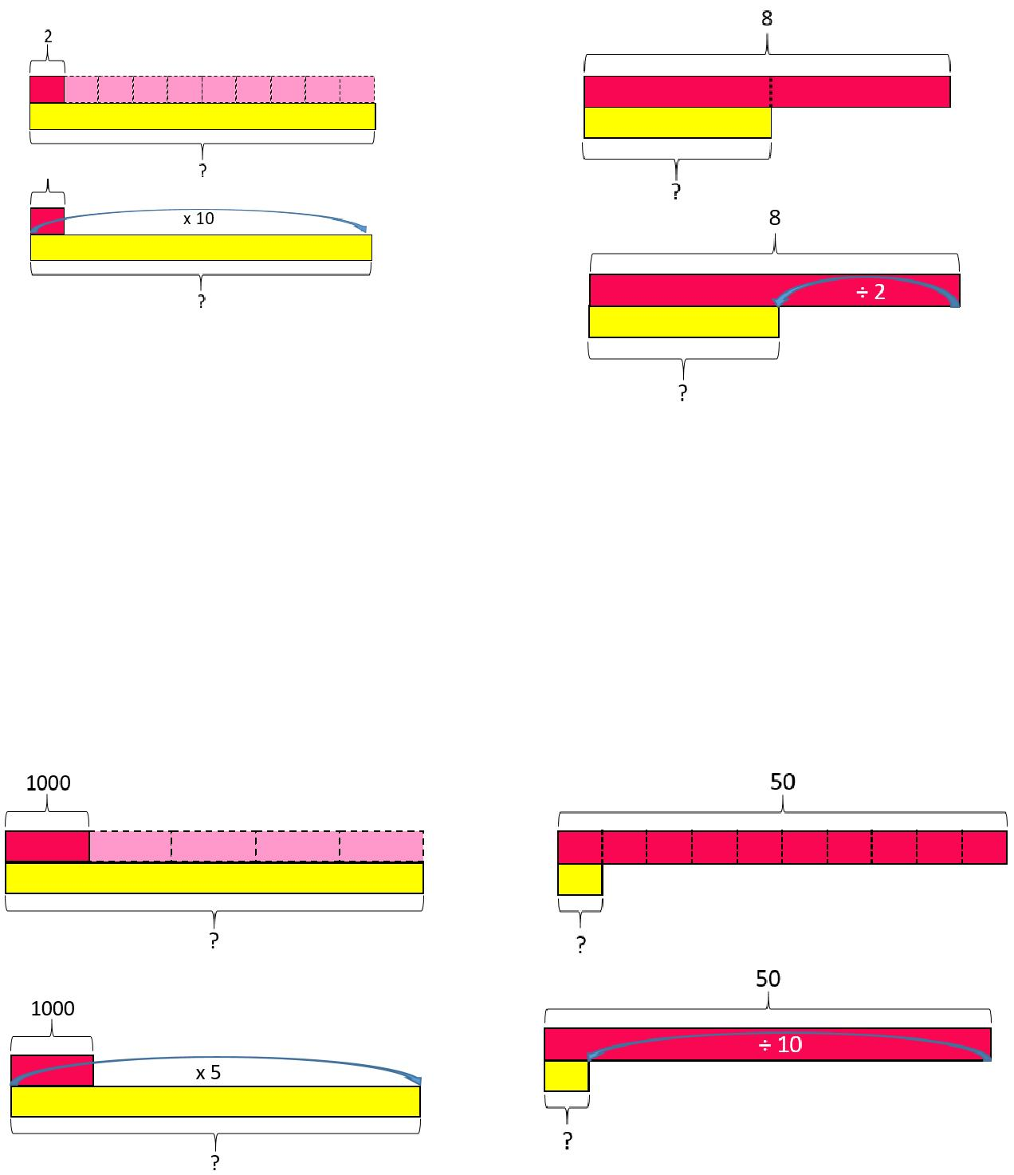
Copyright © 2017 Mathematics Mastery. This can be printed out and photocopied by Mathematics Mastery toolkit registered users only. For further information, please see our terms and conditions at www.mathematicsmastery.org/terms-and-conditions

10

Progression in calculations Year 1

National curriculum objectives linked to addition and subtraction

These objectives are explicitly covered through the strategies outlined in this document:

- Add and subtract one-digit and two-digit numbers to 100, including zero (N.B. Year 1 N.C. objective is to do this with numbers to 20).

- Add and subtract numbers using concrete objects, pictorial representations, and mentally, including: a two-digit number and ones, a two-digit number and tens, 2 two-digit numbers; add 3 one-digit numbers (Year 2).

- Represent and use number bonds and related subtraction facts within 20.

- Given a number, identify 1 more and 1 less.

- Show that addition of two numbers can be done in any order (commutative) but subtraction of one number from another cannot (Year 2).

- Recognise the inverse relationship between addition and subtraction and use this to solve missing number problems (Year 2).

The following objectives should be planned for lessons where new strategies are being introduced and developed:

- Read, write and interpret mathematical statements involving addition (+), subtraction (−) and equal (=) signs.

- Solve one-step problems that involve addition and subtraction, using concrete objects and
pictorial representations, and missing number problems, such as 7 = ?−9.

- Solve problems with addition and subtraction:

- Using concrete objects and pictorial representations, including those involving numbers, quantities and measures

o Applying their increasing knowledge of mental methods

Teachers should refer to the definitions and guidance on the structures for addition and subtraction to provide a range of appropriate real-life contexts for calculations.

Copyright © 2017 Mathematics Mastery. This can be printed out and photocopied by Mathematics Mastery toolkit registered users only. For further information, please see our terms and conditions at www.mathematicsmastery.org/terms-and-conditions

11

 | Y1 Addition
Strategy & guidance | CPA
Count all | 3 + 4 = 7

Joining two groups and then recounting all objects using one-to-one correspondence

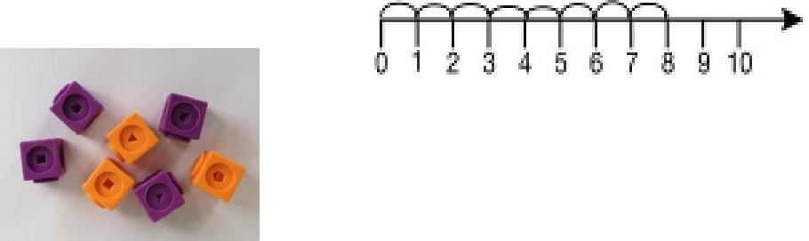
5 + 3 = 8

Counting on | 8 + 1 = 9 | 15 = 12 + 3
As a strategy, this
should be limited to
adding small
quantities only (1, 2 or
3) with pupils
understanding that
counting on from the
greater number is
more efficient.
Part-part-whole
Teach both addition
and subtraction
alongside each other,
as pupils will use this
model to identify the
inverse relationship
between them.
This model begins to |  | 10 = 6 + 4
develop the |  | 10 = 6 + 4
understanding of the |  | 10 −6 = 4
commutativity of |  | 10 −4 = 6
addition, as pupils |  | 10 = 4 + 6
become aware that the
parts will make the
whole in any order.

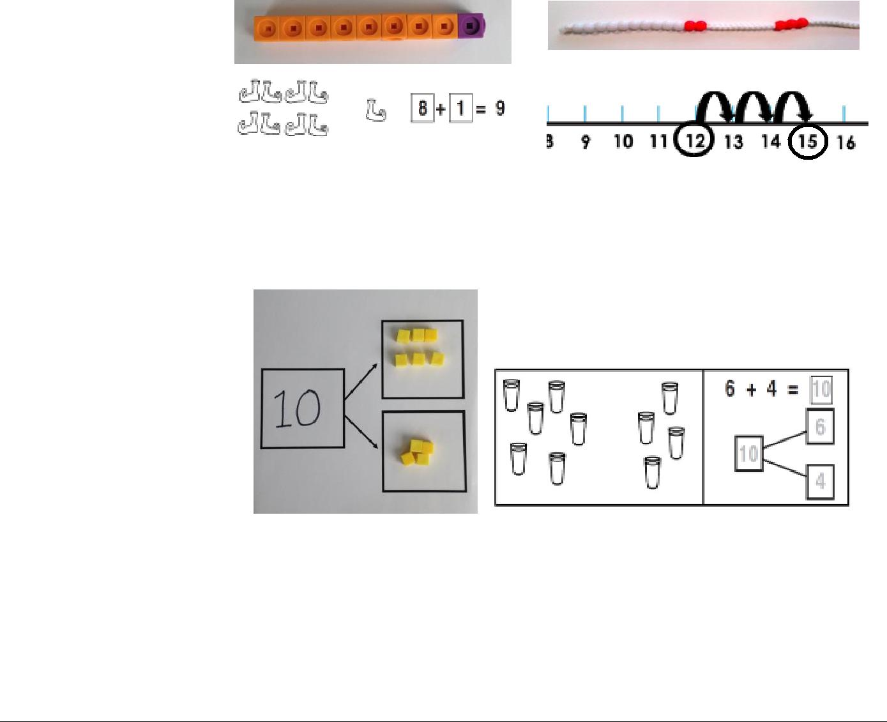

Copyright © 2017 Mathematics Mastery. This can be printed out and photocopied by Mathematics Mastery toolkit registered users only. For further information, please see our terms and conditions at www.mathematicsmastery.org/terms-and-conditions

12


Regrouping ten ones to make ten

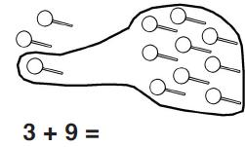
This is an essential skill that will support

column addition later
on.

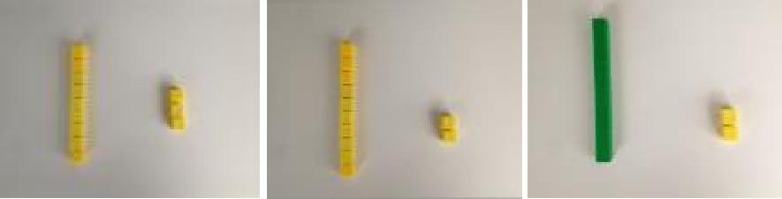

‘Make ten’ strategy | 6 + 5 = 11 | 4 + 9 = 13

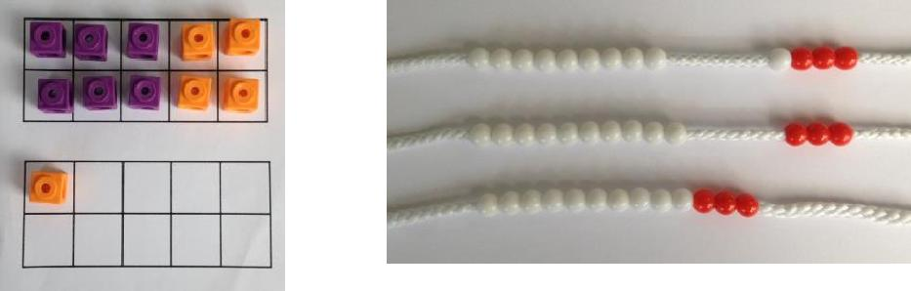
Pupils should be encouraged to start at the greater number and partition the smaller number to make ten.

The colours of the beads on the bead string make it clear how many more need to be added to make ten.

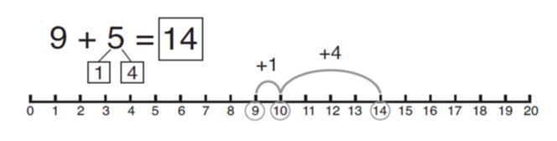
Also, the empty spaces on the ten frame make it clear how many more are needed to make ten.



Copyright © 2017 Mathematics Mastery. This can be printed out and photocopied by Mathematics Mastery toolkit registered users only. For further information, please see our terms and conditions at www.mathematicsmastery.org/terms-and-conditions

13

Adding 1, 2, 3 more | 1 more than 5 | 5 + 1 = 6
Here the emphasis
should be on the
language rather than
the strategy. As pupils
are using the
beadstring, ensure that | 2 more than 5 | 5 + 2 = 7
they are explaining
using language such
as;
‘1 more than 5 is equal
to 6.’
‘2 more than 5 is equal
to 7.’
‘8 is 3 more than 5’
Over time, pupils
should be
encouraged to rely
more on their
number bonds
knowledge than on
counting strategies.
Adding three single
digit numbers
(make ten first)
Pupils may need to try
different combinations
before they find the
two numbers that
make 10.
The first bead string
shows 4, 7 and 6. The
colours of the bead
string show that it
makes more than ten.
The second bead string
shows 4, 6 and then 7.
The final bead string
shows how they have
now been put together
to find the total.
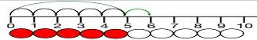
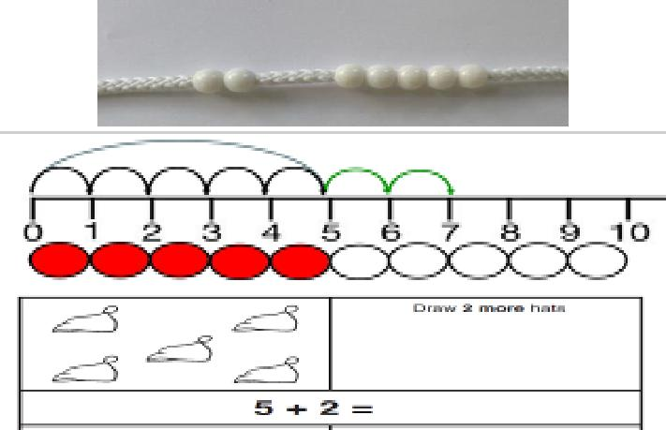
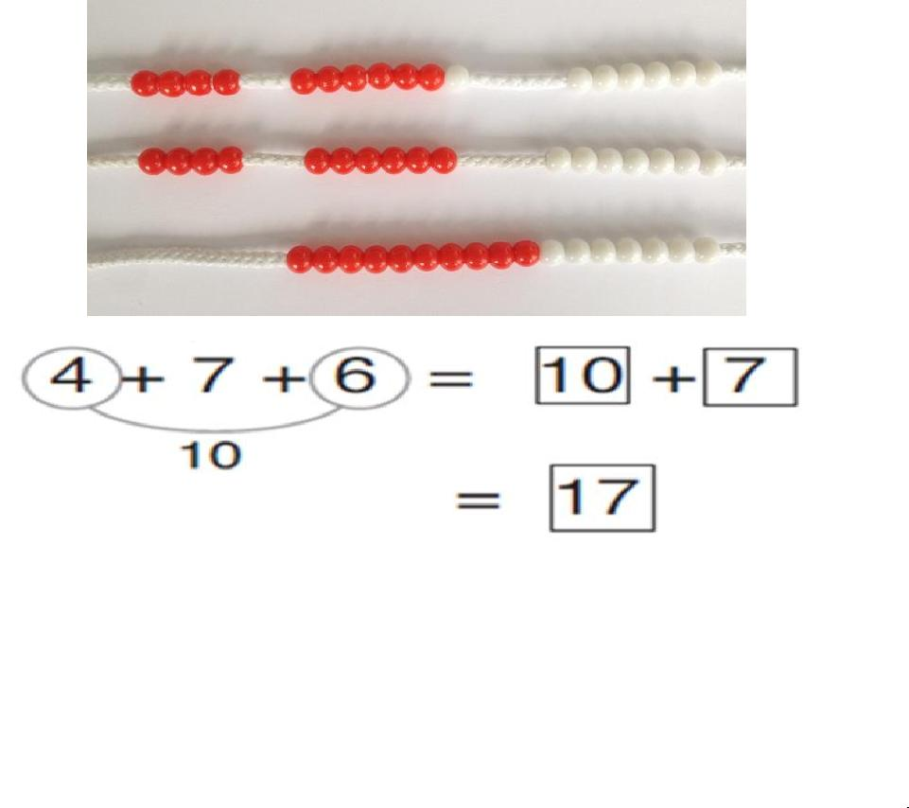

Copyright © 2017 Mathematics Mastery. This can be printed out and photocopied by Mathematics Mastery toolkit registered users only. For further information, please see our terms and conditions at www.mathematicsmastery.org/terms-and-conditions

14

Partitioning to add | 24 + 13 = 37
(no regrouping)
Place value grids and
Dienes blocks could be
used as shown in the
diagram before
moving onto pictorial
representations. Dienes
blocks should always
be available, as the
main focus in Year 1 is
the concept of place
value rather than
mastering the | 24 + 13 = 37
procedure.
When not regrouping,
partitioning is a
mental strategy and
does not need formal
recording in columns.
This representation
prepares them for
using column addition
with formal recording.
Column not taught in Year 1.
 | Tens Ones
 | 2 4
 | + 1 7
 | 1
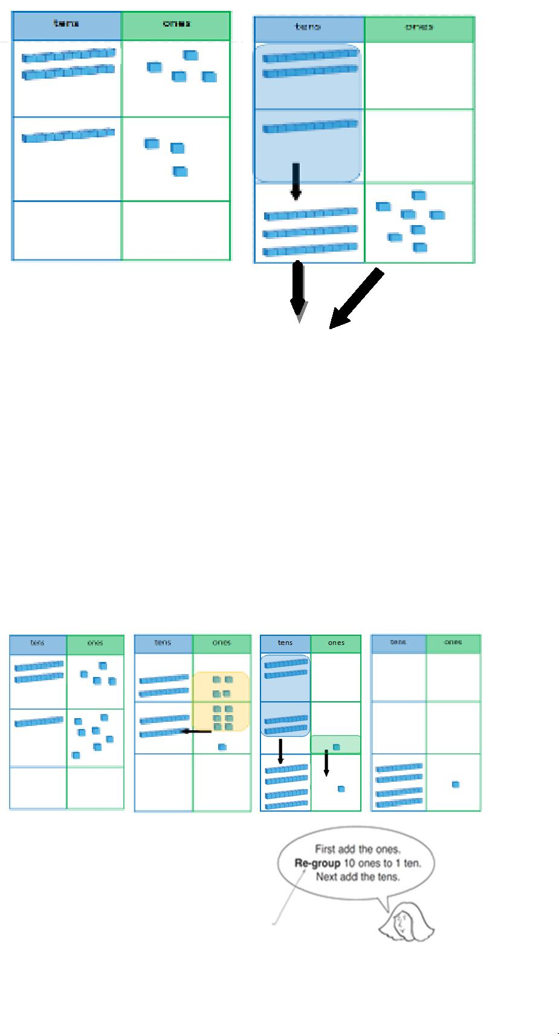

Copyright © 2017 Mathematics Mastery. This can be printed out and photocopied by Mathematics Mastery toolkit registered users only. For further information, please see our terms and conditions at www.mathematicsmastery.org/terms-and-conditions

15

Adding multiples of | 50 = 30 + 20
ten
Using the vocabulary
of 1 ten, 2 tens, 3 tens
etc. alongside 10, 20,
30 is important, as
pupils need to
understand that it is a
ten and not a one that
is being added and
they need to
Understand that a ‘2’
digit in the tens column
has a value of twenty.
It also emphasises the
link to known number
facts. E.g. ‘2+3 is
equal to 5. So 2 tens + 3
tens is equal to 5 tens.
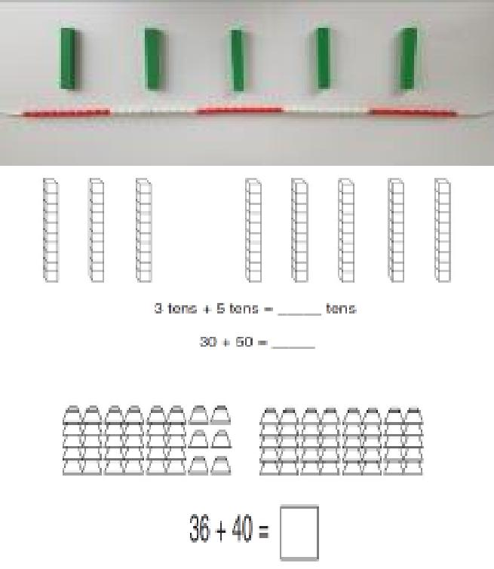

Copyright © 2017 Mathematics Mastery. This can be printed out and photocopied by Mathematics Mastery toolkit registered users only. For further information, please see our terms and conditions at www.mathematicsmastery.org/terms-and-conditions

16

 | Y1 Subtraction
Strategy & guidance | CPA
Taking away from
the ones
When this is first
introduced, the
concrete
representation should
be based upon the
diagram. Real objects
should be placed on
top of the images as
one-to-one
correspondence so
that pupils can take
them away,
progressing to
representing the group
of ten with a tens rod
and ones with ones
cubes.
Counting back
Subtracting 1, 2, or 3 | 16 –2 = 14
by counting back
Pupils should be
encouraged to rely
on number bonds
knowledge as time
goes on, rather
than using
counting back as
their main | 4 = 6 −
strategy. | 4 = 6 −
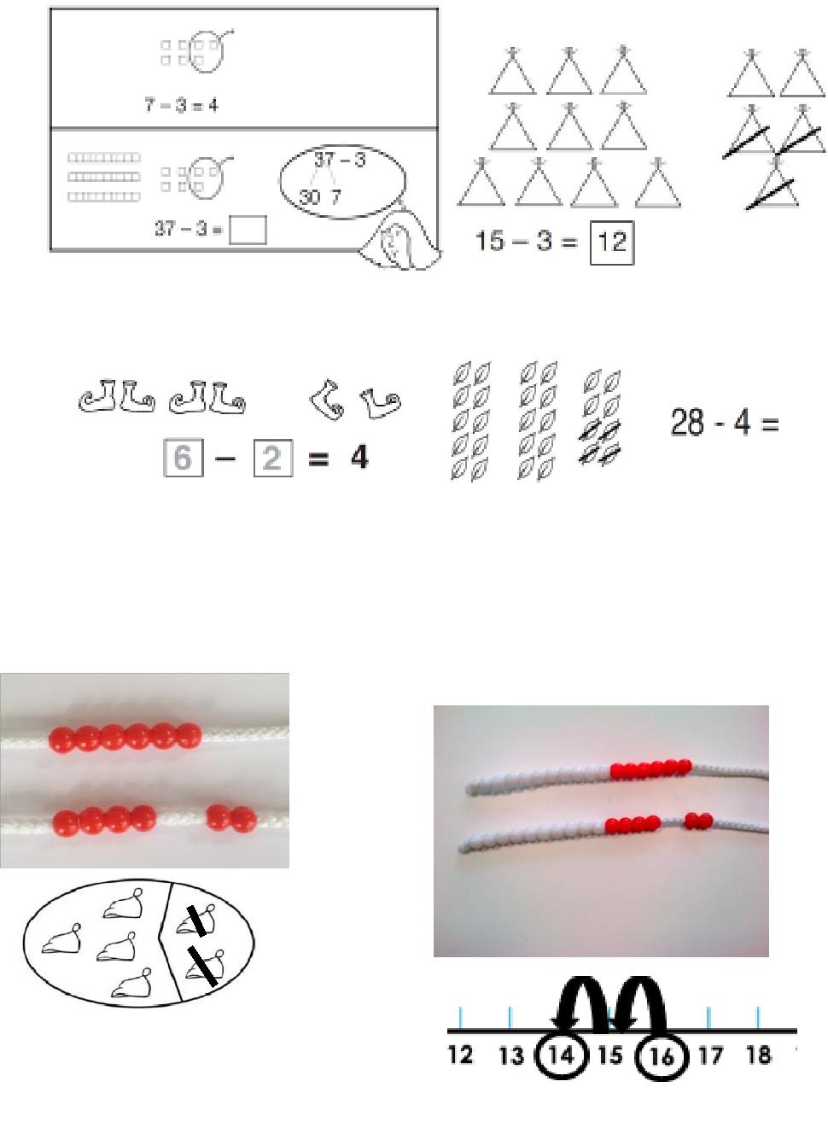

Copyright © 2017 Mathematics Mastery. This can be printed out and photocopied by Mathematics Mastery toolkit registered users only. For further information, please see our terms and conditions at www.mathematicsmastery.org/terms-and-conditions

17

Part-part-whole | 10 −6 = 4
Teach both addition
and subtraction
alongside each other,
as the pupils will use
this model to identify
the link between them.
Pupils start with ten
cubes placed on the
whole.
They then remove
what is being taken
away from the whole
and place it on one of
the parts.
The remaining cubes
are the other part and
also the answer. These
can be moved into the
second part space.
Make ten strategy | 14 –5 = 9
To subtract a 1-digit
number from a 2-digit
number.
Pupils identify how
many need to be taken
away to make ten
first, partitioning the
number being
subtracted. Then they
take away the rest to
reach the answer.
Regroup a ten into
10 ones
After the initial
introduction, the
Dienes blocks should
be placed on a place
value chart to support
place value
understanding. This
will support pupils
when they later use
the column method.
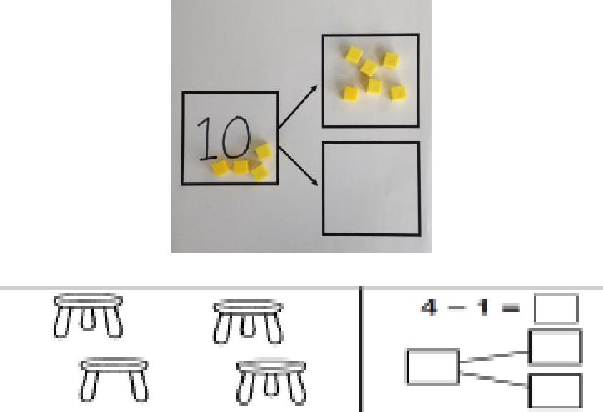
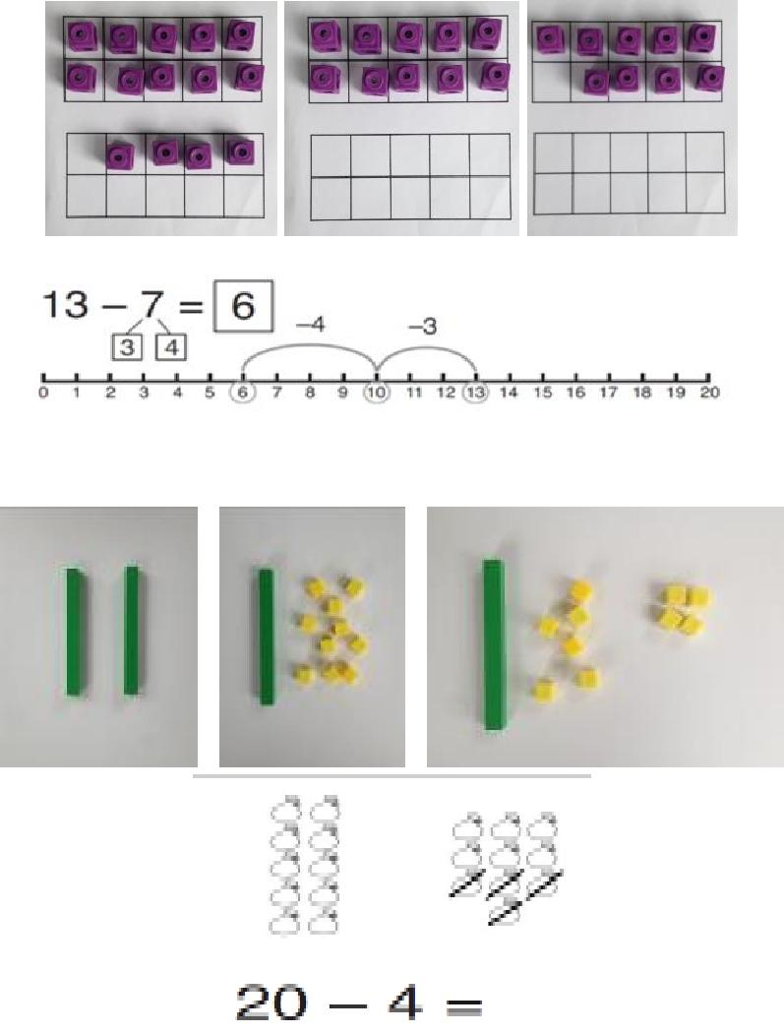

Copyright © 2017 Mathematics Mastery. This can be printed out and photocopied by Mathematics Mastery toolkit registered users only. For further information, please see our terms and conditions at www.mathematicsmastery.org/terms-and-conditions

18


Taking away from | 9 = 15−6
the tens
Pupils should identify
that they can also take
away from the tens
and get the same
answer.
This reinforces their
knowledge of number
bonds to 10 and
develops their
application of number
bonds for mental
strategies.

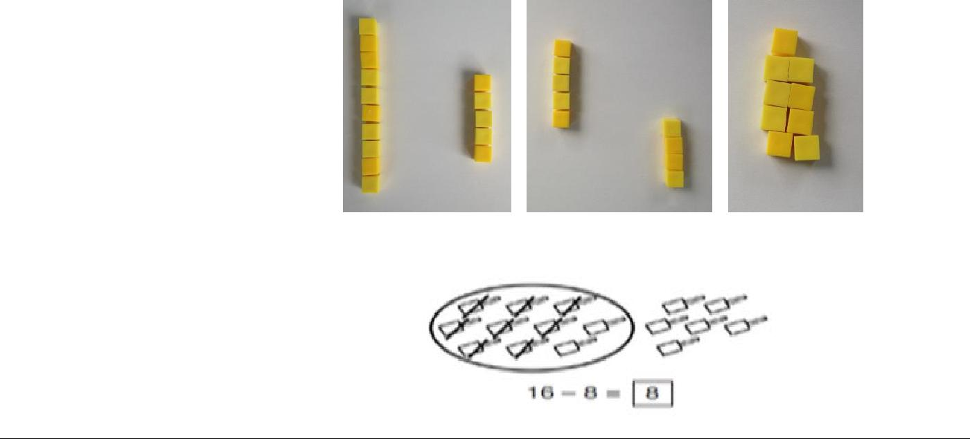

Partitioning to | 34 −13 = 21
subtract without
regrouping
Dienes blocks on a
place value chart
(developing into using
images on the chart)
could be used, as when
adding 2-digit
numbers, reinforcing
the main concept of
place value for Year 1.
 | 34 –13 = 21
When not regrouping,
partitioning is a
mental strategy and
does not need formal
recording in columns.
This representation
prepares them for
using column
subtraction with
formal recording.

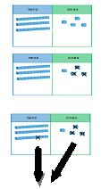

Copyright © 2017 Mathematics Mastery. This can be printed out and photocopied by Mathematics Mastery toolkit registered users only. For further information, please see our terms and conditions at www.mathematicsmastery.org/terms-and-conditions

19

Subtracting | 40 = 60 –20 | 38 −10 = 28
multiples of ten
Using the vocabulary
of 1 ten, 2 tens, 3 tens
etc. alongside 10, 20,
30 is important as
pupils need to
understand that it is a
ten not a one that is
being taken away.
Column method |  | 34 −17 = 17
with regrouping
This example shows
how pupils should
work practically when
being introduced to
this method.
There is no formal
recording in columns
in Year 1 but this
practical work will
prepare pupils for
formal methods in
Year 2.
See additional
guidance on unit
pages to support with
this method.
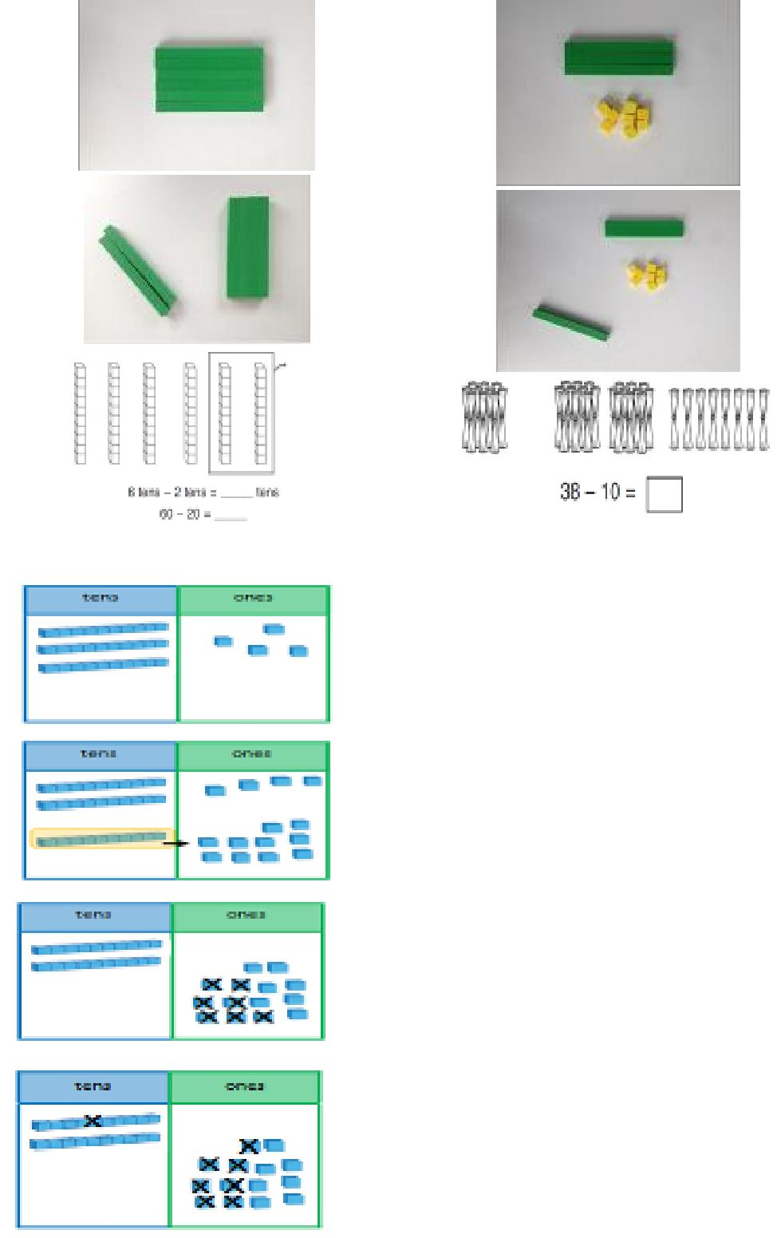

Copyright © 2017 Mathematics Mastery. This can be printed out and photocopied by Mathematics Mastery toolkit registered users only. For further information, please see our terms and conditions at www.mathematicsmastery.org/terms-and-conditions

20

National Curriculum objectives linked to multiplication and division

These objectives are explicitly covered through the strategies outlined in this document:

- Solve one-step problems involving multiplication and division, by calculating the answer using concrete objects, pictorial representations and arrays with the support of the teacher.

Teachers should refer to definitions and guidance on the structures for multiplication and division to provide a range of appropriate real-life contexts for calculations.

 | Y1 Multiplication
Strategy & guidance | CPA
Skip counting in
multiples of 2, 5, 10 from
zero
The representation for the
amount of groups supports
pupils’ understanding of the
written equation. So two | 4 × 5 = 20
groups of 2 are 2, 4. Or five | 4 × 5 = 20
groups of 2 are 2, 4, 6, 8, 10.
Count the groups as pupils
are skip counting.
Number lines can be used in
the same way as the bead
string.
Pupils can use their fingers
as they are skip counting. | 2 × 4 = 8
Making equal groups
and counting the total
How this would be
represented as an equation
will vary. This could be 2 × 4
or 4 × 2. The importance
should be placed on the
vocabulary used alongside
the equation. So this picture
could represent 2 groups of
4 or 4 twice.
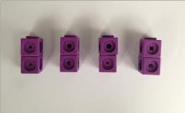
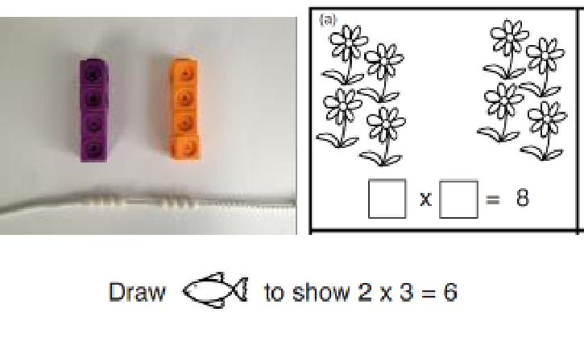
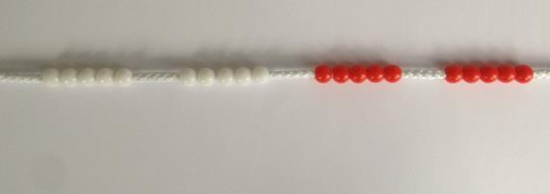

Copyright © 2017 Mathematics Mastery. This can be printed out and photocopied by Mathematics Mastery toolkit registered users only. For further information, please see our terms and conditions at www.mathematicsmastery.org/terms-and-conditions

21

Solve multiplications | 3 x 3 = 3 + 3 + 3
using repeated addition
This strategy helps pupils
make a clear link between
multiplication and division
as well as exemplifying the
‘repeated addition’ structure
for multiplication. It is a
natural progression from
the previous ‘count all’
strategy as pupils can be
encouraged to ‘count on’.
However, as number bonds
knowledge grows, pupils
should rely more on these
important facts to calculate
efficiently.
 | 3 + 3 + 3 = 9
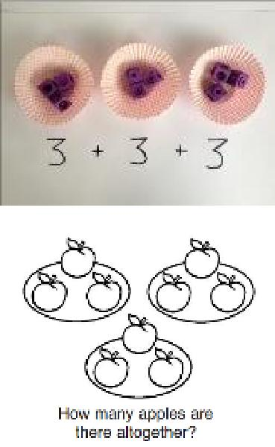

 | Y1 Division
Strategy & guidance | CPA
Sharing objects into | 10 ÷ 2 = 5
groups
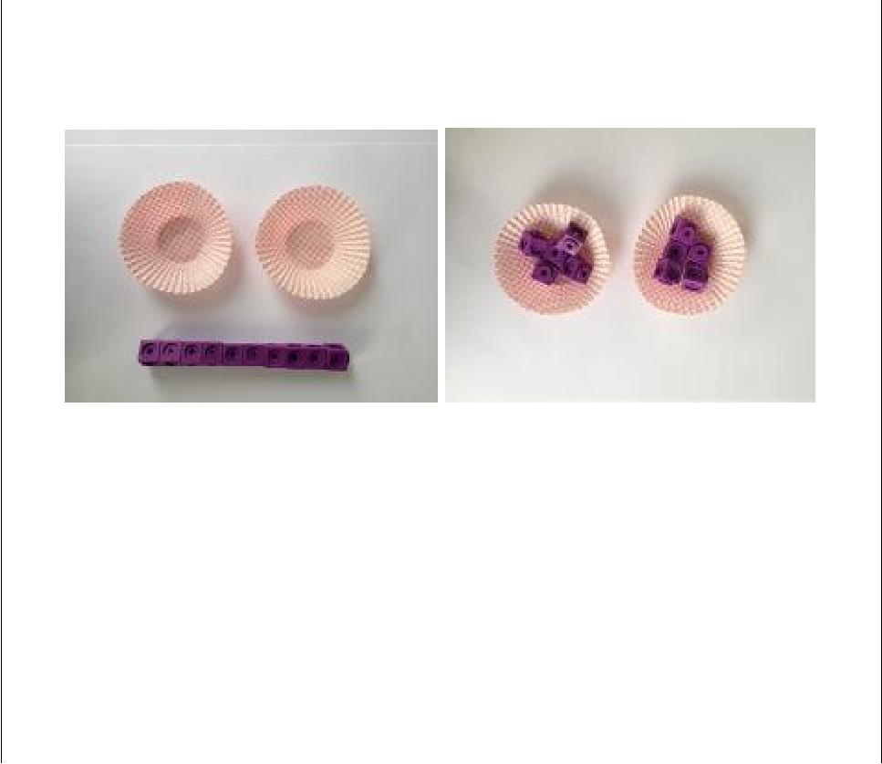
Pupils should become familiar with division equations through working practically.

The division symbol is not formally taught at this stage.

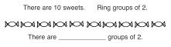

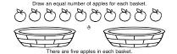

Copyright © 2017 Mathematics Mastery. This can be printed out and photocopied by Mathematics Mastery toolkit registered users only. For further information, please see our terms and conditions at www.mathematicsmastery.org/terms-and-conditions

22

Progression in calculations Year 2

National Curriculum objectives linked to addition and subtraction

These objectives are explicitly covered through the strategies outlined in this document:

- Add and subtract numbers using concrete objects, pictorial representations, and mentally, including: a two-digit number and ones; a two-digit number and tens; 2 two-digit numbers; adding three one-digit numbers.

- Add and subtract numbers mentally, including: a three-digit number and ones; a three-digit number and tens; a three-digit number and hundreds (Year 3).

- Recall and use addition and subtraction facts to 20 fluently, and derive and use related facts up to 100.

- Find 10 or 100 more or less than a given number (Year 3).

- Show that addition of two numbers can be done in any order (commutative) but subtraction of one number from another cannot.

- Recognise and use the inverse relationship between addition and subtraction and use this to check calculations and solve missing number problems.

- Add and subtract numbers with up to three digits, using formal written methods of columnar addition and subtraction (Year 3).

The following objectives should be planned for lessons where new strategies are being introduced and developed:

- Solve problems with addition and subtraction: using concrete objects and pictorial representations, including those involving numbers, quantities and measures; apply increasing knowledge of mental and written methods.

- Solve problems, including missing number problems, using number facts, place value and more complex addition and subtraction. (Year 3)

Teachers should refer to the definitions and guidance on the structures for addition and subtraction to provide a range of appropriate real-life contexts for calculations.

Copyright © 2017 Mathematics Mastery. This can be printed out and photocopied by Mathematics Mastery toolkit registered users only. For further information, please see our terms and conditions at www.mathematicsmastery.org/terms-and-conditions

23

 | Y2 Addition
Strategy & guidance | CPA
Part-part-whole
Pupils explore the different | 20 = 17 + 3
ways of making 20. They | 20 = 17 + 3
ways of making 20. They | 20 = 3 + 17
can do this with all | 20 = 3 + 17
can do this with all | 20 –3 = 17
numbers using the same | 20 –3 = 17
representations. | 20 –17 = 3
This model develops
knowledge of the inverse
relationship between
addition and subtraction
and is used to find the
answer to missing number
problems.
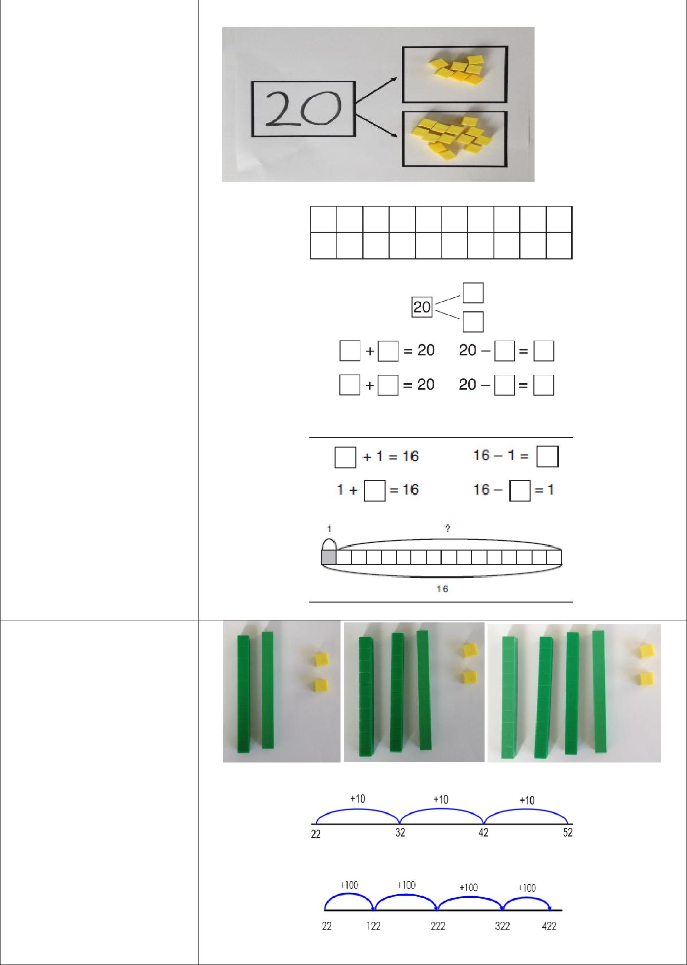

Counting on in tens and hundreds

Copyright © 2017 Mathematics Mastery. This can be printed out and photocopied by Mathematics Mastery toolkit registered users only. For further information, please see our terms and conditions at www.mathematicsmastery.org/terms-and-conditions

24

Strategy & guidance | CPA
Using known facts to | 3 + 4 = 7
create derived facts
 | leads to
Dienes blocks should be
used alongside pictorial | 30 + 40 = 70
and abstract
representations when | leads to
introducing this strategy. | 300 + 400 = 700
Partitioning one
number, then adding
tens and ones
Pupils can choose
themselves which of the
numbers they wish to
partition. Pupils will begin
to see when this method is
more efficient than adding
tens and taking away the
extra ones, as shown.
 | 22 + 17 = 39
Round and adjust
(sometimes known as a
compensating strategy)
Pupils will develop a sense
of efficiency with this
method, beginning to see
when rounding and
adjusting is more efficient
than adding tens and then
ones.
 | 22 + 17 = 39
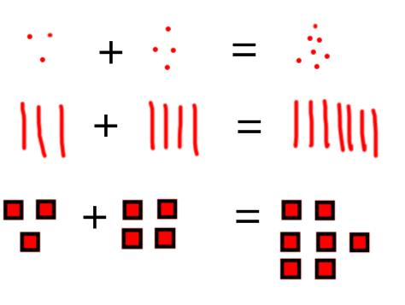
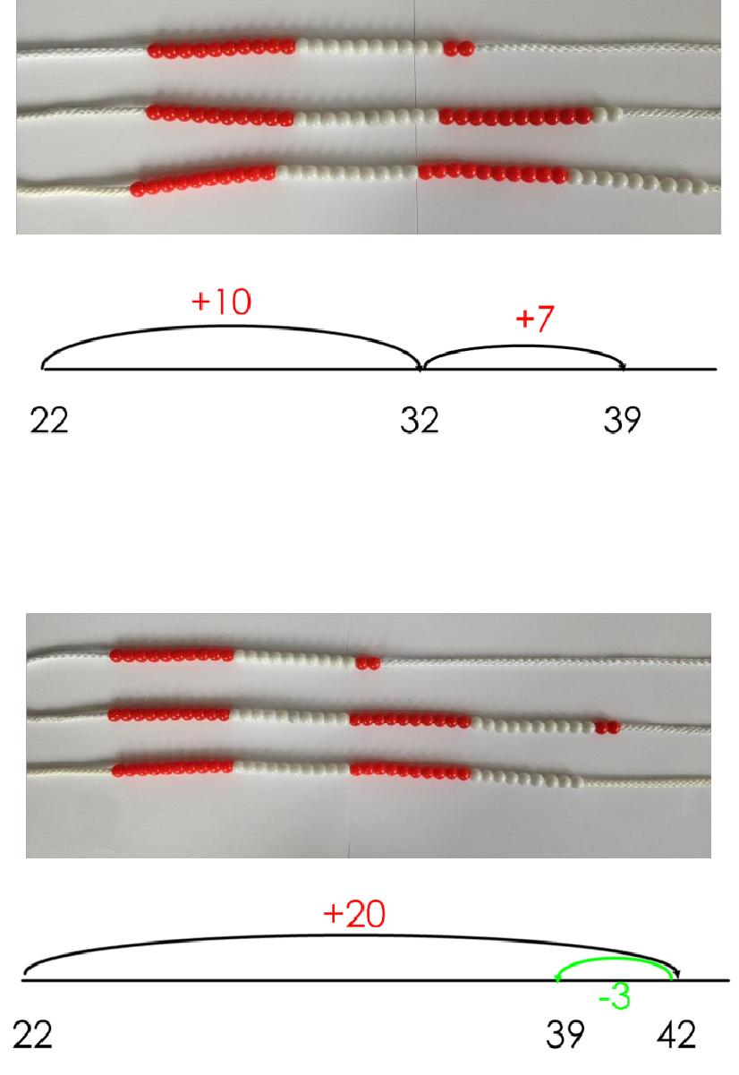

Copyright © 2017 Mathematics Mastery. This can be printed out and photocopied by Mathematics Mastery toolkit registered users only. For further information, please see our terms and conditions at www.mathematicsmastery.org/terms-and-conditions

25

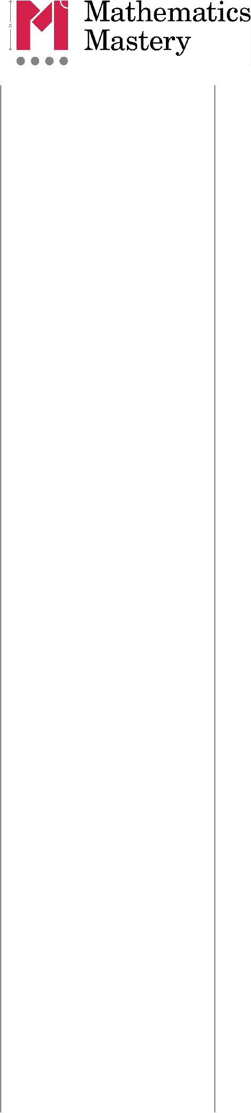
Strategy & guidance | CPA

Make ten strategy

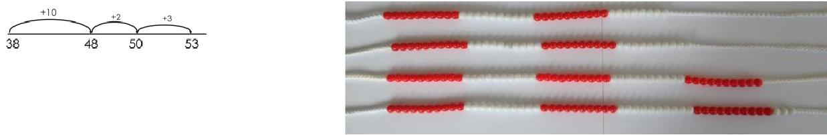

How pupils choose to apply this strategy is up to them; however, the focus should always be on efficiency.

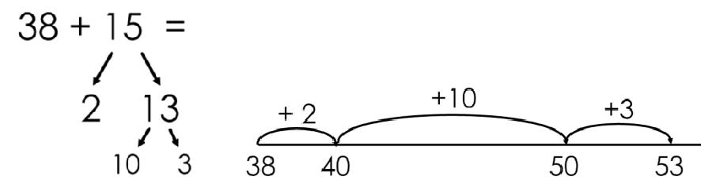
It relies on an understanding that numbers can be partitioned in different ways in order to easily make a multiple of ten.

Partitioning to add without regrouping
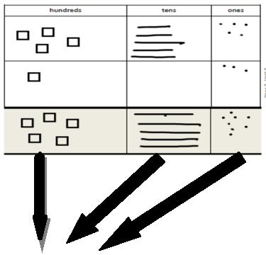
As in Year 1, this is a
mental strategy rather
than a formal written
method. Pupils use the
Dienes blocks (and later,
images) to represent 3-
digit numbers but do not
record a formal written
method if there is no | 4 5 5 + 1 0 3 = 5 5 8
regrouping. | 4 5 5 + 1 0 3 = 5 5 8

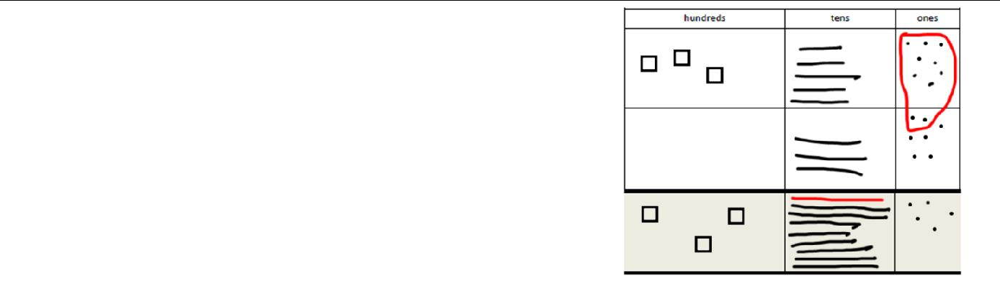
Column method with regrouping

Dienes blocks should be used alongside the pictorial representations; they can be placed on the place value grid before pupils make pictorial representations.

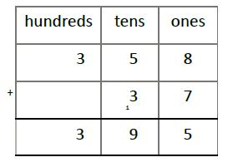
As in Year 1, the focus for the column method is to develop a strong understanding of place value.

Copyright © 2017 Mathematics Mastery. This can be printed out and photocopied by Mathematics Mastery toolkit registered users only. For further information, please see our terms and conditions at www.mathematicsmastery.org/terms-and-conditions

26

 | Y2 Subtraction
Strategy & guidance | CPA
Counting back in
multiples of ten and one
hundred
Using known number
facts to create derived
facts | 8 −4 = 4
Dienes blocks should be | leads to
used alongside pictorial
and abstract | 80 −40 = 40
representations when | leads to
introducing this strategy, | leads to
encouraging pupils to | 800 −400 = 400
apply their knowledge of | 800 −400 = 400
number bonds to add
multiples of ten and 100.
Subtracting tens and | 53 −12 = 41
ones
Pupils must be taught to
partition the second
number for this strategy as
partitioning both numbers
can lead to errors if
regrouping is required.
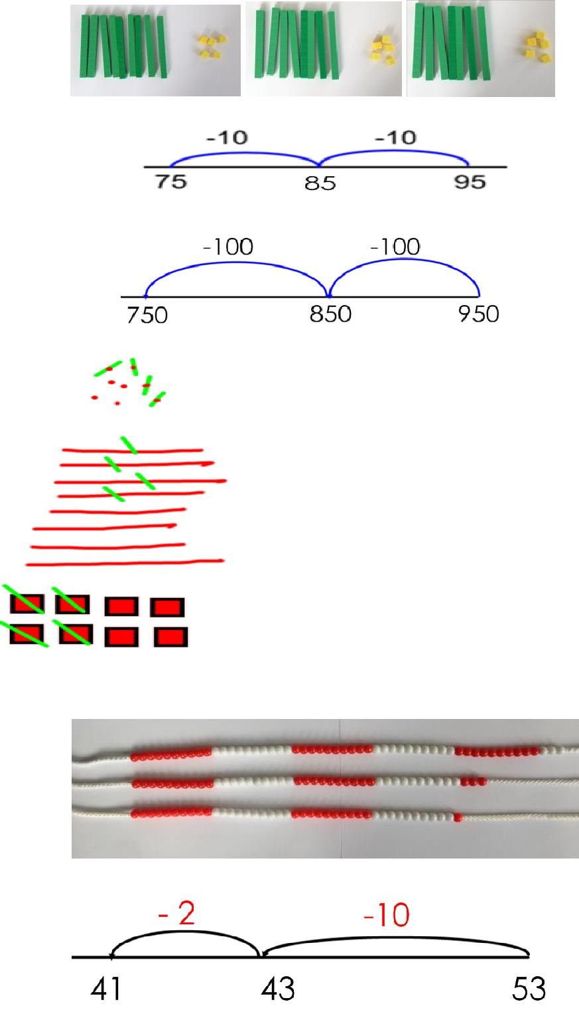

Copyright © 2017 Mathematics Mastery. This can be printed out and photocopied by Mathematics Mastery toolkit registered users only. For further information, please see our terms and conditions at www.mathematicsmastery.org/terms-and-conditions

27

Strategy & guidance | CPA
Round and adjust
(sometimes known as a
compensating strategy)
Pupils must be taught to
round the number that is
being subtracted.
Pupils will develop a sense
of efficiency with this
method, beginning to
identify when this method
is more efficient than
subtracting tens and then
ones.
 | 53 −17 = 36
Make ten
How pupils choose to apply
this strategy is up to them.
The focus should always be
on efficiency.
It relies on an
understanding that
numbers can be partitioned
in different ways in order
to subtract to a multiple of
ten.
Pupils should develop an
understanding that the
parts can be added in any
order.
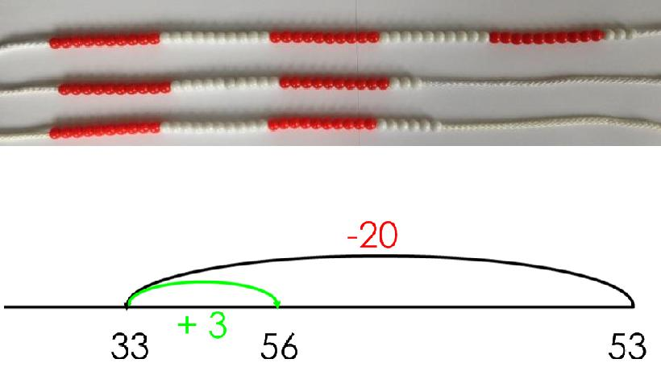
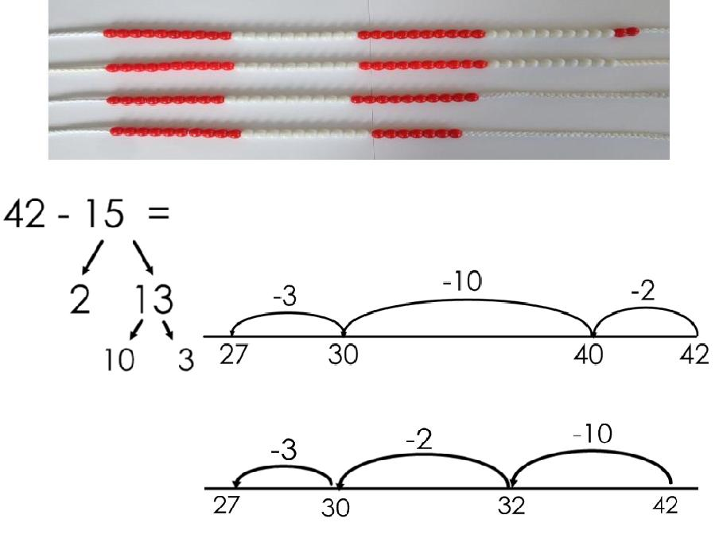

Copyright © 2017 Mathematics Mastery. This can be printed out and photocopied by Mathematics Mastery toolkit registered users only. For further information, please see our terms and conditions at www.mathematicsmastery.org/terms-and-conditions

28

Strategy & guidance | CPA
Partitioning to subtract
without regrouping
As in Year 1, the focus is to
develop a strong
understanding of place
value and pupils should
always be using concrete
manipulatives alongside
the pictorial.
Formal recording in
columns is unnecessary for
this mental strategy. It
prepares them to subtract | 263 −121= 142
with 3-digits when | 263 −121= 142
regrouping is required.
Column method with
regrouping
The focus for the column
method is to develop a
strong understanding of
place value and concrete
manipulatives should be
used alongside.
Pupils are introduced to
calculations that require
two instances of
regrouping (initially from
tens to one and then from
hundreds to tens). E.g. 232
–157 and are given plenty
of practice using concrete
manipulatives and images
alongside their formal
written methods, ensuring
that important steps are
not missed in the recording.
Caution should be exercised
when introducing
calculations requiring
‘regrouping to regroup’
(e.g. 204 –137) ensuring
ample teacher modelling
using concrete
manipulatives and images.
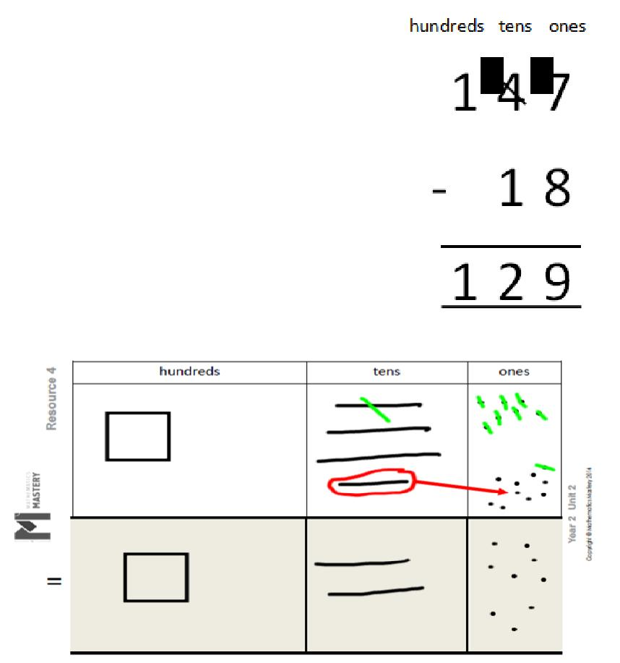
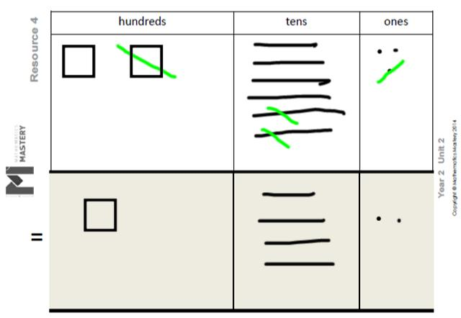

Copyright © 2017 Mathematics Mastery. This can be printed out and photocopied by Mathematics Mastery toolkit registered users only. For further information, please see our terms and conditions at www.mathematicsmastery.org/terms-and-conditions

29

National Curriculum objectives linked to multiplication and division

These objectives are explicitly covered through the strategies outlined in this document:

- Recall and use multiplication and division facts for the 2, 5 and 10 multiplication tables, including recognising odd and even numbers.

- Recall and use multiplication and division facts for the 3 and 4 multiplication tables (Year 3).

- Show that multiplication of two numbers can be done in any order (commutative) but division of one number by another cannot.

The following objectives should be planned for lessons where new strategies are being introduced and developed:

- Calculate mathematical statements for multiplication and division within the multiplication tables and write them using the multiplication (×), division (÷) and equal (=) signs.

- Solve problems involving multiplication and division, using materials, arrays, repeated addition, mental methods and multiplication and division facts, including problems in context.

Teachers should refer to definitions and guidance on the structures for multiplication and division to provide a range of appropriate real-life contexts for calculations.

Copyright © 2017 Mathematics Mastery. This can be printed out and photocopied by Mathematics Mastery toolkit registered users only. For further information, please see our terms and conditions at www.mathematicsmastery.org/terms-and-conditions

30

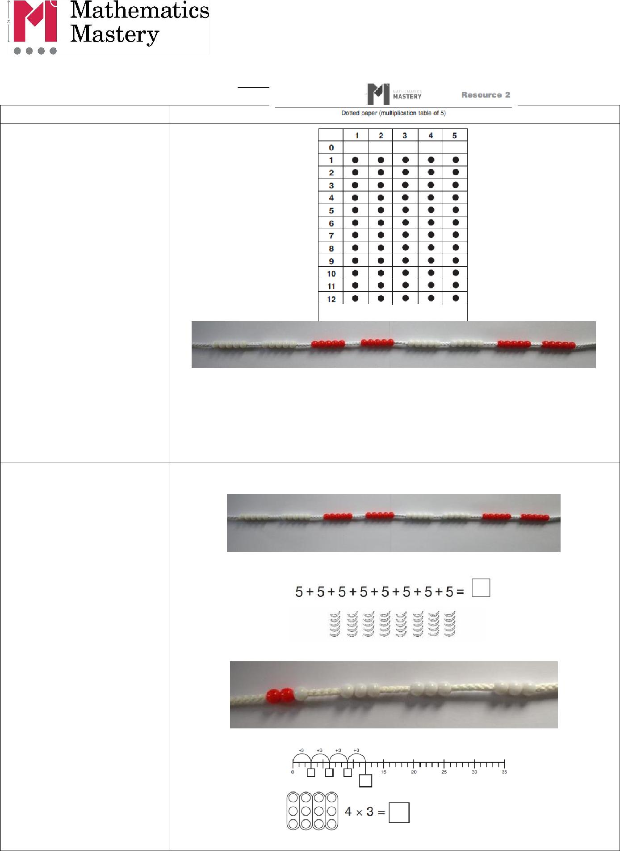
Y2

Strategy & guidance

Skip counting in multiples of 2, 3, 4, 5, 10 from zero

Pupils can use their fingers as they are skip counting, to develop an understanding of ‘groups of’.

Multiplication as repeated addition

Pupils apply skip counting to help find the totals of repeated additions.

Copyright © 2017 Mathematics Mastery. This can be printed out and photocopied by Mathematics Mastery toolkit registered users only. For further information, please see our terms and conditions at www.mathematicsmastery.org/terms-and-conditions

31

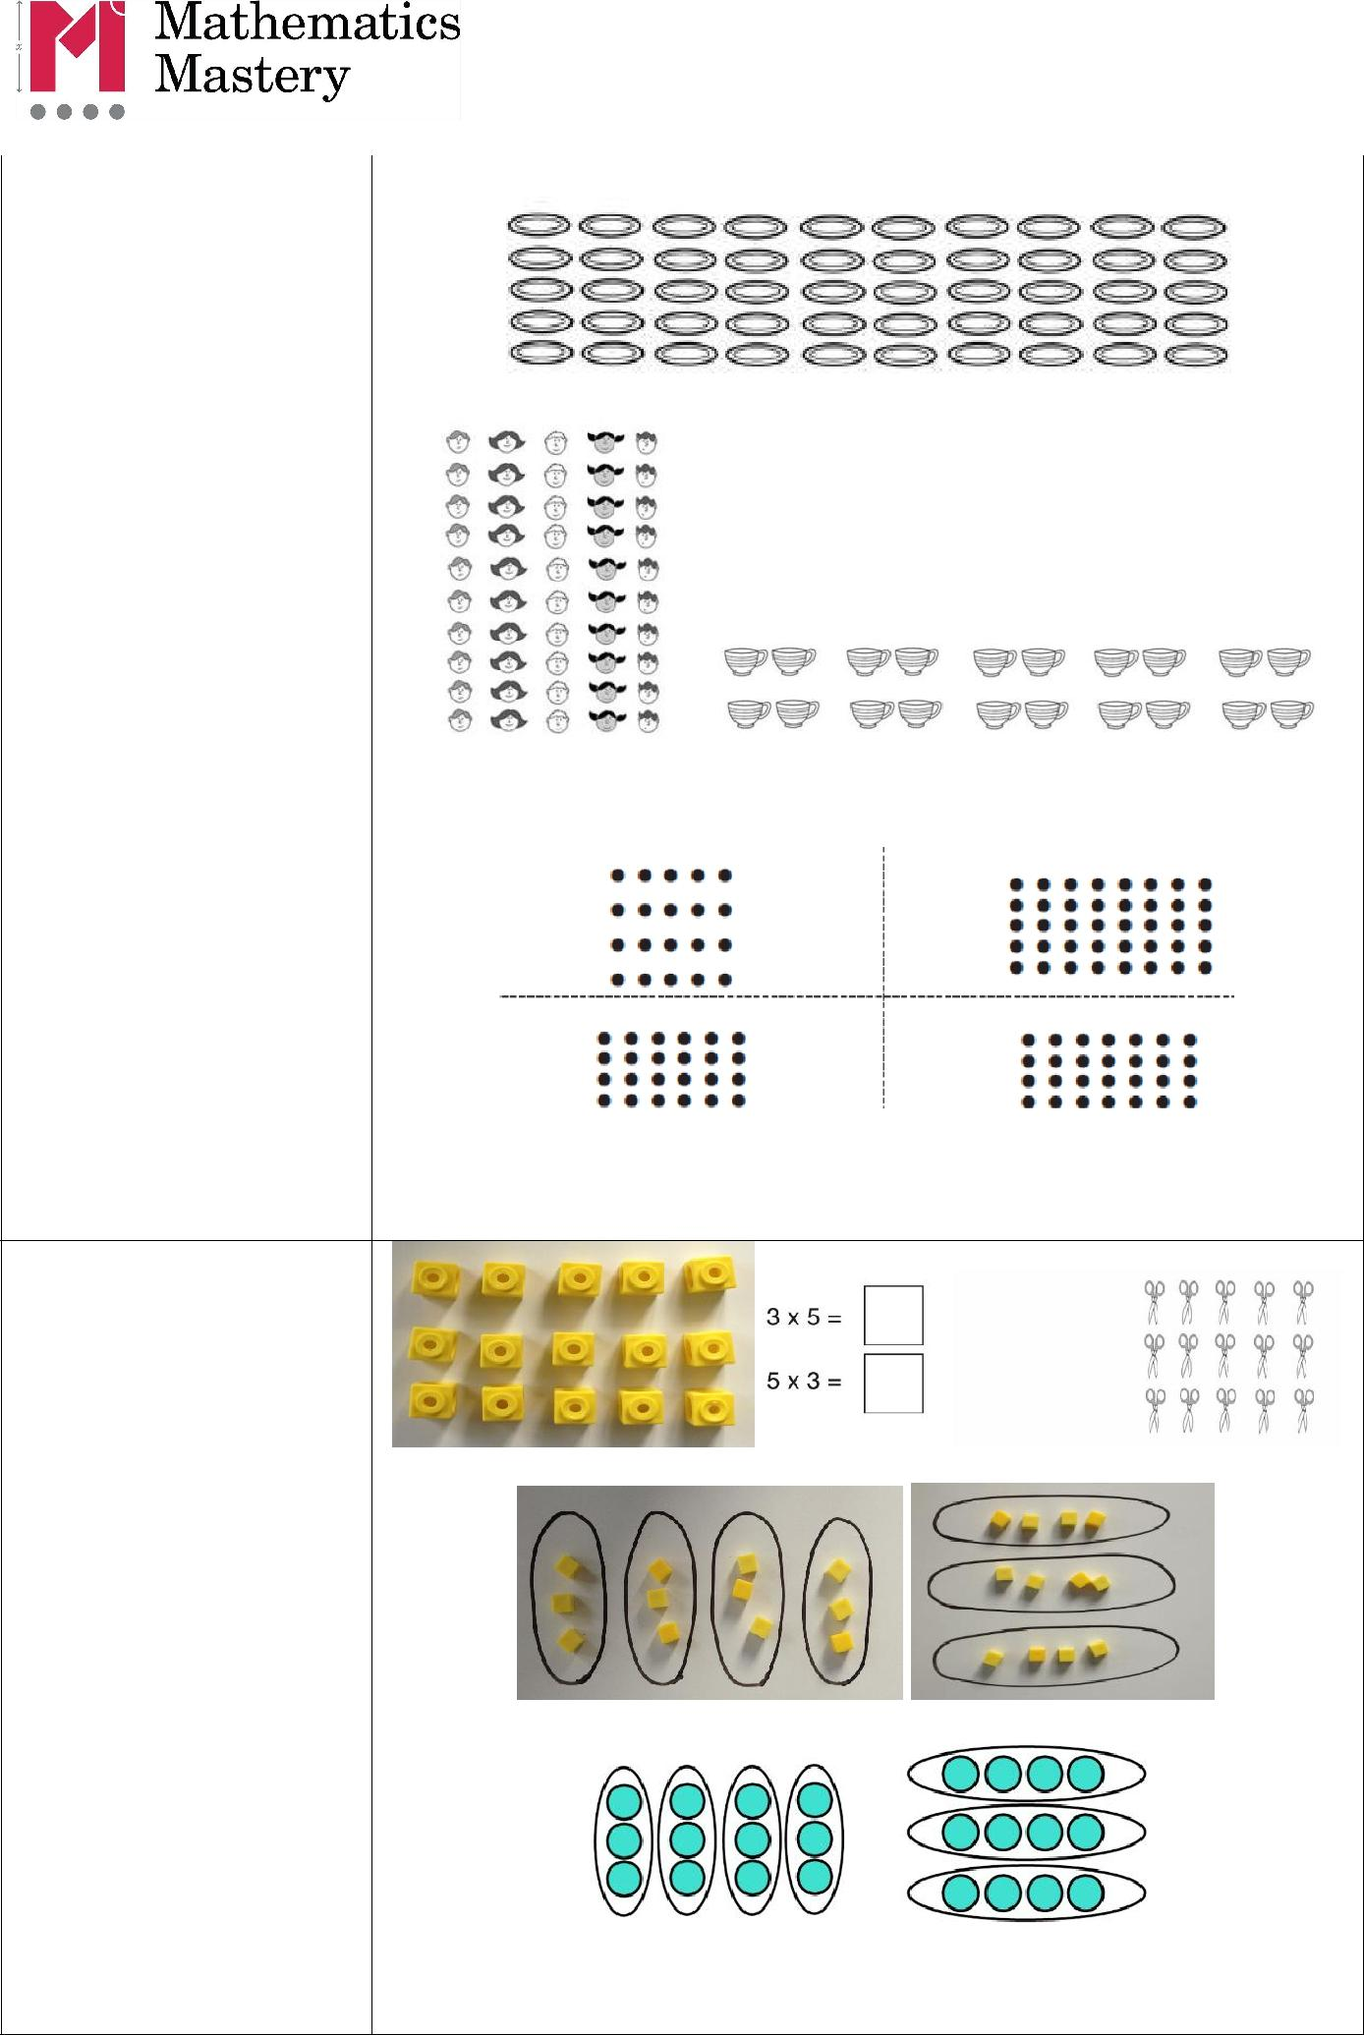
Strategy & guidance | CPA
Arrays to represent
multiplication
equations

Concrete manipulatives and images of familiar objects begin to be organised into arrays and, later, are shown alongside dot arrays. It is important to discuss with pupils how arrays can be useful.

Pupils begin to understand multiplication in a more abstract fashion, applying their skip counting skills to identify the multiples of the 2x, 5x and 10x tables.

The relationship between multiplication and division also begins to be demonstrated.

Multiplication is commutative

Pupils should understand that an array and, later, bar models can represent different equations and that, as multiplication is commutative, the order of the multiplication does not affect the answer.

12 = 3 × 4 12 = 4 × 3

Copyright © 2017 Mathematics Mastery. This can be printed out and photocopied by Mathematics Mastery toolkit registered users only. For further information, please see our terms and conditions at www.mathematicsmastery.org/terms-and-conditions

32


Strategy & guidance |  |  |  | CPA
Use of part-part- | There are three equal parts. Each part has a value of three. What is the whole?
whole model to | 3 × 3 = |  |  | 9 ÷ 3 =
establish the inverse
relationship between
multiplication and
division

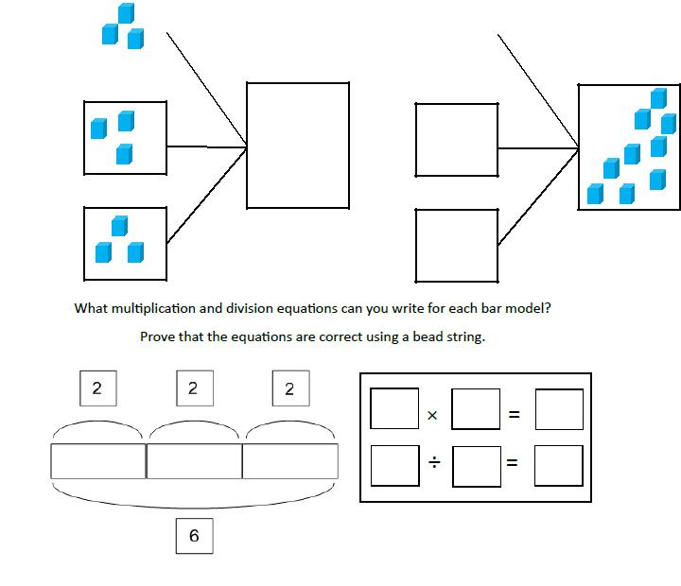
This link should be made explicit from early on, using the language of the part-part-whole model, so that pupils develop an early understanding of the relationship between multiplication and division. Bar models (with Cuisenaire rods) should be used to identify the whole, the value of the parts and the number of parts.

It is important to highlight that with multiplication, the parts are of equal value as this is different to how this model is used for addition and subtraction.


33

 | Y2 Division
Strategy & guidance | CPA
Division as sharing | 10 ÷ 2 = 5
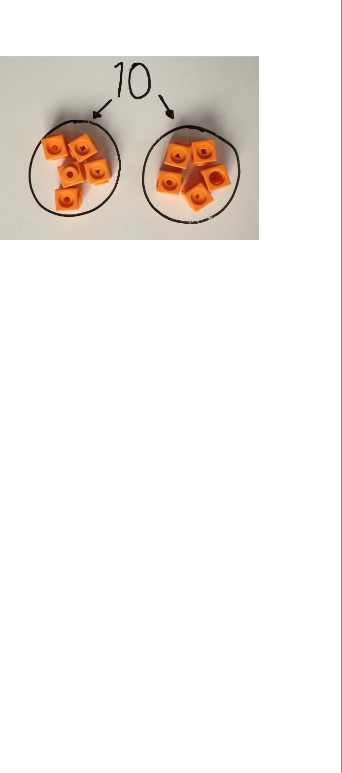
Here, division is shown as sharing.

If we have ten pairs of scissors and we share them between two pots, there will be 5 pairs of scissors in each pot.

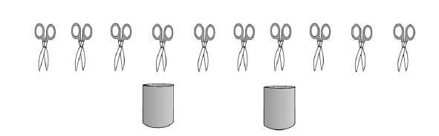

Division as grouping | 10 ÷ 2 = 5

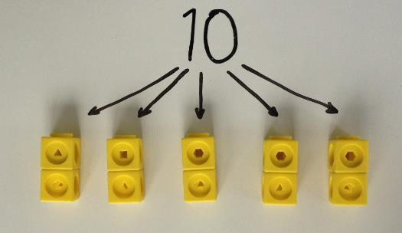
Here, division is shown as grouping.

If we have ten forks and we put them into groups of two, there are 5 groups.

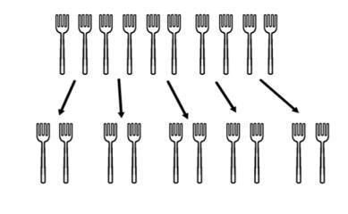

Copyright © 2017 Mathematics Mastery. This can be printed out and photocopied by Mathematics Mastery toolkit registered users only. For further information, please see our terms and conditions at www.mathematicsmastery.org/terms-and-conditions

34


Strategy & guidance | CPA
Use of part-part-whole
model to represent
division equations and
to emphasise the
relationship between
division and
multiplication

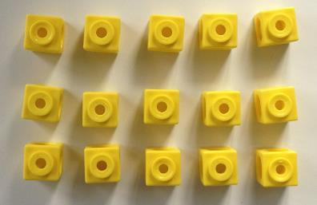
Pupils use arrays of concrete manipulatives and images of familiar objects to solve division equations.

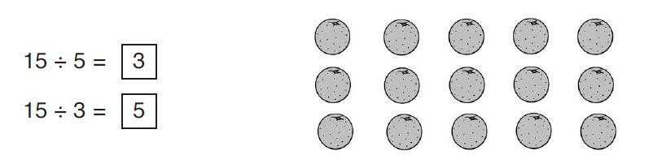
They begin to use dot arrays to develop a more abstract concept of division.

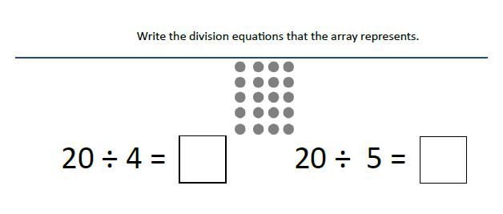
It is important to highlight that with multiplication and division, the parts are of equal value as this is different to how this model is used for addition and subtraction.

The whole is nine. There are three equal parts. What is the value of
each part? |  | 9 ÷ 3 =
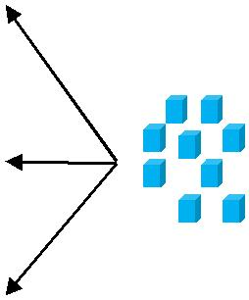

Copyright © 2017 Mathematics Mastery. This can be printed out and photocopied by Mathematics Mastery toolkit registered users only. For further information, please see our terms and conditions at www.mathematicsmastery.org/terms-and-conditions

35

Progression in calculations Year 3

National Curriculum objectives linked to addition and subtraction

These objectives are explicitly covered through the strategies outlined in this document:

- add and subtract numbers mentally, including:
o a three-digit number and ones

o a three-digit number and tens

o a three-digit number and hundreds

- add and subtract numbers with up to four digits, using formal written methods of columnar addition and subtraction (four digits is Year 4)

- find 10 or 100 more or less than a given number

- find 1000 more or less than a given number (Year 4)

- estimate the answer to a calculation and use inverse operations to check answers

The following objectives should be planned for lessons where new strategies are being introduced and developed:

- solve problems, including missing number problems, using number facts, place value, and more complex addition and subtraction

Teachers should refer to definitions and guidance on the structures for addition and subtraction to provide a range of appropriate real-life contexts for calculations.

Copyright © 2017 Mathematics Mastery. This can be printed out and photocopied by Mathematics Mastery toolkit registered users only. For further information, please see our terms and conditions at www.mathematicsmastery.org/terms-and-conditions

36

Y3 Addition & Subtraction

Strategy & guidance |  | CPA
Add and subtract numbers mentally, | It is important to model the mental strategy
including: | using concrete manipulatives in the first
• a three-digit number and ones; | instance and pupils should be able to
 | exemplify their own strategies using
• a three-digit number and tens; | manipulatives if required, with numbers
• a three-digit number and hundreds | appropriate to the unit they are working on
• a three-digit number and hundreds | (3-digit numbers in Units 1 & 4; 4-digit
Pupils learn that this is an appropriate strategy when | numbers in Unit 13). However, pupils
they are able to use known and derived number facts | should be encouraged to use known facts to
or other mental strategies to complete mental
or other mental strategies to complete mental | derive answers, rather than relying on
calculations with accuracy.
calculations with accuracy. | counting manipulatives or images.
To begin with, some pupils will prefer to use this
strategy only when there is no need to regroup, using | No regrouping
number facts within 10 and derivations. More | 345 + 30 | 274 - 50
confident pupils might choose from a range of mental | 345 + 30 | 274 - 50
strategies that avoid written algorithms, including | 1128 + 300 | 1312 - 300
(but not exhaustively): | 1128 + 300 | 1312 - 300
• known number facts within 20, | 326 + 342 | 856 - 724
• derived number facts, |  | I know 4 + 3 = 7,
• ‘Make ten’, |  | so 4 tens plus 3
• ‘Make ten’, |  | tens is equal to 7
• round and adjust |  | tens.
See Year 2 guidance for exemplification of these –the |  | 345 + 30 = 375.
use of concrete manipulatives other than Dienes | With some regrouping
blocks is important in reinforcing the use of these
strategies. | 416 + 25 | 232 - 5
It is important that pupils are given plenty of | 383 + 130 | 455 - 216
(scaffolded) practice at choosing their own strategies | 383 + 130 | 455 - 216
to complete calculations efficiently and accurately. | 611 + 194 | 130 - 40
Explicit links need to be made between familiar | 611 + 194 | 130 - 40
number facts and the calculations that they can be | 1482 + 900 | 2382 - 500
useful for and pupils need to be encouraged to aim for
efficiency.
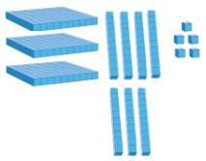

Copyright © 2017 Mathematics Mastery. This can be printed out and photocopied by Mathematics Mastery toolkit registered users only. For further information, please see our terms and conditions at www.mathematicsmastery.org/terms-and-conditions

37

Strategy & guidance |  | CPA
Written column method for calculations that | As for the mental strategies, pupils should
require regrouping with up to 4-digits | be exposed to concrete manipulatives
Dienes blocks should be used alongside the pictorial | modelling the written calculations and
representations during direct teaching and can be | should be able to represent their written
used by pupils both for support and challenge. Place | work pictorially or with concrete
value counters can also be introduced at this stage. | manipulatives when required.
This work revises and reinforces ideas from Key | Again, they should be encouraged to
Stage 1, including the focus on place value –see Year | calculate with known and derived facts and
2 exemplification. | should not rely on counting images or
Direct teaching of the columnar method should | manipulatives.
require at least one element of regrouping, so that
pupils are clear about when it is most useful to use it.
Asking them ‘Can you think of a more efficient
method?’ will challenge hem to apply their number
sense / number facts to use efficient mental methods
where possible.
As in Year 2, pupils should be given plenty of practice
with calculations that require multiple separate
instances of regrouping. In Year 3 they become more
familiar with calculations that require ‘regrouping to
regroup’. Understanding must be secured through the | 5 + 6 = 11 so I will have 11 ones which I
considered use of manipulatives and images, | regroup for 1 ten and 1 one.
combined with careful use of language.
Pupils should be challenged as to whether this is the | Regrouping (including multiple separate
Pupils should be challenged as to whether this is the | instances)
most efficient method, considering whether mental | instances)
methods (such as counting on, using known number | 672 + 136 | 734 –82
facts, round and adjust etc.) may be likelier to | 672 + 136 | 734 –82
produce an accurate solution. | 468 + 67 | 831 - 76
Pupils requiring support might develop their | 275 + 386 | 435 –188
confidence in the written method using numbers that | 275 + 386 | 435 –188
require no regrouping.
See Unit materials for extra guidance on this | ‘Regrouping to regroup’
strategy. | 204 –137
 | 1035 - 851
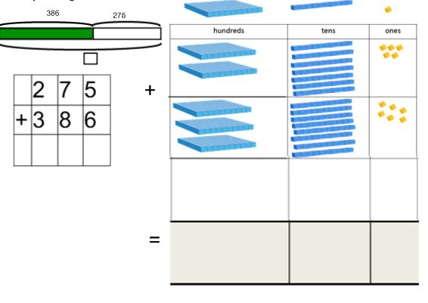

Copyright © 2017 Mathematics Mastery. This can be printed out and photocopied by Mathematics Mastery toolkit registered users only. For further information, please see our terms and conditions at www.mathematicsmastery.org/terms-and-conditions

38


Strategy & guidance | CPA
Find 10, 100 more or less than a given number | 142 + 100 = 242

As pupils become familiar with numbers up to 1000, place value should be emphasised and comparisons drawn between adding tens, hundreds (and, in the last unit of the Summer term, thousands), including use of concrete manipulatives and appropriate images.
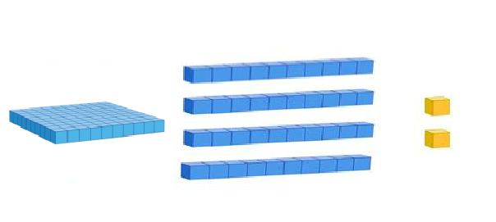
After initial teaching, this should be incorporated into transition activities and practised regularly.
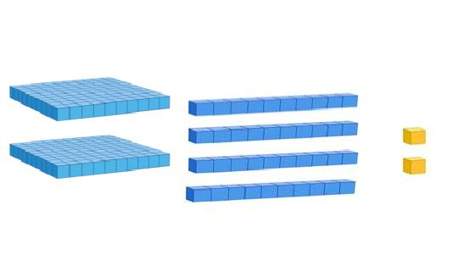

Copyright © 2017 Mathematics Mastery. This can be printed out and photocopied by Mathematics Mastery toolkit registered users only. For further information, please see our terms and conditions at www.mathematicsmastery.org/terms-and-conditions

39

National Curriculum objectives linked to multiplication and division

These objectives are explicitly covered through the strategies outlined in this document:

- count from 0 in multiples of 4, 8, 50 and 100

- recall and use multiplication and division facts for the 3, 4, 6, and 8 multiplication tables

- write and calculate mathematical statements for multiplication and division using the multiplication tables that they know, including for two-digit numbers times one-digit numbers, using mental methods

- solve problems, including missing number problems, involving multiplication and division, including positive integer scaling problems and correspondence problems in which n objects are connected to m objects

Teachers should refer to definitions and guidance on the structures for multiplication and division to provide a range of appropriate real-life contexts for calculations.

 | Y3 Multiplication
Strategy & guidance |  | CPA
Doubling to derive | 3 x 3 = 9 | 3 x 6 = double 9 = 18
new multiplication
facts
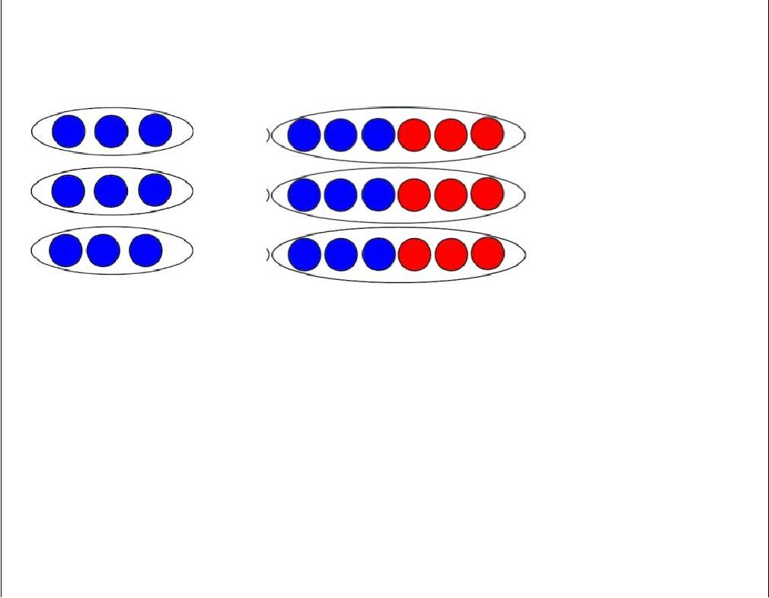
Pupils continue to make use of the idea that facts from easier times tables can be used to derive facts from related times tables using doubling as a strategy.

This builds on the doubling strategy from Year 2.

Copyright © 2017 Mathematics Mastery. This can be printed out and photocopied by Mathematics Mastery toolkit registered users only. For further information, please see our terms and conditions at www.mathematicsmastery.org/terms-and-conditions

40

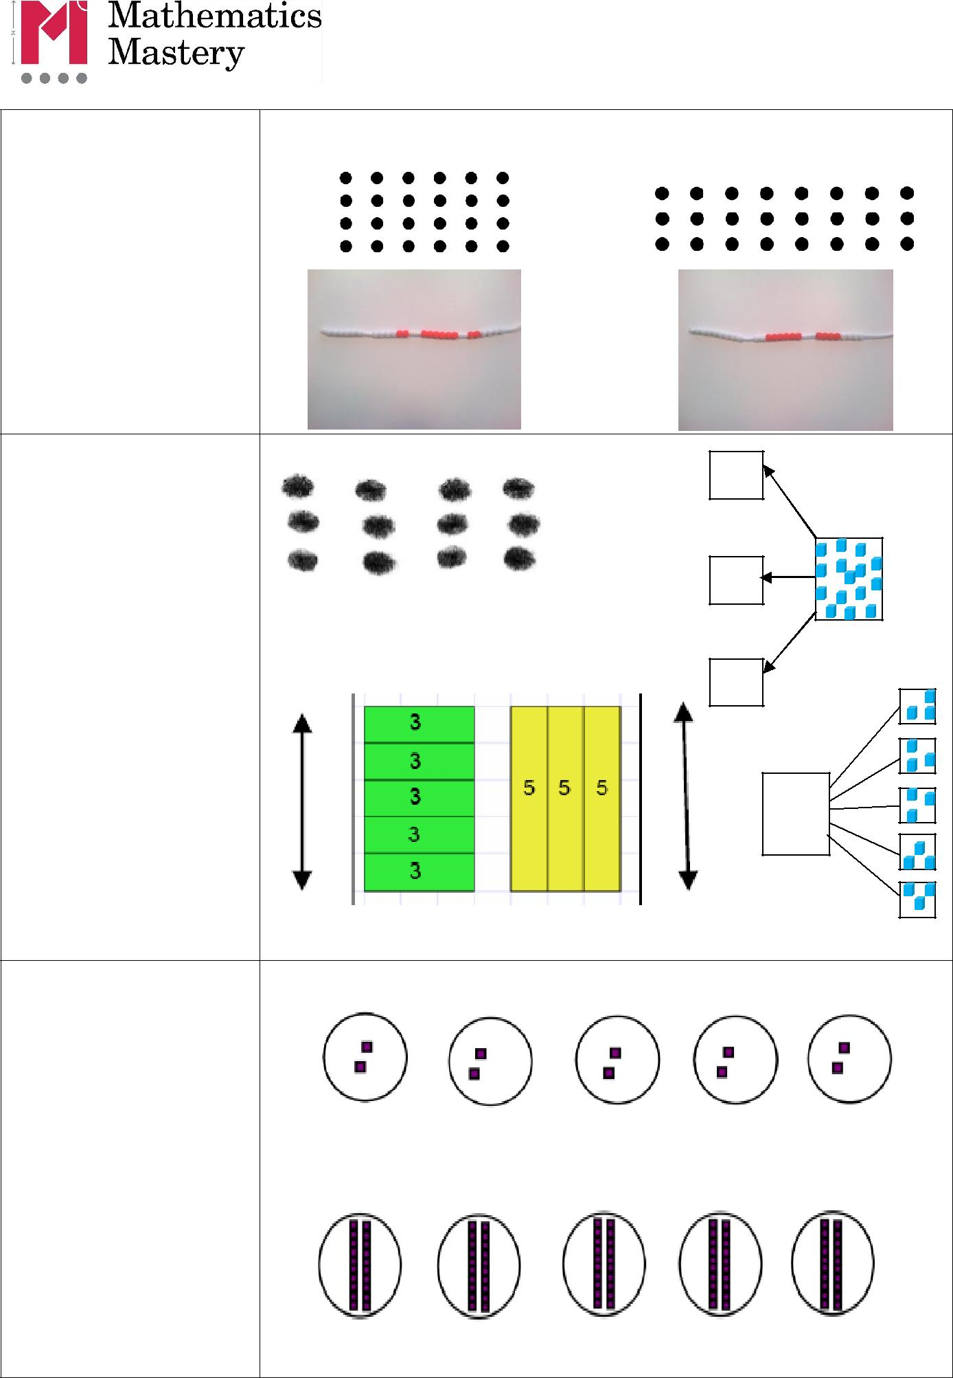
Strategy & guidance | CPA
Skip counting in
multiples of 2, 3, 4, 5,
6, 8 and 10

Rehearsal of previously learnt tables as well as new content for Year 3 should be incorporated into transition activities and practised regularly.

Use of part-part-whole model with arrays and bar models to establish commutativity and inverse relationship between multiplication and division

In these contexts pupils are able to identify all the equations in a fact family.
Also with digits

Ten times greater

Pupils’ work on this must be firmly based on concrete representations

–the language of ten times greater must be well modelled and understood to prevent the numerical

Misconception of ‘adding a zero’.

Copyright © 2017 Mathematics Mastery. This can be printed out and photocopied by Mathematics Mastery toolkit registered users only. For further information, please see our terms and conditions at www.mathematicsmastery.org/terms-and-conditions

41

Strategy & guidance |  | CPA
Multiplying by 10 and
100
Building on the ten times
greater work, pupils use
appropriate Dienes
blocks and place value
counters to multiply 2, 3,
4, 5 and 10 by 10, 100
and 1000.
Using known facts for
multiplying by
multiples of 10 and
100
Pupils’ growing
understanding of place
value, allows them to
make use of known facts
to derive multiplications
using powers of 10.
It is important to use
tables with which they
are already familiar (i.e.
not 7 or 9 tables in Year
3)
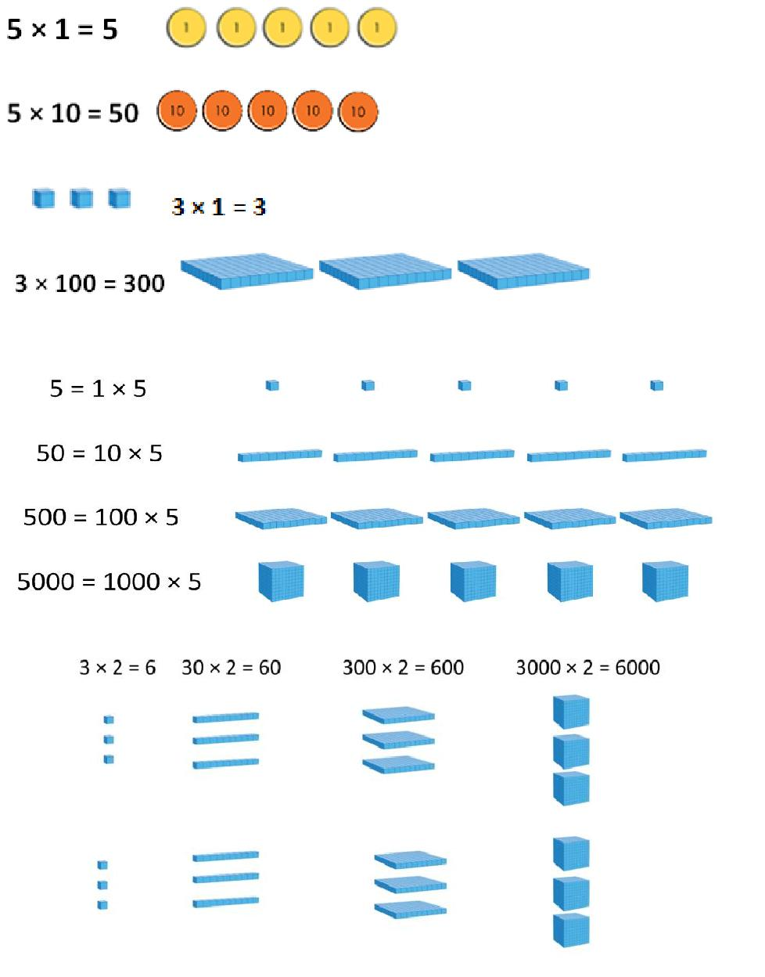

Copyright © 2017 Mathematics Mastery. This can be printed out and photocopied by Mathematics Mastery toolkit registered users only. For further information, please see our terms and conditions at www.mathematicsmastery.org/terms-and-conditions

42

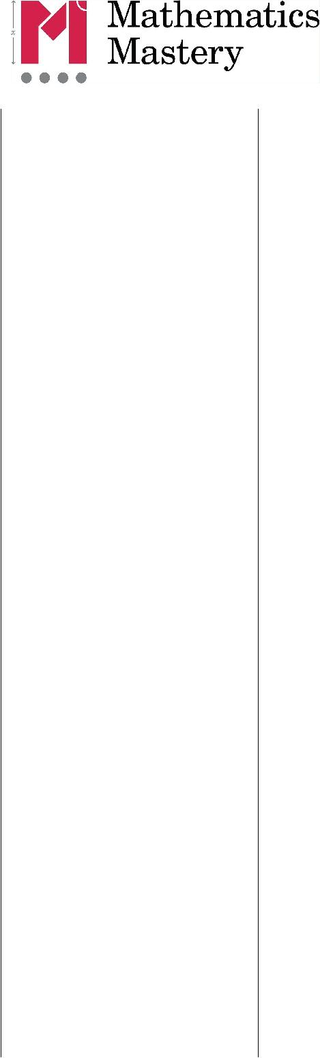
Strategy & guidance | CPA
Multiplication of 2-
digit numbers with
partitioning (no
regrouping)

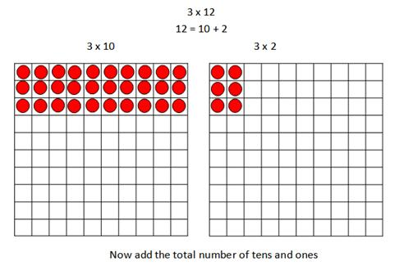
Children should always consider whether partitioning is the best strategy –if it is possible to use strategies such as doubling (some may use doubling twice for ×4), they need to choose the most efficient strategy.

Children may wish to make jottings, including a full grid as exemplified here –but grid method is not a formal method and its only purpose is to record mental calculations. This supports the development of the

necessary mental ^{3 x 12 = 36}
calculating skills but does

not hinder the introduction of formal written methods in Year 4. Concrete manipulatives are essential to develop understanding.

Copyright © 2017 Mathematics Mastery. This can be printed out and photocopied by Mathematics Mastery toolkit registered users only. For further information, please see our terms and conditions at www.mathematicsmastery.org/terms-and-conditions

43

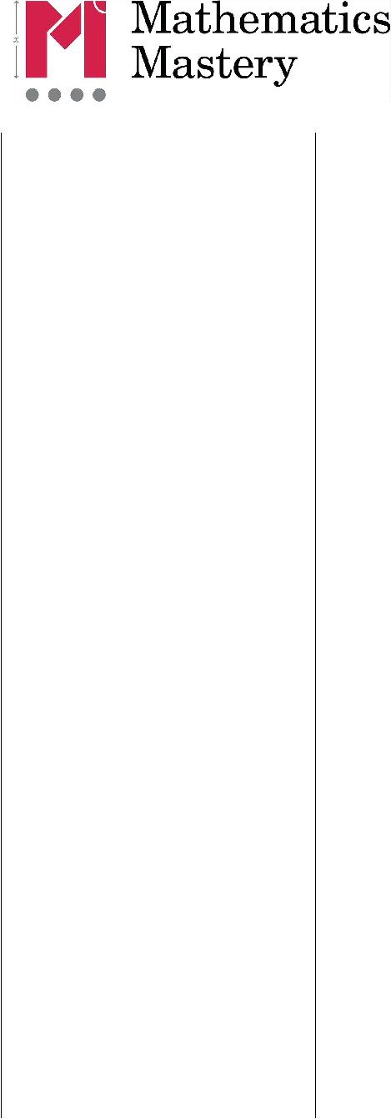
Strategy & guidance | CPA
Multiplication of 2-
digit numbers with
partitioning
(regrouping)

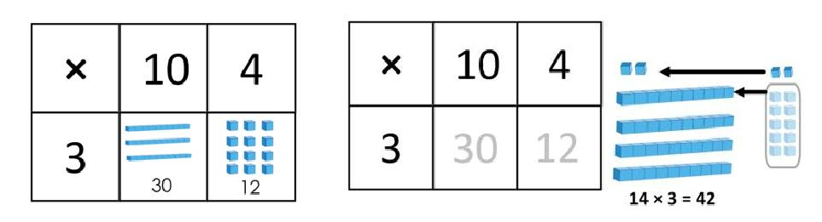
Using concrete manipulatives and later moving to using images that represent them, supports pupils’ early understanding, leading towards formal written methods in Year 4.

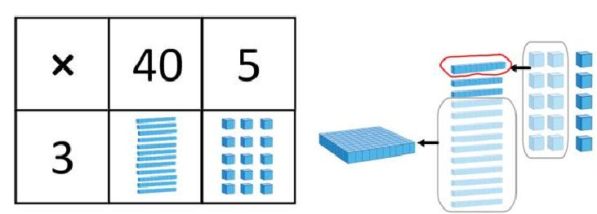
Once again, this is a mental strategy, which they may choose to support with informal jottings, including a full grid, as exemplified here.

Pupils must be encouraged to make use of their known multiplication facts and their knowledge of place value to calculate, rather than counting manipulatives.

Copyright © 2017 Mathematics Mastery. This can be printed out and photocopied by Mathematics Mastery toolkit registered users only. For further information, please see our terms and conditions at www.mathematicsmastery.org/terms-and-conditions

44

 |  | Y3 Division
Strategy & Guidance |  |  | CPA
Dividing multiples of
10, 100 and 1000 by
10, 100 and 1000
using scaling down
Pupils use the strategy of
‘scaling down’
representing numbers
with concrete | 3 × 10 = 30
manipulatives and
making the value ten
times smaller.
 | 30 ÷ 10 = 3
Dividing multiples of
10, 100 and 1000 by
10, 100 and 1000 | 500 ÷ 100 =
using grouping
using grouping | My whole is 500 and the value of the
Pupils divide by 10, 100
Pupils divide by 10, 100 | equal parts is 100. How many parts are
and 1000 by making
and 1000 by making | there?
groups of the divisor.
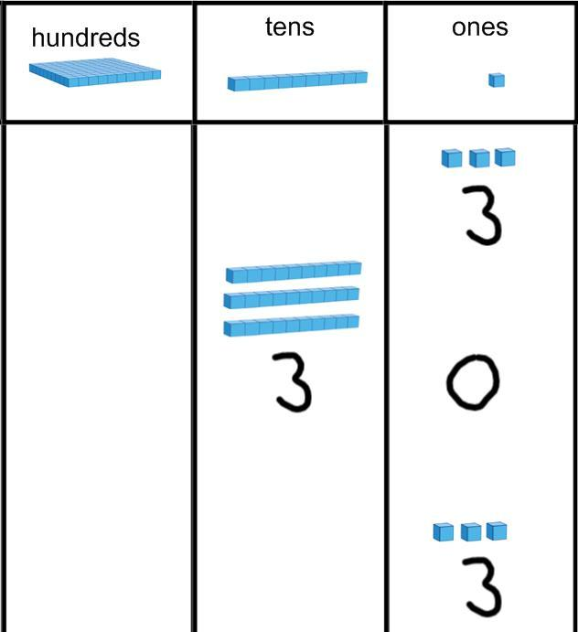
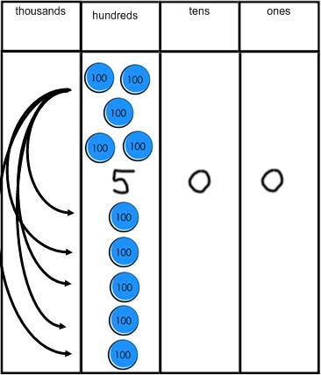

Copyright © 2017 Mathematics Mastery. This can be printed out and photocopied by Mathematics Mastery toolkit registered users only. For further information, please see our terms and conditions at www.mathematicsmastery.org/terms-and-conditions

45

Progression in calculations Year 4

National curriculum objectives linked to addition and subtraction

These objectives are explicitly covered through the strategies outlined in this document:

- add and subtract numbers with up to four digits, using the formal written methods of columnar addition and subtraction where appropriate

- find 1000 more or less than a given number

- estimate and use inverse operations to check answers to a calculation

N.B. There is no explicit reference to mental calculation strategies in the programmes of study for Year 4 in the national curriculum. However, with an overall aim for fluency, appropriate mental strategies should always be considered before resorting to formal written procedures, with the emphasis on pupils making their own choices from an increasingly sophisticated range of strategies.

The following objectives should be planned for lessons where new strategies are being introduced and developed:

- solve addition and subtraction two-step problems in contexts, deciding which operations and methods to use and why

- solve simple measure and money problems involving fractions and decimals to two decimal places

Copyright © 2017 Mathematics Mastery. This can be printed out and photocopied by Mathematics Mastery toolkit registered users only. For further information, please see our terms and conditions at www.mathematicsmastery.org/terms-and-conditions

46

Y4 Addition & Subtraction

Strategies & Guidance | CPA
Count forwards and backwards in
steps of 10, 100 and 1000 for any
number up to 10 000.
Pupils should count on and back in steps
of ten, one hundred and one thousand
from different starting points. These
should be practised regularly, ensuring
that boundaries where more than one
digit changes are included.
Count forwards and backwards in | Pay particular attention to boundaries where regrouping
Count forwards and backwards in | happens more than once and so more than one digit
tenths and hundredths | happens more than once and so more than one digit
tenths and hundredths | changes.
 | E.g. 990 + 10 or 19.9 + 0.1
Using known facts and knowledge
of place value to derive facts. | 2 + 4 = 6
Add and subtract multiples of 10,
100 and 1000 mentally | 20 + 40 = 60
Pupils extend this knowledge to mentally
adding and subtracting multiples of 10, | 200 + 400 = 600
100 and 1000. Counting in different | 200 + 400 = 600
multiples of 10, 100 and 1000 should be
incorporated into transition activities | 2000 + 4000 = 6000
and practised regularly.
Adding and subtracting by | See Y3 guidance on mental addition & subtraction,
partitioning one number and | remembering that use of concrete manipulatives and
applying known facts. | remembering that use of concrete manipulatives and
applying known facts. | images in both teaching and reasoning activities will help
By Year 4 pupils are confident in their | to secure understanding and develop mastery.
place value knowledge and are
calculating mentally both with
calculations that do not require
regrouping and with those that do.
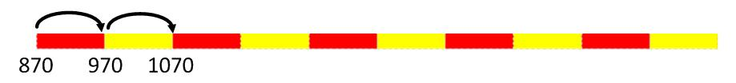
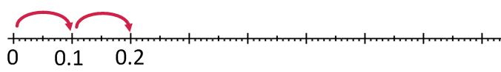
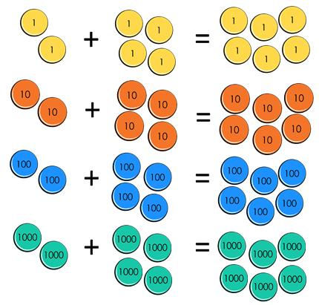

Copyright © 2017 Mathematics Mastery. This can be printed out and photocopied by Mathematics Mastery toolkit registered users only. For further information, please see our terms and conditions at www.mathematicsmastery.org/terms-and-conditions

47

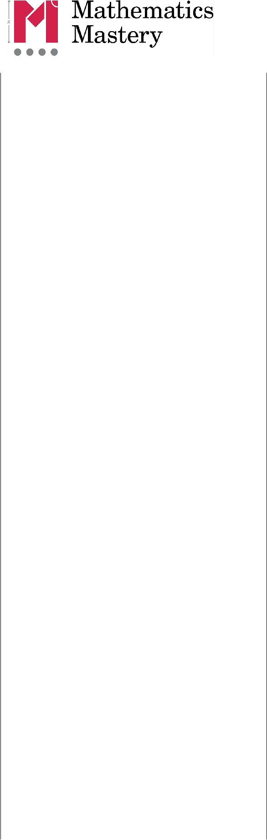
Strategies & Guidance | CPA
Round and adjust | 3527 + 296 = 3827 - 4
Pupils should recognise that this
strategy is useful when adding and
subtracting near multiples of ten. They
should apply their knowledge of
rounding.
It is very easy to be confused about how | Completing the same calculation but adjusting first:
to adjust and so visual representations | 3527 + 296 = 3523 + 300
and logical reasoning are essential to | 3527 + 296 = 3523 + 300
success with this strategy.
Build flexibility by completing the same
calculation in a different order.
 | 4523 –3997 = 523 + 3
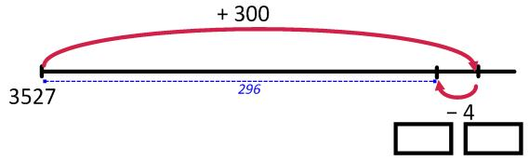
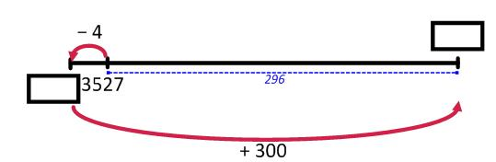
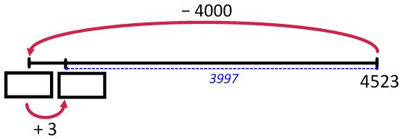

Completing the same calculation but adjusting first: 4523 –3997 = 4526 - 4000
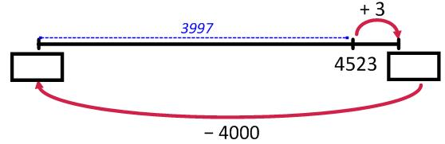

Near doubles | 1600 + 1598 = double 1600 –2

Pupils should be able to double numbers up to 100 and use this to derive doubles for multiples of ten. These facts can be adjusted to calculate near doubles.
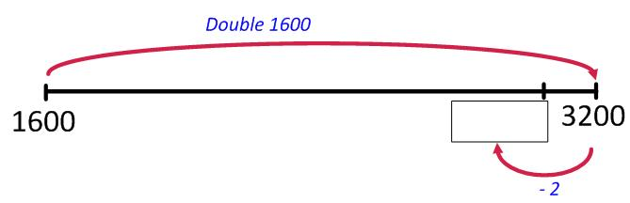

Copyright © 2017 Mathematics Mastery. This can be printed out and photocopied by Mathematics Mastery toolkit registered users only. For further information, please see our terms and conditions at www.mathematicsmastery.org/terms-and-conditions

48

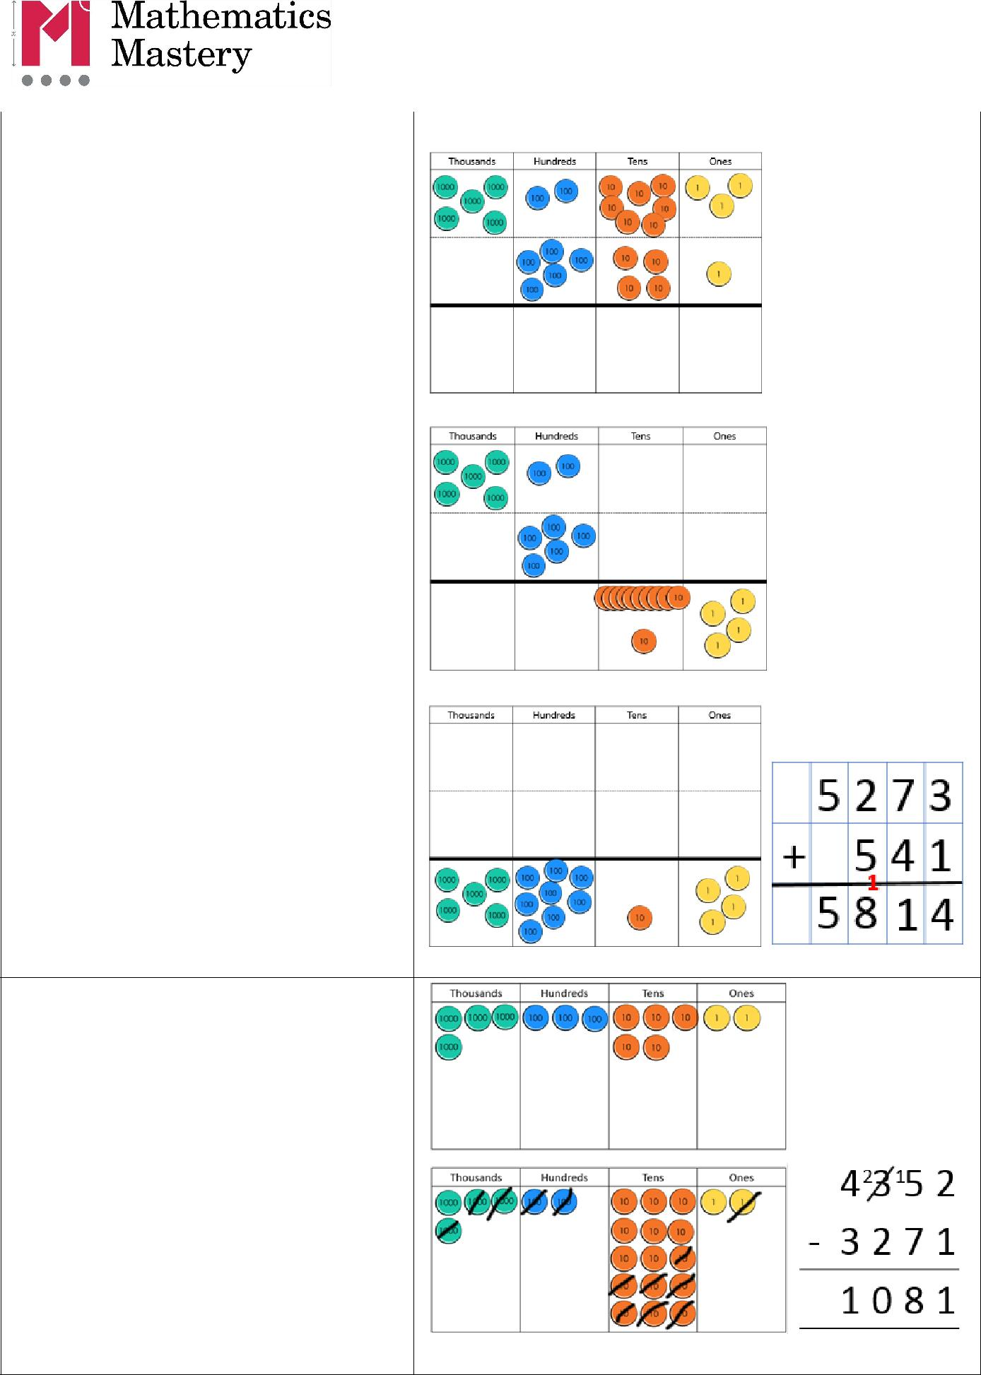
Strategies & Guidance | CPA
Written column methods for
addition

Place value counters are a useful manipulative for representing the steps of the formal written method. These should be used alongside the written layout to ensure conceptual understanding and as a tool for explaining.

This method and the language to use are best understood through the tutorial videos found here on the toolkit.

Written column methods for subtraction

Place value counters are a useful manipulative for representing the steps of the formal written method. These should be used alongside the written layout to ensure conceptual understanding and as a tool for explaining.

This method and the language to use are best understood through the tutorial videos on the toolkit.

Copyright © 2017 Mathematics Mastery. This can be printed out and photocopied by Mathematics Mastery toolkit registered users only. For further information, please see our terms and conditions at www.mathematicsmastery.org/terms-and-conditions

49

Strategies & Guidance | CPA
Calculating with decimal numbers
Assign different values to Dienes
equipment. If a Dienes 100 block has the
value of 1, then a tens rod has a value of
0.1 and a ones cube has a value of 0.01.
These can then be used to build a
conceptual understanding of the | 24.2 + 13.4 =
relationship between these.
Place value counters are another useful
manipulative for representing decimal
numbers.
All of the calculation strategies for
integers (whole numbers) can be used to
calculate with decimal numbers.
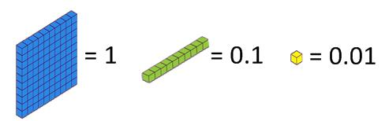
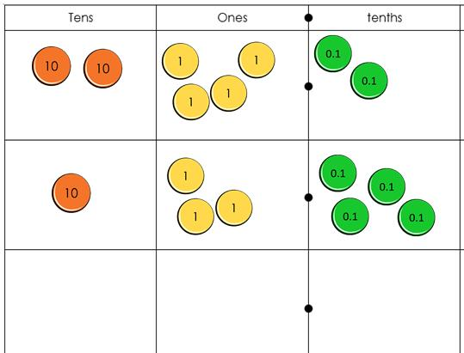

Copyright © 2017 Mathematics Mastery. This can be printed out and photocopied by Mathematics Mastery toolkit registered users only. For further information, please see our terms and conditions at www.mathematicsmastery.org/terms-and-conditions

50

National Curriculum objectives linked to multiplication and division

These objectives are explicitly covered through the strategies outlined in this document:

- count from 0 in multiples of 6, 7, 9, 25 and 1000

- recall and use multiplication and division facts for multiplication tables up to 12 × 12

- write and calculate mathematical statements for multiplication and division using the multiplication tables that they know, including for two-digit numbers times one-digit numbers, using mental and progressing to formal written methods

- recognise and use factor pairs and commutativity in mental calculations

- use place value, known and derived facts to multiply and divide mentally, including: multiplying by 0 and 1; dividing by 1; multiplying together three numbers

- multiply two-digit and three-digit numbers by a one-digit number using formal written layout

- find the effect of dividing a one- or two-digit number by 10 and 100, identifying the value of the digits in the answer as ones, tenths and hundredths.

The following objectives should be planned for lessons where new strategies are being introduced and developed:

- solve problems involving multiplying and adding, including using the distributive law to multiply two digit numbers by one digit, integer scaling problems and harder correspondence problems such as n objects are connected to m objects.

Copyright © 2017 Mathematics Mastery. This can be printed out and photocopied by Mathematics Mastery toolkit registered users only. For further information, please see our terms and conditions at www.mathematicsmastery.org/terms-and-conditions

51

Y4 Multiplication
Strategies & Guidance |  | CPA
Multiplying by 10 and 100
When you multiply by ten, each part is
ten times greater. The ones become tens,
the tens become hundreds, etc.
When multiplying whole numbers, a zero
holds a place so that each digit has a
value that is ten times greater. |  | 3 x 10 = 30
Repeated multiplication by ten will build
an understanding of multiplying by 100
and 1000 |  | 3 x 100 = 300
 |  | 3 x 1000 = 3000
Using known facts and place value
for mental multiplication involving
multiples of 10 and 100
Pupils use their growing knowledge of
multiplication facts, place value and
derived facts to multiply mentally.
Emphasis is placed on understanding the
relationship (10 times or 100 times
greater) between a known number fact
and one to be derived, allowing far
larger ‘fact families’ to be derived from a
single known number fact.
Knowledge of commutativity (that
multiplication can be completed in any
order) is used to find a range of related
facts.
 | 30 x 7 = 210 | 300 x 7 = 2100
 | 70 x 3 = 210 | 700 x 3 = 2100
 | 7 x 30 = 210 | 7 x 300 = 2100
 | 3 x 70 = 210 | 3 x 700 = 2100
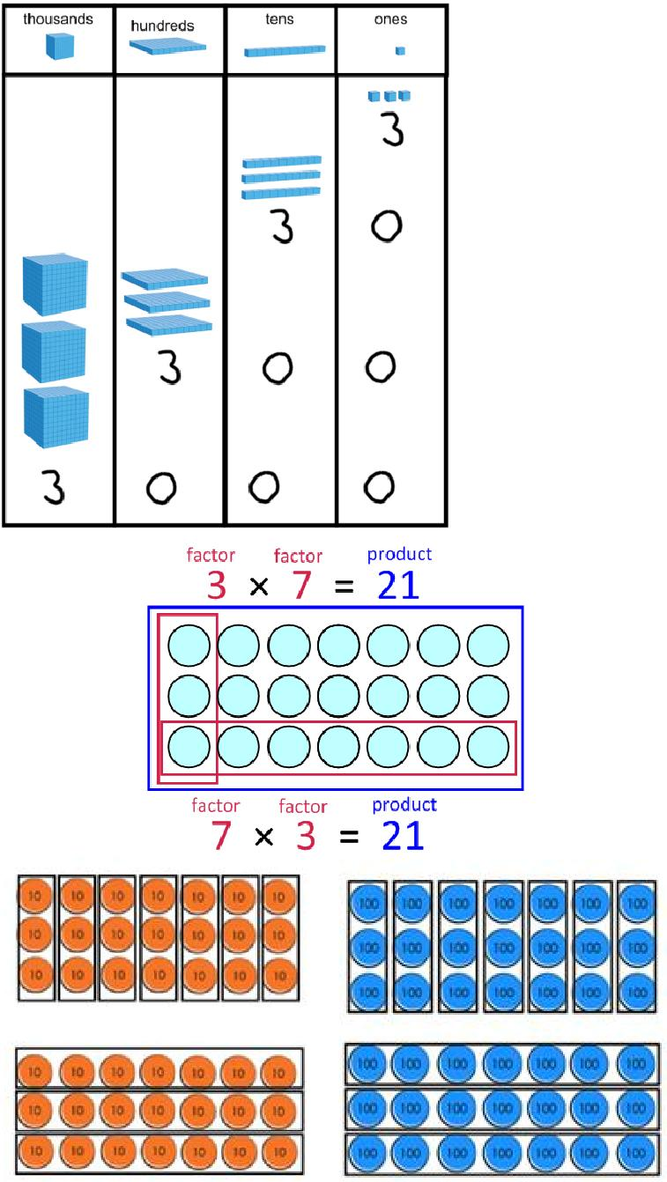

Copyright © 2017 Mathematics Mastery. This can be printed out and photocopied by Mathematics Mastery toolkit registered users only. For further information, please see our terms and conditions at www.mathematicsmastery.org/terms-and-conditions

52


Strategies & Guidance | CPA
Multiplying by partitioning one | 14 x 6
number and multiplying each part
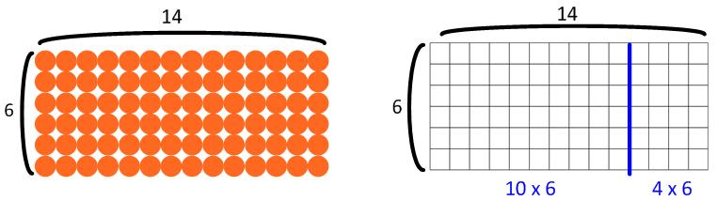
Pupils build on mental multiplication strategies and develop an explicit understanding of distributive law, which allows them to explore new strategies to make more efficient calculations.
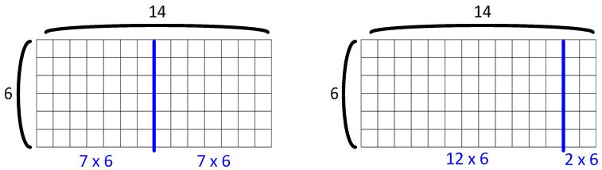
As well as partitioning into tens and ones (a familiar strategy), they begin to explore compensating strategies and factorisation to find the most efficient solution to a calculation.

Distributive law

34 × 6

a x (b + c) = a x b + a x c
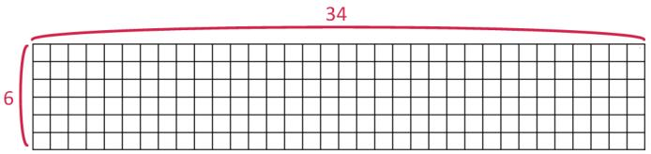

30 × 6 + 4 × 6
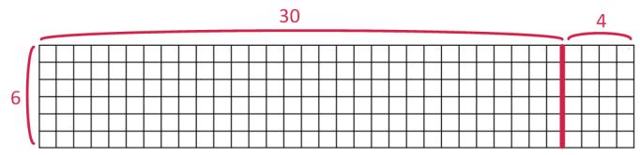

Mental multiplication of three 1- | Four pots each containing two flowers which each have
digit numbers, using the associative | seven petals. How many petals in total?
law | seven petals. How many petals in total?
Pupils first learn that multiplication can
be performed in any order, before
applying this to choose the most efficient
order to complete calculations, based on
their increasingly sophisticated number
facts and place value knowledge. | (4 x 2) x 7 or 4 x (2 x 7)
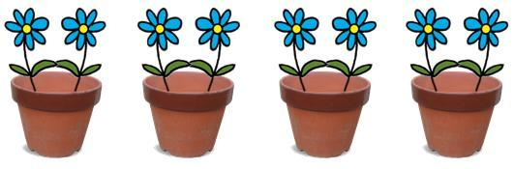

Copyright © 2017 Mathematics Mastery. This can be printed out and photocopied by Mathematics Mastery toolkit registered users only. For further information, please see our terms and conditions at www.mathematicsmastery.org/terms-and-conditions

53

Strategies & Guidance | CPA
Short multiplication of 3-digit | Exemplification of this process is best understood
number by 1-digit number | through viewing the video tutorial
To begin with pupils are presented with
calculations that require no regrouping | To calculate 241 x 3,
or only regrouping from the ones to the | represent the
tens. Their conceptual understanding is | number 241.
supported by the use of place value | number 241.
supported by the use of place value | Multiply each part
counters, both during teacher | Multiply each part
counters, both during teacher | by 3, regrouping as
demonstrations and during their own | by 3, regrouping as
practice. | needed.
With practice pupils will be able to
regroup in any column, including from
the hundreds to the thousands, including
being able to multiply numbers
containing zero and regrouping through
multiple columns in a single calculation.
This method and the language to use are
best understood through the tutorial
videos found on the toolkit.
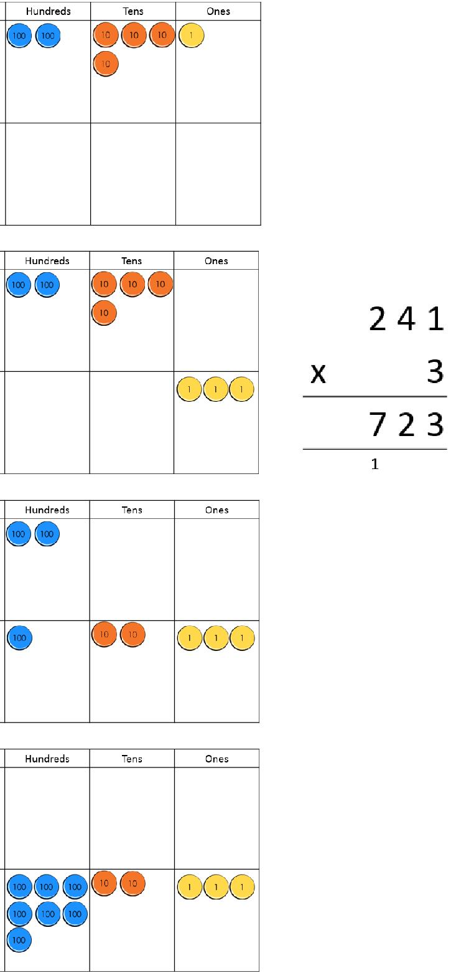

Copyright © 2017 Mathematics Mastery. This can be printed out and photocopied by Mathematics Mastery toolkit registered users only. For further information, please see our terms and conditions at www.mathematicsmastery.org/terms-and-conditions

54

 | Y4 Division
Strategies & Guidance |  | CPA
Dividing by 10 and 100
When you divide by ten, each part is |  | 30 ÷ 10 = 3
ten times smaller. The hundreds |  | 30 ÷ 10 = 3
ten times smaller. The hundreds |  | 300 ÷ 100 = 3
become tens and the tens become ones. |  | 300 ÷ 100 = 3
become tens and the tens become ones. |  | 3000 ÷ 1000 = 3
Each digit is in a place that gives it a |  | 3000 ÷ 1000 = 3
value that is ten times smaller.
When dividing multiples of ten, a place |  | 300 ÷ 10 = 30
holder is no longer needed so that each |  | 3000 ÷ 100 = 30
digit has a value that is ten times
smaller. E.g. 210 ÷ 10 = 21
 |  | 3000 ÷ 10 = 300
Derived facts
Pupils use their growing knowledge of
multiplication facts, place value and
derived facts to multiply mentally.
Understanding of the inverse
relationship between multiplication
and division allows corresponding
division facts to be derived.
 | 210 ÷ 7 = 30 | 2100 ÷ 7 = 300
 | 210 ÷ 3 = 70 | 2100 ÷ 3 = 700
 | 210 ÷ 30 = 7 | 2100 ÷ 300 = 7
 | 210 ÷ 70 = 3 | 2100 ÷ 700 = 3
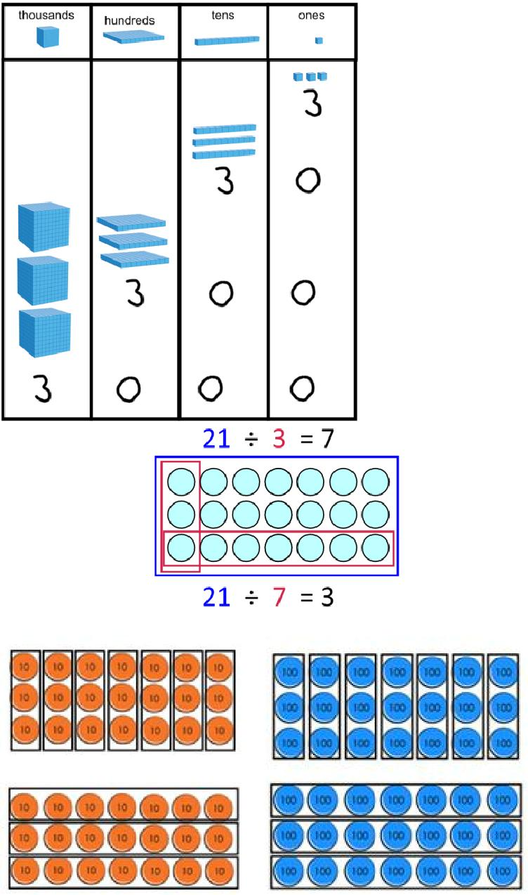

Copyright © 2017 Mathematics Mastery. This can be printed out and photocopied by Mathematics Mastery toolkit registered users only. For further information, please see our terms and conditions at www.mathematicsmastery.org/terms-and-conditions

55

Strategies & Guidance | CPA
Short division of 4-digit numbers | Division as sharing
by 1-digit numbers
Pupils start with dividing 4-digit
numbers by 2, 3 and 4, where no
regrouping is required. Place value
counters are used simultaneously in a
place value chart, to develop conceptual
understanding.
They progress to calculations that
require regrouping in the hundreds or
tens columns. | Division as grouping
Pupils build on their conceptual
knowledge of division to become
confident with dividing numbers where
the tens digit is smaller than the
divisor, extending this to any digit
being smaller than the divisor.
Exemplification of this method and the
language to use are best understood
through viewing the tutorial videos
found on the toolkit.
Division of a one- or two-digit | 24 ÷ 10 = 2.4
number by 10 and 100, identifying
the value of the digits in the
answer as ones, tenths and
hundredths
When you divide by ten, each part is
ten times smaller. The tens become ones
and the ones become tenths. Each digit
is in a place that gives it a value that is
ten times smaller.
 | 24 ÷ 100 = 0.24
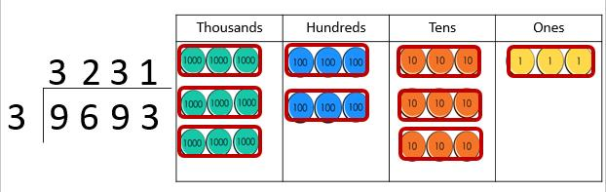
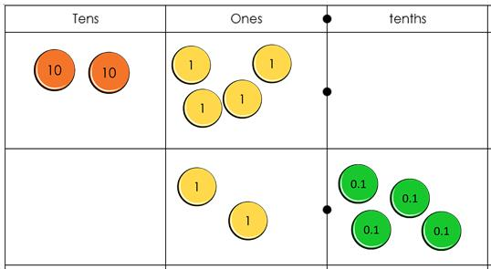
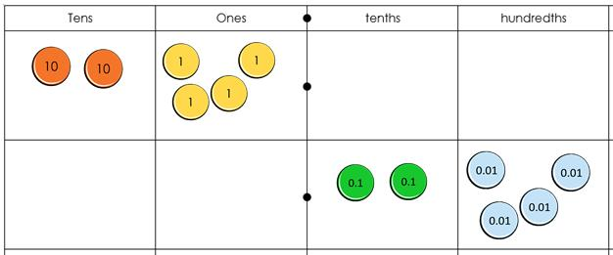
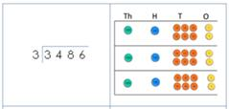

Copyright © 2017 Mathematics Mastery. This can be printed out and photocopied by Mathematics Mastery toolkit registered users only. For further information, please see our terms and conditions at www.mathematicsmastery.org/terms-and-conditions

56

Progression in calculations Year 5 + Year 6

Year 5 and Year 6 are together because the calculation strategies used are broadly similar, with Year 6 using larger and smaller numbers. Any differences for Year 6 are highlighted in red.

National Curriculum objectives linked to integer addition and subtraction

These objectives are explicitly covered through the strategies outlined in this document:

- add and subtract numbers mentally with increasingly large numbers

- add and subtract whole numbers with more than 4 digits, including using formal written methods (columnar addition and subtraction)

- use negative numbers in context, and calculate intervals across zero

- perform mental calculations, including with mixed operations and large numbers

- use estimation to check answers to calculations and determine, in the context of a problem, an appropriate degree of accuracy

The following objectives should be planned for lessons where new strategies are being introduced and developed:

- use rounding to check answers to calculations and determine, in the context of a problem, levels of accuracy

- solve addition and subtraction multi-step problems in contexts, deciding which operations and methods to use and why

- solve problems involving addition, subtraction, multiplication and division and a combination of these, including understanding the meaning of the equals sign.

Copyright © 2017 Mathematics Mastery. This can be printed out and photocopied by Mathematics Mastery toolkit registered users only. For further information, please see our terms and conditions at www.mathematicsmastery.org/terms-and-conditions

57

 |  | Y5 and Y6 Addition & Subtraction
 | Strategies & Guidance |  | CPA
Count forwards or |  |  | Support with place value counters on a place value chart,
backwards in steps of |  |  | repeatedly adding the same counter and regrouping as needed.
powers of 10 for any given |  |  | repeatedly adding the same counter and regrouping as needed.
number up to 1 000 000
Skip counting forwards and
backwards in steps of powers of
10 (i.e. 10, 100, 1000, 10 000
and 100 000) should be |  |  | Counting sticks and number lines:
incorporated into transition
activities and practised
regularly.
In Year 5 pupils work with
numbers up to 1 000 000 as well
as tenths, hundredths and
thousandths. |  |  | Pay particular attention to boundaries where regrouping
In | Year 6 | pupils work with | happens more than once and so more than one-digit changes.
numbers up to 10 000 000. |  |  | e.g. 9900 + 100 = 10000 or 99 000 + 1000 = 100 000
Using known facts and |  |  | 3 + 4 = 7
understanding of place
value to derive |  |  | 30 000 + 40 000 = 70 000
Using the following language |  |  | 300 000 + 400 000 = 700 000
makes the logic explicit: I know
three ones plus four ones is
equal to seven ones. Therefore,
three ten thousands plus four
ten thousands is equal to seven |  |  | 20 000 + 40 000 = 60 000
ten thousands. |  |  | 20 000 + 40 000 = 60 000
 |  |  | 40 000 + 20 000 = 60 000
In Year 5 extend to multiples of |  |  | 60 000 - 40 000 = 20 000
10 000 and 100 000 as well as |  |  | 60 000 - 20 000 = 40 000
tenths, hundredths and
thousandths.
In | Year 6 | extend to multiples of | 0.6 = 0.2 + 0.4
one million. |  |  | 0.6 = 0.2 + 0.4
 |  |  | 0.6 = 0.4 + 0.2
These derived facts should be |  |  | 0.2 = 0.6 - 0.4
used to estimate and check |  |  | 0.4 = 0.6 - 0.2
answers to calculations. |  |  | 0.4 = 0.6 - 0.2
 |  | Y6 Bar modelling also
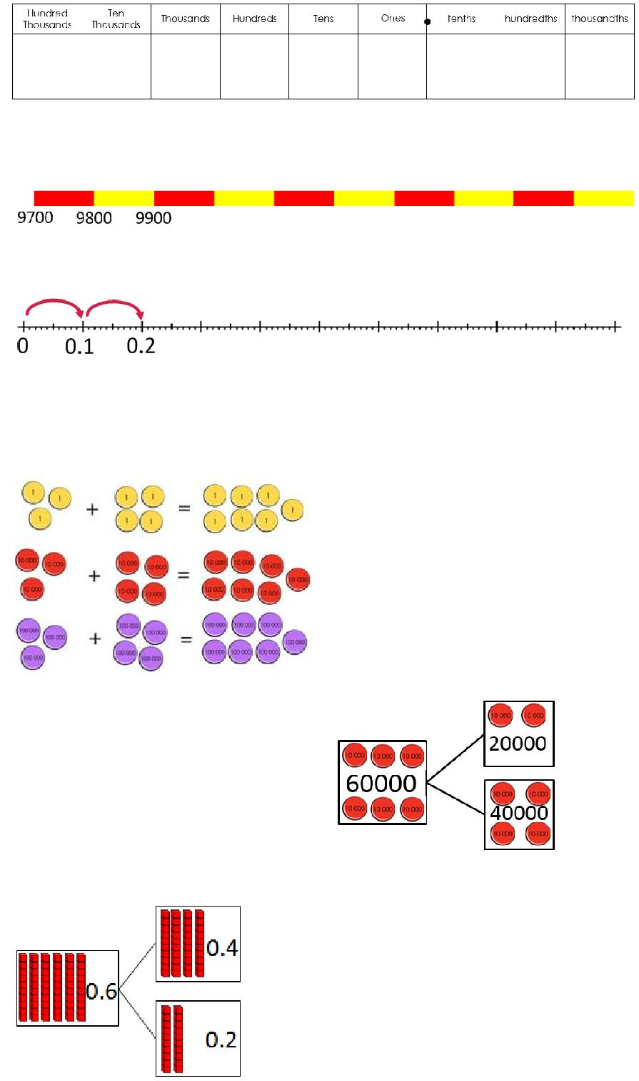

Copyright © 2017 Mathematics Mastery. This can be printed out and photocopied by Mathematics Mastery toolkit registered users only. For further information, please see our terms and conditions at www.mathematicsmastery.org/terms-and-conditions

58

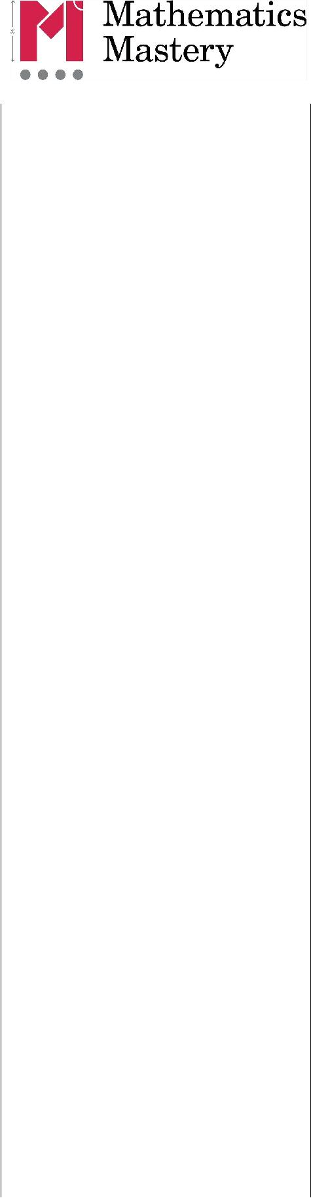
Strategies & Guidance | CPA

Partitioning one number | Partitioning into place value amounts (canonical partitioning):
and applying known facts to
add. | 4650 + 7326 = 7326 + 4000 + 600 + 50
Pupils can use this strategy
mentally or with jottings as
needed.
Pupils should be aware of the
range of choices available when
deciding how to partition the
number that is to be added.
They should be encouraged to | With place value counters, represent the larger number and then
count on from the number of | add each place value part of the other number. The image above
greater value as this will be
greater value as this will be | shows the thousands being added.
more efficient. However, they | shows the thousands being added.
should have an understanding | Represent pictorially with an empty numberline:
of the commutative law of | Represent pictorially with an empty numberline:
addition, that the parts can be
added in any order.
Pupils have experience with
these strategies with smaller | Partitioning in different ways (non-canonical partitioning):
numbers from previous years | Partitioning in different ways (non-canonical partitioning):
and so the focus should be on | Extend the ‘Make ten’ strategy (see guidance in Y1 or Y2) to
developing flexibility and | Extend the ‘Make ten’ strategy (see guidance in Y1 or Y2) to
developing flexibility and | count on to a multiple of 10.
exploring efficiency. | count on to a multiple of 10.
 | 6785 + 2325 = 6785 + 15 + 200 + 2110
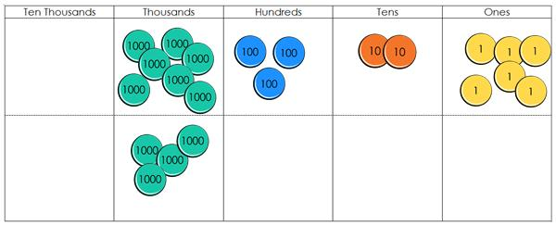
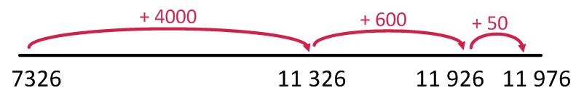
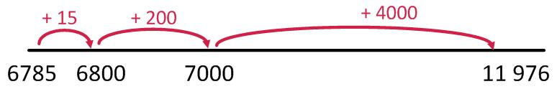

The strategy can be used with decimal numbers, Make one: 14.7 + 3.6 = 14.7 + 0.3 + 3.3 = 15 + 3.3
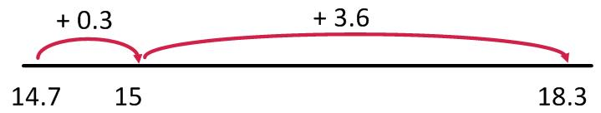

Copyright © 2017 Mathematics Mastery. This can be printed out and photocopied by Mathematics Mastery toolkit registered users only. For further information, please see our terms and conditions at www.mathematicsmastery.org/terms-and-conditions

59

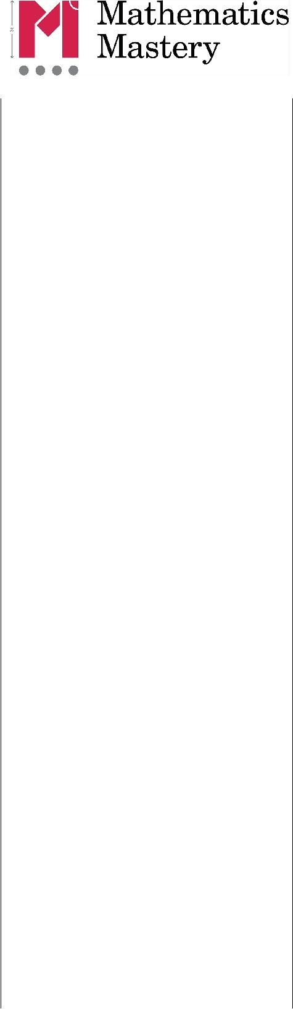
Strategies & Guidance | CPA

Subtraction by partitioning | Partitioning into place value amounts (canonical partitioning):
and applying known facts.
Pupils can use this strategy | 75 221 –14 300 = 75 221 –10 000 –4000 –300
mentally or with jottings as
needed.
Pupils should be aware of the
range of choices available when
deciding how to partition the
number that is to be subtracted.
Pupils have experience with
these strategies with smaller | Represent pictorially with a number line, starting on the right and
numbers from previous years | having the arrows jump to the left:
and so the focus should be on
developing flexibility and
exploring efficiency.
 | Develop understanding that the parts can be subtracted in any
 | order and the result will be the same:
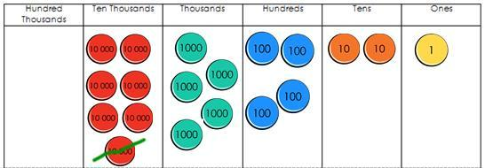
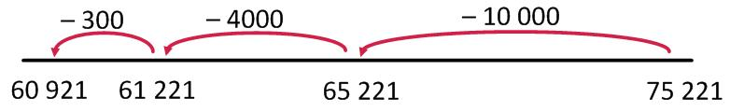
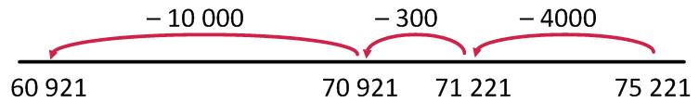

Partitioning in different ways (non-canonical partitioning):

Extend the ‘Make ten’ strategy (see guidance in Y1 or Y2) to
count back to a multiple of 10.
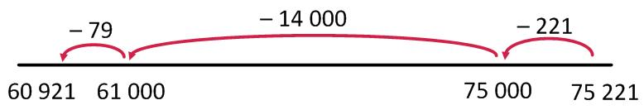

Copyright © 2017 Mathematics Mastery. This can be printed out and photocopied by Mathematics Mastery toolkit registered users only. For further information, please see our terms and conditions at www.mathematicsmastery.org/terms-and-conditions

60

Strategies & Guidance | CPA
Calculate difference by | 75 221 –14 300
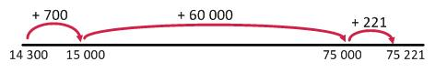
“counting on”
It is interesting to note that
finding the difference is
reversible. For example, the
difference between 5 and 2 is the
same as the difference between 2
and 5. This is not the case for
other subtraction concepts.
Addition strategies can be | 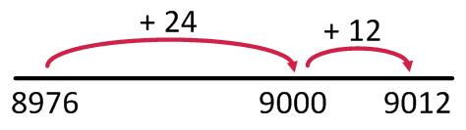
Finding the difference is efficient when the numbers are close to
each other 9012 –8976

Copyright © 2017 Mathematics Mastery. This can be printed out and photocopied by Mathematics Mastery toolkit registered users only. For further information, please see our terms and conditions at www.mathematicsmastery.org/terms-and-conditions

61

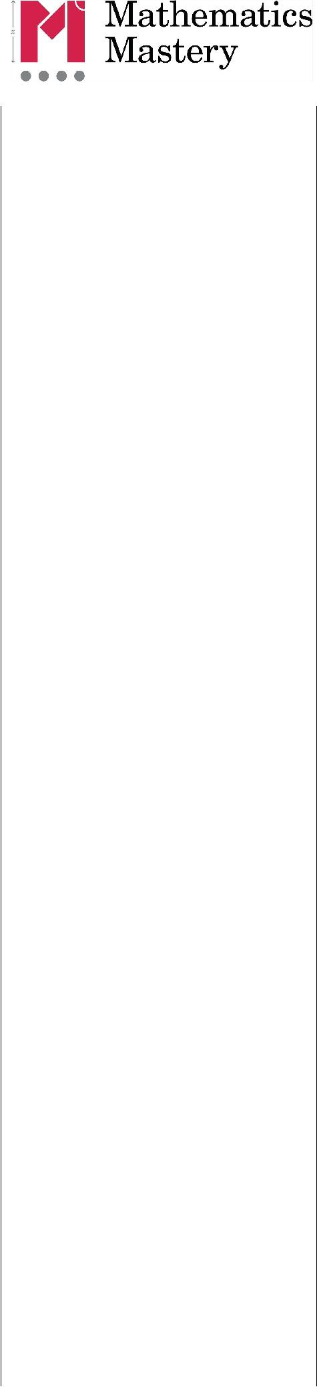
Strategies & Guidance | CPA
Round and adjust | Addition
Addition and subtraction
using compensation
Pupils should recognise that this
strategy is useful when adding
and subtracting near multiples
of ten. They should apply their
knowledge of rounding. | 54 128 + 9987 = 54 128 + 10 000 –13 = 64128 - 13
It is very easy to be confused | Pupils should realise that they can adjust first:
about how to adjust and so | Pupils should realise that they can adjust first:
visual representations and
logical reasoning are essential
to success with this strategy.
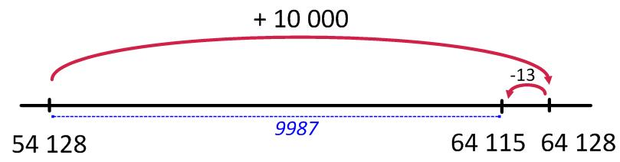
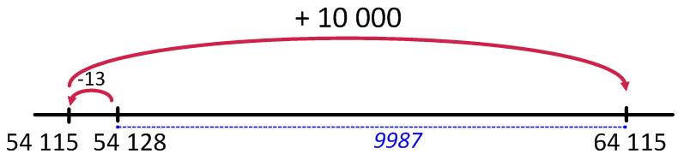

54128 + 9987 = 54128 –13 + 10 000 = 54 115 + 10 000

Subtraction
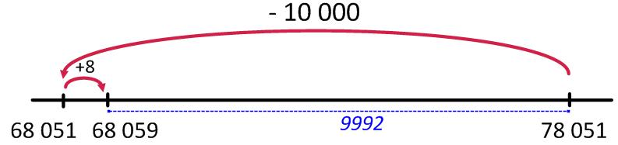

78 051 –9992 = 78 051 –10 000 + 8 = 68 051 + 8 Pupils should realise that they can adjust first:
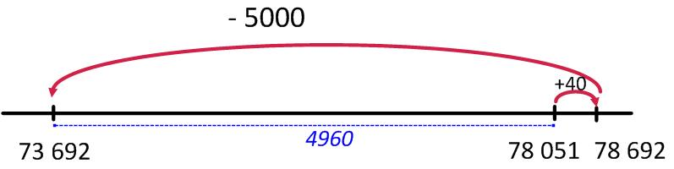

 | 78 051 –4960 = 78 051 + 40 –5000 = 78 |  |  |  | 692 - 5000
Near doubles
Pupils should be able to double | 160 | + 170 | = double 150 | + 10 + 20
numbers up to 100 and use this | 160 | + 170 | = double 160 | + 10 or 160 | + 170 = double 170 - 10
to derive doubles for multiples of
ten as well as decimal numbers. | 2.5 + 2.6 = double 2.5 + 0.1
These facts can be adjusted to
calculate near doubles.

Copyright © 2017 Mathematics Mastery. This can be printed out and photocopied by Mathematics Mastery toolkit registered users only. For further information, please see our terms and conditions at www.mathematicsmastery.org/terms-and-conditions

62

Strategies & Guidance |  |  |  |  |  |  |  | CPA
Partition both numbers and | 7230 + 5310 = 12 000 + 500 + 40
combine the parts
Pupils should be secure with this
method for numbers up to 10
000, using place value counters
or Dienes to show conceptual
understanding.
If multiple regroupings are
required, then pupils should
consider using the column
method. |  |  | Pupils should be aware that the parts can be added in any order.
Written column methods |  |  | For this method start with the digit of least value because if
for addition |  |  | regrouping happens it will affect the digits of greater value.
In Year 5, pupils are expected to
be able to use formal written
methods to add whole numbers | 3 |  |  | 4 | 6 | 2 | 3
with more than four digits as
well as working with numbers | + |  |  | 5 | 5 | 4 | 1
with up to three decimal places.
Pupils should think about
whether this is the most efficient
method, considering if mental
methods would be more |  |  | Combine the counters in each column and regroup as needed:
effective.
Continue to use concrete | 3 |  |  | 4 | 6 | 2 | 3
manipulatives alongside the
formal method. | + |  |  | 5 | 5 | 4 | 1
When adding decimal numbers |  |  | 1 | 1
When adding decimal numbers | 4 |  |  | 0 | 1 | 6 | 4
with a different number of
decimal places, in order to avoid
calculation errors, pupils should
be encouraged to insert zeros so |  |  | Decimal numbers:
that there is a digit in every
row. This is not necessary for
calculation and these zeros are
not place holders as the value of
the other digits is not changed
by it being placed.
Exemplification of this method
and the language to use are best
understood through viewing the
tutorial videos found on the
toolkit.
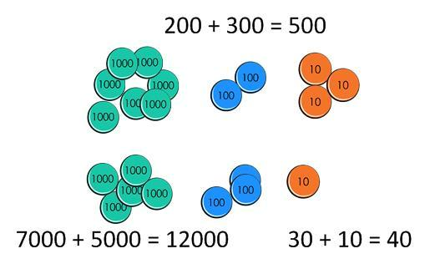
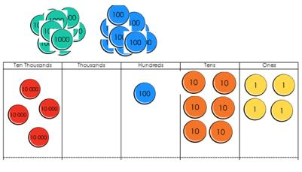
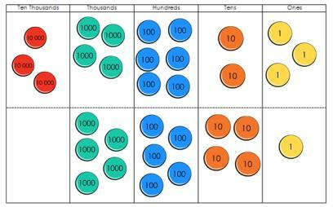
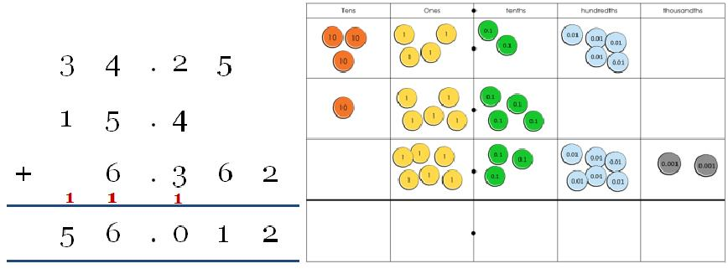
Copyright © 2017 Mathematics Mastery. This can be printed out and photocopied by Mathematics Mastery toolkit registered users only. For further information, please see our terms and conditions at www.mathematicsmastery.org/terms-and-conditions

63

Strategies & Guidance |  |  |  |  |  |  |  | CPA
Written column methods |  |  | 4 | 1 | 3 | 6 | 2
for subtraction
In Year 5, pupils are expected to |  |  | - 3 | 2 | 2 | 4 | 3
be able to use formal written
methods to subtract whole
numbers with more than four
digits as well as working with
numbers with up to three |  |  | 3 | 1 | 3 | 5 | 1
decimal places. |  |  | 4 | 1 | 3 | 6 | 2
Pupils should be given plenty of |  |  | - 3 | 2 | 2 | 4 | 3
practice with calculations that
practice with calculations that |  |  |  | 9 | 1 | 1 | 9
require multiple separate
instances of regrouping.
In Year 3 and 4 they become |  |  | The term regrouping should be the language used. You can use
more familiar with calculations
more familiar with calculations | the terms ‘exchange’ with subtraction but it needs careful
that require ‘regrouping to
regroup’. Understanding must | consideration.
be secured through the
considered use of manipulatives |  |  | You can regroup 62 as 50 and 12 (5 tens and 12 ones) instead of
and images, combined with |  |  | 60 and 2 (6 tens and 12 ones).
careful use of language.
Pupils should think about if this |  |  | Or you can ‘exchange’ one of the tens for 10 ones resulting in 5
Pupils should think about if this |  |  | tens and 12 ones.
is the most efficient method,
considering whether mental |  |  | If you have exchanged, then the number has been regrouped.
strategies (such as counting on,
using known number facts,
compensation etc.) may be
likelier to produce an accurate
solution.
Exemplification of this method
and the language to use are best
understood through viewing the
tutorial videos found on the
toolkit.
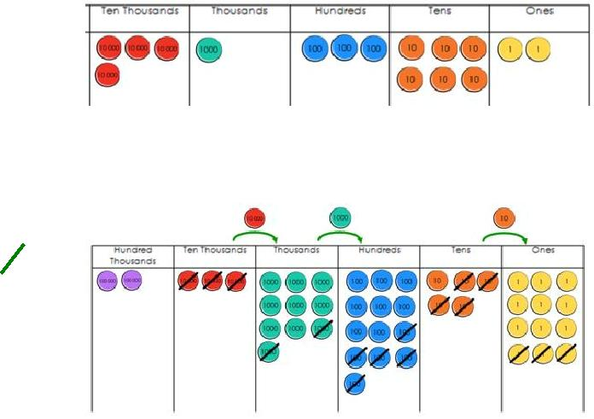

Copyright © 2017 Mathematics Mastery. This can be printed out and photocopied by Mathematics Mastery toolkit registered users only. For further information, please see our terms and conditions at www.mathematicsmastery.org/terms-and-conditions

64

Progression in calculations

Year 5 + Year 6

National Curriculum objectives linked to multiplication and division

These objectives are explicitly covered through the strategies outlined in this document:

- multiply and divide whole numbers by 10, 100 and 1000

- multiply numbers up to 4 digits by a one- or two-digit number using a formal written method, including long multiplication for two-digit numbers

- multiply and divide numbers mentally drawing upon known facts

- divide numbers up to 4 digits by a one-digit number using the formal written method of short division and interpret remainders appropriately for the context

- multiply multi-digit numbers up to 4 digits by a two-digit whole number using the formal written method of long multiplication

- divide numbers up to 4 digits by a two-digit whole number using the formal written method of long division, and interpret remainders as whole number remainders, fractions, or by rounding, as appropriate for the context

- divide numbers up to 4 digits by a two-digit number using the formal written method of short division where appropriate, interpreting remainders according to the context

- multiply one-digit numbers with up to two decimal places by whole numbers

- use written division methods in cases where the answer has up to two decimal places

The following objectives should be planned for lessons where new strategies are being introduced and developed:

- solve problems involving multiplication and division including using their knowledge of factors and multiples, squares and cubes

- solve problems involving addition, subtraction, multiplication and division and a combination of these, including understanding the meaning of the equals sign

- use their knowledge of the order of operations to carry out calculations involving the four operations

- solve addition and subtraction multi-step problems in contexts, deciding which operations and methods to use and why

- solve problems involving addition, subtraction, multiplication and division

- solve problems involving the relative sizes of two quantities where missing values can be found by using integer multiplication and division facts.

Copyright © 2017 Mathematics Mastery. This can be printed out and photocopied by Mathematics Mastery toolkit registered users only. For further information, please see our terms and conditions at www.mathematicsmastery.org/terms-and-conditions

65

 | Y5 and Y6 Multiplication
Strategies & Guidance | CPA
Multiply and divide whole | When you multiply by ten, each part is ten times greater. The ones
numbers and those | become tens, the tens become hundreds, etc.
involving decimals by 10, | become tens, the tens become hundreds, etc.
100 and 1000 | When multiplying whole numbers, a zero holds a place so that each
Avoid saying that you “add | digit has a value that is ten times greater.
a zero” when multiplying | 102.14 x 10 = 1021.4
by ten and instead use the | 102.14 x 10 = 1021.4
language of place holder.
Use place value counters
and charts to visualise and
then notice what happens
to the digits.
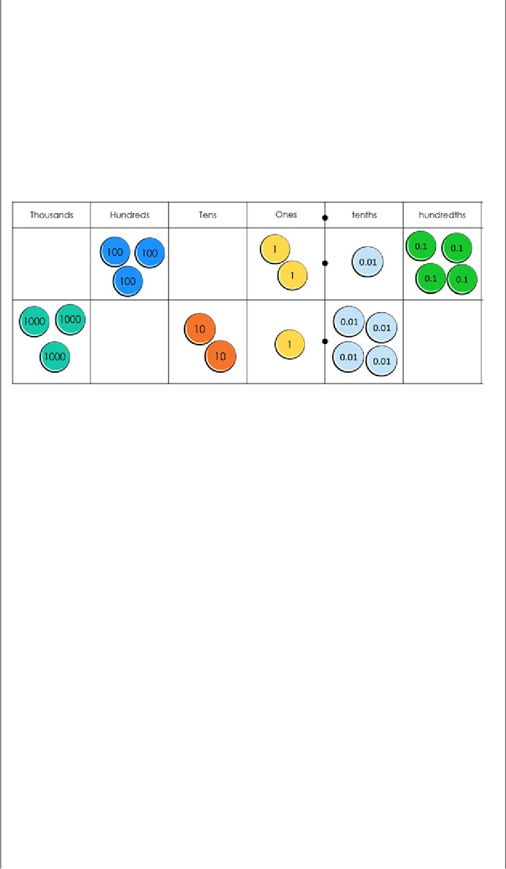

When you divide by ten, each part is ten times smaller. The hundreds become tens and the tens become ones. Each digit is in a place that gives it a value that is ten times smaller.

When dividing multiples of ten, a place holder is no longer needed so that each digit has a value that is ten times smaller.

E.g. 210 ÷ 10 = 21

210.3 ÷ 10 = 21.03

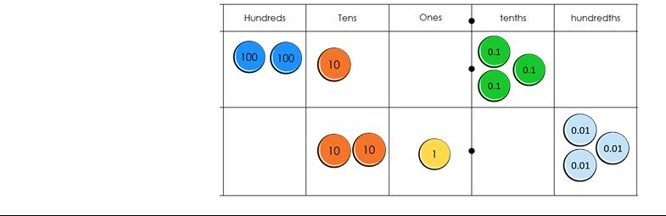

Copyright © 2017 Mathematics Mastery. This can be printed out and photocopied by Mathematics Mastery toolkit registered users only. For further information, please see our terms and conditions at www.mathematicsmastery.org/terms-and-conditions

66

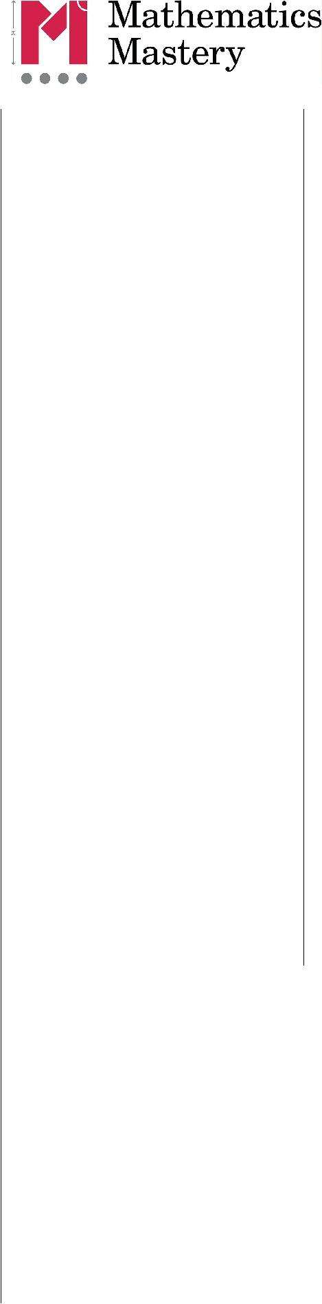
Strategies & Guidance | CPA
Using known facts and
place value to derive
multiplication facts | Children are encouraged to look for significant figures
Smile representation from big maths
Emphasis is placed on understanding the relationship (10 times or 100 times greater) between a known number fact and one to be derived, allowing far

larger ‘fact families’ to be derived from a single known number fact.

Knowledge of commutativity is further extended and applied to find a range of related facts.

Pupils should work with decimals with up to two decimal places.

These derived facts should be used to estimate and check answers to calculations.

These are the multiplication facts pupils should be able to derive from a known fact

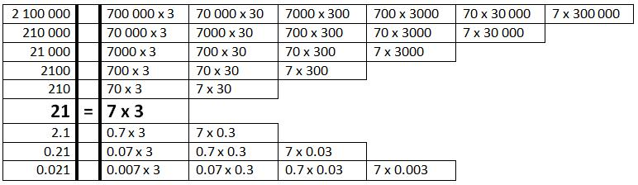

Copyright © 2017 Mathematics Mastery. This can be printed out and photocopied by Mathematics Mastery toolkit registered users only. For further information, please see our terms and conditions at www.mathematicsmastery.org/terms-and-conditions

67

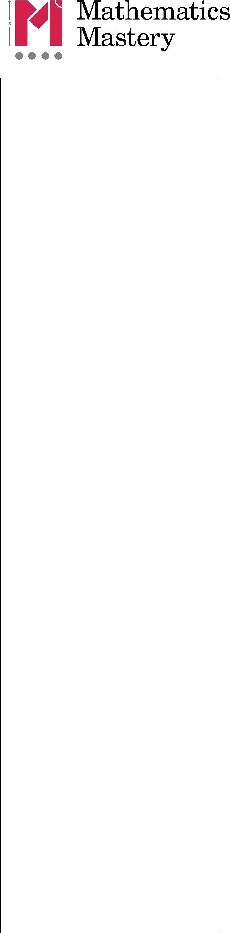
Strategies & Guidance | CPA


Doubling and halving

Pupils should experience doubling and halving larger and smaller numbers as they expand their understanding of the number system.

Doubling and halving can Multiply by 4 by doubling and doubling again

then be used in larger
_{calculations.} e.g. 16 × 4 = 32 × 2 = 64

Divide by 4 by halving and halving again e.g. 104 ÷ 4 = 52 ÷ 2 = 26
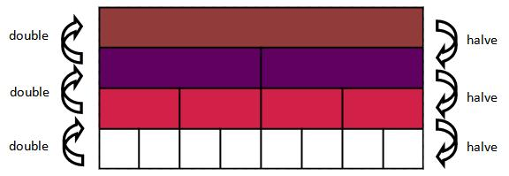

Multiply by 8 by doubling three times e.g. 12 × 8 = 24 × 4 = 48 × 2 = 96

Divide by 8 by halving three times e.g. 104 ÷ 8 = 52 ÷ 4 = 26 ÷ 2 = 13

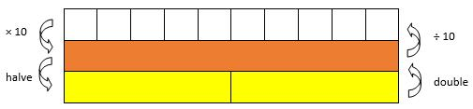

Multiply by 5 by multiplying by 10 then halving, e.g. 18 × 5 = 180 ÷ 2 = 90.

Divide by 5 by dividing by 10 and doubling, e.g. 460 ÷ 5 = double 46 = 92
Links to fraction

Copyright © 2017 Mathematics Mastery. This can be printed out and photocopied by Mathematics Mastery toolkit registered users only. For further information, please see our terms and conditions at www.mathematicsmastery.org/terms-and-conditions

68

Strategies & Guidance | CPA
Multiply by partitioning | 8 x 14 = 8 x 10 + 8 x 4 - Year 6
one number and
multiplying each part
Distributive law | 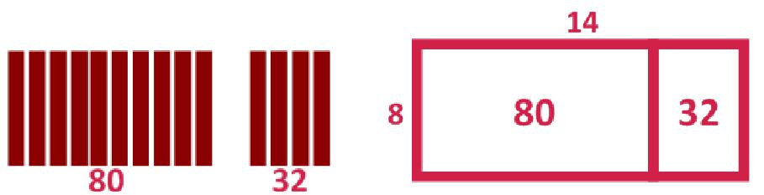
a x (b + c) = a x b + a x c | Cuisenaire rods to build arrays | Represent with area model
Build on pupils’ understanding | Year 5 area models
of arrays of counters to
represent multiplication to
see that area models can be a
useful representation:
Using knowledge of | Calculate 6 x 24 by using factor pairs of 24
factors
In Year 5 pupils are expected
to be able to identify factor
to be able to identify factor | Children are taught to recognise factors in pairs and write these down systematically to ensure they have not missed any.  Factor bugs are introduced in year 5 as a starting point however once understood children write down underneath the number.  e.g.  factors of 24  1 x 24  2 x 12  3 x 8  4 x 6
pairs and this knowledge can
be used to calculate.
Pupils will be using the
commutative and associative
laws of multiplication.
Commutative law
a x b = b x a
Associative law
a x b x c = (a x b) x c
= a x (b x c)
They should explore and
compare the different options
and choose the most efficient
order to complete
calculations.

69

Strategies & Guidance |  |  | CPA
Formal written method of
short multiplication
Conceptual understanding is
supported by the use of place
value counters, both during
teacher demonstrations and
during their own practice.
Exemplification of this
method and the language to
use are best understood
through viewing the tutorial
videos found on the
toolkit.
Multiplying by a 2-digit
number
Formal written method of
long multiplication
 |  |  |  | 243 x 2
In | Year 6 | pupils are extended
from multiplication by a 1-
digit number to multiplication
 |  |  |  | 243 x 10
by a 2-digit number.
Extend the place value chart
model used in Year 4, using
an additional row on the
place value chart.
Extend understanding of the
distributive law to develop
conceptual understanding of
the two rows of the formal
written method.
Dienes blocks can be used to
construct area models to
represent this.
Year 5
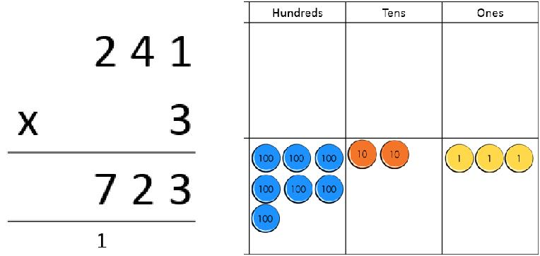
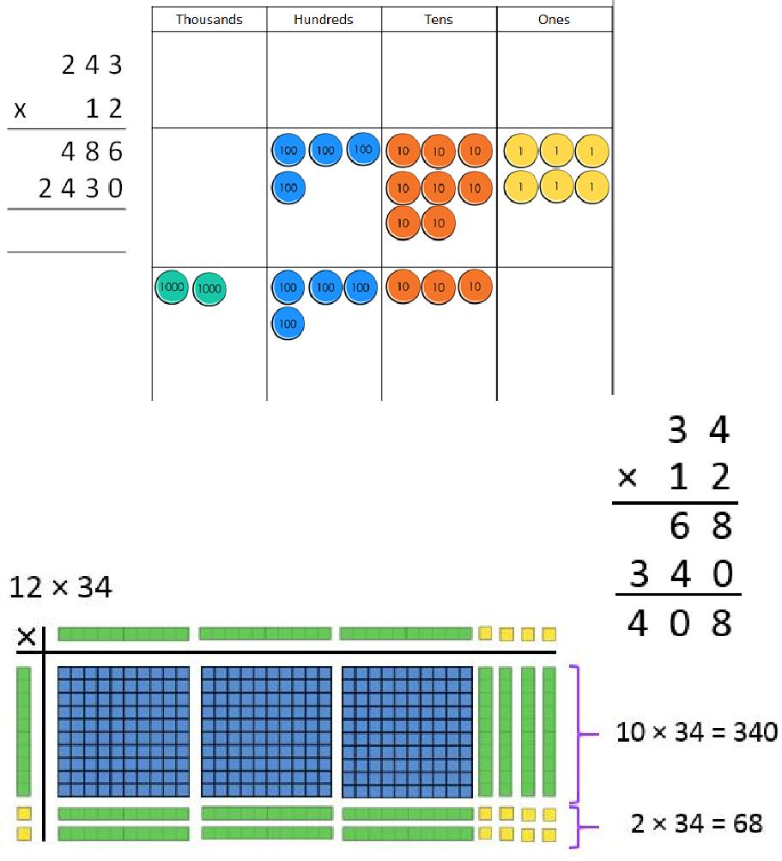

Copyright © 2017 Mathematics Mastery. This can be printed out and photocopied by Mathematics Mastery toolkit registered users only. For further information, please see our terms and conditions at www.mathematicsmastery.org/terms-and-conditions

70

Strategies & Guidance | CPA
Short division | 8528 ÷ 4
Dividing a 4-digit numbers
by 1-digit numbers
The thought process of the | Sharing
traditional algorithm is as
follows:
How many 4s in 8? 2
How many 4s in 5? 1 with 1
remaining so regroup.
How many 4s in 12? 3
How many 4s in 8? 2
Warning: If you simply apply
place value knowledge to each
step, the thinking goes wrong if | 8 thousands shared into 4 equal groups
you have to regroup. | 8 thousands shared into 4 equal groups
 | 5 hundreds shared into 4 equal groups
How many 4s in 8000? 2000 | Regroup 1 hundred for 10 tens
How many 4s in 500? | Regroup 1 hundred for 10 tens
How many 4s in 500? | 12 tens shared into 4 equal groups
100 with 1 remaining (illogical) | 12 tens shared into 4 equal groups
100 with 1 remaining (illogical) | 8 ones shared into 4 equal groups.
The answer would be 125. | 8 ones shared into 4 equal groups.
Sharing the dividend builds | Grouping
conceptual understanding
however doesn’t scaffold the
“thinking” of the algorithm
Using place value counters and
finding groups of the divisor for
each power of ten will build
conceptual understanding of the
short division algorithm.
Area models are also useful | How many groups of 4 thousands in 8 thousands?
representations, as seen with | How many groups of 4 hundreds in 5 hundreds?
other strategies and exemplified | Regroup 1 hundred for 10 tens.
for long division. | How many groups of 4 tens in 12 tens?
Exemplification of this method | How many groups of 4 ones in 8 ones?
and the language to use are best
understood through viewing the
tutorial videos found on the
toolkit.
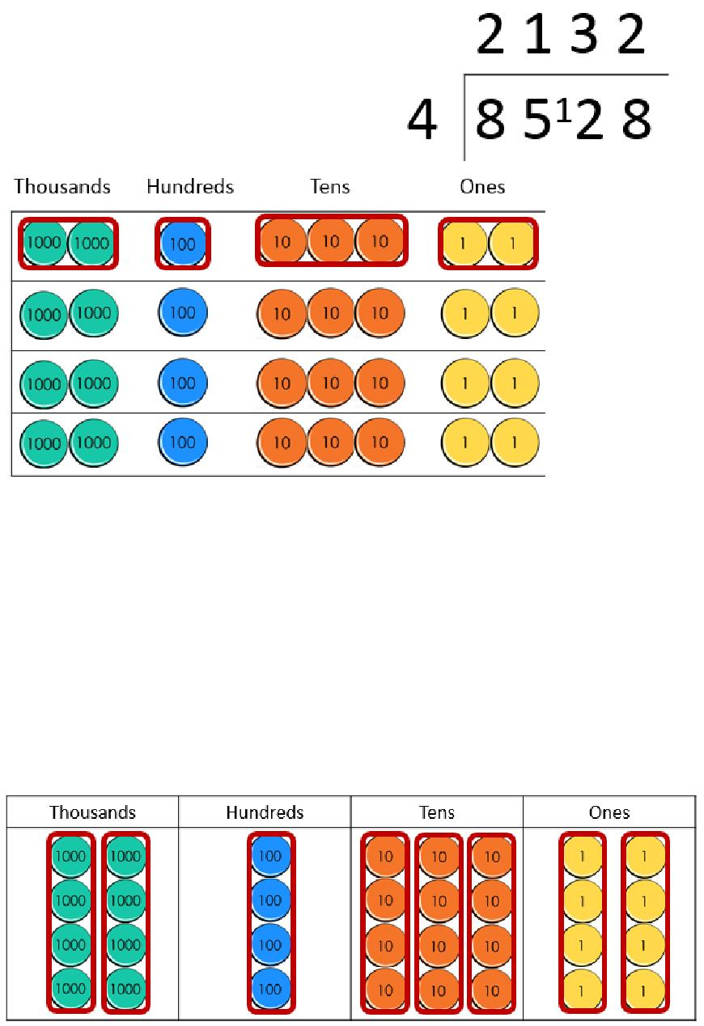

Copyright © 2017 Mathematics Mastery. This can be printed out and photocopied by Mathematics Mastery toolkit registered users only. For further information, please see our terms and conditions at www.mathematicsmastery.org/terms-and-conditions

73

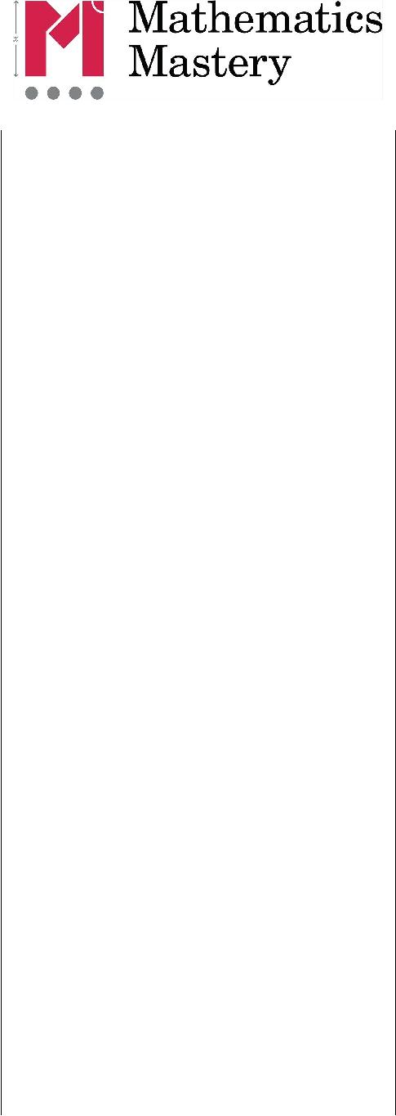
Strategies & Guidance | CPA
Long division taught using the  Formal method of division  Bus stop  Children are encouraged to  write down multiples to help | 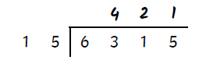

Dividing a 4-digit number by a 2-digit number

If dividing by a number outside of their known facts, pupils should start by recording some multiples of that number to scaffold.



Copyright © 2017 Mathematics Mastery. This can be printed out and photocopied by Mathematics Mastery toolkit registered users only. For further information, please see our terms and conditions at www.mathematicsmastery.org/terms-and-conditions

74

