PE.  Make up your own game, Make sure you write the rules down so you can share it with the class.  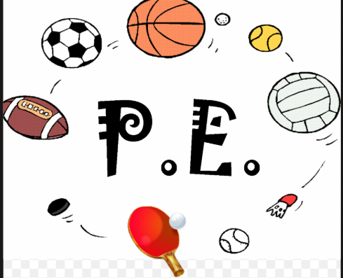 | What piece of homework would you want to do? Can you come up with your own?   | SPaG  Create a help guide for common grammar words . e,g, noun, adjective adverb preposition etc .  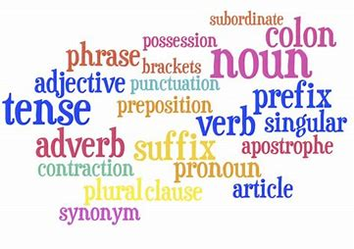  .
Science  Research the gestation periods of animals  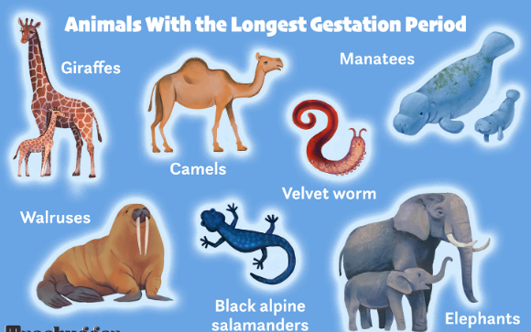 | Geography  Which part of North America would you like to travel to and why?  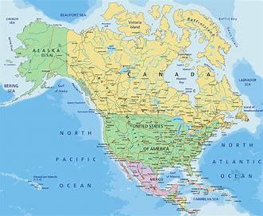 | French  Design your own clothing- can you remember the French phrases we looked at in class? Use the ones below to help.  