Computing  Make a digital self-portrait.  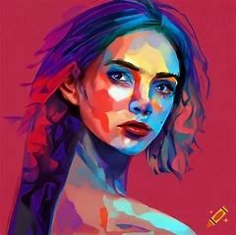 | History  Create a short information text about the history of Liverpool.  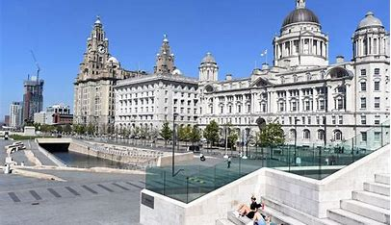 | SPaG  Create a guide to explain parenthesis.  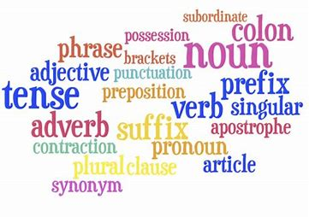  .
Science  Make a poster about light.   | Geography  Research a country in North America and present your findings.  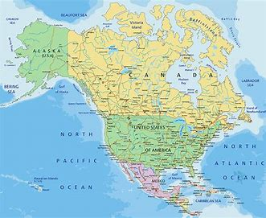 | French  Draw and label a carnival outfit in French.  