Year 4 Spring 2 Research Questions
RE  How might Christians celebrate Pentecost? | History  Who was Tutankhamen?  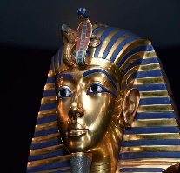  This Photo by Unknown Author is licensed under CC BY-ND | Geography  Why are National Parks important?  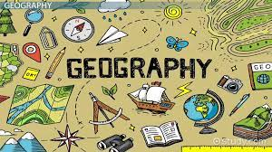  Can you make a poster for a U.K National Park that would encourage visitors?
Science  Can you label bones on a human skeleton?   | Maths  Can you design a poster showing multiplication facts for x6 and x12? How are they linked? | English  Write a book review for your favourite book.

Over the next half term, complete some research based on these questions. You will be learning more about them in class and will be able to contribute to your lessons.

