PE  Create game using 3 pieces of equipment that we have in school to be played by a small group. Write instructions.   | History  Create an poster advertising the Rainhill Trials including information about all the participating engines.  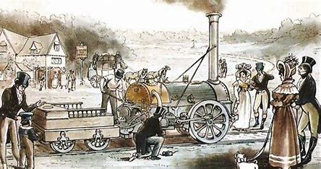 | RE  Write an acrostic poem using the NAMASTE.  
Science  Write a mnemonic to remember the order of the planets in the solar system and make a model/ drawing to show them.  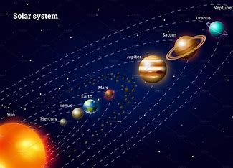 | Geography  How is land used in North America?  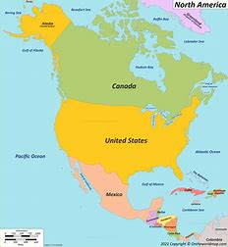 | French  Use the language you have learned to write a recipe for a fruit salad. Can you use an online dictionary to add new fruits?  

