Year 4 Spring 1 Homework
You can present your answers to the questions in any way you want. Some ideas are PowerPoints, posters, leaflets, comic strips, diagrams. Be as creative as you like.
PSHE  Let’s celebrate YOU! What makes you happy? What makes you YOU? Create a poster all about yourself. These questions may help you design your poster.  I am proud of myself for……  My qualities are………….  I am happiest when ………….  My favourite place to be is ………………  My hobbies and talents are ………………….  I am kind to myself when ………….  My goal this year is ………………  I want to improve ………………………. | History  Who was Alfred the Great?  | Geography  Can you research a famous volcano and make a fascinating fact file?  
Science - Electricity – Design a poster on how to safe around electricity.  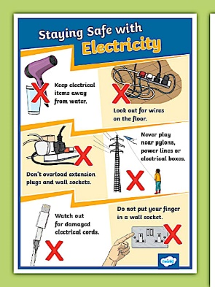 | RE - What is fairness? What about a fairer world – what would that look like? How could we make the world a fairer place?  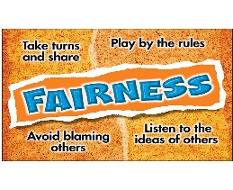 | PE – Can you build a 5 minute workout using the bingo sheet below and complete it. How long do you need to complete each exercise for and how many repetitions? 