PE  Design a warm-up activity for PE.   | History  Draw a birds-eye view plan of a bronze age home. Compare it to life in the Stone Age and Iron Age.  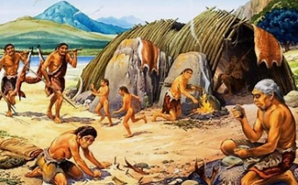 | PSHE  Make a guide to internet safety. Can you add a slogan to remind children and young people how to behave online?  
Science  How can you explain gravity. List some examples and create diagrams that explain it. Who discovered it? What do you know about him?  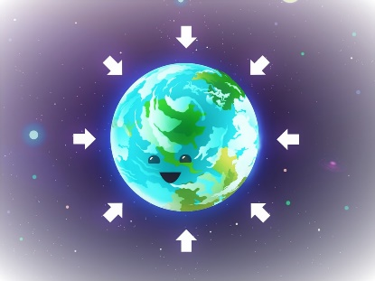 | Geography  How is land used in the UK?  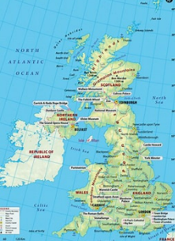 | RE  Research the festival of Holi and present your findings.  