Guided Reading  Write a review of Kensuke’s Kingdom and design a front cover with blurb.   | History  Write down 5 facts about The Bronze Age and present them however you like.  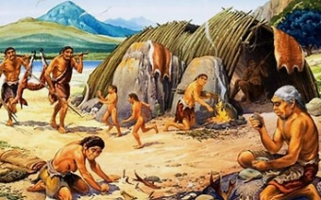 | PSHE  Make a healthy living guide.  
Science  Have a go at making something by melting (ask an adult for help)  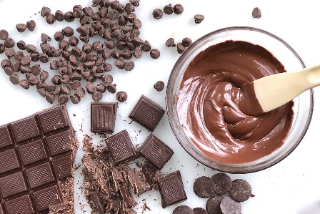 | Geography  Make a booklet about mountains.  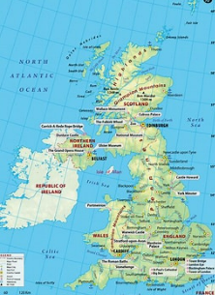 | Maths  Design a game to practise a times table that you find tricky  

