Year 6 Autumn 1 Research Questions
  PSHE  What sorts of stereotypes are you aware of and how do they influence attitudes and understanding of groups? | History  Who were the ancient Maya and where did they live?  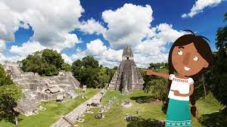 | Geography  What are the main features of each continent?  
Science  What is the difference between the life cycle of a mammal and a bird?   | Languages    Can you describe your feelings in French? | 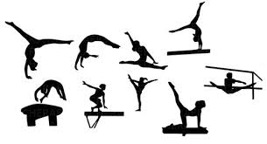  PE  Can you explain how to perform consistently accurate and precise rolls/ jumps/ movements etc in gymnastics?

Over the next half term, complete some research based on these questions. You will be learning more about them in class and will be able to contribute to your lessons.

