Guided Reading  Design your own Island. Think about what you might include to be able to survive.  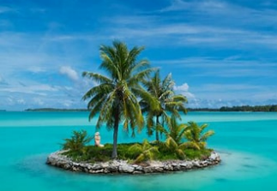 | History  Write down 5 facts about The Stone Age and present them however you like.  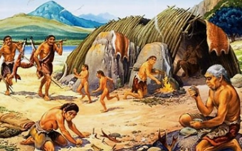 | PSHE  Design a poster or leaflet about how we can show compassion for the environment  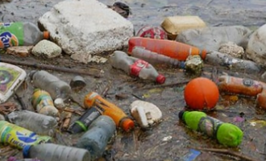
Science  Look around your house. How many different types of material can you find? Write down a few examples of each.  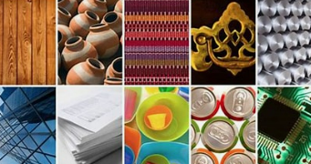 | Geography  Choose a country of the UK and write a fact file about it.  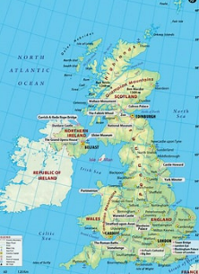 | Maths  Pick 5 6-digit numbers and order them. Can you also identify the value of each digit?  