
Cycle A – Class 1

 | Autumn |  | Spring |  | Summer
 | Autumn 1 | Autumn 2 | Spring 1 | Spring 2 | Summer 1 | Summer 2
English | The Last Wolf  - A Hunting Narrative  - Instructions | The Secret of Black Rock  - Return Narrative  - Recount | Where the Wild Things Are  - A Portal Narrative  - Information | Juniper Jupiter  - A Superhero Narrative  - Letter | The Extraordinary Gardener  - A Plant Growing Narrative  - Instructions | The Storm Whale  - Seaside Narrative  - Describing poem
Maths | Place Value  Addition and Subtraction  Shape |  | Place Value  Addition and Subtraction  Length and Height  Mass and Volume |  | Multiplication and Division  Fractions  Position and Direction  Place Value  Money Time
RE | I Am Special  Harvest | Giving and Receiving Gifts | Stories Jesus Heard  Stories Jesus Told | Love at Easter | Baptism | Joseph  My World Jesus’ World
Science | Animals including humans | My Body | Nature Protectors |  | Seasonal Changes  Spring/ Summer | Life Cycles
Computing  Online Safety to be taught explicitly within each unit |  | Skills Showcase: Rocket to the Moon | Computer Systems and Networks – What is a computer? | Computing Systems and Network – improving mouse skills | Programming – All about instructions | Programming– Algorithms unplugged
History | The Gunpowder Plot |  | Dinosaurs |  | Travel and Transport
Geography |  | Our School |  | Rainforest |  | Manchester!
Art and Design | Paint my world |  | Marvellous Marks |  | Sculpture and 3D: Paper Play
D&T |  | Cooking and nutrition:  Soup |  | Bookmarks |  | Stable Structures
PE | Small ball skills | Large ball skills | Team games | Travelling & moving | Bat and ball | Individual challenges
Music |  | Music and movement |  | Pitch  superhero’s |  | Musical symbols  (under the sea)
PSHE | Be Yourself |  | One World |  | TEAM!
No Outsiders | You Choose |  | Elmer |  | Blue Chameleon
Enrichment and Outdoor Learning | Dance | Forest School | Forest School | Gymnastics | Cookery and Physical development (bikes)
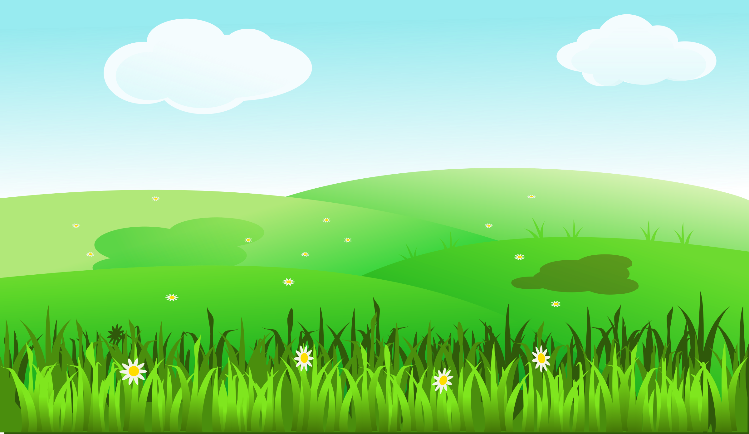
Cycle B – Class 1

 | Autumn |  |  | Spring |  | Summer
 | Autumn 1 |  | Autumn 2 | Spring 1 | Spring 2 | Summer 1 | Summer 2
English | The Something  - A Friendship and Animal Narrative  - Recount |  | Star in a Jar  - A Star Narrative  - Information | Old Bear  - A Discovery Narrative  - Recount | Hermelin  A Detective Story Narrative  - Recount | Rapunzel  - A Traditional Tale  - Instructions | Little Red  - A Tradition al Tale Narrative  - Instructions
Maths | Place Value  Addition and Subtraction  Shape |  |  | Place Value  Addition and Subtraction  Length and Height  Mass and Volume |  | Multiplication and Division  Fractions  Position and Direction  Money  Time
RE | Creation |  | Jesus’ Birthday | Jesus | Easter Story | Special Places | Prayer  Special Times
Science | Seasons: Autumn/ Winter |  |  | Everyday Materials |  | Plants
Computing  Online Safety to be taught explicitly within each unit |  |  | Creating Media:  Digital Imagery | Programming: Bee-Bots | Programming: Bee-Bots | Data Handling: Introduction to Data A | Data Handling: Introduction to Data B
History | People who help us |  |  | Toys |  | Growing up
Geography |  |  | Antarctica |  | Our Country |  | Weather
Art and Design | Craft and design:  Creation Station |  |  | Drawing:  Exploring line and shape |  | Craft and design:  Woven Wonders
D&T |  |  | Textiles:  Puppets |  | Junk Modelling |  | Moving Storybook: Mechanisms
PE | Small ball skills |  | Large ball skills | Team games | Travelling & moving | Bat and ball | Individual challenges
Music |  |  | Exploring sound |  | Keeping my pulse  (favourite things) |  | Sound patterns  (fairy tales)
PSHE | Safety First |  |  | VIP’s |  | Aiming High
No Outsiders | Red Rockets and Rainbow Jelly |  |  | My Grandpa is Amazing |  | My World, Your World
Enrichment and Outdoor Learning | Dance | Forest School |  | Gymnastics | Forest School | Cookery and Physical Development (bikes)
