Autumn 2021
WHATS ON AT VISYON:
Here are details of our groups, webinars and parent workshops. Maybe you are looking for opportunities to have fun, be creative and meet others who are experiencing similar things or maybe you are a young person or parent looking to learn more about mental health and ways to manage emotions and improve your wellbeing. If so, have a look at the groups and courses we are running this term. All friendly, supportive and free.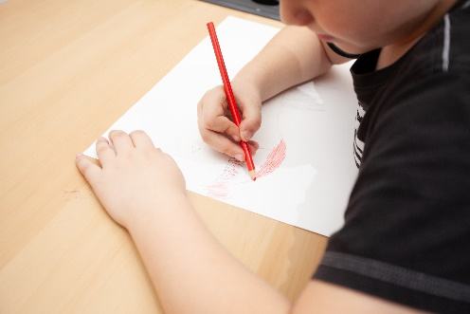
CREATE AND CONNECT
Tuesdays 4.30-5.30pm (on Zoom)
Age 11+
Enjoy some time out to do something creative alongside other like-minded people. Whether you are crafty already or want to learn some new skills, this group is designed to help you relax, have fun and connect with others.

EXPLORING EMOTIONS
Tuesdays 6-7pm (Grp 1) (Face to Face,Congleton Age 15+
Wednesdays 6-7pm (Group 2) (On Zoom) Age 12+

A chance to explore emotions in a creative way and to use art as a therapeutic tool. A small, supportive group provides a safe place to be yourself and find ways to cope when things are tough. This is an 8 week closed group which is very popular so may have a waiting list.


PARENT/CARER WEBINARS
Wednesdays/Thursdays 9.30-10.30am (on Zoom)
For adults

A series of informative webinars on topics relevant to parents in supporting their children’s mental health and wellbeing. The webinars are available as live sessions or recordings (see website for registration links)


PRACTICAL STRATEGIES WEBINARS
Wednesdays 4.30-5.00pm (on Zoom)
Age 11+

A series of webinars for young people to explore topics such as Anger, Anxiety, School stress and Self Care and to learn practical tools to help manage overwhelming emotions. Recorded sessions available on the website


OUR VISYON
Thursdays 4.30-5.30pm (on Zoom)
Age 14+

A group for people who are interested in mental health, campaigning, rights and having a voice on all things that matter to young people


UNDERSTANDING ANXIETY WORKSHOPS
Thursdays 6-7pm (on Microsoft Teams)
Age 15-18

A series of workshops (6 sessions weekly) to explore what anxiety is, how it affects people and to learn practical tools to help manage overwhelming emotions. This is run as a small, closed group. Please enquire for next available start date.

PARENT WORKSHOPS
Various Dates

Parent Workshops on topics such as Sleep, Anxiety and Transitions are available. These workshops are evidence based and are a chance to meet other parents in similar situations as well as improve your skills and confidence.
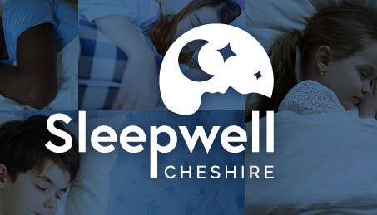

To find out more about the groups and activities or to book onto any of the sessions please phone Visyon on 01260 290000. These sessions are free of charge and open to all in Cheshire East.

