Disability Positive Short Breaks offer 2021

Buzz Youth Group
Youth group for disabled young people aged 12-18 years (up to 18th Birthday)
Thursday 6.30-8.00 term time and daytime during school holidays
Crewe (Lifestyle Centre) and Macclesfield (Kings School)
Alternate weeks provision in each area
Fully accessible provision and 1-1 will be provided for personal care, behaviour and medical requirements
Registration is required before attendance
Waiting list may be in operation
Contact Helen@disabilitypositive.org for further information or to submit the attached request for services form.

Duke of Edinburgh Award Programme
Bronze Award for 14-18 years
Macclesfield base but open to any young person wishing to join
Monthly support sessions on third Saturday of the month : June-January (Kings School)
24 hour residential will take place January-May
Fully accessible provision and 1-1 will be provided for personal care, behaviour and medical requirements
Registration is required before attendance
Waiting list may be in operation
Contact Helen@disabilitypositive.org for further information or to submit the attached request for services form.

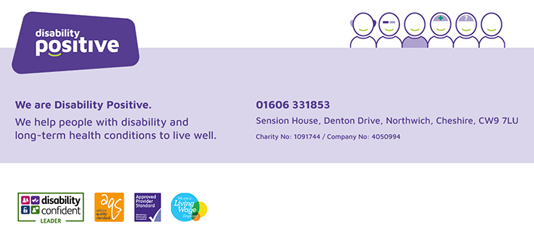

Community Engagement Team
Request for Services

Name of Young Person/Adult
Address
Date of Birth of Young Person/Adult
Name of Parent/Carer if appropriate
Email contact for family/adult
This is our preferred method of contact – if no email address please advise below and provide an alternative contact method
Disability / Diagnosis
Please give as much detail as possible
Request made by
Name
Organisation
Contact Number
Signature of young person/family/adult to confirm consent for referral

Request Details
Buzz Youth Activity Group 5-18 years (Cheshire West)
- Ellesmere Port
- Northwich
- Neston
- Lifeskills
- Weekend Group

Buzz Youth Activity Group 12-18 years (Cheshire East)
- Crewe (12-18)
- Macclesfield (12-18)
- Duke of Edinburgh (14-18)

Good Company 18+
- Weekly (Cheshire West)

Please give details of anything we would need to know before visiting the child/young person/adult including any assessed risk

Please note the request for services may be returned if information is not completed in full.
Please return to:
Helen Webb, Community Engagement Team Administrator ,
Sension House, Denton Drive, Northwich, Cheshire, CW9 7LU
Tel: 01606 331853 or Email: helen@disabilitypositive.org

Internal use only
Date referral received -------------------------
Received by ……………………..

