
Newsletter / Website Announcement

ParentPay - our new online payment service
We are pleased to announce that we will shortly be accepting payments online for items such as dinner money, school trips and uniform. Using a secure website called ParentPay you will be able to pay online using your credit / debit card or continue to make cash payments at PayPoint stores. ParentPay will be our preferred method of making payments to school.
What are the benefits to parents & pupils? | What are the benefits to our school?
- ParentPay is easy-to-use and will offer you the freedom to make online payments whenever and wherever you like, 24/7  - The technology used is of the highest internet security available ensuring that your money will reach school safely – offering you peace of mind  - Payments can be made by credit/debit card or also through PayPoint  - Full payment histories, balance alerts and statements are available to you securely online at anytime | - You can help us reduce workloads for all staff as no more counting cash, chasing debt and stop cash collection services  - Creates more time to lend to educational support and the smooth running of the school  - Improves school security  - Using ParentPay also ensures that all financial transactions are safe and secure - helping us to remove costs associated with us having to manage cash securely on the school premises  - The more parents that use ParentPay, the greater the benefit is to our school.

How to get started with ParentPay?

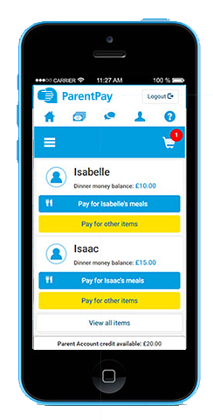
We will send you your account activation details. Once you receive these:
- Visit www.parentpay.com

- Enter your Activation username and password in the Account Login section of the homepage
NB. These are for one-time use only, please choose your own username and password for future access during the activation process

- Provide all the necessary information and choose your new username
and password for your account - registering your email address will enable us to send you receipts and reminders

- Once activation is complete you can go straight to Items for payment, select which item(s) you want to add to your basket and proceed to complete your payment
If you have any questions, please contact the school finance office. For more information, visit www.parentpay.com/parents/

©ParentPay Ltd 2019 Promotional Pack

