
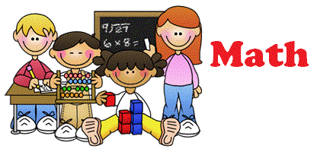




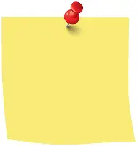
Date set: 18 Sept
Date due: Wed 23 Sept
Reading:
Reading is so important.
Please remember to read at least 5 times a week. Reads are counted from Friday to Friday.
When you have completed a book remember to take a quiz.
Rewards
Complete your daily challenge questions on Doodle and earn 2 raffle tickets.
Read 5 times a week and earn a raffle ticket.
Read every day each week and earn 2 raffle tickets.
Don’t forget:
PE kits should be worn on Thursday and Friday each week.
English:
Two tasks have been set on Rollama – homophones and common/proper nouns.
Y5 Homework

Maths:
Log on to Doodle Maths.
For homework, spend at least 10 minutes a day looking at your daily challenge questions.
Also complete your assignment on comparing numbers.

