
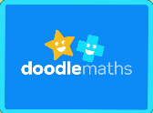

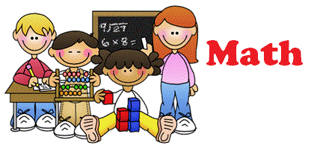



Date set: 04 Sept
Date due: 09 Sept (Wednesday)
English:
Write a mnemonic for remembering the order of the planets. It’s up to you if you include the sun and Pluto.
(Sun) Mercury, Venus, Earth, Mars, Jupiter, Saturn, Uranus (Pluto)
Maths:
Log on to Doodle Maths.
For homework, spend 10 minutes a day on your daily challenge questions.
Also complete your assignments set on place value..
Reading:
Reading is so important.
Please remember to read at least 5 times a week. Reads are counted from Friday to Friday.
When you have completed a book remember to take a quiz.
Rewards
Complete your daily challenge questions on Doodle each day and earn 2 raffle tickets.
Read 5 times a week and earn a raffle ticket.
Read every day each week and earn 2 raffle tickets.
Don’t forget:
PE kits should be worn on Thursday and Friday each week.
Y5 Homework

