 | Autumn |  |  |  | Spring |  |  |  |  |  | Summer
Theme | The world we live in. |  |  |  | New Beginnings |  |  |  |  |  | Exciting Explorers
Hook | 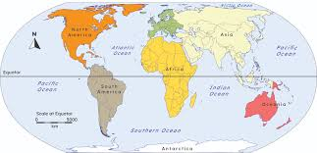 |  |  |  | What could hatch from the egg?  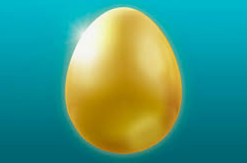 |  |  |  |  |  | Mystery Case. Who could this suitcase belong to?  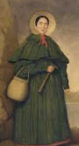  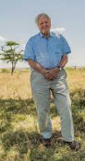  (David Attenborough & Mary Anning)
Enrichment | Visit to St. Helens Museum |  |  |  | Duck Eggs/ Ducklings |  |  |  |  |  | Celebrate David Attenborough’s 100th Birthday
Learning Showcase | Geography- Assembly for Parents |  |  |  | Special Worship -Easter |  |  |  |  |  | Read Our Stories & Poems to KS1 Classes.
 | Autumn |  |  |  | Spring |  |  |  |  |  | Summer
Reading  Phonics  Spelling | Supersonic Phonics Friends  Recap of Basics 2, 3 and 4 (including tricky words)  Higher Levels Choose to Use: new spellings for sounds, reading and writing words and sentences Set 1 -3  Recap tricky words: Basics 2,3 and 4  Reading tricky words: Choose to Use  RIC: Verbal RIC Comprehension  Reading for enjoyment, enjoy listening to stories  Spelling  Weekly spelling matched to phonics learning.  Learning how many syllables are in the words we say, hear and read.  Reading real and nonsense words matched to the phonics learning this term. |  |  |  | Supersonic Phonics Friends  Higher Levels Choose to Use: new spellings for sounds, reading and writing words and sentences  Set 4 – 6  Reading tricky words: Choose to Use  Written RIC comprehension (retrieve, inference and choice of vocabulary)  Reading for enjoyment, enjoy listening to stories  Spelling  Weekly spelling matched to phonics learning.  Y1 Spelling Rules: Adding ‘s’ or ‘es’ (singular to plurals)  Adding ‘ing’ to the end of words with no root change.  Adding ‘ed’ to the end of words to change it into the past tense.  Reading real and nonsense words matched to the phonics learning this term. |  |  |  |  |  | 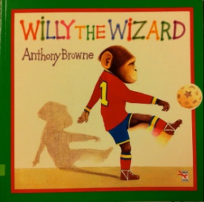  Supersonic Phonics Friends  Recap Higher Levels Choose to Use  Higher Levels Switch it Spell: new sounds for spellings, reading and writing words and sentences  Set 1 – 5  Reading tricky words: Switch it Spell  Written RIC Comprehension (retrieve, inference and choice of vocabulary)  Reading for enjoyment, enjoy listening to stories  Spelling  Weekly spelling matched to phonics learning.  Y1 Spelling Rules:  Adding ‘er’ to the end of words to make it a comparative adjective.  Adding ‘est’ to the end of words to change it to mean most.  Adding ‘un’ to words to change it to mean the opposite.  Learning the spelling of compound words.  Reading real and nonsense words matched to the phonics learning this term.
 | Word Reading  Apply phonic knowledge and skills as the route to decode words.  Respond speedily with the correct sound to graphemes (letters or groups of letters) for all 40+ phonemes, including, where applicable, alternative sounds for graphemes.  Read accurately by blending sounds in unfamiliar words containing GPCs that have been taught.  Read common exception words, noting unusual correspondences between spelling and sound and where these occur in the word. ▪  Read words containing taught GPCs and –s, –es, –ing, –ed, –er and –est endings.  Read other words of more than one syllable that contain taught GPCs.  Read words with contractions [for example, I’m, I’ll, we’ll]. Understand that the apostrophe represents the omitted letter(s).  Read aloud accurately books that are consistent with their developing phonic knowledge and that do not require them to use other strategies to work out words. ▪  Re-read books to build up their fluency and confidence in word reading. |  |  |  |  |  | Comprehension  Develop pleasure in reading, motivation to read, vocabulary and understanding by: listening to and discussing a wide range of poems, stories and non-fiction at a level beyond that at which they can read independently.  Be encouraged to link what they read or hear read to their own experiences.  Become very familiar with key stories, fairy stories and traditional tales, retelling them and considering their particular characteristics.  Recognising and joining in with predictable phrases. ▪ Learning to appreciate rhymes and poems, and to recite some by heart.  Discus word meanings, linking new meanings to those already known.  Understand both the books they can already read accurately and fluently and those they listen to by: ▪ drawing on what they already know or on background information and vocabulary provided by the teacher.  Check that the text makes sense to them as they read and correct inaccurate reading.  Discus the significance of the title and events.  Make inferences on the basis of what is being said and done predicting what might happen on the basis of what has been read so far.  Participate in discussion about what is read to them, taking turns and listening to what others say.  Explain clearly their understanding of what is read to them.
Handwriting | Handwriting  Presentation, letter formation, ascenders/descenders, finger spaces, capital letters, full stops, size.  Sit correctly at a table, holding a pencil comfortably and correctly.  Begin to form lower-case letters in correct direction, starting/ finishing in the right place.  Form Capital Letters and Digits 0-9
Writing  (English) | 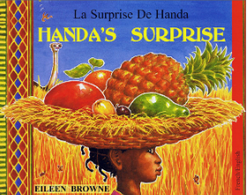    All About Me: (Non Fiction)  Sentence writing  Handa’s Surprise: (Fiction)  Sequencing, Sentence Writing, using senses to describe tropical fruit.  Instructions: (Non-Fiction)  How to make a fruit salad  Fruit Poems: (Poetry)  Senses poem  Sydney the Spider: (Fiction)  Character profile, sequencing, lists, sentence writing, short narrative |  |  |  | 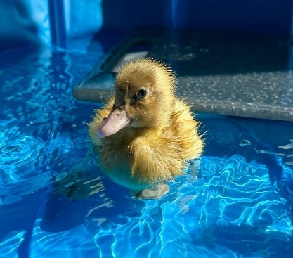  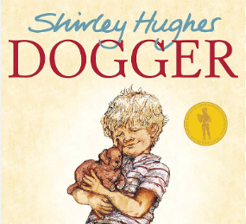  Dogger: (Fiction)  My special object, sequencing events, lost poster, story writing  Brenda’s Boring Egg (Fiction): sequencing events, writing sentences  Ducks (Non Fiction):  Report and diary of real events  (ducks egg hatching at school)  Humorous Poems: (Poetry)  Make a Silly Face |  |  |  |  |  | 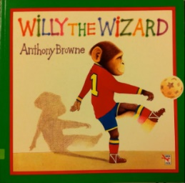  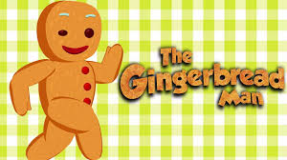  The Ginger Bread Man: (Fiction) Sentences and story writing  Seasons Poems: (Poetry)  Writing a Poem  Willy The Wizard (Fiction):  Sequencing, story mapping and story writing.  Molly Mc Drew Adventures Around the World: (Fiction)  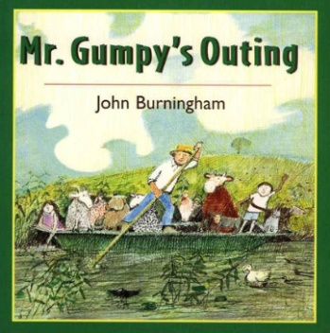  character description, country/weather descriptions (Relating to seasons and geography)
Grammar and Punctuation | Leave spaces between words.  Join words and clauses using ‘and’.  Begin to punctuate sentences using a capital letter and full stop.  Use a capital letter for names of people. |  |  |  | Leave spaces between words.  Join words and clauses using ‘and’.  Become more confident to punctuate sentences using a capital letter and full stop, question mark and exclamation mark.  Use a capital letter for names of people, places, the days of the week, and personal pronoun ‘I’.
Maths | Place Value to 10  Addition and Subtraction Within 10  2D Shape and 3D Shape |  |  |  | Place Value Within 20  Addition and Subtraction Within 20  Place Value Within 50  Length and Height  Mass and Volume |  |  |  |  |  | Multiplication and Division  Fractions  Position and Direction  Place Value Within 100  Money  Time
RE | Unit 1.1 - Harvest  How can we help those who do not have a good Harvest?  Unit 1.9 - My World, Jesus’ World.  How was Jesus’ Life different to our life? |  | Unit 1.3 -Christmas Gifts  Why do we give and receive gifts?  Christmas in Africa.  How do they celebrate Christmas in Africa? |  | Unit 1.4 - Jesus Was Special  Why was Jesus special? |  |  |  | Unit 1.5 - Easter  Celebrating New Life and Beginnings. |  | Unit 1.2 - God and Creation  What do you feel about the wonder of God’s Creation? |  | Unit 1.7 – Baptism  Why is Baptism so Special?
Christian Value | Friendship |  | Love |  | Generosity |  |  |  | Courage |  | Perseverance |  | Generosity
Science | All about animals including  humans |  |  |  | Materials and their Properties |  |  |  |  |  | Seasons  Plants
Working Scientifically | ▪Ask simple questions and recognise that they can be answered in different ways observing closely, use simple equipment, perform simple tests, identify and classify using observations and ideas to suggest answers to questions, gathering and recording data to help in answering questions.
Computing | Internet Safety |  |  |  | Algorithms Unplugged |  |  |  |  |  | Digital Imagery
History | Changes within Living Memory  (How us, our lives, our community has changed since the 1950’s) |  |  |  |  |  |  |  |  |  | The Lives of Significant People:  Mary Anning and David Attenborough.
Geography | Continents And Oceans |  | Countries of the UK and Capital Cities |  | Hot and Cold Places |  |  |  |  |  | Mapping and Fieldwork.
Art | Drawing  Albrecht Durer (1471 – 1528) |  | Painting  Piet Mondrian (1872 -1944) |  | Printmaking  Karen Lederer (Born 1986) |  |  |  | Textiles  Anne Kelly |  | 3D  Kenojuak Ashevak (1927 – 2013) |  | Collage  Paul Klee (1879 – 1940)
DT | Food and Nutrition C |  |  |  | Textiles E |  |  |  |  |  | Mechanisms A
PE | Mindfulness | Fundamentals | Fitness | Gymnastics | Dance | Target Games |  | Sending & Receiving |  | Invasion Games | Athletics | Team Building | Striking | Field Games
Music | Menu Song* (6weeks)  Magical Musical Aquarium (3 weeks) |  | The King is in the Castle  (6weeks) |  | Football*  (6weeks) |  |  |  | Musical  Conversations  (3weeks) |  | As I was walking down the Street  (6Weeks) |  | Come Dance with Me*  (6 weeks)
PSHE | Me and My Relationships  Special People and Family  School Rules  Classroom Rules Friendship  Sharing  Showing respect |  | Valuing Difference  Love  Anti-Bullying  Being Kind to Each Other  Personal Space |  | Keeping Safe  How our feelings can keep us safe – including online safety  Safe and unsafe touches  Medicine Safety  Sleep |  |  |  | Rights and Respect  Taking care of things:  Myself  My money  My environment |  | Being My Best  Growth Mindset  Healthy eating  Hygiene and health  Cooperation |  | Growing and Changing  Getting help  Becoming independent  My body parts  Taking care of self and others

