 | Autumn |  |  |  | Spring |  |  |  |  | Summer
Theme | World War II    The local area |  |  |  | The Windrush Generation  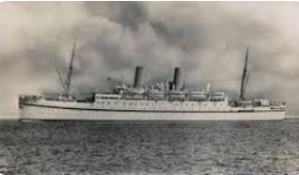  Changes made |  |  |  |  | Moving on    The Next Chapter
Hook | Letters From The Lighthouse  Poetry The Walrus and The Carpenter |  |  |  | Holes |  |  |  |  | Hetty Feather
Enrichment | Cinderella  Pantomime  Western Approaches Trip |  |  |  | The Eucharist- Church Visit  Life Education Caravan |  |  |  |  | Adventure Education
Showcase | Performance World War II assembly |  |  |  | The Eucharist- I Movie |  |  |  |  | End of Year Performance
 | Autumn |  |  |  | Spring |  |  |  |  | Summer
Reading | 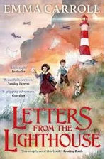  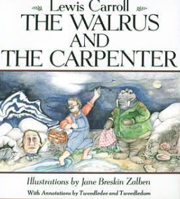  Letter From The Lighthouse  Classic poetry-Lewis Carroll |  |  |  | 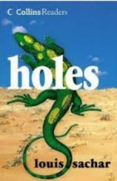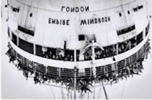  All aboard the Empire Windrush-Jillian Powell  Holes - Louis Sachar |  |  |  |  | 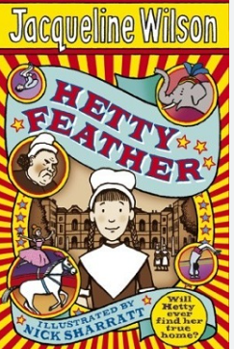  Hetty Feather- Jaqueline Wilson
 | Reading Objectives taught throughout the year
 | Word Reading  - apply their growing knowledge of root words, prefixes and suffixes (morphology and etymology), as listed in English Appendix 1, both to read aloud and to understand the meaning of new words that they meet. |  |  | Comprehension  Maintain positive attitudes to reading and understanding of what they read by:  - continuing to read and discuss an increasingly wide range of fiction, poetry, plays, non-fiction and reference books or textbooks  - reading books that are structured in different ways and reading for a range of purposes  - increasing their familiarity with a wide range of books, including myths, legends and traditional stories, modern fiction, fiction from our literary heritage, and books from other cultures and traditions  - recommending books that they have read to their peers, giving reasons for their choices  - identifying and discussing themes and conventions in and across a wide range of writing  - making comparisons within and across books  - learning a wider range of poetry by heart  - preparing poems and plays to read aloud and to perform, showing understanding through intonation, tone and volume so that the meaning is clear to an audience  Understand what they read by:  - checking that the book makes sense to them, discussing their understanding and exploring the meaning of words in context  - asking questions to improve their understanding  - drawing inferences such as inferring characters’ feelings, thoughts and motives from their actions, and justifying inferences with evidence  - predicting what might happen from details stated and implied  - summarising the main ideas drawn from more than one paragraph, identifying key details that support the main ideas  - identifying how language, structure and presentation contribute to meaning  - discuss and evaluate how authors use language, including figurative language, considering the impact on the reader  - distinguish between statements of fact and opinion  - retrieve, record and present information from non-fiction  - participate in discussions about books that are read to them and those they can read for themselves, building on their own and others’ ideas and challenging views courteously  - explain and discuss their understanding of what they have read, including through formal presentations and debates, maintaining a focus on the topic and using notes where necessary  - provide reasoned justifications for their views.
Writing | L F L Missing person description  Prediction  Diary From Olivia and CUSP  Job Description  Character similarities and Differences  Inference in Role  Summarise writing  The Walrus and the carpenter-  Newspaper Report |  |  |  | Holes Description of setting- Camp Green Lake  Information Leaflet- YSL  Narrative Madam Zeroni’s Adventure  Information Text YSL  The Windrush Generation  Non Chronological Report  Instructions  Limericks |  |  |  |  | Hetty Feather- Biography Queen Victoria  Persuasive Leaflet The Coronation  CUSP reciepes
Grammar and Punctuation | - extending the range of sentences with more than one clause by using a wider range of conjunctions  - using relative clauses beginning with who, which, where, why, whose, that or with an implied relative pronoun  - using and punctuating direct speech  - use expanded noun phrases to convey complicated information concisely  - using modal verbs or adverbs to indicate degrees of possibility  - Indicate grammatical and other features by:  - Using semi-colons and colons to mark boundaries between main clauses  - punctuating bullet points consistently  - using brackets, dashes or commas to indicate parenthesis |  |  |  | - Word classes: noun, verb, adjective, adverb, preposition, determiner, pronoun, conjunction]  - Learning the grammar for years 5 and 6 in English Appendix 2 (and revising years 3 & 4)  - Revision of expanded noun phrases and Relative clause  - using hyphens to avoid ambiguity  - Phrases, clauses, verbs  - Using and punctuating adverbials [indicating possession by using the possessive apostrophe with singular and plural nouns/ apostrophes for  - contracted forms]  - using conjunctions, adverbs and prepositions to express time and cause [verbs and tense]  - recognise vocabulary and structures that are appropriate for formal speech and writing, including subjunctive forms |  |  |  |  | - using passive verbs to affect the presentation of information in a sentence  - Past progressive, Present progressive verb forms
Spelling | Adding suffix ably (2)  Adding suffix ibly(2)  CEW e at endof words(1)  Words ending in fer(1)  CEW Remembering doubles(1)  Hyphens in words(2)  Or sound ough(2)  Ough alternative sounds(2) |  |  |  | CEW uncommon silent letters (1)  Silent letters mb (2)  Silent Letters (le) (2)  CEW uncommon Silent Letters (1)  Silent Letters kn gh 2 weeks  Silent Letters mixed (2)  Homophones (2) |  |  |  |  | Ee sound ei spelling (2)  CEW ee sound y at end (1)  Z sound s spelling (1)  Homophones(8)  CEW complex (1)
Maths | Place Value (2 weeks)  Addition, Subtraction, Multiplication, Division (5 weeks)  Fractions A (2 weeks)  Fractions B (2 weeks)  Measure(1Week)  Conversions (1 week) |  |  |  | Ratio (2 weeks)  Algebra (2 Weeks)  Decimals (2 weeks)  Fractions, Decimals, Percentages( 2 weeks)  Area , Perimeter, Volume (2 weeks)  Statistics (2 weeks) |  |  |  |  | Shape (4 weeks)  Geometry, Position and Direction (1 week)  Themes and Projects consolation  Problem Solving
RE | Unit 6.1 - Life as A Journey  Is every person’s journey the same? | Unit 6.2 - Advent  How do Christians prepare for Christmas? |  |  | Unit 6.3 - The Eucharist  Why do Christians celebrate The Eucharist? | Unit 6.3A - The Exodus  Why is the events of the Exodus so significant event for Jewish and Christian history? |  |  | Unit 6.4 - Jesus  Who was Jesus? Who is Jesus? | Unit 6.5 -Ascension and Pentecost  What is the importance of Ascension and Pentecost for Christians? |  | Unit 6.6 -God  What is the nature and character of God? |  |  | Unit 6.7 -People of Faith  How does having faith affect peoples lives?
Christian Value | Friendship | Love |  |  | Generosity |  |  | Courage |  | Perseverance |  |  | Truthfulness
Science | Electricity | Animals including humans |  |  | Light |  |  |  |  | Evolution  And Inheritance |  |  |  | Living Things
Computing | Bletchley Park  Computing Systems and Networks |  |  |  | Intro to Python  Programming |  |  |  |  | On Line Safety
History | Beyond 1066  WW2 in Locality |  |  |  | Windrush Generation |  |  |  |  | 5 Significant Monarchs
Geography | Physical Processes |  |  |  | Settlements Uk Europe and N America |  |  |  |  | N America  OS Maths Field work
Art | Drawing |  | Paint and Collage |  | Print Making  Textiles |  | 3D |  |  | Painting |  |  |  | Creative  Response
DT | Electrical Systems |  |  |  | Textiles |  |  |  |  | Food and Nutrition
PE | Netball  Dance | Football  Rugby |  |  | Mindfulness  Gymnastics |  |  | Fitness  Tennis |  | Rounders  Athletics |  |  | Outdoor Adventure  Volleyball
Music | Hey Mr Miller | Touch the Sky |  |  | Dona Nobis Pacem |  |  | Twinkle Variations |  | Race! | Exploring Identity Through Song |  |  |  | Ames au vala tara bal
PSHE | Me and My Relationships  Assertiveness Co-operation  Safe/unsafe touches  Positive Relationships | Valuing Differences Recognising and celebrating difference Recognising and reflecting on prejudice-based bullying  Understanding Bystander behaviour  Gender stereotyping |  |  | Keeping Safe  Understanding emotional needs  Staying safe online Drugs: norms and risks (including the law) |  |  | Rights and Respects  Understanding media bias, including social media  Caring: communities and the environment  Earning and saving money  Understanding democracy |  | Being My Best  Aspirations and goal setting  Managing risk Looking after my mental health |  |  | Growing and Changing  Coping with changes  Keeping safe  Body Image  Sex education  Self-esteem
MFL | I am Learning Spanish  Phonetics 1 and 2 | Presenting Myself |  |  | My Family |  |  | The Date |  | Do you have a pet? |  |  | My Home

