Year 6 Autumn Term overview 2026
English  We will be reading Star of Fear, Star of Hope where we will build on and develop our writing skills. This will be followed by the book Can We Save The Tiger.  We will explore different writing genres embedding Y5/6 spelling and grammar. We will be focussing on diary writing, newspapers, reports, dialogue and narrative.  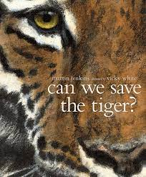.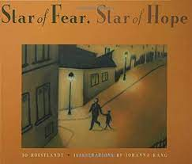 | Maths  In Maths, we will use Power Maths to spark curiosity and excitement. We want to nurture confidence in Maths. We will work on our place value skills, solve calculations and problems involving the four operations. We will work on fractions and further our work on position and direction.  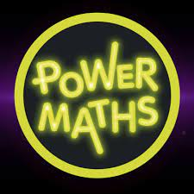 | Science  In Science, we will be looking at Forces. We will explain that unsupported objects fall towards the Earth because of the force of gravity acting between the Earth and the falling object. We will investigate the effects of air and water resistance.  We will also be exploring inheritance and evolution, and how we inherit features from our relatives.  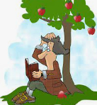  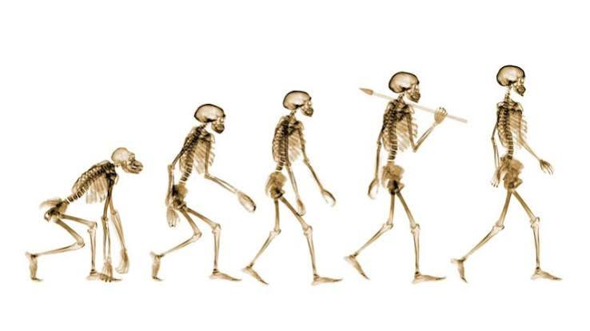 | History  We will be looking at World War II. We will learn about how the war began, key events which took place during WWII (The Blitz, D-Day), and we will also explore the social aspects of war such as evacuation, rationing and propaganda.  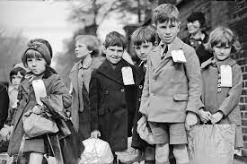
Geography  We will be investigating population. We will learn about the different population patterns across the world and compare the figures from place to place, as well as looking at how and why population changes happen..  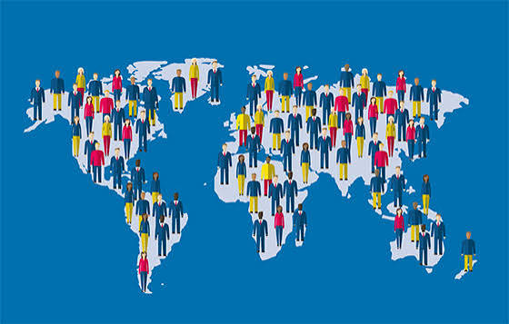 | Art  We will focus on expressing ideas. We will explore how you can make marks in expressive and varied ways on a variety of different surfaces. We will look at how different media can affect the marks we make.  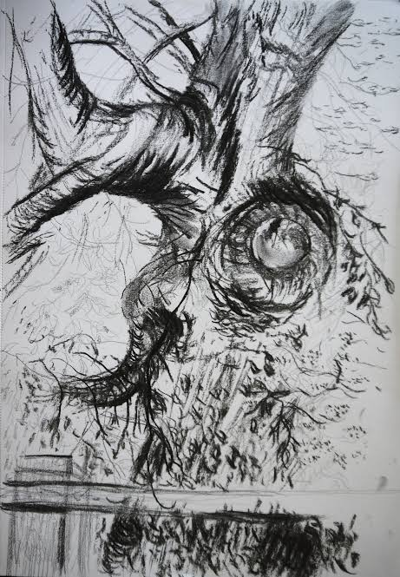 | DT  We will be using our textile skills to design and create waistcoats. We will explore existing products, decide on our target audience and then use a variety of stitches, tools and materials to create and embellish our waistcoats.  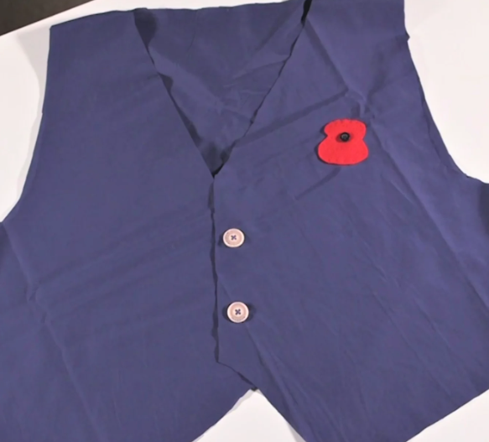 | RE  In Year 6, we will be looking at Hinduism and how people worship in the Hindu faith. The children will learn about who Brahman is and how many Hindus understand Brahman as the ultimate reality.  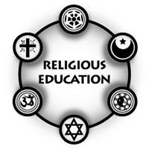
PSHE  We will be starting our PSHE curriculum with health. We will be disussing how our choices affect our health, including teeth maintenance, healthy diets and exercise.  . | Music  In Music, we will be exploring changes in pitch and dynamics. We will look at how music can transport us to different places and emotions using a range of techniques and recreate these in our own compositions..   | PE  In PE, we will be taking part in play leader training, in preparation for becoming play leaders on the playground at lunchtime. They will be leading games and working with younger children, supporting them in playing team games together.  . | Computing  We will be continuing with our units of work alongside MGL. We are exploring excel documents this term, and looking at how formulas and searches are used to explore and use Google Sheets effectively.  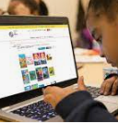
Additional information
- Practise spellings that will be given out every Monday for a test the following Monday.
- Read at home 3 times a week and record in your reading diaries. These comments can be written by your child or a parent/carer.
- Maths homework will be set each week for your child to complete.
- Please bring PE kits to school on TUESDAY and FRIDAY

