Great Moor Junior School

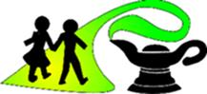

PRIVACY NOTICE – child friendly privacy notice aimed at 7-11 year olds


We are Great Moor Junior School
When you come to our school, we collect data about you to help us support you whilst you are here.
What information about me do you collect?
How we use information about you
Who we are?

Personal data is information about you. It includes things like:
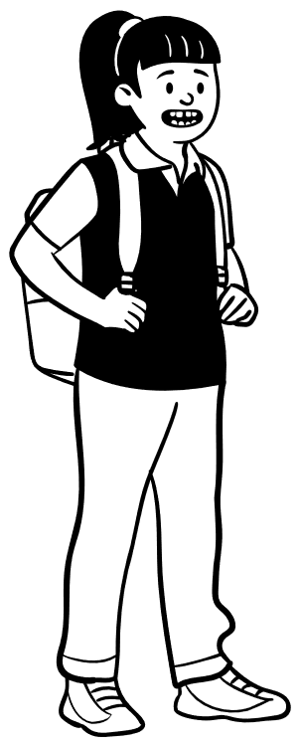
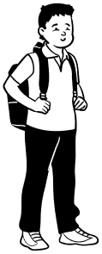
My religion
Any medication I take
Any special support I
receive

My name
My address
My date of birth
My school records

Why do you need this information?

To help you learn

To keep you safe in school

To make sure you have the right support

Because the law says we have to






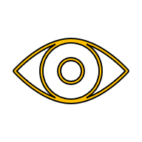
How do you keep my information safe?
Store it securely in locked cabinets and on school computers
Make sure only people who support you can see it
Only keep it for as longed as is needed

Who else can see my information?
We always ensure your data is kept safe. When you leave school, your information goes with you to the next school, or it is deleted

Your choices
Only people who work for us, or those we give permission to, can see it. These include;
- The government
- Your local council
- Health workers (like the school nurse)


You can ask us to correct any information that is wrong

You can say no to some uses (such as website photographs)
You and your parents can ask to see your information

Remember: Your information belongs to you. We use it to help you learn, stay safe and do the best we can for you while you are at school

What if I want to find out more?

Speak to the Data Protection Officer
igschoolsupport@stockport.gov.uk

If you are unhappy visit ico.org.uk/concerns
Speak to your teacher

Document Control
Title | School Privacy Notice – Child friendly
Document Owner | Information Governance – Stockport Metropolitan Borough Council
Document Status | For School Approval
Links with other policies, procedures, or guidance | IGSSPN 002 - Privacy Notice for Pupils
Target Audience | Pupils, Parents
Distribution | Website/Hard copy
File Classification | Public
Version | 1.0

Revision and Approval
Reviewed by | SMBC IG Team
Issue Date | 01/09/2026
Approved by (school) | TBC
Approval date (by school) | TBC
Next review date | 01/09/2028
Any changes made | New – Child friendly format to help children understand their privacy rights

Change History
Version | Author | Issue Date | Review date | Changes made?
V1 | SMBC IG Team | 21.11.2018 | 01.09.2026 | *New*

