Great Moor Junior School


Freedom of Information Policy

Contents

1. Introduction 3
2. Scope 3
3. Responsibilities 3
4. Requirements 3
5. Publication Scheme 4
6. Dealing with Requests 4
7. Exemptions and Exceptions 4
8. Public Interest Test 4
9. Charging 4
10. Complaints 4
Annex A - Procedure for Dealing with Requests 6
Annex B – Request Flowchart 11
Annex C – Common School Exemptions and Exceptions 14

Introduction

Maintained schools are legally required to comply with the Freedom of Information Act 2000 (FOIA) and the Environmental Information Regulations 2004 (EIR).
The Governing Body of Great Moor Junior School is defined as a public authority under Schedule 1 of the FOIA and will use all appropriate and necessary means to ensure that it complies with the legislation and associated Codes of Practice issued by the Minister for the Cabinet Office and the Secretary of State pursuant to Section 45 (5) and Section 46 (6) of the Freedom of Information Act 2000; and section 16 (4) of the Environmental Information Regulations.
The FOIA gives the public a general right to ask public authorities whether they hold certain information and, if they do, the right to be given that information, subject to certain conditions and exemptions.
The EIR regulates public access to all environmental information held by public authorities.

Scope

This policy applies to all information that is created, received or maintained by the School. It covers all types of information, regardless of format such as official documents, drafts, emails, notes, telephone and CCTV recordings, and information held by other organisations on the school's behalf.

FOIA and EIR do not deal with the collection and use of personal data, which is governed by UK data protection legislation. Subject access requests are dealt with under the Data Protection Act 2018 (DPA 2018) and not FOIA or EIR (see Data Protection Policy).

Responsibilities

The Governing body has delegated the day-to-day responsibility for compliance with the FOIA to the Head Teacher.

All staff must promptly forward requests to the designated person and must not delay because the request does not mention FOIA or EIR.

Requirements

Under the FOIA and EIR the School is required to:
- provide advice and assistance to anyone requesting information.
- tell enquirers whether or not we hold the information they are requesting (the duty to confirm or deny) and provide access to the information we hold in accordance with the procedures laid down in Annex A.

Publication Scheme

Great Moor Junior School has adopted the Model Publication Scheme for Schools approved by the Information Commissioner. The Publication Scheme is published on our website and the materials it covers will be readily available from the office or online at https://www.greatmoor-jun.stockport.sch.uk.

Dealing with Requests

The school will respond to all requests in accordance with the procedures laid down in Annex 1.

Exemptions and Exceptions

The school will consider if information requested is subject to an exemption or an exception. Most of these are listed in Annex C..

Where necessary the school will invoke the public interest test procedures to determine if public interest in applying the exemption outweighs the public interest in disclosing the information.

Public Interest Test

The school will apply the Public Interest Test before any qualified exemptions are applied. Unless it is in the public interest to withhold information, it will be released.

Charging

The school will respond to most requests free of charge, and only charge where significant costs are incurred. The school may choose to charge a fee for complying with requests for information under FOI. The fees will be calculated according to FoI regulations and the person notified of the charge before information is supplied.

Complaints

Any comments or complaints will be dealt with through the school’s normal complaints procedure. The school will maintain records of all complaints and their outcome.

If on investigation the school’s original decision is upheld, then the school has a duty to inform the complainant of their right to appeal to the Information Commissioner’s office.

Annex A - Procedure for Dealing with Requests

To handle a request for information the governing body or delegated person will need to ask themselves a series of questions. These are set out below and shown in Annex B.

Is it a request for information under the Freedom of Information Act (FOIA) or Environmental Information Regulations (EIR)?

A request for information may be covered by one, or all, of three information rights:

Data Protection enquiries (or subject access requests) are ones where the enquirer asks to see what personal information the school holds about the enquirer. If the enquiry is a Data Protection request, we will follow our existing school Data Subject Rights guidance.

EIR enquiries are ones which relate to air, water, land, natural sites, built environment, flora and fauna, and health, and any decisions and activities affecting any of these. These could therefore include enquiries about recycling, phone masts, school playing fields, car parking etc.

FOI enquiries are concerned with all other information and the reasoning behind decisions and policies. The request does not have to mention the FOI Act. An FOI request is a request for information that is not already available, made by an applicant to the school. Under Section 1 (1) of the FOIA, any person making a request for information to a public authority is entitled to be informed in writing by the public authority, whether it holds information of the description specified in the request, and if that is the case, to have that information communicated to them.

Do I have to treat EIR requests differently to FOI requests?

There are many similarities between the two regimes, including the timescales for responding to a request.
However, the EIRs do not specify that requests must be in writing, which means that telephone requests on environmental matters will also be valid (although in practice it is advisable to make a written record of any verbal requests received).
There are some differences in the way that information that is not disclosed is dealt with. FOI has a series of exemptions that can be applied, while the EIRs have a series of exceptions. There are also some differences in the way that extremely time-consuming requests are dealt with.

What information is covered by the Freedom of Information Act 2000 (FOIA) and EIR?

The FOIA and EIR covers all recorded information held by the school. This is defined in Section 84 of the Act as ‘information recorded in any form’. This includes official documents, drafts, emails, notes, telephone and CCTV recordings, and information held by other organisations on the school's behalf.

Contracts and service arrangements should require suppliers to assist the school in identifying, retrieving and preserving information needed to respond to FOIA and EIR requests within the relevant statutory timescales. The school remains responsible for determining whether information held on its behalf should be disclosed.

What information is not covered?

The FOIA and EIR does not cover information that is not held in recorded form. The school is not required to create new information to respond to a request. Additionally, the FOIA does not cover information that the school holds solely on behalf of another person, body or organisation.

Who can make a request?
Anyone, anywhere in the world can submit an request to the school. The applicant does not need to be a UK citizen or resident. FOI and EIR requests can also be submitted by organizations such as newspapers, campaign groups or even other public authorities.
What makes a request valid?
For a request to be valid under the FOIA and EIR it must:
- include the applicant's real name
- include an address for correspondence (this can be an email address)
- describe the information requested.
The FOIA also requires the request to be submitted in writing.
Requests do not need to be submitted in writing under EIR although it is good practise to keep a written record of the request.
The requester has not said their request is under FOIA or EIR. Does that mean we don’t have to deal with it as an FOIA or EIR?

A request does not have to mention ‘FOIA’ or ‘EIR’ for it to be valid. A request to a public authority for public information is still an FOIA or EIR request.
For example:
- Under the Freedom of Information Act 2000, please provide details of your payments relating to stationary for the year 17/18
- How much did you spend on stationary last academic year?
Both of the above are FOIA requests and are asking for the same information, albeit in different ways.
What if we are unsure what’s being asked for?

There may be occasions where you cannot identify the information being asked for from the request. In this case, you can seek clarification from the requester. The statutory timescale does not start until you have received this.

How long does the school have to respond to a request?
Requests under the Freedom of Information Act 2000 will normally be answered within 20 school days, or 60 working days from receipt, whichever is sooner. Requests under the Environmental Information Regulations 2004 will be answered as soon as possible and no later than 20 working days after receipt. The EIR timescale may be extended to 40 working days where a request is complex and voluminous, provided the requester is informed within the original 20-working-day period.

Are extra time limits allowed if the information is difficult to collate?

FOIA - the Act does not allow extra time for searching for information. However, if finding the information and drawing it together to answer the request would be an unreasonable burden on your resources and exceed a set costs limit, you may be able to refuse the request.

EIR - the Regulations permit you to extend the 20-working day limit to 40 working days to give you more time to answer the request. You will still need to notify the requester that you are extending the time for compliance as soon as possible, and no later than 20 working days after the date you receive the request.
Can we have extra time to consider exemptions?
No, but if the exemption is qualified you can have extra time to consider the public interest test. In doing so you must:
- identify the relevant exemption(s) before you can claim any extra time for the public interest test;
- write and let the requester know why you are claiming extra time.
Can the school charge a fee for an FOI or EIR request?
The school will normally provide information free of charge. However, reasonable charges may be applied for communication costs such as printing, copying and postage, or where permitted by the Freedom of Information Act 2000, Environmental Information Regulations 2004 and associated Fees Regulations. Any fee will be explained in writing before the information is provided
What happens if we don’t hold the information requested?

FOIA and EIR apply to recorded information held by, or on behalf of, the school, regardless of the format in which it is recorded. The school is only required to consider information that it holds at the time a request is received and is not required to create new information, provide explanations, answer questions, or give opinions where no recorded information exists.
Before you decide that you don’t hold any recorded information, you should make sure that you have carried out adequate and properly directed searches.
Where the school does not hold the information but believes that another public authority may hold it, the school should normally advise the requester to contact that authority and provide relevant contact details where possible.

In what format should the school provide the information?

The school can make information available in response to an FOI or EIR request in a number of ways, including via email, as a printed copy, or by arranging for the applicant to view the information. Normally, the information is provided to the applicant by whatever means are most reasonable. However, under Section 11 of the FOIA and Regulation 6 of the EIR, applicants have the right to specify their preferred means of communication in their initial request.

Do I always have to release information under the FOIA?

Under the FOIA and EIR there is a presumption in favour of disclosure,
However, both pieces of legislation provide ‘exemptions’ (FOIA) and ‘exceptions’ (EIR) for particular circumstances when you can refuse to provide information in response to a request.
Annex B provides you with information about common school exemptions. Schools are advised to contact the IG Team igschoolsupport@stockport.gov.uk if it thinks an exemption will apply.
What if we consider the request to be vexatious or repeated?
As a general rule, you should not take into account the identity or intentions of a requester when considering whether to comply with a request for information. However, a minority of requesters may sometimes abuse their rights under this legislation, which can threaten to undermine the credibility of the freedom of information system and divert resources away from more deserving requests and other public business.
The key question to ask yourself is whether the request is likely to cause a disproportionate or unjustifiable level of distress, disruption or irritation to the school. Bear in mind that it is the request that is considered vexatious, not the requester. If after refusing a request as vexatious you receive a subsequent request from the same person, you can refuse it only if it also meets the criteria for being vexatious.
What do we do if someone complains?
When issuing a response to a request under the Freedom of Information Act 2000 (FOIA) or the Environmental Information Regulations 2004 (EIR), the school will provide details of its internal review procedure and how it can be accessed. For requests made under the Environmental Information Regulations 2004, an internal review process is a statutory requirement and must be offered to any requester who believes the school has failed to comply with the Regulations.

An internal review will:

- be triggered whenever a requester expresses dissatisfaction with the handling or outcome of a response;
- be a straightforward, single-stage process;
- involve a fresh consideration of the request, taking account of all relevant information and evidence available at the time of the review;
- be conducted, where possible, by someone who was not involved in the original decision and who has appropriate seniority; and
- be completed within 20 working days in most cases and no later than 40 working days in exceptional circumstances.

The outcome of the internal review will be provided in writing and will explain the decision reached. If the requester remains dissatisfied, they will be informed of their right to complain to the Information Commissioner's Office (ICO).
https://ico.org.uk

Annex B – Request Flowchart

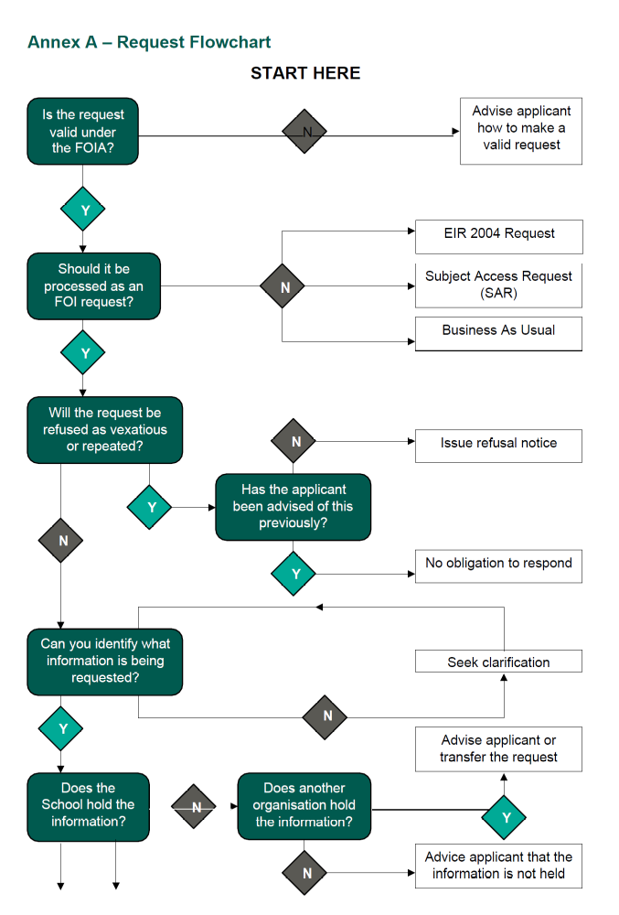
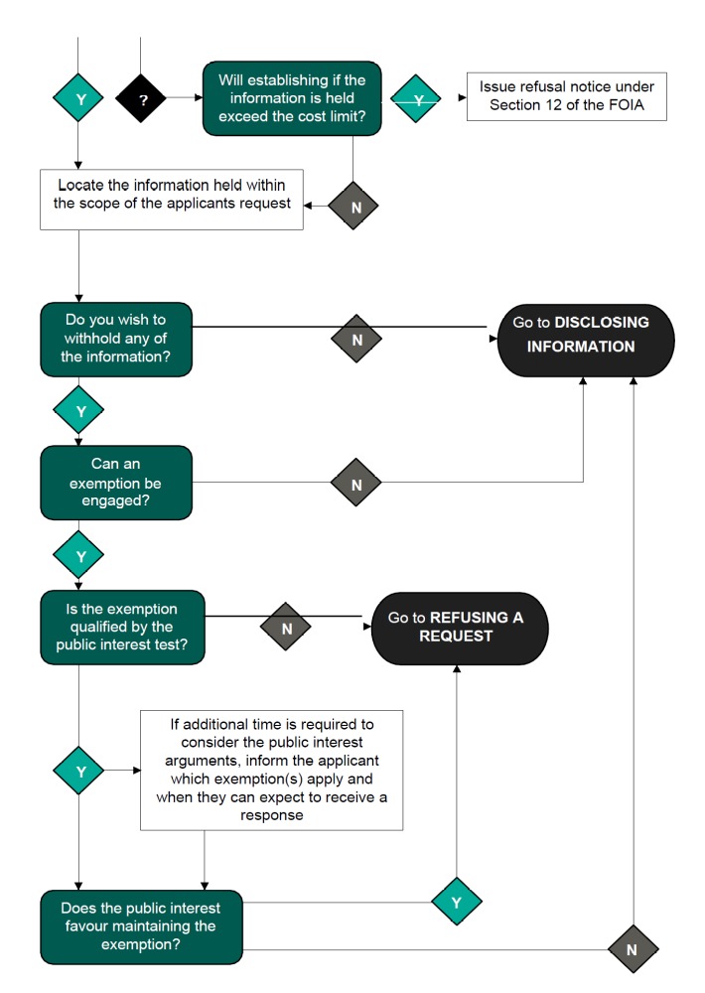
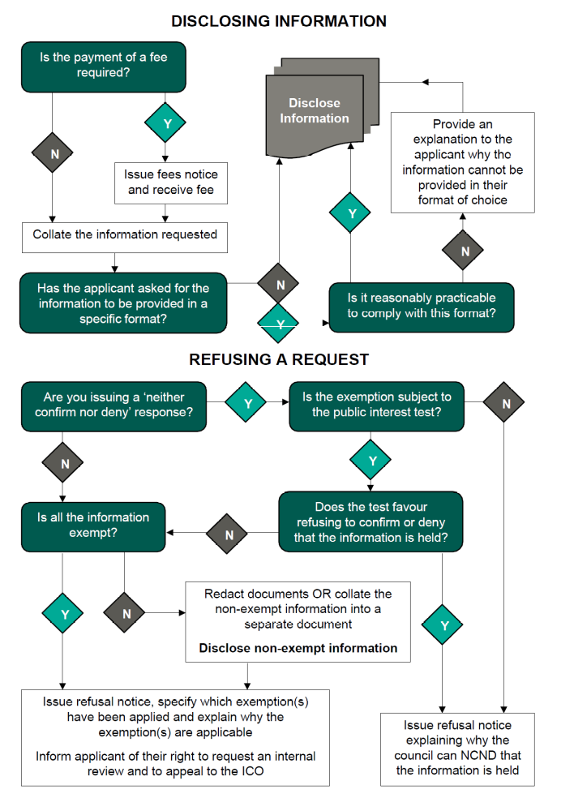

Annex C – Common School Exemptions and Exceptions

Tables below show some of the common exemptions and exceptions that may be used by schools under the FOIA and the EIR.

Freedom of Information Act

Section | Exemption Name and Description | Type | Public Interest Test required
S.12 | Appropriate time limit/cost threshold – provides an exemption from a public authority’s obligation to comply with a request for information where the cost of compliance is  estimated to exceed the appropriate limit (£450 or 18 working  hours). |  | No
S.14 | Vexatious requests – The school does not have to comply with a vexatious or repeated  request. |  | No
S.21 | Information accessible to the applicant by other means - applies if the information requested is already accessible to the applicant by other means, even if only on payment of a fee. | Absolute –  Class  based | No
S.22 | Information intended for future publication - can apply when the schools is preparing the information for publication, whether a publication date has been determined or not. | Qualified –  Class  based | Yes
S.31 | Law enforcement - can apply if disclosure of the information would be likely to prejudice law enforcement. | Qualified –  Prejudice  based | Yes
S.32 | Court records - provides an exemption for information held only by virtue of being contained in documents that are created or held for the purposes of court, inquiry or arbitration proceedings. | Absolute –  Class  based | No
S.38 | Health and safety - where complying with the request would be likely to endanger the physical health, mental health or safety of any person. | Qualified –  Prejudice  based | Yes
S.40 | Personal information – Information is exempt from disclosure if it is personal information about the requestor 40(1) or personal information about another party 40(2) | Absolute –  Class  based | No
S.41 | Information provided in confidence – Information will be covered if it was obtained from another person, its disclosure would constitute a breach of confidence, a legal person could bring a court action for that breach of confidence and that court action would be likely to succeed | Absolute –  Class  based | No
S.42 | Legal professional privilege - information may not be disclosed if it is legally privileged. The concept of legal professional privilege (LPP) protects the confidentiality of communications between a lawyer and client. | Qualified –  Class  based | Yes
S.43 | Commercial interests – Information is exempt from disclosure if it relates to a trade secret or if it is likely to prejudice the commercial interests of any legal person. | Qualified –  Class  based | Yes

Environmental Information Regulations
Section | Exemption Name and Description | Public Interest Test required
12 (4) (a) | Information not held - you should make sure you have done adequate and properly directed searches, and that you have convincing reasons for concluding that you hold no recorded information. | Yes
12 (4) (b) | the request is manifestly unreasonable - Requests may be manifestly unreasonable if:  - dealing with a request would create unreasonable costs or an unreasonable diversion of resources; and  - an equivalent request would be found ‘vexatious’ if it was subject to the Freedom of Information Act. | Yes
12 (4) (c) | the request is formulated in too general a manner - you can refuse disclosure if a request is unclear or non-specific. You should give the requester relevant advice and assistance to help them rephrase or clarify their request | Yes
12 (4) (d) | the request is for unfinished documents– information which relates to material still in the course of completion or is unfinished or incomplete does not have to be disclosed. | Yes
12 (4) (e) | the request involves the disclosure of internal communications - the purpose of this exception is to allow you to discuss the merits of proposals and the implications of decisions internally without outside interference. | Yes
12 (5) (b) | The course of justice and inquiries - You can refuse to disclose information that would adversely affect formal legal proceedings, whether criminal or civil, including enforcement proceedings. Covers a range of information, such as court documents and documents covered by legal professional privilege. | Yes
12 (5) (e) | Confidentiality of commercial or industrial information – you can refuse to disclose information to the extent that its disclosure would adversely affect the confidentiality of commercial or industrial information, where such confidentiality is provided by law to protect a legitimate economic interest. | Yes
12 (5) (f) | Interests of the person who provided the information – information can be excepted from disclosure if the interests of the person who provided the information would be adversely affected. | Yes
13 | Personal data - When information is the personal data of someone other than the applicant, regulation 12(3) requires you not to disclose that personal data, except in accordance with regulation 13. Regulation 13 prohibits you from disclosing third party personal data if this would contravene the UK GDPR or the DPA 2018. | No

Document Control
Title | Freedom of Information Policy
Document Owner | Information Governance – Stockport Metropolitan  Borough Council
Document Status | For School Approval
Links with other policies, procedures, or guidance | Publication Scheme and Guide to Information
Target Audience | School workforce, School governors
Distribution | Website, hard copy
File Classification | Public
Current Version | 2.0

Revision and Approval
Reviewed by | SMBC IG Team
Issue Date | 01/09/2026
Approved by (school) | TBC
Approval date | TBC
Next review date | 01/09/2028
Any changes made | Pg8 – changes to fees  Pg9 – changes to information held  Pg10 – Complaints/IR’s reviewed and updated

Change History
Version | Author | Issue Date | Review date | Changes made?
V1 | IG Team | 01/09/24 | 01/09/26 | New Policy

