
January 2025 Great Moor Junior School
BEHAVIOUR POLICY
This policy should be seen as an important practical and relevant document in the daily life of the school. It should, therefore, not be read in isolation but interpreted in conjunction with our Anti-Bullying and Equality Policies as well as, our School Mission Statement and our School Teaching and Learning Policy.
AIMS
We believe that 'every child has a right to learn and every teacher has a right to teach'. The aims of our Behaviour Policy are:-
- To maintain a secure and stable school environment in which effective teaching and learning can be achieved.
- To support each child in developing the values of respect, kindness, tolerance, responsivity and co-operation regardless of gender, age, race, colour religion, cultural and social background or disability.
- Ensure every child understands the importance of behaving appropriately.
We believe that these aims are best realised in the context of our school ethos with our pupils encouraged to give of their best, both in and out of the classroom.
At Great Moor we believe a positive approach of praise, encouragement, rewards and the raising of self-esteem is effective behaviour management for our learners.
OBJECTIVES
We will achieve our aims through a variety of strategies and objectives which will include:
- The application by all staff of a coherent, fair and consistent approach to discipline and behaviour throughout the school.
- The adoption of a simple code of behaviour which is easily understood by our pupils.
- The setting by staff of appropriate and acceptable standards for children to follow which include dress, attitude, punctuality and commitment.
- The creation of a positive, stimulating environment for our pupils.
- To ensure a child is aware that whilst he or she is always acceptable, it is his or her inappropriate behaviour which is not.
- To recognise the importance of the home-school partnership and that early consultation with parents is essential in order to discuss problems encountered and agree upon an appropriate course of action.
- To adopt a rewards system which acknowledges children’s achievements.
BEHAVIOUR
Acceptable Behaviour – conforms to the reasonable expectations of the school community. It shows mutual respect for the needs and aspirations of everyone. It involves caring for the whole school environment and the reputation of the school.
Unacceptable Behaviour – is to be seen when individuals behave in a way that prevents their own development and where conduct disrupts the process of teaching and learning for themselves and others and lowers the reputation of the school.
In seeking to build a positive school, we see several elements as essential to our policy:
- An agreed school policy for effective teaching and learning which aims to create a harmonious learning environment.
- School values which are known and accepted.
- Acknowledgement of those children who keep to the school values.
- Deliberate teaching to develop self-discipline and personal responsibility.
- Correction of behaviour that is outside the school values, including appropriate sanctions when necessary
SCHOOL VALUES
A Value is a principle that guides our thinking and our behaviour. At Great Moor Juniors, every individual is valued for who they are and what they contribute to the school. Values are intended to support the personal, social and spiritual development of every pupil throughout the school. We have high expectations of all our children, encouraging them always to do their best regardless of their gender, ethnicity, additional needs or beliefs.
The values were selected after consultation with our school community and are ones we deem to be important throughout life. The whole staff team, parents and pupils are involved in promoting our values and recognising where others are ‘living the values’. These are the values that our pupils felt represented our school the best:
- Respect
- Kindness
- Tolerance
- Responsibility
- Co-operation
These will be prominently displayed within each classroom and around school.
THE BENEFITS OF POSITIVE SCHOOL BEHAVIOUR
At Great Moor Junior School we believe that because staff, pupils and parents value positive behaviour, there are benefits for all in the daily life in our school.
Children
- Learn what good behaviour means.
- Learn to respect each other in a safe, secure and fair-minded environment
- Learn the value of friendship
- Develop self-esteem and self-confidence
- Achieve the highest standards in all their school work and have opportunities to take part in a wider range of activities
Staff
- Can teach effectively without lessons being constantly disrupted
- Can work to meet the varied needs of all children
- Can develop personally and professionally and see the home school partnership strengthened.
Parents
- Are secure in the knowledge that their children are happy and safe in school, growing personally, socially, spiritually, culturally and academically, emotionally,
- Know that their children will receive constructive support when they need it and feel welcome in the positive atmosphere of our school.
PROCEDURES FOR MAINTAING GOOD BEHAVIOUR
Maintaining good behaviour will be achieved through: -
- A positive approach, highlighting appropriate ways to behave.
- Having a clear set of school values which are communicated fully to pupils and their parents.
- Using a system of rewards recognising children's efforts and successes in behaving well, including for example; certificates, badges, notes home, 'cup of the week' as well as lots of praise and verbal recognition.
- A set system of sanctions to deal with unwanted behaviour including warnings and missing playtimes.
- Making use of PSHE lessons, school assemblies and the 'hidden curriculum' to promote appropriate behaviour.
SANCTIONS
We recognise that the vast majority of our pupils are well-behaved and contribute greatly to the positive atmosphere within our school.
Nevertheless, for a small minority of our pupils, we are aware that clearly understood sanctions may be necessary on occasions when praise and reward strategies prove ineffective. It is important children know that they are under supervision, that checks are made, and that there is an expectation from each child of behaviour which meets our school values. Please see sanctions at the end of this policy.
At playtimes/lunchtimes:
- Isolate from group for stipulated period
- Refer to Senior Midday Supervisor, Deputy Headteacher or Headteacher
If behaviour is unacceptable in extra-curricular activities a warning should be given and if behaviour does not improve then the pupil will not be allowed to attend the activity.
MANAGING SERIOUS BEHAVIOURAL DIFFICULTIES
Pupils whose behaviour presents serious problems for the school, in terms of, harming the education welfare of themselves or others in school, will be managed through the following as necessary:-
- Liaison with parents.
- A pastoral support/behaviour support programme/appointing a key mentor.
- Further sanctions, which may include: loss of privileges, 'report' forms, debarment at lunchtimes/breaks, extra-curricular activities and events, internal exclusion or exclusion from school (short term and/or permanent).

EXCLUSIONS
If a pupil's behaviour leads to exclusion, fixed term or permanent, we will follow the guidelines provided by Stockport MBC and parents will be informed of actions taken. Unacceptable behaviour which might result in exclusion includes - repeated misbehaviour, serious disruption, refusal to do as staff ask, fighting, verbal abuse towards staff or other pupils, physical violence, bullying, theft, racism, vandalism, damage to property and drug-related incidents.
PARENTAL INVOLVEMENT
Where significant concerns are raised by staff or another pupil’s parents then the child’s parents will be contacted.
- Parents’ contribution may throw more light on problems behind the misbehaviour
- This helps provide consistent action between school and home
- Class teacher/Parent emails or home/school book may be set up after discussion – can be daily or weekly for a set period
Where behaviour outside school (on visits, matches, swimming, etc) is unacceptable the child’s parents will be asked to discuss this with the child’s teacher and agree the action to be taken.
Where a child’s behaviour at lunchtime is persistently unacceptable, the school may exclude the child for the lunchtime period following appropriate prior notification to parents by the Headteacher or Deputy Headteacher or internal lunchtime exclusions may take place.
Where inappropriate standards of behaviour continue to be exhibited by the child the Headteacher or Deputy Headteacher, in consultation with the child’s parents may seek the involvement of the LA Educational Psychologist or LA’s Inclusion team to provide specialist guidance and counselling.
CARE CONTROL AND PHYSICAL RESTRAINT OF PUPILS
It is recognised that situations may occur when a member of staff decides that physical intervention may become necessary to restrain an individual pupil or pupils. Such situations will be in line with the DFE Restrictive interventions, including use of reasonable force, in schools guidelines.
Key points from this document are summarised below for our staff:
Before Intervening
- Evaluate the situation and where necessary and where possible obtain help from another member of staff to initially assist with the situation and thereafter be a witness
- Every effort should be made to de-escalate the situation by remaining calm, knowing what to say, responding rather than reacting, staying in control
Circumstances Justifying Physical Intervention
On occasions when teachers and other persons who are authorised by the Headteacher to have control or charge of pupils, may use such force as is reasonable in circumstances:
- where action is necessary in self defence or because there is an imminent risk of injury to self, the pupils or others.
- where a pupil is behaving in a way that is compromising good order and discipline or damaging property.
Application of Reasonable Force
There is no legal definition of “reasonable force”. It will always depend on all the circumstances. The use of force can be regarded as reasonable if:
- it is used for the minimum length of time to achieve its objective
- it is used as a last resort
- the degree of force must be the minimum necessary taking into account the age and size of the child and in proportion to the incident and seriousness of the behaviour or the consequences it is intended to prevent
Lawful methods of reasonable force might involve:
- physically interposing between pupils
- blocking a pupil’s path
- holding
- leading a pupil by the hand or arm
- shepherding a pupil away by placing a hand in the centre of the back
- in extreme circumstances using more restrictive holds
Authorised Staff
The Headteacher has authorised all the school’s employees to use reasonable force whenever deemed necessary, in accordance with the circumstances outlined in this policy.
Recording Incidents
If for any reason staff use force to restrain a pupil it is important that the Headteacher or Deputy Headteacher is informed immediately and that the member of staff involved completes a written Physical Intervention Reporting form (RPI). This may help alleviate any misunderstandings or misrepresentation of the incident and will be helpful evidence should there be a complaint from a parent or pupil. Parents will also be informed if a pupil has had to be restrained.
Seclusion
Seclusion (where a pupil is confined to a place away from others and prevented from leaving) will only be used as a safety measure to protect the child or others from harm when a pupil is experiencing high levels of emotional or behavioural dysregulation. The pupil will be supervised at all times during the period of seclusion. The use of seclusion will be recorded and reported to parents.
BULLYING AND RACIAL INTOLERANCE
The school is committed to ensuring that pupils are taught the importance of treating others properly, and bullying is not acceptable. We aim to minimise the incident of bullying. If incidents occur we will deal with them as soon as possible and as fairly as possible, supporting both the victim and the bully as appropriate (see Anti-Bullying Policy).
SEXUAL HARMFUL BEHAVIOUR
Sexual harassment and sexually harmful behaviour will not be tolerated in school. This can happen between children of any age. All staff are encouraged to have a ‘it could happen’ here attitude and to deal with and report/record an issue as they would with all behaviour incidents. It is essential that all victims are reassured that they are being taken seriously and that they will be supported and kept safe.
MANAGING THE SCHOOL BEHAVIOUR POLICY
The way our teaching and support staff conduct their relationships within school will inevitably influence the children and we should always provide good role models in this respect. Staff and Governors should be aware that:
- The Senior Leadership Team will encourage and support our staff in their efforts to implement this policy.
- Behaviour related incidents will be recorded on CPOMs and serious incidents will be brought to the attention of the Senior Leadership Team.
- Parents will be contacted when necessary.
- The Headteacher will discuss with new intake parents our expectations of children’s behaviour in school, based on our agreed policy.
- The Senior Leadership Team will be available to discuss with teaching and support staff concerns about the behaviour of individuals and groups of children.
- Class Teachers will always be responsible for the behaviour of their pupils in the normal course of their duties, with recourse to the Senior Leadership Team.
- This policy will be reviewed annually and revised as necessary by the Headteacher and Deputy Headteacher in consultation with the staff and School Governing Body
RESTORATIVE APPROACHES
- It is a firm belief that there is a reason behind all behaviours that are shown. At Great Moor Junior School when dealing with any behavior issues we adopt a restorative approach. This promotes active thinking about how we build our relationships, how we work to keep healthy and how we can repair them when there has been conflict. It is important that children realise that all actions have an impact on those around them. At Great Moor we aim to equip children with the strategies to repair conflict.
SANCTIONS
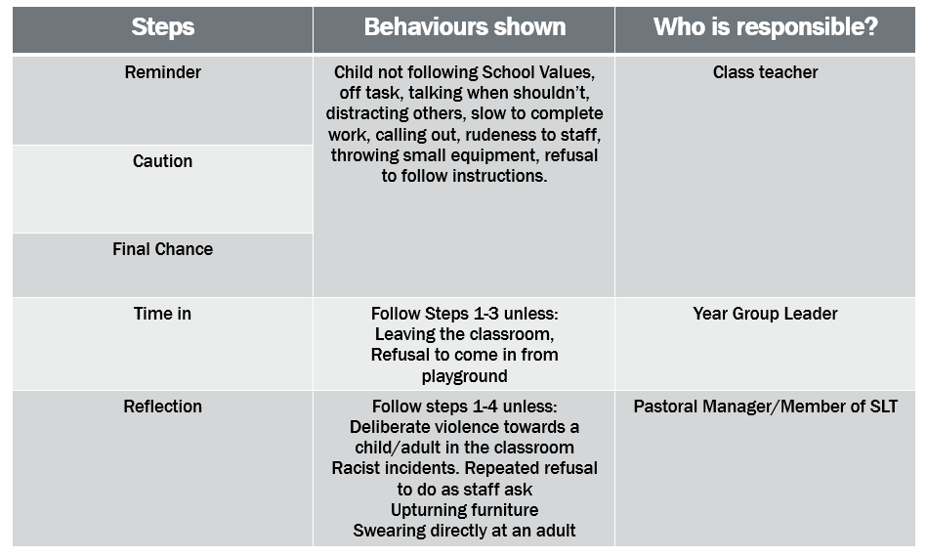

BEHAVIOUR LADDER
Step 1 | Reminder given to the child and name put in a closed clipboard
Step 2 | A caution is given to the child and child is spoken to by classteacher. Their name is ticked inside the clipboard.
Step 3 | The child is given a final chance. The classteacher will speak to the child about their behaviour and what the next steps are if it continues.
Step 4 | Time in. The child will be taken immediately to have some time in with the Year Group Leader. After the child has completed their time in they will then have a follow up discussion with the Year Group Leader and classteacher.
Step 5 | 15 minute period of reflection with Pastoral Manager/member of Senior Leadership Team issued at lunchtime or breaks to reflect on their behaviour. Discussion will take place around which of the School Values they are not adhering to. At these sessions a decision will be made by the member of the Pastoral Manager/Senior Leadership Team as to whether the behaviour warrants being placed on report. Parents to be informed as necessary.
Step 6 | If a child has been placed on report and then receives further reflections the Pastoral Manager/Senior Leadership Team will meet to discuss if internal exclusion procedures need to be applied.
Step 7 | If a child has received an internal exclusion and is subsequently placed on report again then the Pastoral Manager/Senior Leadership Team will meet to discuss if internal/external fixed term exclusion procedures should be applied.

