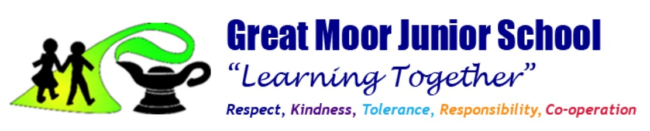

September 2025

GREAT MOOR JUNIOR SCHOOL FUN CLUB

SPECIAL EDUCATION NEEDS AND DISABILITY (SEND) POLICY

Aims

• To provide a safe, welcoming and secure environment for children out of school hours.
• Help children to develop responsibility for themselves and their actions and to become competent, confident, independent and cooperative individuals.
• Encourage children to have a positive attitude and respect for both themselves and other people.
• Promote a positive relationship with parents/carers and work in partnership with them to provide high quality play and care for their children.

Inclusion

The facility seeks to remove any barriers to participation that could hinder or exclude pupils with SEND, aiming to meet their needs in a positive and proactive way. The LA’s Primary Inclusion Service supports the facility in this.
The school is a single storey building with access for children with a physical disability.

The Management of SEND

The facility endeavours to ensure that the appropriate provision is made for any pupil who has been identified as having special educational needs.
It is parent’s responsibility to inform Fun Club of their child’s SEND needs.

The Head teacher and SENCO of Great Moor Junior School will liaise with the manager of Fun Club each term to review the SEND provision and make reasonable adjustments where necessary.

Members of staff in Fun Club will work holistically to deliver high quality provision to meet the needs of children and young people with SEND and to ensure that the facility is accessible to all pupils. They will maintain a consistent approach by ensuring that all staff are aware of a child’s specific needs and will develop and maintain a partnership and high levels of engagement with parents.

Behaviour Management

Our Club recognises the importance of positive and effective behaviour management strategies in promoting children’s welfare, learning and enjoyment. We help children to develop a sense of caring and respect for one another and to build co-operative relationships with children and adults. We support children to develop a range of social skills and to help them learn what constitutes acceptable behaviour. We endeavour for children to develop confidence, self-discipline and self-esteem in an atmosphere of mutual, respect and encouragement.

We reserve the right to refuse a child who fails to meet these standards. If the behaviour of the child is unacceptable for the safe and efficient running of the club, parents will be informed of this by a member of the school’s senior leadership team.

Identification
The SEND Code of Practice defines Special Educational Needs as the following:

“A child or young person has SEN if they have a learning difficulty or disability which calls for special educational provision to be made for him or her.

A child of compulsory school age or a young person has a learning difficulty or disability if he or she:
• has a significantly greater difficulty in learning than the majority of others of the same age, or
• has a disability which prevents or hinders him or her from making use of facilities of a kind generally provided for others of the same age in mainstream schools or mainstream post-16 institutions”

The Code of Practice divides SEND into four categories:
- Communication and interaction (CI)
Children and young people with speech, language and communication needs (SLCN) have difficulty in communicating with others. This may be because they have difficulty saying what they want to, understanding what is being said to them or they do not understand or use social rules of communication. The profile for every child with SLCN is different and their needs may change over time. They may have difficulty with one, some or all of the different aspects of speech, language or social communication at different times of their lives.

- Cognition and Learning (CL)
Support for learning difficulties may be required when children and young people learn at a slower pace than their peers, even with appropriate differentiation. Learning difficulties cover a wide range of needs, including moderate learning difficulties (MLD), severe learning difficulties (SLD), where children are likely to need support in all areas of the curriculum and associated difficulties with mobility and communication, through to profound and multiple learning difficulties (PMLD).

- Social, Mental and Emotional Health (SMEH)
Children and young people may experience a wide range of social and emotional difficulties which manifest themselves in many ways. These may include becoming withdrawn or isolated, as well as displaying challenging, disruptive or disturbing behaviour.

- Sensory and/or Physical Needs (SP)
Some children and young people require special educational provision because they have a disability which prevents or hinders them from making use of the educational facilities generally provided. These difficulties can be age related and may fluctuate over time. Many children and young people with vision impairment (VI), hearing impairment (HI) or a multi-sensory impairment (MSI) will require specialist support and/or equipment to access their learning, or habilitation support.

Behaviour difficulties are often a result of underlying issues and do not necessarily mean that a child has a SEND and should not automatically lead to a pupil being registered as having SEND.

Complaints Procedures
Complaints from parents of children with SEND concerning the provision made at the facility are dealt with in the way of all Fun Club complaints (please refer to the Fun Club Complaints Procedure). Parents may also contact the Independent Advice and Support Service (IASS) and the Authority’s Disability Discrimination Policy for further advice of their own involvement and actions open to them.

In-Service Training
In-Service training for all staff is co-ordinated by the Headteacher in conjunction with the SENDCO and, where applicable, outside agencies.

