
Great Moor Junior
School
Knowledge Organiser
Year 6

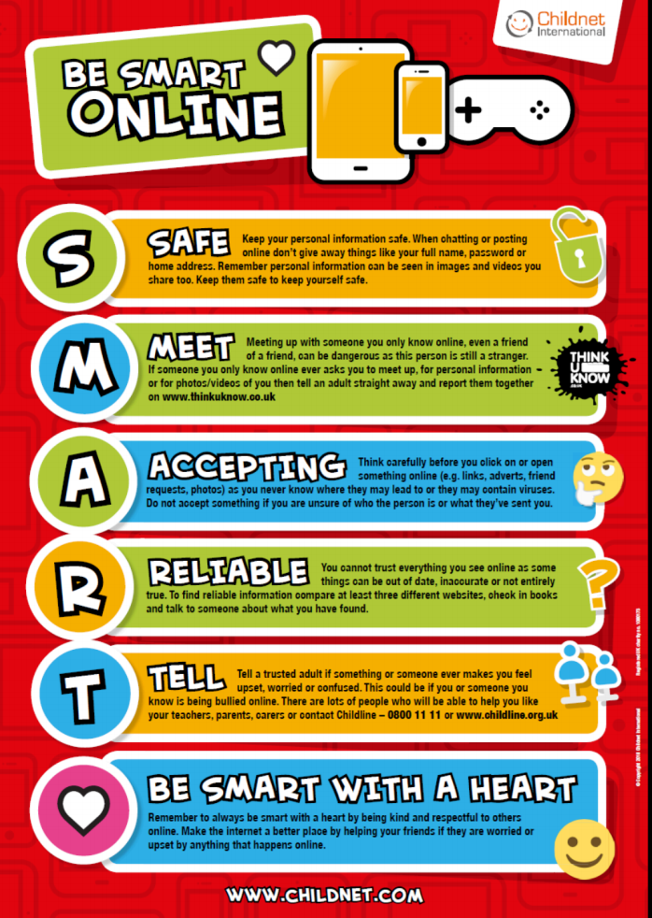

Year 6 Autumn1 : Websites

Computing Focus: Digital Literacy
What they should know from Years 3,4 and 5: Searching the world wide web, making videos, using presentation software
In this unit we will create a web page, adding text, images and hyperlinks;
changing the appearance and position of these; and embedding content
Key Knowledge, vocabulary and skills
HTML HyperText Markup Language. It marks the content up into different
types, sections or structures, like paragraphs, blocks, lists, images, tables,
forms, comments etc. It has start and end tags for each of these and some basic ways to present these sections.
CSS Cascading Style Sheets tell the browser how each type of element should be displayed, which may vary for different media (like screen, print or handheld
device). It gives a lot more control and variety over presentation of web pages
Tags Mark the beginning and end of sections in HTML. e.g., <p> the start of a paragraph and, </p> the end of a paragraph
Components of a web page
Site name: the name of the whole site
Headers: four types of header in Google Sites and it will appear on that page: Layouts: various template layouts in to which you can put text images sound etc Footer: whatever you put there appears on every page of your website
Hyperlinks: Links one page to another on a web site or to another website’s page or pages
Navigation Path: By default , the pages you add to your Site will automatically
appear in the Navigation bar and show the path from one page to another on your website to enable visitors to navigate from one page to another easily
Embed content Add content from another website
A home page (or homepage) is the main web page of a website.
Subpages Other pages (than the home page) on your web site

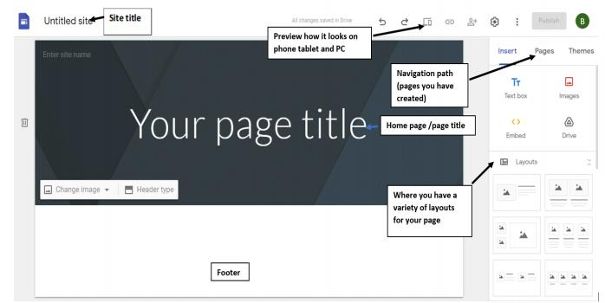

Online safety / E-safety
Focus on Privacy and security to help identify scams and phishing.

Year 6 Autumn 2: Using spreadsheets to organisedata

Computing Focus: Data
What they should know from Years 3, 4 and 5: data, questionnaires, collecting data, presenting data in graphs, bars charts etc.
In this unit we learn about using a spreadsheet to create totals and averages and solving a problem. We will use Google Sheets too.
K K l d b l d kill
ey now e ge, voca u ary an s s
Excel spreadsheet layout
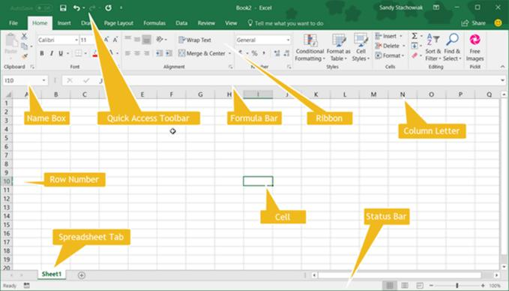
Data | It can be letters, words, numbers, dates, images, sounds, etc. It needs a context to turn it into information otherwise it has little meaning to humans e.g., 03.09.20., blue.
Information | This is data that has been processed so that it refers to  something and so people can read, understand, and use it, e.g. date started school 03.09.12. Colour of eyes: blue.
Formula | A formula is an equation e.g., 4 + 6 = 10 that calculates data in your spreadsheet. They are entered into a cell in your spreadsheet.  They begin with an = sign.
Cell | A cell is a rectangle in the spreadsheet, They each have a name: co umn etter an row num er e. . B6  l l d b g

Online safety / E-safety
Focus on Online Bullying: (linked to anti-bullying week) help to report online bullying in different contexts.

Year 6 Spring 1: Modelling the Internet

Computing Focus: Understanding Technology (Communication and Networks)
What they should know from Year 3, 4 and 5:learnt about Local Networks and devices that link up a local network
In this unit we deepen knowledge of the Internet and how it works
Key Knowledge, vocabulary and skills
Search Engines Examples are Bing, Duck DuckGo, Google Chrome etc. They all have different algorithms for searching and so come up with different results. Their
algorithms will include how web crawlers create an index and how pages are ranked. Some search engines rely on advertisers and this affects the order of results.
An Index in a non-fiction book allows us to quickly locate something. Indexes for search engines are ordered (e.g. alphabetically), which helps us to find what we’ re looking for quickly and efficiently.
Selection explains which web pages a search engine displays.
Ranking explains the order in which they are displayed. Points are given depending on where a word is placed. eg. the algorithm might give more weighting (points) if the
word searched for is in the title.
Routers are devices that get information to where it needs to be across the internet
Internet protocol (IP) address. An IP address is a label which is used to identify devices on a computer network. IP addresses are usually written as a set of numbers in a given order. All we see is the web address beginning www.
Servers are computers set up locally to provide services to a LAN. Or setup to provide internet services, such as the world wide web, e-mail or online games.
Packets If your computer sends a request to a web server for an image, the request is sent in a ‘packet’ . A packet is like a virtual parcel that has lots of information
attached to it. The most important information is the IP address of the web server the image is stored on and the IP address of your computer.
Cyber security deals with online threats e.g. hacking and keeping your data secure
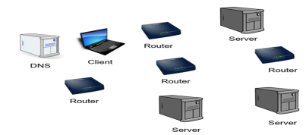 | Devices you might come across when modelling the internet.

Online safety / E-safety
Safer Internet day. Focus on online reputation and describe ways that regulate age-related content (e.g. PEGI, BBFC, parental warnings etc.)

Year 6 Spring 2: Kodu
What they should know from Years 3, 4 and 5 sequence, algorithm, debugging, repetition (loops), selection, variables.
Links to coding in Year 5: · can use repetition (loops) in a program/can refine my program after testing it
In this unit: introduced to Kodu software as a programming environment and evaluate its features and how it works
Object-Oriented Programming Language
The programming language in Kodu is based on image tiles and utilizes a simple “When...Do” conditional statement to instruct the object what to do and when to do it. Although importing content from outside sources is not possible (only the objects that are available in the game are able to be programmed, which
somewhat limits creative aspects), the commands that can be programmed are quite dynamic. There are more than 20 different types of objects that can be programmed to move, respond to other things in the environment that they can see or hear, talk to other characters, and express emotions. Instructions that are higher in the list do take priority over statements that are lower in the list, but statements can be coupled to the same “When” clause by indenting the line.
http://educade.org/teaching_tools/kodu
Kodu uses in its programming, a condition is something that must be true in
order for something to happen. A condition is thus said to "evaluate to true" or "evaluate to false." In Scratch, any block whose label says "if," "when," or
"until" is a sort of conditional construct.
.Key Knowledge, vocabulary and skills
Computing Focus:  Computer Science |  |  |  | Programming with Kodu  Comparisons with Scratch
Key Knowledge
Prior learning | In Key Stage 2, children build on skills and extend their mastery of computers, as both  user and creator. The computing curriculum aims to make children computationally aware, teaching them concepts (how to predict and analyse results, how to break a problem down into parts, how to spot and use similarities and how to evaluate) and approaches to help  them problem-solve.
Sequence |  |  | In Kodu any series of instructions that can be run/executed.
Selection/Condition  In Scratch  Events    Selection:  If… then  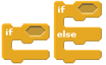 |  |  | Examples in  Kodu  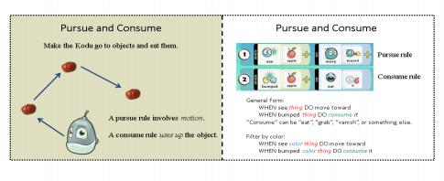
Repetition /loops   |  |  | When using Kodu you will notice the lack of repetition commands. This is due to the nature of the Kodu programming environment. In Kodu when the program is run, all the commands are triggered to run all the time as though each command is running as a forever loop waiting for its condition to occur.
Variable  A Variable is used to hold values and strings (that can change) and these can be in Scratch and Kodu displayed.  In Scratch  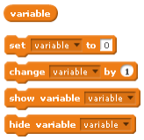 |  |  | Examples in Kodu  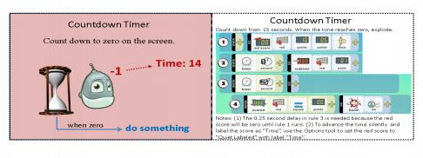
Key Vocabulary |  |  |  |  | Possible experiences
tinkering  sequence  algorithm  debugging  repetition / loops |  | decomposition  logical reasoning  selection  variable  executing/running a program |  |  | Tinkering with Kodu  Using the Kodu tutorials  Reading a game in Kodu programming language  Planning and creating a game in Kodu  Creating a game with at least one variable in Kodu

Online safety / E-safety
Focus on Self-Image and Identity: to describe issues online that could make anyone feel sad, worried, uncomfortable or frightened

Year 6 Summer 1: BBC Micro: bits

Computing Focus: Computer Science
What they should know from Years 3, 4 and 5 sequence, algorithm,
debugging, repetition (loops), selection, variables, decomposition, MakeCode, and flashing programs
Links to Micro:bits in Year 5: we used sequences, repetition, selection and variables utilising - the micro:bit.
In this unit we will again use and build further upon sequences, repetition, selection and variables utilising - the micro:bit and Scratch. We will build and
test a number of projects linking Scratch to the micro:bit
The links below will be used during lessons:
How to link your micro:bit to Scratch guide
Microbit/ Scratch join projects link
Key Knowledge, vocabulary and skills
MakeCode | Programming language for the BBC micro:bit (similar to Scratch)
flashing  programs | The code that is initially created on a website and then clicking on ‘download’ moves it to the local machine in the form of a .hex file. Flashing occurs when the code is copied to the micro:bit (a device you will see on your computer or iPad).
Emulator | Is used to test your program and see how it will appear
program  flow  flow chart | Example of flow chart for shaking the micro:bit using algorithm to the left.
program  flow  flow chart | 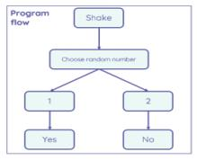 | 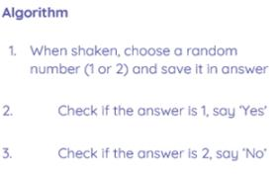

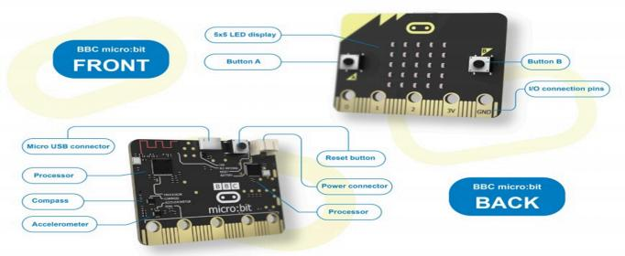

Online safety / E-safety
Focus on Health Well-being and lifestyle to explain the ways in which anyone can develop a positive online reputation

Year 6 Summer 2: Code Cracking

Computing Focus: Digital Literacy (IT and E-safety) and Using technology
What you should know from Year 3 4 and 5: using iMovie, creating algorithms, PowerPoints and using effective searching
In this unit we will crack a code. Use effective searching. Learn about Alan Turing. Create a storyboard and plan a presentation.
Key Knowledge, vocabulary and skills

Algorithm | An algorithm is a sequence of instructions that are followed to complete a task. Computers need the algorithm to be translated into code which the computer will then follow to complete a task. This code is written in a programming language. There are many different types of programming languages e.g. Scratch. For more information:https://www.bbc.com/bitesize/articles/zqrq7ty
Debug | Computer programmers sometimes make mistakes when writing  their code. These mistakes are known as “ bugs” . An important part of programming is testing your program and 'debugging ' (removing the bugs).https://www.bbc.com/bitesize/articles/ztkx6sg
Alan  Turing |  | Alan Turing was a British mathematician. He  made major contributions to the fields of  mathematics, computer science, and artificial intelligence. He worked for the British  government during World War II, when he  succeeded in breaking the secret code Germany used to communicate.
Code | A code is a system of rules to convert information—such as a letter or word - into another form of letters, numbers or  numbers, sometimes it is done to make the message secret.
Enigma  machine | 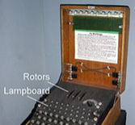 |  | Enigma was a device used by the German  military command to encode strategic  messages before and during World War II.

Online safety / E-safety
Focus on copyright and ownership. We assess and justify when it is
acceptable to use the work of others. And give examples of content that is permitted to be reused and knowhow this content can be found online.

