Great Moor Junior
School
Knowledge Organiser
Year 5

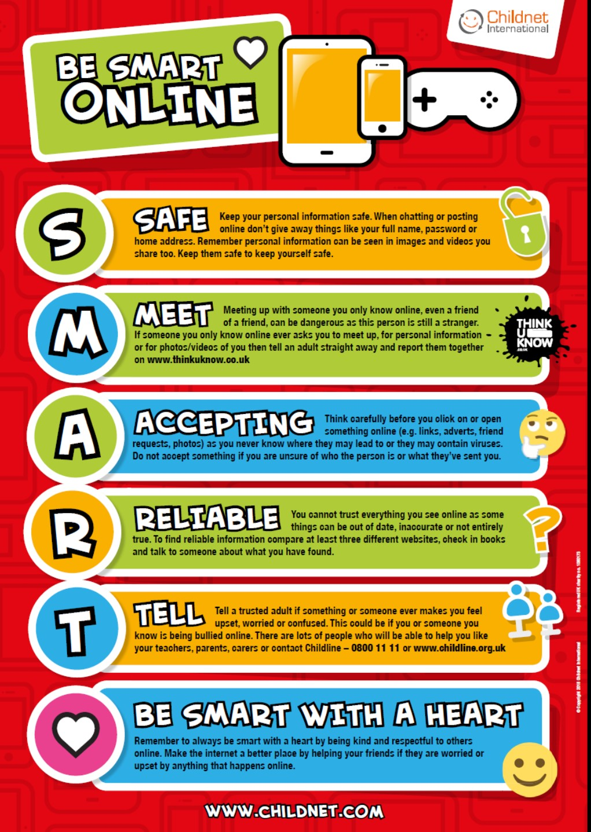

Year 5 Autumn 1: presenting about the Vikings
Computing Focus: Networks, Searching and Computer Science
What you should know from Year 3 and 4: sequence, algorithm, debugging, executing/running a program, repetition, loops and decomposition and filming. In this unit we will improve our search skills. Make an animation about the
Vikings. Use a green screen. Make a presentation based on my work in history

Key Knowledge, vocabulary and skills
Green screen:the green coloured background you want to make transparent and remove from your shot to be replaced by a background of your choice.
Exclude words from search: When searching put a - in front of a word you want to leave out. For example, jaguar speed -car.
Exact Search: put a word or phrase inside quotation marks (speech marks). For example, "tallest building".
Using PowerPoint and Google slides The Tool bar where you can insert: music /sounds to slides; hyperlinks ; moving graphics; animation; and video
Scratch 3 layout
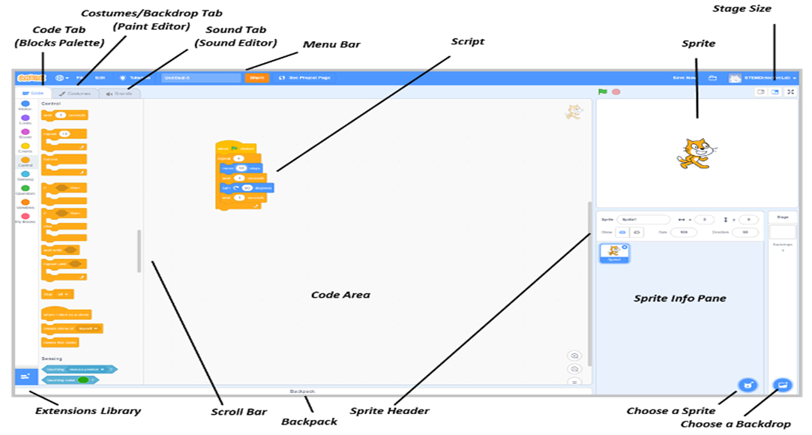

Online safety / E-safety
Focus on Privacy and security consider what responsible choices should be made when sharing things related to identity online.

Year 5 Autumn 2: Using selection to create a maze game in Scratch
Computing Focus: Programming with Scratch
What they should know from Years 3a, 3b,4a and 4b: sequence algorithm repetition (See Year 3 and Year 4 Knowledge organisers)
In this unit we read a program and predict what will happen. Create a simple maze game and then a more complex game, with at least one variable

Key Knowledge, vocabulary and skills
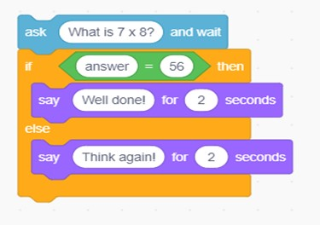
Selection is where in programming, a computer executes one or other set of instructions according to whether a particular condition is met e.g. if the answer is right then get a reward, otherwise (else) the answer is wrong. You can use this in a game so the player inputting data can either be correct or else incorrect.
Selection gets your programs to make decisions. So, if one thing happens then do another, or else if it doesn’t do the first thing, then do something completely different.

If… then
 If…then…else
Logical reasoning: Understanding the algorithm or program so that you know what should happen when the program is run (executed) and if it doesn’t run as expected you know why from looking at the algorithm or program why it is not running the way it should.
computer program: It is a set of instructions (algorithm) that has been turned into a computer code that performs a task when run by a computer.

Online safety / E-safety
Focus on Online Bullying: (linked to anti-bullying week) identify a range of ways to report concerns and access support both in school and at home about online bullying.

Year 5 Spring 1: Flat File databases
Computing Focus: Data and information
What they should know from Years 3a, 3b, and 4: collecting and presenting data, using data loggers
In this unit we get to understand, create and use flat-file databases.

Key Knowledge, vocabulary and skills
Record: it refers to the rows of field data. (See picture below).
field: it is the columns of data. (See picture below)
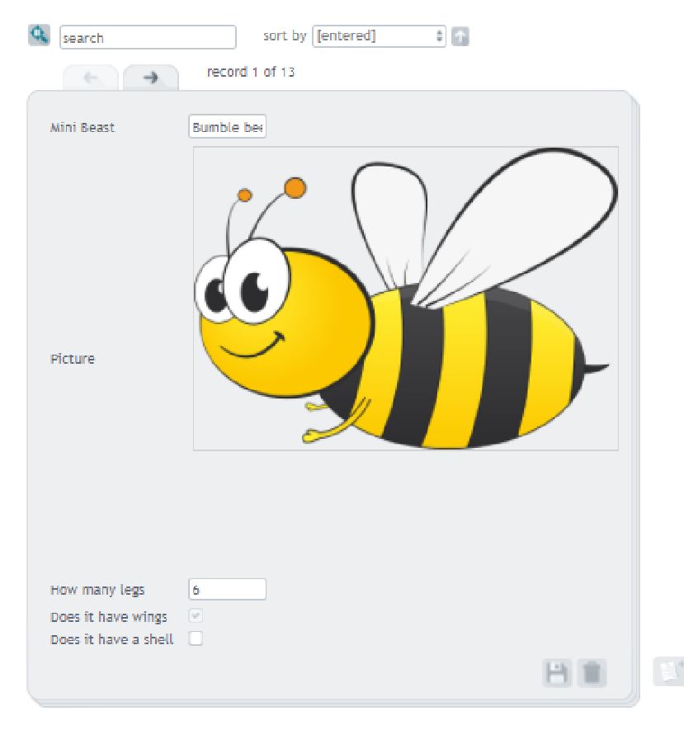
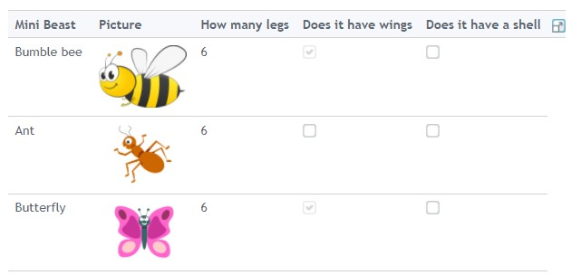
database: it is a collection of data that is stored in a computer and that can easily be used and added to.
To the right is an example of a database.
You can see the first record with various fields. Below is the table from which it comes from with its rows and columns and values for each.
sort and group Use search button and drop down boxes to help sort and group data.
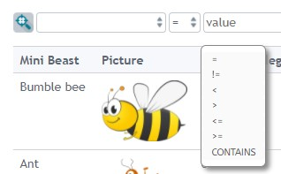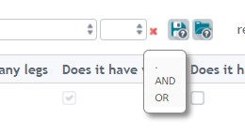
(All images from https://www.j2e.com/data/examples/minibeasts )
Online safety / E-safety
Focus on Self-Image and Identity: consider what responsible choices should be made when sharing things related to identity online.

Year 5 Spring 2: Video Editing
Computing Focus: Multimedia
What they should know from Years 3, 4 and 5 to have used a camera/video before, used iMovie, including Green screening.
In this unit we will develop our knowledge and skills with videoing and filming using iMovie. For more details go to
https://support.apple.com/en-gb/guide/imovie-ipad/welcome/ipados
Or https://sway.office.com/IS1ZebW7uFo6qYhr

Key Knowledge, vocabulary and skills
Capture video |   Location on the device to record video. Create button -to create a new movie or trailer project, or tap an existing project to see information about the project and options for editing, playing, and sharing it.
Capture video |  Play button - To preview a selected template, tap the Play button below the viewer
Capture video | Hold the device to record in landscape
Capture video | Press stop/start button to end recording
 | You can change the volume or speed of a voiceover
Transitions | Movement from one piece of media to the next.
Trimming Tool | Allows you to shorten or lengthen a photo in your movie. (see below the scissors icon)
Put effects on |   To apply effects to a section of video or to delete a section of video. iMovie includes effects that can change the way your clips look. If you want a particular look, use a preset filter like B&W (black and white) or Sepia. And for any photos in your iMovie project, you can adjust the Ken Burns effect that sweeps across and zooms in and out on the image.  Tap a video clip in the timeline to select it.  Then tap one of these buttons to  apply an effect.  Tap the Actions button to show the Ken Burns effect controls in the viewer.

Online safety / E-safety
Focus on Health Well-being and lifestyle We can describe ways technology can affect healthy sleep and can describe some of the issues.

Year 5 Summer 1: : BBC Micro: bits
Computing Focus: Computer Science
What they should know from Years 3, 4 and 5 sequence, algorithm, debugging, repetition (loops), selection, variables and decomposition
In this unit we will use sequences, repetition, selection and variables utilising the micro:bit. We will build and test a number of projects with the micro:bit. Key Knowledge, vocabulary and skills
MakeCode | Programming language for the BBC micro:bit (similar to Scratch)
flashing programs | The code that is initially created on a website and then clicking on ‘download’ moves it to the local machine in the form of a .hex file. Flashing occurs when the code is copied to the micro:bit (a device you will see on your computer or iPad).
Emulator | Is used to test your program and see how it will appear
program flow flow chart | Example of flow chart for shaking the micro:bit using algorithm to the left.  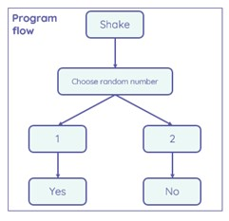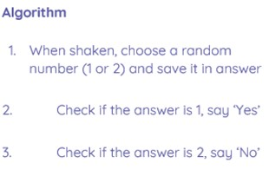
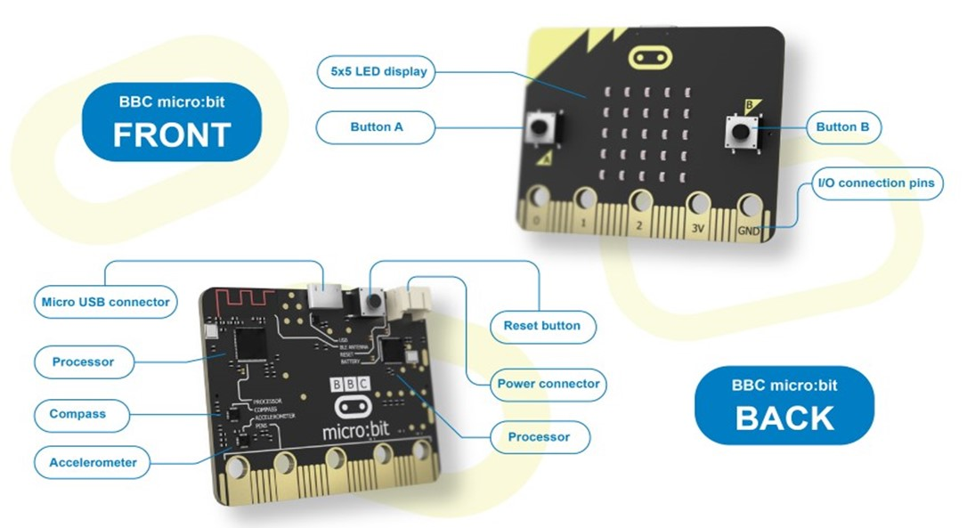
 | 
 | 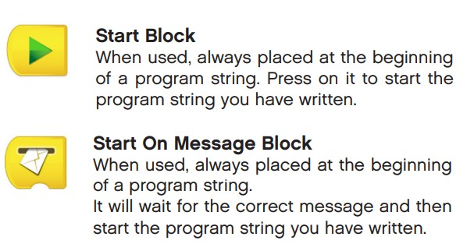
 | 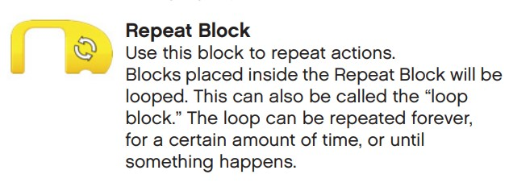

Online safety / E-safety
Safer Internet day. Focus on online reputation can describe ways that information about anyone online can be used by others to make judgments about an individual and why these may be incorrect.

Year 5 Summer 2: Introducing variables to create Maths games
Computing Focus:Computer Science
What they should know from Years 3a, 3b, 4a, 4b and 5 :sequence,
algorithm, bug, debugging, computer program, executing/running a program, repetition loops and decomposition
In this unit we will create a simple Maths game and then one with variables

Key Knowledge, vocabulary and skills
Selection | See autumn 2
Event blocks |   These start Scratch to start running a program by setting a triggering moment, e.g. clicking the green flag, pressing the spacebar etc.
repetition:  loops |     It is a set of actions or events that are repeated either a number of times or forever.
variable | 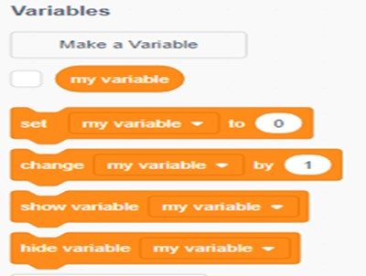  A variable is a changeable value (it can change as the program runs). Variables only hold one value at a time. These values can be either numbers or strings — any text.  Variables are found in variable blocks in Scratch, which you create.  This enables the computer program to count down the game or score points. To find dout more  https://www.bbc.co.uk/bitesize/topics/zkcqn39/articles/zw3dwmn
strings | Strings are sequences of letters and numbers
Online safety / E-safety
Focus on Copyright and ownership: We assess and justify when it is acceptable to use the work of others. And give examples of content that is permitted to be reused and know how this content can be found online.

