Great Moor Junior
School
Knowledge Organiser Year 4

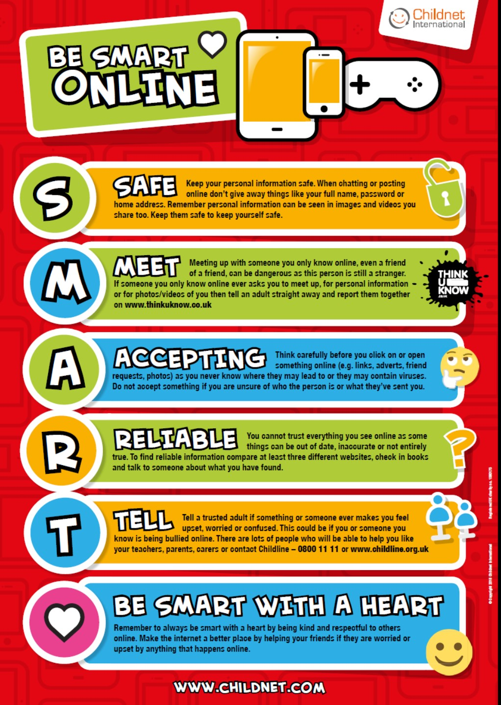

Year 4 Autumn 1: Creating Wikis
Computing Focus: Digital Literacy (IT and E-safety) and
Using technology
What you should know from Year 3: Searching with keywords. Using Word to create simple documents, Use iMovie for filming and photos. Used a website for uploading work. Used a mouse, use a keyboard, copy and paste
In this unit we use the internet to search the World Wide web safely and develop the use of wikis and word processing skills to communicate information
Key Knowledge, vocabulary and skills
Search the World Wide web through the Internet using key words and child friendly websites :
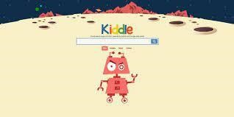 Kiddle https://www.kiddle.co/
 Swiggle https://swiggle.org.uk/

DK Findout
https://www.dkfindout.com/uk/
The  Internet | An interconnected network made of computers connected to each other around the world.
Search | Search technology is any tool that can look for websites you want to find.
web browser | Finds and displays pages from the World Wide Web, Examples of browsers are: Safari, Google Chrome, Internet Explorer, Edge etc.
Wiki | A wiki which is a website that allows users to contribute and modify its content individually and collaboratively. It is named wiki after a Hawaiian word meaning "quick." The most famous wiki is Wikipedia.

Online safety / E-safety
Remind about BE SMART rules
Focus on Privacy and security ways to improve your privacy and security when online

Year 4 Autumn 2: Programming with MSW Logo using Repetition
Computing Focus: Computer Science
What they should know from Year 2: sequence, algorithm, bug, debugging In this unit we learn about creating algorithms and using Logo to create programs to implement them
Key Knowledge, vocabulary and skills
Vocabulary and skills | Examples in Logo
Algorithm  An algorithm is a precise set of ordered instructions, which can be turned into code | Here is an example of an algorithm: Right turn 90 degrees, forward 10 steps, right turn 90 degrees (code below)
Turtle Home position  (centre of screen for Turtle) | 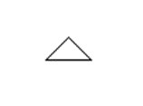
Debugging Finding and correcting errors in your code. | Commands typed incorrectly  e.g. rt90; no space between rt and 90
Sequence is a specific order for a set of instructions. | A sequence in Logo.  RT 90 FD 10 RT 90 FD 10
Repetition a sequence that is repeated a number of times | ⭐⭐⭐🌙🌙⭐⭐⭐🌙🌙 here the sequence is repeated twice
Repetition in an algorithm  Repeat 3 times: Draw ✳♡  Draw ♡ | output is ✳♡♡✳♡♡✳♡♡
Count controlled loops (Repetition) These repeat the loop a number of times | The number after repeat is the number of times to repeat the code. The code to be repeated is in square brackets. e.g. repeat 4 [FD 100 LT 90]
Decomposition breaking down a task into smaller, more-manageable parts. | In Logo breaking the code sequence into chunks or snippets
Procedure is a code snippet that is given a name and can be reused in programming. | When creating a procedure in Logo, the word ‘TO’ is typed, followed by the procedure name, e.g. TO SQUARE.

Online safety / E-safety
Focus on Online Bullying: (linked to anti-bullying week) To know about different media in which you can be unkind. Bullying online is the use of technology to upset, threaten, embarrass or target another person regularly.

Spring 1: Investigating data using data logging
Computing Focus: Collecting and presenting data
What they should know from Year 3:data and information, collected and
presented data as a bar chart, inputs, outputs
In this unit we learn about collecting and presenting data
Key Knowledge, vocabulary and skills
data It is a collection of numbers, words and symbols gathered by observation, questioning or measurement e.g. yes, no, 5, 7. cheese etc. , measurements, observations or just descriptions of
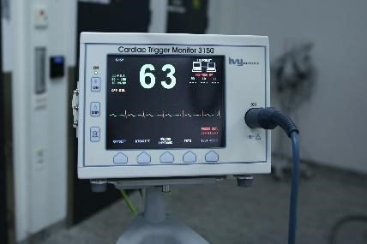
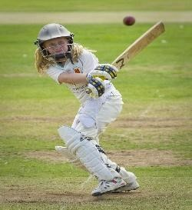
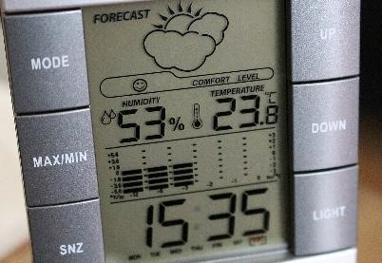
E.g. the values for health: temperature, heart rate; sport: number of runs; weather:
rainfall, wind speed etc.
information is where data is presented in graphs, sentences etc. so that it makes sense and tells the reader something about the data. Data = 17 can become “The temperature is 17 degrees C .”
Weather
Day | Summary | Temperature (°C) | Rainfall (mm)
Sunday | Sunny | 21 | 0
Monday | Partly cloudy | 17 | 0
Tuesday | Overcast | 16 | 2
Wednesday | Overcast | 15 | 1
data set data attribute data value
The entire table is a data set.
The headings of each column is the data attribute.
The answers in the columns are the data values .
data logger | 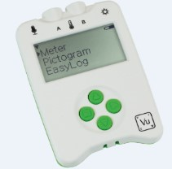  A digital device that can collect data from sensors over time and store it. Data loggers can collect data about brightness of light, temperature, and loudness of sound etc.
data point | The moment data is collected by a sensor/data logger. Each moment is datum (singular of data).

Online safety / E-safety
Safer Internet day. Focus on online reputation to know that some information about anyone online could have been created, copied or shared by others.

Spring 2: Programming games in Scratch using Repetition
Computing Focus: Computer Science
What they should know from Year 3 Autumn 2, Summer 1 and Year 4:
sequence, algorithm, bug, debugging, loops, count controlled loops
In this unit we read and use count controlled loops and infinite loops in Scratch
Key Knowledge, vocabulary and skills
 | Examples in Scratch
Algorithm  An algorithm is a precise set of ordered instructions, which can be turned into code | 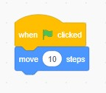  When the user clicks on the green flag, the sprite moves by 10 steps from its actual location. The code will be
Sequence is a specific order for a set of instructions. | The above code is in a specific order to be run through when the program is executed.
Execute  Makes the program run. | Using any of these event blocks will start a program  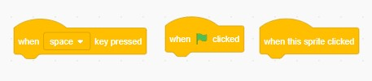
Count controlled loops  (Repetition)  These repeat the loop a number of times.  Forever loop (Repetition) These repeat the loop forever. | 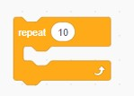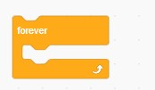
Wait blocks are used in many projects. A common use is with animation  Hide block  Show block | 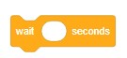
Online safety / E-safety Focus on Self-Image and Identity:

Summer 1: Photo Editing
Computing Focus: Multimedia
What they should know from Year 3 to have used a camera before.
In this unit you will learn how to use a camera and photo editing software
Key Knowledge, vocabulary and skills
Main features of image editor: paint.net | 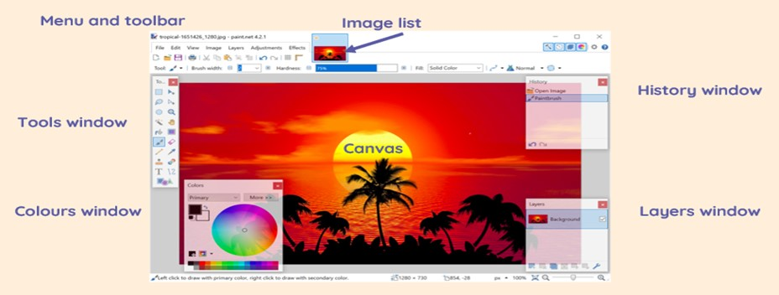
Cropping | Remove the outer layers of a picture is called cropping
image effects to use | 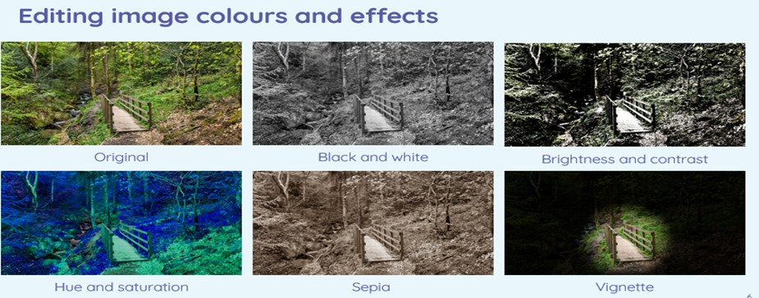
some tools to use:  clone stamp, recolor, magic wand | 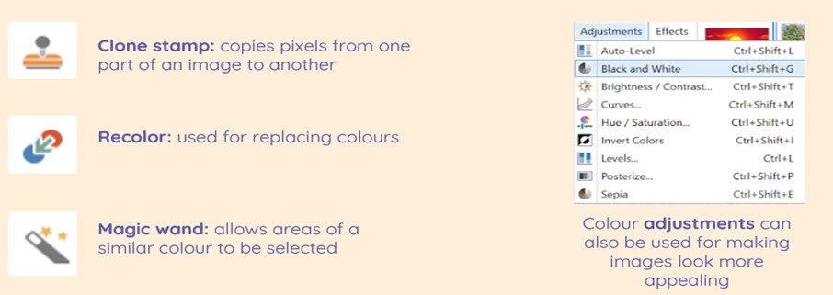
Online safety / E-safety
Focus on Health Well-being and lifestyle: Looking at the effects of using technology, especially online and computer games on our moods and feelings

Summer 2: The Internet and Networks
Computing Focus: Networks
What they should know from Year 3: local networks
In this unit we will understand more about networks and how the Internet is a network; where it is; and how it relates to web pages.
Key Knowledge, vocabulary and skills
A local network connected by a router to other networks | 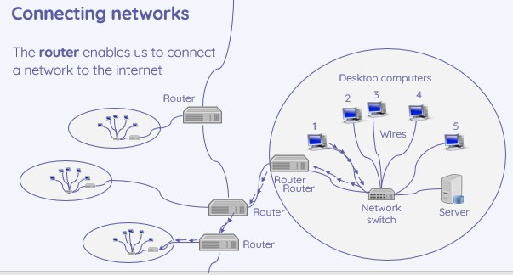
The global network that forms the Internet (physically connected) and linked by cabling under the sea | 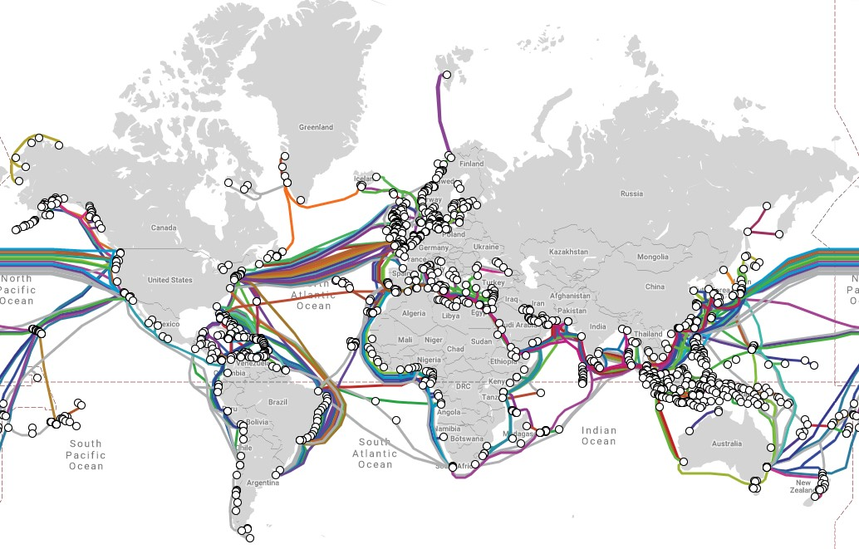
web browser | It lets you look at web pages (pages created and held on computers) and then found by searching the Internet. Examples of web browsers: Chrome, Safari, Edge, Firefox
domains and websites: | domain website address that ends .gov is a government website domain website address that ends .sch.uk is a school or college domain website address that ends .fr is a website from France domain website address that ends .com is a company

Ownership of content online | In most cases, copyright of any material is owned by the creator of that material.
Creating content online | Some websites enable you to create content e.g. Scratch, Chrome Music Lab and YouTube .  But others e.g BBC Newsround, only lets you view or listen to content.
(all images from NCCE plans)

Online safety / E-safety
Focus on Copyright and ownership To begin to find out about what you can and can’t reuse from the internet because of who owns the content.

