Great Moor Junior
School
Knowledge Organiser
Year 3

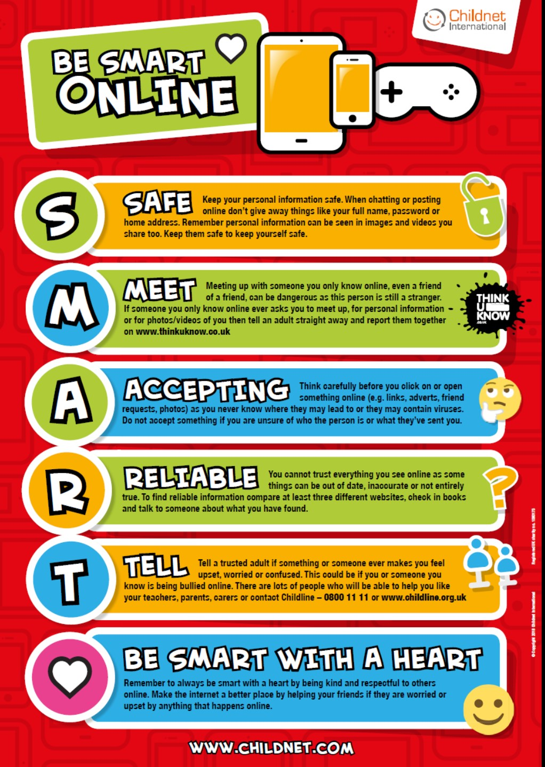

Year 3 Autumn 1: Creating a document about my world
Computing Focus: Computing Focus: Digital Literacy
What you should know from Year 2 Use a mouse, use a keyboard, copy and paste, edit text
In this unit They will be using the internet to search the World Wide web safely.
Using a word processing app: both Word and Google Docs
Key Knowledge, vocabulary and skills
Layout of Word
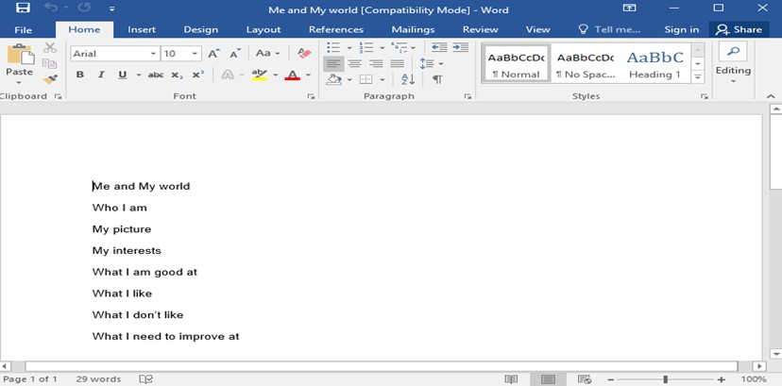
Layout of Google Docs

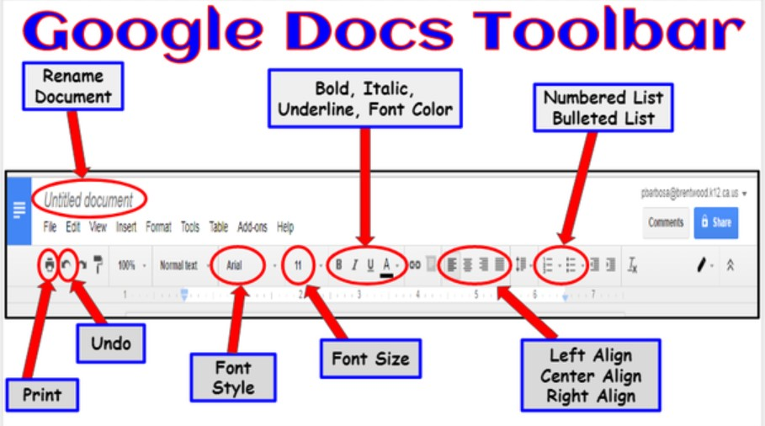
Word processing is a computer program to input, edit, format, and output a text, often with additional features e.g. insert photos and other features Examples we use are Microsoft Word and Google Docs.
Some of the key features of Word
 | The B makes the text Bold. The I writes the text in Italics. The U underlines the text.
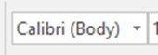 | This will change the font (style) of the text.
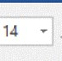 | This changes the size of the text. .
 | The text colour tool. It allows you to change the colour of the text.
 | The undo tool reverses the last action or actions that you did. Great way to correct mistakes. Helps get it back to how your document looked like before.
 | Clicking this enables you to insert pictures from our network, your saved picture or the internet. If you can’t get pictures from the internet this way go the Google images and save.
 | Quick save icon. Use once you have saved your document once as “Save as”
Use keywords to find age appropriate websites, e.g. use the phrase “for kids”, “for children”
Online safety / E-safety
The BE SMART rules (knowing how to stay safe when using the internet)

Year 3 Autumn 2: Introduction to Programming with Scratch
Computing Focus:Computer Science
What they should know from Year 2: algorithm, bug, debugging
In this unit we learn about reading and creating a simple sequence based on an algorithm. And sequence the way fossils are created. E-safety
Key Knowledge, vocabulary and skills
Scratch is a website and app that lets you code your own stories, games and animations.

Programming:A set of instructions for computers to follow. Scratch is a program that we can use to program (code) stories, games and animations. We can use event and action blocks to make sprites carry out actions e.g. move 10 steps.
Algorithm: A set of instructions to perform a task e.g. to sequence movements, actions and sounds.
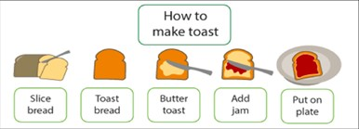
A sequence is a particular order for instructions. Sequence-based algorithms are made from a precise set of instructions. For example: how to make toast.
Sprites: they are either user-created, uploaded, or found in the sprites’ library. They are the objects that perform actions in a project. You can use sprites to trigger a sound or music. The cat is a sprite.
Stage: The stage is the background of the project. It can have scripts, backdrops and sounds.

Event blocks are used to start an action or sequence of actions, e.g. the green flag being clicked. They are needed for every project.
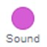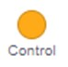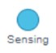Action blocks make the sprite move, make sounds and change appearance (costume).
Debug Bugs are errors in algorithms and code. Debugging is the process of finding and fixing these.
See screen below to show where each of the above are in Scratch
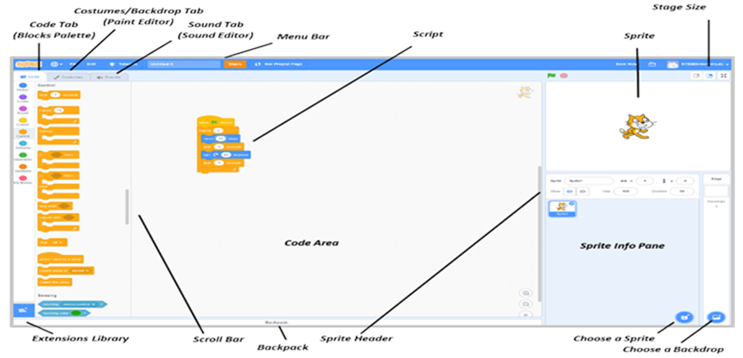

Online safety / E-safety
Focus on Online Bullying: (linked to anti-bullying week) Know examples of online bullying and how to act when it happens.

Year 3 Spring 1: Sandwich Party (collecting data and using iMovie)
Computing Focus: Data and Multimedia
data is a collection of numbers, words and symbols gathered by observation, questioning or measurement e.g. yes, no, 5, 7. cheese etc.
information is data presented in graphs, sentences etc. and tells the reader something about the data. Data = cheese can become information “12 of the class like cheese sandwiches.” Go to: https://www.mathsisfun.com/data/data-graph.php to create
iMovie is a video/filming editing software application found on an iPad
Projects browser displays all of the movie and trailer projects on your device.
 Create button - to create a new movie or trailer project, or tap an existing project for editing, playing, and sharing it
 Play button - preview a selected template, tap the Play button below the viewer
storyboard used to create a trailer outline allows you to edit names and credits
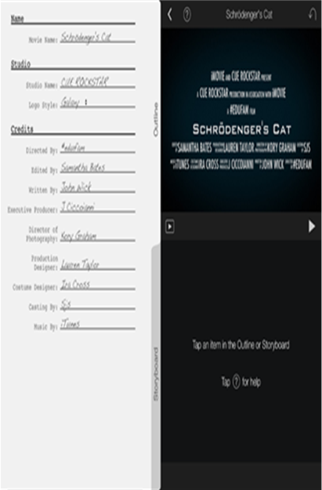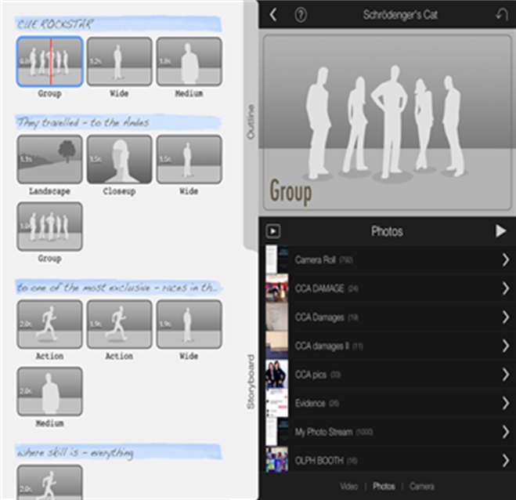
What they should know from Year 2 data and word processing
In this unit we create a Fact File about sandwiches; create a bar chart; and then film and use iMovie and Trailer.
Key Knowledge, vocabulary and skills

Online safety / E-safety
Safer Internet day. Focus on online reputation. I can explain the need to be careful before sharing anything personal when online and know what I should share.
Year 3 Spring 2: Understanding digital devices and connecting computers
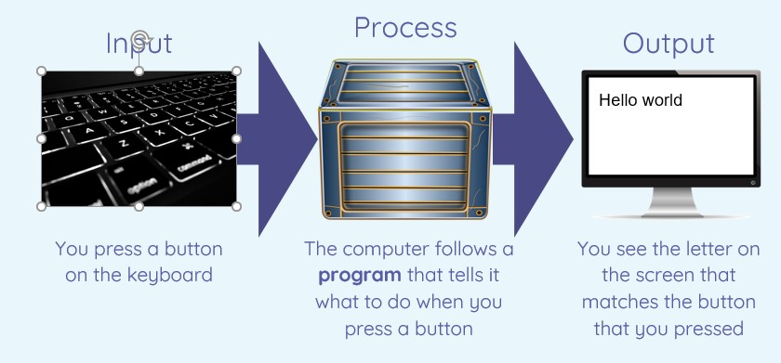
computer is an input- process -output machine
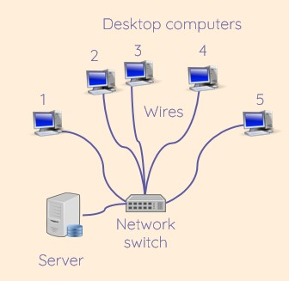
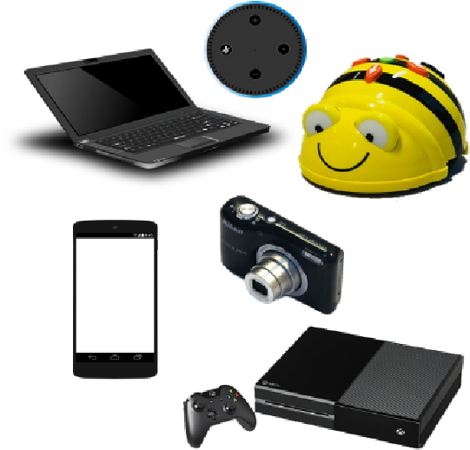
digital devices and a network
There are lots of examples of digital devices. Can you spot all the ones below?
(all images from NCCE Year 3
Connecting Computers)
input is what a computer receives to be processed e.g., through a keyboard, microphone or a touch screen. https://www.bbc.com/bitesize/articles/zx8hpv4
process is what computer software does with the input.
Computing Focus: Networks and Devices
What they should know from Year 2 There are computers and different devices In this unit we will look at digital devices and focus on inputs, processes, and outputs and how some devices link to computer networks.
Key Knowledge, vocabulary and skills

Online safety / E-safety
output is what a computer sends out after the process, usually through some sort of hardware having been processed e.g. a monitor screen or a speaker.
https://www.bbc.com/bitesize/articles/zx8hpv4
Examples of input and output devices and the device that processes
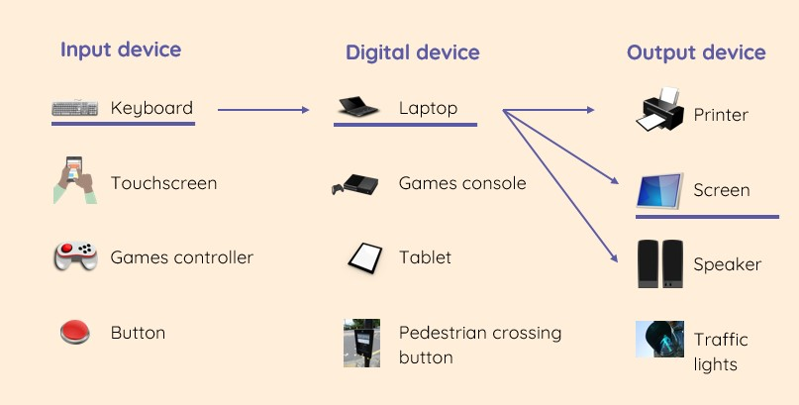
Focus on Self-Image and Identity: explain how people can represent themselves in different ways online.

Year 3 Summer 1: Events and Actions with Scratch
Computing Focus: Computer Science
abulary and skills
For algorithm, sequence, Event Blocks and Action Blocks, debug and the Scratch screen see autumn 2. Go back and read again.

To add extension Click on this icon bottom left of screWhatthey should know from Year 2 and 3 sequence, algorithm, bug, debugging
In this unit we will use
Key Knowledge, vocen.
And then a new page appears and click on pen for all the different pen blocks to appear. 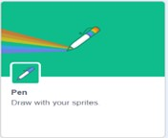
Online safety / E-safety Focus on Health Well-being and lifestyle

Year 3 Summer 2: Branching databases
Computing Focus: Data and information
What they should know from Year 2 and Year 3 some knowledge of data, information and pictograms
In this unit we get to explore and create a branching database structure and explain the information shown in a pictogram and a branching database. Key Knowledge, vocabulary and skills
j2data An online computer program to help us to create a branching database.
Branching database used to identify objects, people, animals etc. within sets of data. They are useful when we want to classify those objects by their attributes
(characteristics).
Creating a branching database First, you need to select which objects you would like to use in your database e.g. minibeasts. You can then type in ‘yes’ or ‘no’ questions to help sort out your objects. Add as many questions as needed until all of the objects, people, animals etc., are sorted out.
Yes or No Questions You create questions that need a yes and no answer. For example “Has it wings?” Yes or No?
Structure of a branching database needs to be good. And to do that you need to make sure that the yes or no questions are good. “Has it got 3 letters in the word?” is not good about a fly. But “Has it got wings?” is a good question, as it identifies the attributes or characteristics of the fly.
Presenting data as information Data can be presented in many ways as pictograms or bar charts. Branching database diagrams are best used to identify different types of living things.
A finished database in j2data
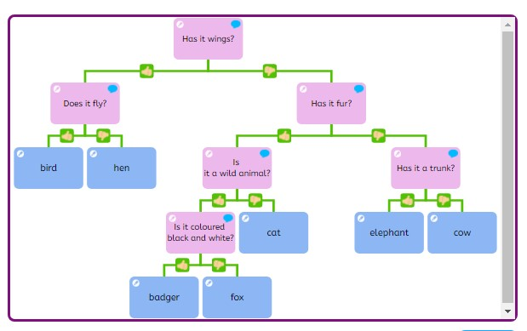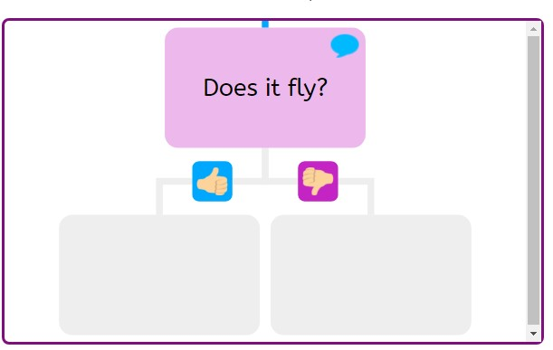
Playing
a
branching
database
in
j2Data

Online safety / E-safety
Focus on Copyright and ownership: to explain why copying someone else’s work from the internet without permission can cause problems.

