Great Moor Junior School: Home - School - Pupil Agreement 2022

Name of Pupil: __________________________________________

We believe that a good relationship between home and school is the most effective way for each pupil to fulfil his or her potential and make the most of the wide range of opportunities available at Great Moor Junior School.
Great Moor Junior School is a school where teachers, parents/carers, pupils and governors all play a vital role in achieving success for our pupils so it is important that our expectations are set out clearly.

Great Moor Junior School will:
- provide a fulfilling and challenging education;
- provide a secure and caring environment which, in turn, promotes a safe and healthy lifestyle;
- encourage every pupil to do his/her best;
- provide a clear framework for behaviour management and encouraging pupils to make the right choices;
- set homework regularly;
- maintain a positive environment for learning;
- communicate regularly with parents/carers about their child and his/her progress;
- provide a range of extra-curricular activities;
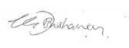
Signed: Kate Bushaway, Headteacher on behalf of the staff and School Council at Great Moor Junior School.

Our families will:
- take an active interest in their child’s education;
- encourage their child to do their best;
- provide good facilities to help with homework;
- actively support the school’s approach to behaviour and standards;
- share responsibility for their child’s behaviour;
- encourage their child to take a pride in their school and play a full part in school activities;
- contact the school at an early stage in the event of any problems;
- attend consultation evenings and other school events whenever possible;
- support their child in extra-curricular activities;
- ensure that their child attends school in accordance with the school’s attendance policy;
- act as responsible digital role models and refrain from using social media to voice concerns about school issues.

Signed: ______________________________________________ Parent /Carer.

Our pupils will:
- do their best and show a positive attitude to learning;
- complete homework on time and to the best of their ability;
- take an active part in extra-curricular activities;
- take a pride in their appearance;
- keep to the school values
- exercise self-discipline and take responsibility for their actions in the real world and online worlds;
- show courtesy and respect to all members of the school community in the real and online worlds;
- respect the school environment;

Signed: ______________________________________________ Pupil.

Together we will:
Uphold the values of the school and support our children’s learning so they can be proud of themselves, our school and our community.
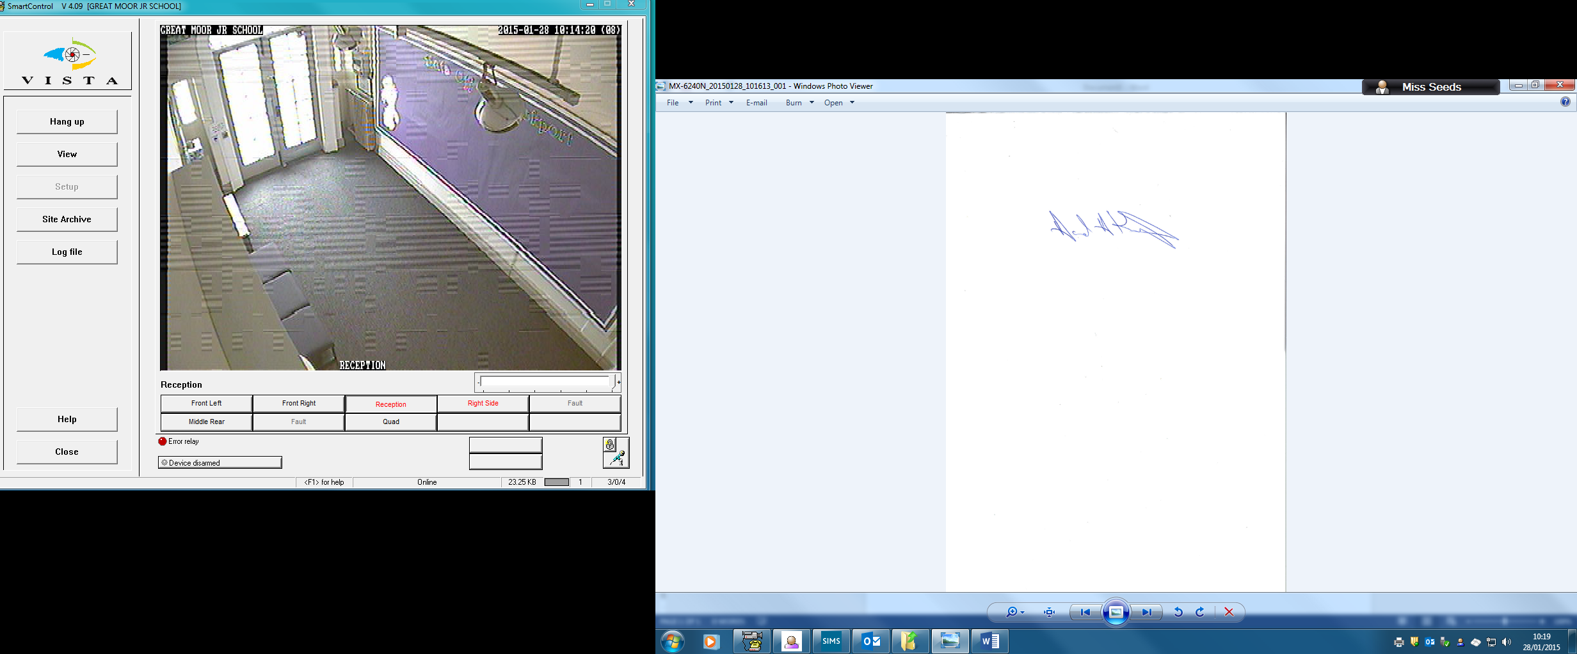
Signed: Chair of Governors

High achievement for all is our shared responsibility
Our school values: Respect Kindness Tolerance Responsibility Co-operation

