Hello to all the Year 6s who will be joining us at St Peter’s in September! My name is Mrs Prior and I am a Maths teacher at St Peter’s. Our Maths department is made up of ten Maths teachers and is led by the Head of Department Miss Bradley. Miss Bradley says ‘we are looking forward to being a part of your St Peter’s Maths journey, helping you develop and learn. We have a fantastic team of enthusiastic and supportive Maths teachers who are excited to welcome you all into our community’.
We love Maths at St Peter’s and all the Maths teachers can’t wait to teach you all and pass our love and passion for Maths on to you!
When you start high school you will have Maths three times a week and will be taught in the Maths Zone, which is actually where most of your form rooms will be too. You will be taught in ability groups and may have pupils from your old school and your new form with you.
You will spend your lessons working through the White Rose scheme which involves a lot of problem solving and discussion work. (A lot of you will be familiar with this from primary school). You will have weekly homework which is often skills based written work or a computer task on some Maths websites. We use Mathswatch or Hegarty Maths.
We want you to feel confident starting your Maths lessons in September so we are asking you to have a play about on another website, called MyMaths. When you begin in Year 7 you will be given your very own log in for this – right now you can log on to the site with our school username sphs and password ruler.
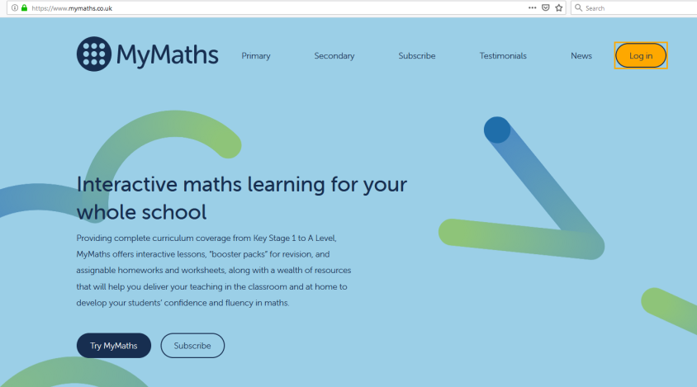
Using this log on you can access online videos, lessons and challenges. Have a play around and learn some new Maths!
Some topics we would really like you to have a good look at are some topics that you would have covered in school this summer. You may well have done these if they have been set by your primary teachers – even if you think you have covered it - it will be still worth having a look and testing yourselves!
These are the topics we would like you to have a go at:
Shape – Angles
Shape – 2D and 3D Shape, 3D Shapes, Nets of 3D shapes, Parts of a circle,
Data – Presenting Data
Data – Processing Data – Mean and Mode

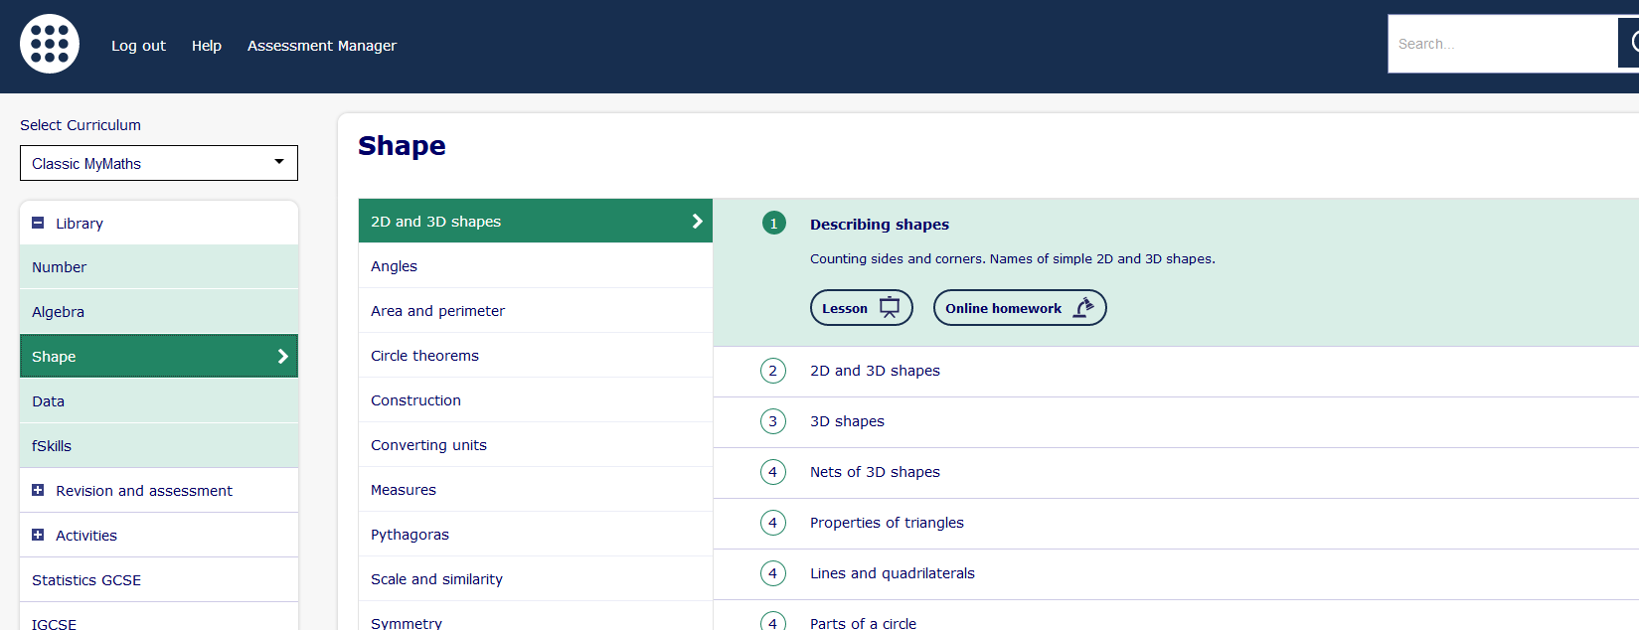
I have also attached some PowerPoints for all of these topics for you to have a look through.
Please also keep practising your times-tables – little and often is key!!
And finally – between now and September please invest in a Casio Scientific calculator. These really are the best and most user friendly and will last you all of your St Peter’s school life and beyond! I’ve shared a link to it on Amazon but other supermarkets and stationery shops also stock them.
Casio fx-83GTX Scientific Calculator
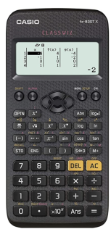
https://www.amazon.co.uk/Casio-fx-83GTX-Scientific-Calculator-Black/dp/B07L5YWTPH/ref=sr_1_3?dchild=1&keywords=Casio+fx-83GTX+Scientific+Calculator&link_code=qs&qid=1592313573&sourceid=Mozilla-search&sr=8-3&tag=firefox-uk-21
There may seem like a lot here – please don’t worry! If you can do just some of these then that will keep you ticking over until we meet in September! We really can’t wait to have you join our Maths team at St Peter’s. Don’t forget to get your parents, carers and older siblings follow us on @stpetersMaths on Instagram where you will see us regularly sharing some outstanding work and Homeschool Stars! You may even recognise some faces!!
We can’t wait to meet you all,
Mrs Prior and the Maths Team at St Peter’s


