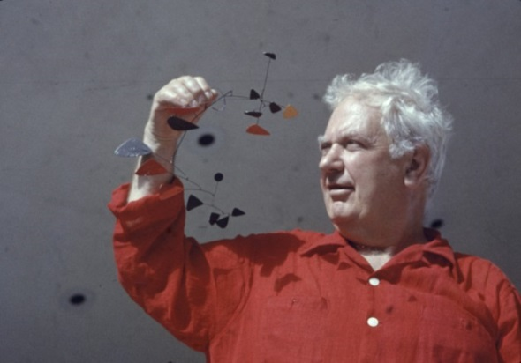

Why I chose this mobile

Interesting Facts:

These websites may help you
http://artsmarts4kids.blogspot.com/2008/04/alexander-calder.html
https://www.sothebys.com/en/articles/21-facts-about-alexander-calder
https://kids.britannica.com/kids/article/Alexander-Calder/352899

A sketch of my favourite Calder Mobile:

Born: 1898
Died:
Alexander Calder

