St Mary’s Parish,
For our prayers...

The Sick
Eilish Fairclough, Joan Rhodes, Antonia Murphy, Molly Scott, Eileen Hale, Pat Reynolds, Jackie Rogers, Bernadette Bannon, Tanya Rattigan, Marie Teresa Travis, Matthew Valentine, Shaun Hale, Rose Bennett, Colette Leyland, Margaret Diffley, Michael Kerrigan, Kath Berry, Kate, Margaret Ledger, Marjorie Caudwell, Michael Cunliffe, Paul Carr, George, Anne Lodge, Arthur Melia, James Edgerton.

The Universal Cycle of Prayer
During Lent we are asked to pray for the following intentions: Candidates to be received into the Church at Easter; World Day of Prayer; The needy and hungry of the world; Penitents and wanderers.

Pope Leo’s Prayer Intentions for March
For disarmament and peace: Let us pray that nations move toward effective disarmament, particularly nuclear disarmament, and that world leaders choose the path of dialogue and diplomacy instead of violence.

Birchley, Billinge, Moss Bank, Carr Mill & Clinkham Wood
Archdiocese of Liverpool
Served by the Society of the Divine Saviour – The Salvatorians
Parish Priest: Very Rev Paul Vianney Harris SDS VF
Administrator: Lynsey Speakman
St Mary’s Birchley R.C Church
The Presbytery, Birchley Road, Billinge WN5 7QJ
Tel: 01744- 892227
e-mail: stmary.birchley@rcaol.org.uk

Parish School: St Mary's Primary, Birchley Road.
Tel: 01744-678610
Headteacher: Mrs Ruth Martin
1st March 2026 2nd Sunday of Lent
Public Mass Schedule & Intentions

Sat 28th Feb: Vigil Mass of Sunday
16.00: Barbara Brighouse + (1st ann)
Sun 1st Mar: 2nd Sunday of Lent
08.00: Hugh Chisholm +
11.00: Colin & Audrey Little ++ (b’day ann)

Wed 4th Mar: Weekday Feria
09.15: Harry Fletcher +
Fri 6th Mar: Weekday Feria
19.15: Beverley McDonald +

Sat 7th Mar: Vigil Mass of Sunday
16.00: Fred Richardson + (b’day)
Joy Wilkinson + (ann)
Sun 8th Mar: 3rd Sunday of Lent
08.00: Karen Bailey (sick)
11.00: Zena Miller +

Parish Offerings (last weekend)
Plate: £ 898.28 Third World: £ TBA
Sacrament of the Sick: Please speak with Father Paul if the Sacrament of the Sick is required. For those in hospital, you must inform the staff that the patient is Catholic and request a chaplain’s visit in the first instance, especially in the case of emergency. If someone at home requires the Last Rites, please contact Father Paul as soon as possible.
Laying on of Hands: Usually takes place after all weekend masses on the last weekend of every month. All are welcome to receive this special form of prayer for themselves or for another.

Solemn Benediction: Every third Sunday of the month, beginning at 3pm. Confessions are also heard during this time.
Confessions: Available upon request at any time, or during monthly Benediction.
Marriages & Baptisms: Please speak with Father Paul directly regarding these sacraments.
Funerals: Please inform Father Paul if you have suffered a bereavement in the family. However, the booking of funerals is usually made via the undertaker.
Mass Intentions & Prayers: Anybody may request for a mass to be offered for various reasons, for plenty of notice must be given in advance.
If you would like a person included on the prayer list, which is published each week in the newsletter, please submit the name to Father Paul (permission should be obtained from the person in question before publishing).
Rainford Mass Times: Saturday at 17.30, Sunday at 09.30, Wednesday at 19.00.
Weekend Ministry Rotas: Readers
4pm: Tony Oll
8am: S Forrester 11am: R Buckner
Next Week: 4pm: T Whitton
8am: P Coupe 11am: E McBernie

Eucharistic Ministers
4pm: J Dwyer
8am: J Clarke 11am: C Parker
Next Week: 4pm: C McDonnell
8am: H Valentine 11am: R Buckner

Children’s Liturgy
Mar 1st: Kath & Pat – Judith & Monica
Mar 8th: Andrea & Geraldine – Chris & Brenda
Votive Candle Intentions

Our Lady: Sick friends St Patrick: Liz Broughton (b’day)
St Joseph: A sick person Sacred Heart: Ray Kelly + (b’day)
St Therese: Thanksgiving (Fletcher Family) St Anthony: Harry Fletcher +
O/L Walsingham: Benson, Hague, & Keenan families


Our Parish Facebook page is:
Catholic Parishes of Rainford & Birchley

The Parochial Club Facebook page is:
St Marys Club Billinge

The Sacred Triduum 2026

HOLY THURSDAY
Mass of the Lord’s Supper: 8pm
(Rainford at 6pm)

GOOD FRIDAY
(Day of Fasting & Abstinence)
Liturgy of the Lord’s Passion: 4pm
(Rainford at 2pm)

HOLY SATURDAY
Confessions: 2pm
The Solemn Easter Vigil: 8pm

Stations of the Cross
This traditional devotion of meditating on the last moments of Our Blessed Lord’s life by reflecting on the 14 Stations of the Cross takes place every Sunday during Lent, 2pm in the church (4pm at Rainford) All are welcome.

Annual Irish Coach Holiday 2026
+ In memory of John Moriarty +
Sunday 26th April – Saturday 2nd May 2026. Following the sign-up session at the parochial club, the trip is now full. Final payments now due. Cheques payable to “Catholic Excursions” Bank transfers to be made using the same name to the following account: Sort 04-00-03; a/c: 90433245. Please speak with Father Paul if you would like to join the reserve list.

House Blessings & Masses
If you would like to have your house blessed, or you would like to have a mass celebrated at home with your family, please speak with Father Paul who is most happy to accommodate such requests. What better way to experience the Lord’s presence and peace upon your home than with the celebration of mass or a house blessing?

Mother’s Day Service at St Helens Crematorium
The annual Mother’s Day Service of Remembrance will again be officiated by Father Paul. This will be held at St Helens Crematorium on Saturday 14th March 2026 at 1pm. All are welcome to attend, and refreshments will be available on the day. This is supported by the Friends of St Helens Cemetery and Bereavement Services Team.
New Curate for Birchley & Rainford

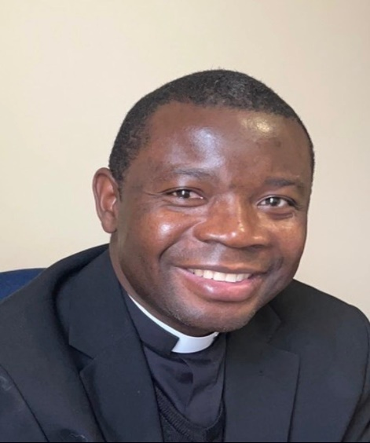

With the approval of Archbishop John, Father Paul has appointed Father Dieudonne Zeng SDS, as assistant priest in our parishes. Father Dido (pronounced “Deedo”) will take up his appointment on the 3rd Sunday of Easter and will reside with Father Paul in Rainford.

Chrism Mass 2026
Takes place this year on Wednesday 1st April, 7pm at the Metropolitan Cathedral. Father Paul has the coach arranged for this event, free of charge to parishioners. Sign up at the back of the church - please do not sign up unless you are absolutely certain of going – arranging a 70-seat vehicle and only 50 people turn up is very annoying and a waste of money!

The Chrism Mass is one of the most beautiful masses in the Church calendar when the whole family of the diocese come together. During the mass, the priests present renew their priestly promises made at their ordination and the Holy Oils of Baptism, Chrism, and for the Sick are presented and consecrated for use throughout the diocese by the Archbishop. All parishioners are welcome and encouraged to attend.

SVP Easter Cards
Once again, the SVP are selling Easter cards to boost much needed funds to support local families and individuals. The cards are available for purchase at the back of the church.

St Mary’s Parochial Club
OPENING TIMES
Mon – Thur: 1900 - 0000
Fri: 1700 – 0030
Sat: 1600 – 0030
Sun: 1400 – 2200

2026 MEMBERSHIPS AVAILABLE NOW

UPCOMING EVENTS

Wednesday Afternoon Cabaret
18th March – 1.30pm-5.30pm
Male Vocalist, Jason Ashton
Tickets £6 per person
On sale at the club from 7pm Monday 23rd March

