St Mary’s Parish,
For our prayers...

The Sick
Eilish Fairclough, Joan Rhodes, Antonia Murphy, Molly Scott, Eileen Hale, Pat Reynolds, Jackie Rogers, Bernadette Bannon, Tanya Rattigan, Marie Teresa Travis, Matthew Valentine, Shaun Hale, Rose Bennett, Colette Leyland, Margaret Diffley, Michael Kerrigan, Kath Berry, Kate, Margaret Ledger, Marjorie Caudwell, Michael Cunliffe, Paul Carr, George, Anne Lodge, Arthur Melia, James Edgerton.

The Universal Cycle of Prayer
During Lent we are asked to pray for the following intentions: Candidates to be received into the Church at Easter; World Day of Prayer; The needy and hungry of the world; Penitents and wanderers.

Pope Leo’s Prayer Intentions for February
For children with incurable diseases: let us pray that children suffering from incurable diseases and their families receive the necessary medical care and support, never losing strength and hope.

Birchley, Billinge, Moss Bank, Carr Mill & Clinkham Wood
Archdiocese of Liverpool
Served by the Society of the Divine Saviour – The Salvatorians
Parish Priest: Very Rev Paul Vianney Harris SDS VF
Administrator: Lynsey Speakman
St Mary’s Birchley R.C Church
The Presbytery, Birchley Road, Billinge WN5 7QJ
Tel: 01744- 892227
e-mail: stmary.birchley@rcaol.org.uk

Parish School: St Mary's Primary, Birchley Road.
Tel: 01744-678610
Headteacher: Mrs Ruth Martin
22nd February 2026 1st Sunday of Lent
Public Mass Schedule & Intentions

Sat 21st Feb: Vigil Mass of Sunday
16.00: David Graham Bird +
Mabel Byrne +
Sun 22nd Feb: 1st Sunday of Lent
08.00: Arthur Melia (sick)
Paul Forrester +
11.00: Margaret Heaton +(ann)
Anne Taylor + (ann)

Wed 25th Feb: Weekday Feria
09.15: Harry Fletcher +
Fri 27th Feb: Weekday Feria
19.15: Parishioners

Sat 28th Feb: Vigil Mass of Sunday
16.00: Barbara Brighouse + (1st ann)
Sun 1st Mar: 2nd Sunday of Lent
08.00: Hugh Chisholm +
11.00: Colin & Audrey Little (b’day ann)

Parish Offerings (last weekend)
Plate: £ 793.66 Third World: £ 174.53
Sacrament of the Sick: Please speak with Father Paul if the Sacrament of the Sick is required. For those in hospital, you must inform the staff that the patient is Catholic and request a chaplain’s visit in the first instance, especially in the case of emergency. If someone at home requires the Last Rites, please contact Father Paul as soon as possible.
Laying on of Hands: Usually takes place after all weekend masses on the last weekend of every month. All are welcome to receive this special form of prayer for themselves or for another.

Solemn Benediction: Every third Sunday of the month, beginning at 3pm. Confessions are also heard during this time.
Confessions: Available upon request at any time, or during monthly Benediction.
Marriages & Baptisms: Please speak with Father Paul directly regarding these sacraments.
Funerals: Please inform Father Paul if you have suffered a bereavement in the family. However, the booking of funerals is usually made via the undertaker.
Mass Intentions & Prayers: Anybody may request for a mass to be offered for various reasons, for plenty of notice must be given in advance.
If you would like a person included on the prayer list, which is published each week in the newsletter, please submit the name to Father Paul (permission should be obtained from the person in question before publishing).
Rainford Mass Times: Saturday at 17.30, Sunday at 09.30, Wednesday at 19.00.
Weekend Ministry Rotas: Readers
4pm: L Ormshaw
8am: P Coupe 11am: C Parker
Next Week: 4pm: A Ollerton
8am: S Forrester 11am: R Buckner

Eucharistic Ministers
4pm: P Burns
8am: S Forrester 11am: D Cairns
Next Week: 4pm: J Dwyer
8am: J Clarke 11am: C Parker

Children’s Liturgy
Feb 22nd: Half Term
Mar 1st: Kath & Pat, Judith & Monica
Votive Candle Intentions

Our Lady: A Special Intention St Patrick:
St Joseph: Joseph Cannon (b’day) Sacred Heart: Terry Grace + (ann)
St Therese: St Anthony:
O/L Walsingham:


Our Parish Facebook page is:
Catholic Parishes of Rainford & Birchley

The Parochial Club Facebook page is:
St Marys Club Billinge

Lent 2026
We are now at the beginning of our Lenten journey of 40 days and 40 nights, which excludes Sundays and Holydays. All parishioners are encouraged to use this season for spiritual growth in preparation for Easter – why not make an extra effort by attending a weekday mass, or stations of the cross? Prayer, fasting, and almsgiving are the three traditional practises of Lent, including abstinence from meat on Fridays and fasting on Good Friday. You may also wish to consider donating to the parish Third World Group in order to support those overseas who have far less in life than most. Whatever you do, please do make an effort this Lent to journey closer to the Lord in your daily life.

Stations of the Cross
This traditional devotion of meditating on the last moments of Our Blessed Lord’s life by reflecting on the 14 Stations of the Cross takes place every Sunday during Lent, 2pm in the church (4pm at Rainford) All are welcome.

Annual Irish Coach Holiday 2026
+ In memory of John Moriarty +
Sunday 26th April – Saturday 2nd May 2026. Following the sign-up session at the parochial club, the trip is now full. Final balances may be paid anytime but must be paid by March 1st 2026. Cheques payable to “Catholic Excursions” Bank transfers to be made using the same name to the following account: Sort 04-00-03; a/c: 90433245. Please speak with Father Paul if you would like to join the reserve list.

House Blessings & Masses
If you would like to have your house blessed, or you would like to have a mass celebrated at home with your family, please speak with Father Paul who is most happy to accommodate such requests. What better way to experience the Lord’s presence and peace upon your home than with the celebration of mass or a house blessing?

Mother’s Day Service at St Helens Crematorium
The annual Mother’s Day Service of Remembrance will again be officiated by Father Paul. This will be held at St Helens Crematorium on Saturday 14th March 2026 at 1pm. All are welcome to attend, and refreshments will be available on the day. This is supported by the Friends of St Helens Cemetery and Bereavement Services Team.
New Curate for Birchley & Rainford

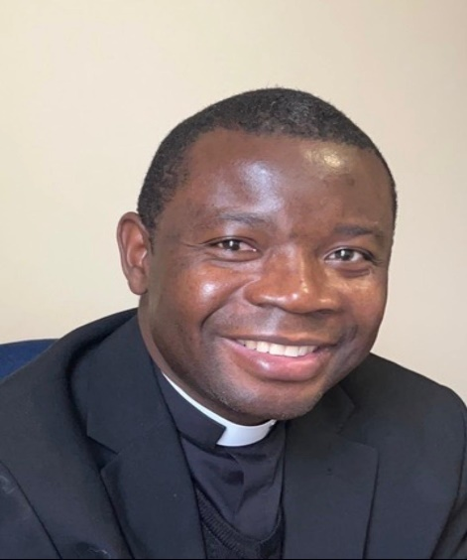

With the approval of Archbishop John, Father Paul has appointed Father Dieudonne Zeng SDS, as assistant priest in our parishes. Father Dido (pronounced “Deedo”) will take up his appointment on the 3rd Sunday of Easter and will reside with Father Paul in Rainford.

At present, Father Dido serves as assistant priest of Abbots Langley & Chipperfield parishes in the Archdiocese of Westminster, where he also serves as chaplain to Watford Hospital. A very kind-hearted, warm and approachable priest, originally from the Democratic Republic of Congo, Father Dido will be a most welcome addition to our parishes and to the Archdiocese. It is also hoped that he will take on some additional duties at Whiston Hospital.

St Mary’s Parochial Club
OPENING TIMES
Mon – Thur: 1900 - 0000
Fri: 1700 – 0030
Sat: 1600 – 0030
Sun: 1400 – 2200

2026 MEMBERSHIPS AVAILABLE NOW

UPCOMING EVENTS

Wednesday Afternoon Cabaret
18th March – 1.30pm-5.30pm
Male Vocalist, Jason Ashton
Tickets £6 per person
On sale at the club from 7pm Monday 23rd March

