How can I describe and group different animals?
Animals can be described and grouped based on their features, e.g. wings or fur.

We can group animals into the following groups: fish, amphibians, reptiles, birds and mammals).

Animals can also be described and grouped based on their diet. We can describe an animal’s diet by identifying it as herbivore, carnivore or omnivore.
What are the 5 senses and how do they help me?
There are 5 senses that humans use.
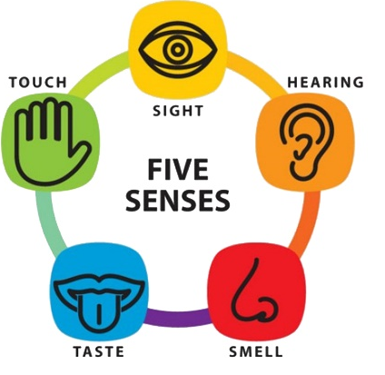
They are each associated with different body parts.
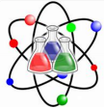

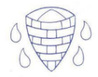
Science Knowledge Organiser - Animals, including humans
Year 1 – spring term
Know how to:
- Describe and compare the structure of a variety of common animals (fish, amphibians, reptiles, birds and mammals, including pets).
- Identify, name, draw and label the basic parts of the human body and say which part of the body is associated with each sense

What are the parts of the human body and how do they help me?
We have different parts of the human body.

Each part has a role to play to help us.
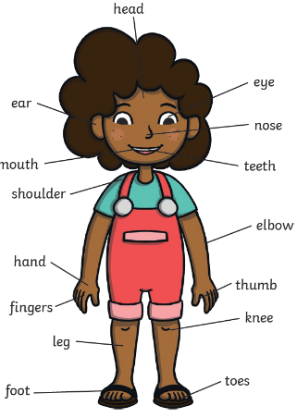

Key vocabulary:
- Fish – fish live and breathe under water. They have scaly skin, fins to help them swim and they breathe through gills.
- Mammals – mammals are animals that breathe air, grow hair or fur and feed on their mother’s milk as a baby.
- Birds- All birds have a beak, two legs, feathers and wings.
- Reptile – all reptiles breath air. They have scales on their skin.
- Amphibian – Amphibians live in the water as babies and on land as they grow older. They have smooth, slimy skin.


Prior learning:
EYFS: Explore the natural world around them, making observations and drawing pictures of animals and plants.
End of unit quiz

