
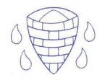
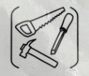
Year 1 Spring Term: Sliders and Levers
Main Theme: National PSHE Link: Pride
Key Vocabulary
Mechanism – allows movement.
Key Questions
How can you make pictures move?
We can make pictures move with a slider or lever mechanism.
What is a mechanism?
It allows movement.
How can you attach a slider or lever?
We can use split pins, tape or glue to attach a slider or lever.

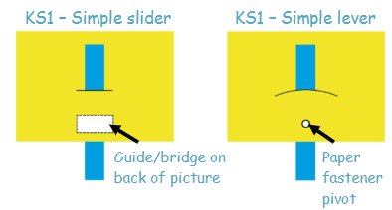
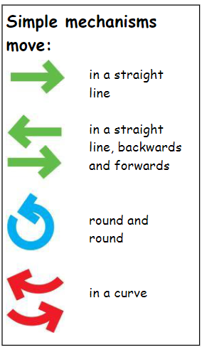

Prior Learning
Nursery and Reception – physical development and use of a range of equipment.

