
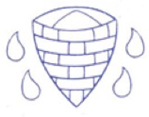
Creating media – Digital painting
Year 1 Knowledge Organiser
Key Vocabulary
Word | Definition
Paint | software which is used to create original pieces of work using your mouse or graphics tablet.
Drawing Tool | A tool which can be used to draw.
Save | Storing work onto a device for future use.
Gallery | Somewhere you can permanently view files and pictures.

Know how to:
Describe what different freehand tools do
Use the shape tool and the line tools
Make careful choices when painting a digital picture
Explain why I chose the tools I used
Use a computer on my own to paint a picture
Compare painting a picture on a computer and on paper

Key questions:
How can digital media be used to create a piece of artwork?
Which digital tools can be used to draw electronically?
How do we save work digitally to access it later?



