|  |
| --- |
| **WINSFORD HIGH STREET COMMUNITY PRIMARY AND NURSERY SCHOOL** |
| BEHAVIOUR MANAGEMENT POLICY |

|  |  |
| --- | --- |
| LAST REVIEWED | Autumn 2025 |
| AUTHOR/OWNER | Inclusion Team |
| REVIEW CYCLE | Annual |
| NEXT REVIEW DATE | AUTUMN 2026 |

**High Street Community Primary School**

**Behaviour Policy**

The aim of this behaviour system is to be inclusive. The steps of the behaviour system provide opportunity to discuss any issues that may be leading to negative behaviours and the emotional effects this has had on the pupils. Children’s wellbeing will be promoted through positive strategies in this policy, emphasis on belonging to the school community and an inclusive approach to behaviour management. To support children with their emotional and sensory self-management we educate children to identify their feelings in the moment and guide them to regulate their emotions through the “Zones of Regulations” framework.

**Restorative Practices**

Being ‘Restorative’ focuses on building positive relationships based on respect and fairness. In turn

this creates a community that is supportive, accountable and respectful. We believe that every

individual is responsible for their own behaviour. The Restorative framework is based upon ‘knowing

the effect that I have on others’. Making changes to the way we approach incidences and issues

provides children, and others, the opportunity to think about how they relate to each other and how

they can find positive ways of repairing harm caused, rather than focusing solely on punishing poor

behaviour or individuals avoiding taking responsibility for their actions. Children and adults are

encouraged to put things right together. All members of staff understand the importance of modelling

positive language, behaviour and take time to develop positive and meaningful relationships with

colleagues and pupils. When positive relationships are developed and connections are made

individuals are less likely to cause harm to others or choose to damage relationships.

**School Ethos**

Our school is a safe, healthy, caring and friendly place to learn. During each day we do our best to develop new skills and learn interesting information, to help us become excellent members of the community.

**Principles of our behaviour policy**

Good behaviour is essential for effective teaching and learning to take place. At Winsford High Street Community Primary School, we believe that pupils and staff have the right to work in an environment that is safe, friendly, peaceful and fair. Good behaviour must be carefully developed and supported. High self-esteem promotes good behaviour, effective learning and positive relationships. The best results, in terms of promoting good behaviour arise from rewarding success and giving praise for effort and achievement, rather than focusing on shortcomings and failure. This we achieve through our general practice and through the use of the PSCHE and regular assemblies.

It is the responsibility of parents to share with the school in helping their children to behave well. We believe good behaviour means that everyone in school is:

* careful and kind
* polite and friendly
* helpful to each other
* hardworking
* respectful and tolerant
* calm and ready to learn

**Aims of the policy**

* To develop a moral framework within which initiative, responsibility and sound relationships can develop
* To enable children to develop a sense of self-worth and a respect for others
* To create an environment in which children feel safe, secure and respected
* To work consistently and fairly in the positive management of behaviour
* To encourage staff, children and parents to value good behaviour
* To encourage our children to co-operate with one another and with adults in the school
* To work alongside parents to encourage our children to develop socially, personally, academically, morally and spiritually in preparation for a positive role in society.

**Equality and fairness**

##### At High Street Primary School all pupils, parents and staff are treated equally, with respect and in a just and fair manner. The school promotes equality of opportunity and a sense of fairness is evident in the work of the school. Pupils and parents as well as staff are invited to take part in decision-making, and policy decisions. Views of stakeholders are regularly sought through discussion and questionnaires.

**Implementation of the Behaviour System**

**The School Rules**

These are to be displayed in all classrooms and teaching areas.

Be Ready  
Be Respectful

Be Safe

These rules encompass the previous Golden Rules and all behaviour expectations in the school, for example, Fantastic Walking, Good Looking, Good Listening, Good Sitting.

See appendix A for further details regards the expectations (our social norms).

**PiP and RiP**

Behaviour will be managed through a PiP (Praise in Public) and RiP (Reprimand in Private) approach.

This ensures that the children who make good choices and follow the rules will receive the most attention and encourage others to follow suit. When a child does not follow the rules, the member of staff will implement Restorative Steps. This is to be done in private so as not to draw attention to the negative behaviour or shame the child. Restorative Steps should take place at eye-level to the child, in private and in a gentle manner. The child should be allowed time to reflect and change their behaviour between each step.

To support the Reception children visually with the restorative steps the use of coloured blocks will be used.

**Rewards**

The children have the opportunity to be rewarded by the class teacher and Headteacher when the school rules are followed and when exceptional behaviour and attitude is noticed. This follows the PiP aspect of the approach and can be done in the following ways:

* Verbal Praise should be the most frequent reward used and should be given publicly to celebrate the child’s behaviour and set an example.
* Class Dojo points awarded for positive behaviour. Each class to set a weekly Dojo targets and to identify subsequent rewards if the targets set are achieved. E.g. 30 Class Dojo points = 5 minutes extra play 40 Class Dojo = A whole class game e.g quiz. 50 Class Dojo = A 30 minute movie for the class. (Ensure staff are aware these replace golden moments)
* High Street Hero awards in class for behaviours/ work that demonstrates the pupil has gone above and beyond. The pupil will receive a High Street Hero sticker to celebrate their achievement. If a child receives 5 High Street Hero awards during a half term they will receive a Deputy and Head teacher award/sticker.
* Good work being recognised and being sent to Headteacher and Deputy Headteacher for recognition and stickers which alongside, the children will receive Dojo points.
* Use of Facebook, ClassDojo, the school newsletter and the school website to promote engagement and enjoyment of school activities.
* Star of the Day/ VIP of the day - an unconditional reward chosen at random each day. Star of the Day/ the VIP is able to line up first and go first for lunch etc.
* If a child receives a Headteacher/ Deputy Headteacher award their name will be placed in a box. At the end of each half term, one name will be drawn from the box and a special award.

**Restorative Steps:**

This has replaced the previous Peg System and follows the RiP part of the approach.

1. **Reminder**  
   The child will be reminded of the rules/expectations.   
   For example: *Remember our rule, Be Respectful.*
2. **Warning**  
   The child will receive a warning for not following the rule and given a chance to make the right choice.   
   For example: *I noticed you are not following this rule. I need you to show me you are listening.*
3. **Time-Out**  
   The child will have a 5 minute time-out in a parallel classroom. If a child receives 3 time-outs in a day, they will discuss their behaviour with Mr Joule or a member of the SLT. Parents may be contacted about the incident if Mr Joule or a member of the SLT feel it is appropriate.   
   For example: *You have chosen to continue not to listen and so will have 5 minutes time-out in the next classroom.   
   Class teachers may choose when the time-out is taken. This could be at the next timetabled break time to ensure minimal loss of learning. Children must be given opportunity to go to the toilet and have their snack prior to the start of time-out.*
4. **Repair**  
   The member of staff who gave the child a time-out will have a Restorative Conversation with the child at the next opportunity.
5. **Reflection**The child will attend a lunchtime reflection with a member of the SLT. During this time they will reflect upon what went wrong and actions they will take in future if a similar scenario were to arise. If a child does reach ‘reflection’, communication must be had with parents/ carers.

**A Personalised Approach**

In circumstances where a child does not consistently respond appropriately to the steps above a personalised behaviour plan may be sought.

**Restorative Conversations**

The member of staff who underwent the restorative steps will have the restorative conversation after a time-out. The aim of this conversation is to repair damage, build relationships, reinforce expectations and reset behaviours for the following lesson/session of the day.

The conversation follows the following format:

1. What happened?
2. What were you thinking at the time?
3. What have you thought since?
4. How did this make you feel?
5. Who has been affected?
6. How can we do things differently in the future?

**Behaviour Tracking**:

Tracking of attendance in “Reflection” is conducted to identify patterns which may cause require and indicate the need for further intervention or a more personalised approach.

**A Consistent Approach**

There is a consistent approach to dealing with behaviour during lesson time and lunchtimes. Procedures are followed by teachers, teaching assistants and midday assistants so that children can adhere to the routines and rules within the school.

On arrival, supply teachers are also informed of the reward strategies, school rules and procedures of the behaviour system.

*See Appendix B and C.*

**Keeping Parents Informed:**

As a school, we understand the importance of working in partnership with parents. We will keep parents informed of the progress of their child with respect to the behaviour system. This will be done through Dojo Messages phone calls, formal letters and meetings with class teacher/Headteacher.

Where a child has exceeded the behavioural expectations, parents may receive a phone call or message to celebrate the child’s behaviour.

**ABCD forms**

ABCD is a form of behavioural analysis. Where behaviour needs to be understood in more depth, a member of staff may complete an ABCD form which outlines the:

**Antecedent** (what came before the behaviour even if not obviously linked)  
**Behaviour** (a summary of the behaviour observed)  
**Consequence**  (anything that happened after the behaviour)

**Decision (**What could be put into place next time or make it even better?)

The form is then used to look for patterns in behaviour and is only used as an intervention tool (not part of our everyday behaviour policy). A form may be used to understand behaviour in more depth to reduce or change the behaviour. The form can be of use to monitor and log behaviour patterns, particularly in children with particular behaviour-related needs.

ABCD forms are completed by the adult most involved and completed as soon as possible after the behaviour. The teacher will invite the parent/guardian into school to share the details of the ABCD form on the same day. A hard copy of the ABCD form is then given to the SENCo and an electronic copy uploaded onto CPOMs.

*See appendix D*

**Expectation of Teachers/Teaching Assistants**

We expect every adult to:

* Meet and greet at the door
* Refer to ‘Be Ready, Be Respectful, Be Safe’ in their daily conversations with children
* Follow up all behaviour including restorative conversations and communication with parents
* Teach behaviour as part of the weekly curriculum
* Plan lessons that engage, challenge and meet the needs of all pupils
* Deal with all poor behaviour in private
* At breaktime and lunchtime, ensure children are led to their playground in a line (modelling fantastic walking) and are subsequently collected from the playground and the process repeated until the children are back in the classroom.

**Expectations of all adults:**

Lead by example to model Be Ready, Be safe, Be Respectful

Praise positive behaviour

Always model and encourage the use of good manners

Never walk past or ignore pupils who are failing to meet expectations

**Expectation of SEND Team**

* To provide support and advice to adults.
* To support teachers in managing pupils with more complex or challenging behaviour so that needs are being met.
* To use behaviour data to target and assess interventions at universal and SEND support

**Expectations of the Head teacher and the Senior Leadership Team**

* Meet and greet learners at the beginning of the day
* Be a visible presence around the school
* Celebrate staff, leaders and pupils whose effort goes over and above expectations
* Ensure staff training needs are identified and met
* To support the SEND Team in managing learners with more complex or negative behaviours
* Use behaviour data to target and assess the effectiveness of the behaviour policy and practice

**The Governing Body is responsible for:**

* Reviewing and approving the Behaviour Policy
* Monitoring the policy’s effectiveness
* Holding the headteacher to account for its implementation

**Expectations of Midday Assistants:**

* Implement the behaviour system at lunchtime following the school rules.
* Midday Assistants to use positive rewards to encourage good behaviour including verbal praise and the use of ‘Midday Stickers’ which will equate to the ClassDojo.
* Midday Assistants to feedback any behaviour to teachers at end of playtime.
* Midday Assistants to encourage playtime games using the game cards provided and lunchtime rota.

**What will happen if all of the above procedures don’t work?**

If the procedures appear to be not meeting the needs of the child’s and their behaviour, a further meeting will be arranged. This meeting may also involve the Head teacher, Special Needs Co-ordinator, Lead Behaviour Professional, EWO or Educational Psychologist.

**Exclusion**

In rare cases it may be necessary to exclude a child. This is only ever considered after all other avenues have been explored. At all times, the DFE procedures are followed. Any child returning to school following exclusion is reintegrated using a behaviour modification programme. Where appropriate, a *part time timetable* may be introduced which will subsequently be logged with the Local Authority.

**Positive Handling**

It is important to remember that any restraint should be in line with the school’s policy on Positive Handling and Cheshire West and Chester’s guidelines.

Where Positive Handling has been enforced, the adults involved must complete a Team Teach form outlining the details of the incident and this is shared with the parent on the same day.  
Please see Positive Handling policy.

**Monitoring and Evaluation**

This policy will be monitored by the Headteacher, Special Educational Needs Coordinator and Inclusion facilitator and Lead Behaviour Professional, with the support of the Senior Leadership Team of the school.

**Appendices**

Appendix A – Behaviour Expectations  
  
**Behavioural Expectations**

|  |  |
| --- | --- |
| Be Ready | * On time * Look smart in the correct uniform * Line up in single file in silence when asked * Equipment ready * Tidy workspace * Following instructions first time * On task * Stay seated * Ask for help when needed |
| Be Safe | * Always keep your hands and feet to yourself * Never open external doors * Stay on the school grounds * Don’t leave belongings on the floor as a trip hazard * Leave jewellery at home * Report any hazards immediately to an adult * Stay safe online and report any concerns or worries to an adult * Listen to and follow instructions first time * Use equipment appropriately * Keep your chair flat on the floor * Walk on the left, in single file and in silence around the school |
| Be Respectful | * Follow instructions first time * Good looking, sitting and listening * Turn-taking * Positive attitude * Celebrating others’ achievements * Good manners (please, thank you, holding doors) * Listening to others * Respect of the classroom. E.g. using the bin and tidying up * Looking after own property. E.g. jumpers in bags, coats on pegs * Picking up dropped items * Kind words * Following the other rules * Seeking permission / consent * Waiting your turn * Respecting wishes and feelings * When a signal is given, children to focus * Enter/Leave the assembly hall quietly and sit attentively. |

Appendix B One-Page Behaviour Policy

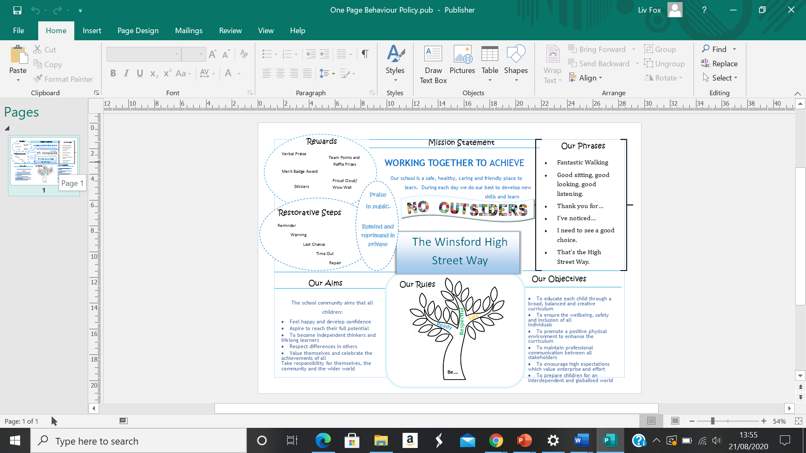

Appendix C

|  |  |  |
| --- | --- | --- |
| Behaviour | Consequence | Example |
| Breaking School Rule (Be Ready, Be Respectful, Be Safe) | **Reminder** of the school rules to be followed.  You are given a chance to change your behaviour. | ‘Remember our rule to be Respectful.’ |
| Continued behaviour following reminder/ Breaking of an additional rule | **Warning**  You are given a chance to change your behaviour. | ‘I have noticed that you are talking whilst I am teaching. I need to see you are being respectful and ready to learn or there will be a consequence.’ |
| Continued behaviour following Last Chance/ Breaking of an additional rule  Behaviour displayed that is perceived as serious or dangerous. | **Time Out**  You will have a 5-minute time-out in a different classroom in your year group.  During lunch times, the time-out will take place to one side of the designated area you are in.  **Repair**  You will have a Restorative Conversation with the member of staff to discuss the events and consequences. | ‘You have had two chances to change your behaviour and have continued. Therefore, you will have a time-out in another classroom.’  **Restorative Conversation:**  1.What happened?​  2.What were you thinking at the time?​3.What have you thought since?​  4.How did this make you feel?​  5.Who has been affected?​  6.How can we do things differently in the future?​ |

Appendix D

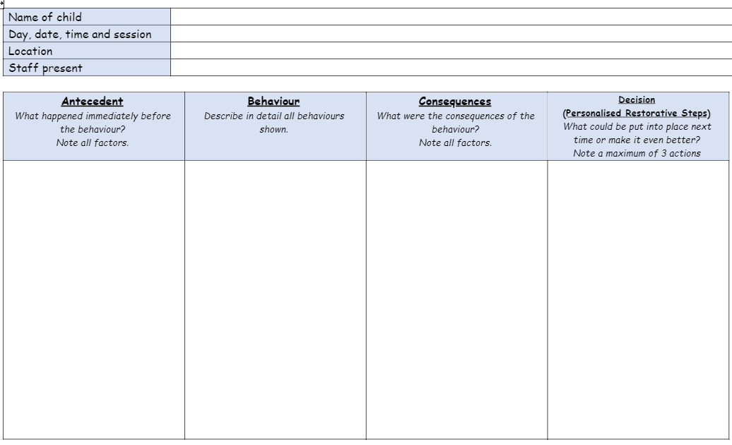

**Reviewed**:

Date:

Name:

Bullying (including measure to prevent bullying, including cyberbullying, prejudice-based and discriminatory bullying- as of Keeping Children Safe Sep 21)

Cyberbullying Definition from: [Advice for parents and carers on cyberbullying (publishing.service.gov.uk)](https://assets.publishing.service.gov.uk/government/uploads/system/uploads/attachment_data/file/444865/Advice_for_parents_on_cyberbullying.pdf):

Cyberbullying is bullying that takes place using technology. Whether on social media sites, through a mobile phone, or gaming sites. Parents, carers and teachers need to be aware that most children have been involved in cyberbullying in some way, either as a victim, perpetrator, or bystander. By its very nature, cyberbullying tends to involve a number of online bystanders and can quickly spiral out of control. Children and young people who bully others online do not need to be physically stronger and their methods can often be hidden and subtle. Social Networks have a minimum age restriction, usually age thirteen. Accessing such sites too early can expose children to unnecessary bullying.

Advice to children and prevention strategies:

* Make sure you use the privacy settings.
* Always respect others – be careful what you say online.
* Be careful what pictures or videos you upload. Once a picture is shared online it cannot be taken back.
* Only add people you know and trust to friends/followers lists online. When talking to strangers, keep your personal information safe and location hidden.
* Keep your password to yourself and change it regularly.
* Block the bully – learn how to block or report someone who is behaving badly.
* Do not retaliate or reply to offending e-mails, text messages or online conversations.
* Save the evidence. Always keep a copy of offending e-mails, text messages or a screen grab of online conversations and pass to a parent, a carer or a teacher.
* Make sure you tell an adult you trust, for example, a parent, a carer, a teacher, or the anti-bullying co-ordinator or call a helpline like Childline on 08001111 in confidence.
* Most social media services and other sites have a button you can click on to report bullying. Doing this can prevent a bully from targeting you and others in the future. Many services take bullying seriously and will either warn the individual or eliminate his or her account.
* While you are on your mobile phone make sure you also pay attention to your surroundings

Through the work we complete at High Street during Computing lessons, e-safety days and other assemblies and instances, we teach children the key preventive strategies to cyberbullying, as well as teaching to use our inclusiveness view on society and education online and offline. By doing so, we are combining inclusiveness and online safety. The children are aware of who to contact and rely upon as soon as a possible incident arises, we teach that the quicker we know about online incidents the better, as quoted above, online incidents can quickly spiral.

We value key communication with parents and adults at home regarding cyber bullying due to the technology used outside of school and therefore how it can impact school life and behaviour within the classroom.

Possible signs of cyberbullying to be aware of inside and outside of school:

* Being upset after using the internet or their mobile phone.
* Unwilling to talk or secretive about their online activities and mobile phone use.
* Spending much more or much less time texting, gaming or using social media.
* Many new phone numbers, texts or e-mail addresses show up on their mobile phone, laptop or tablet.
* After texting or being online they may seem withdrawn, upset or outraged.
* Not wanting to go to school and/or avoiding meeting friends and school mates.
* Avoiding formerly enjoyable social situations.
* Difficulty sleeping.
* Low self-esteem.

Source: ([Advice for parents and carers on cyberbullying (publishing.service.gov.uk)](https://assets.publishing.service.gov.uk/government/uploads/system/uploads/attachment_data/file/444865/Advice_for_parents_on_cyberbullying.pdf) )

Prejudice Based and discriminatory bullying definition:

Prejudice-based bullying is any type of direct physical or verbal bullying, indirect bullying or cyberbullying based on protected characteristics such as:

* age
* disability
* gender reassignment
* pregnancy and maternity
* race
* religion or belief
* sex
* sexual orientation

Prevent prejudice-based and discriminatory bullying:

To prevent prejudice-based bullying, we use a whole school approach. We must ensure that to prevent prejudice based and discriminatory bullying we follow what our school is required to do under the Public Sector Equality Duty; create a school culture which reflects safety and inclusivity; celebrate differences; use language of diversity; including and involving all pupils and empower both staff and pupils. Many of which is taught through the schools ‘No Outsiders’ scheme where children learn to celebrate and respect differences, but also by using assemblies and dedicated events or projects (for example, National Anti-Bullying days).

Source: [How can we stop prejudice-based bullying in schools? | Equality and Human Rights Commission (equalityhumanrights.com)](https://www.equalityhumanrights.com/en/advice-and-guidance/how-can-we-stop-prejudice-based-bullying-schools#:~:text=%20Prejudice-based%20bullying%20is%20any%20type%20of%20direct,belief%207%20sex%208%20sexual%20orientation%20More%20)