Winsford High Street Primary School
CHILD-FRIENDLY
SAFEGUARDING POLICY
What is Safeguarding about?
All of the adults around you think that your health, safety and welfare are very important. In our school, we respect our children and help to protect their rights. We do our best to help children make good educational progress. We teach children how to recognise risks in different situations and how to protect themselves and stay safe.

How will we try to protect children?
We try to provide a safe environment for our children to learn in. We want to help to ensure that children remain safe at home, online and at school. We think it is important for our children to know where to get help if they are worried or unhappy about something.

Need to talk?
You can talk to any adult at school if you need to, but Mrs Robbins, Mrs Taylor, Mr Joule, Mrs Trigg and Miss Lee’s special jobs are to make sure everyone feels happy and safe, if you want to talk to any of them you can, at any time. We also have a Year 6 Safeguarding Team who are responsible for being a voice for you to ensure that you feel safe and are happy in school.

You can also talk to someone at ChildLine- they are also there for you whenever you need to talk.

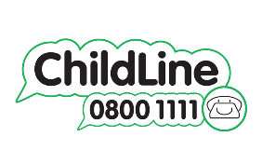

We want ALL children to feel safe and be confident. Let’s fulfil our school motto of ‘Working together to achieve” and make High Street a wonderful place to learn, flourish and grow together!

