English
- Watch: https://www.bbc.co.uk/bitesize/clips/zqxjmp3
- Create your own advert to promote a vegetable of your choice.
- Refresh your memory for the use Fronted Adverbials and use in your advert.
- Use different paragraph headings for your advert.

Maths
https://whiterosemaths.com/homelearning/year-4/week-10-number-multiplication-division/

- Work your way through the division videos and tasks. Check carefully on the symbols for each one. Remember to set your work out neatly in columns.


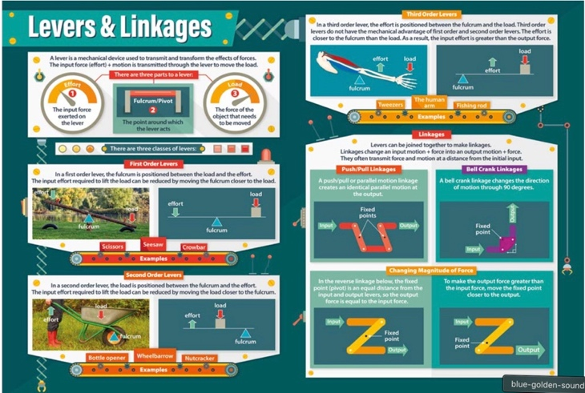

Why Time- Sound / Levers and Linkages
Week beginning 23rd November 2020

Topic / D&T
Watch: https://www.bbc.co.uk/bitesize/clips/zrp6n39
Make a list of what uses linkages in your home.

RE
- Have a look at these designs: https://www.pinterest.co.uk/donnateve63/stained-glass-bible-stories/
- Choose a parable from the bible then create a stained glass design that reflects the story.

Science
https://www.bbc.co.uk/bitesize/clips/zswsbk7
- Refresh your knowledge on sound by using the link above.
- If you can make your own tin can telephone.
- Write up a report explaining how it works.

