Pupil premium strategy statement St Oswald’s CE Primary School

This statement details our school’s use of pupil premium (and recovery premium) for the 2025 to 2026 academic year funding to help improve the attainment of our disadvantaged pupils.

It outlines our pupil premium strategy used the Tired approach, recommended by the Education Endowment Foundation (EEF), how we intend to spend the funding in this academic year and the outcomes for disadvantaged pupils last academic year.

School overview
Detail | Data
Number of pupils in school | 221
Proportion (%) of pupil premium eligible pupils | 41.62%
Academic year/years that our current pupil premium strategy plan covers (3 year plans are recommended) | 2025 - 2027
Date this statement was published | 26/11/2025
Date on which it will be reviewed | October 2026
Statement authorised by | E Murtagh
Pupil premium lead | E Murtagh
Governor / Trustee lead | S Varga

Funding overview
Detail | Amount
Pupil premium funding allocation this academic year | £129,825
Recovery premium funding allocation this academic year | £0
Pupil premium (and recovery premium*) funding carried forward from previous years (enter £0 if not applicable) | £15,445
Total budget for this academic year | £147,270

Part A: Pupil premium strategy plan

Statement of intent
- To provide additional early reading support for disadvantaged pupils.
- To provide Speech and Language screening and intervention in EYFS.
- To ensure those pupils who are disadvantaged in EYFS achieve a good level of development.
- To continue to diminish the difference between disadvantaged pupils in phonics, Reading, Writing and Maths at KS1 and those who are not.
- For disadvantaged pupils to make at least expected progress and better in order to achieve age related expectations in English and Maths at the end of KS2.
- To ensure there are no financial barriers for disadvantaged pupils to be included in any part of school life and they have equal educational experiences as those pupils who are not disadvantaged.
- To ensure disadvantaged pupils have good attendance and punctuality at school.
- To support those who are disadvantaged and vulnerable through other social issues the best possible way in order to achieve. E.g. free breakfast in breakfast club, school uniform, PE kits etc.
- To ensure the more able disadvantaged pupils are challenged.
- The purchase of technology and other resources to support high quality teaching and learning.
- Targeted interventions and resources to meet the specific needs of disadvantaged pupils with SEND
- Teaching assistant deployment and interventions supporting pupils’ social, emotional and behavioural needs.
- To support the recruitment and retention of staff by providing cover for staff to complete NPQs.
- To facilitate coaching for staff to improve the quality of their teaching.

Challenges
This details the key challenges to achievement that we have identified among our disadvantaged pupils.

Challenge number | Detail of challenge
1 | On entry to school in Early Years, pupils who are elidable for PP, are significantly below in communication and language than would be expected at this stage. This slows their progress in all other areas as language skills are limited.
2 | On entry to school in Early Years pupils who are elidable for PP have significantly poorer social skills and struggle to work well with others. We feel there has been a notable difference since lockdown and these cohorts of children have suffered because of this.
3 | Pupils eligible for PP have disproportionately lower attendance and punctuality at school than their peers.
4 | A higher proportion of pupils eligible for PP have greater involvement with social care and early help, this adversely affects their mental health and well-being and often need further emotional support so that they are able to learn.
5 | Most disadvantaged pupils in the school also have additional needs that need identifying, assessing and acting on professional advice to ensure we can provide the best possible provision for them.
6 | Some eligible pupils are also on the Vulnerable Children’s Register due to social factors, which can create difficulties for them to learn effectively. e.g. Lack of sleep, hunger, lack of stability at home, Domestic Violence, Drug or Alcohol abuse, Mental Health or other health problems which affect parenting, issues within the family, limited parenting skills and ability to support children effectively in their learning, crime and antisocial behaviour within the family, pupils at risk of financial exclusion due to family circumstances.
7 | There are other social factors which have caused further home issues such as loss of work, the increased cost of living or additional stress in the home environment affecting the mental health and well-being of children and their families.
8 | Parental engagement and support from home is disproportionate for eligible pupils and results in further disadvantage in the quality of support pupils receive at home with their learning.
9 | There are low levels of literacy within the community which adversely affects family’s abilities to support the most disadvantaged pupils.
10 | Poor vocabulary and language development in the community, particularly for the most disadvantaged.
11 | Higher levels of mobility for those pupils who are eligible compared to those who are not – lack of consistency.
12 | The number of pupils with SEND in the school is now as high as those who are disadvantaged. There is an increasing number of pupils who require additional support or 1:1 support.
13 | There is a disproportionate number of pupils with additional needs in some classes.
14 | There is a huge demand on staff time and resources due to the level of need in each class.

Intended outcomes
This explains the outcomes we are aiming for by the end of our current strategy plan, and how we will measure whether they have been achieved.

Intended outcome | Success criteria
To improve oracy which have a positive impact on pupils’ writing across the school, particularly those who are disadvantaged. | Pupils meet their writing targets and the gap between the attainment of those who are disadvantaged and those who are not is closing.
To improve maths attainment for those pupils who are disadvantaged. | Pupils meet their maths targets and the gap between the attainment of those who are disadvantaged and those who are not is closing.
To ensure the achievement gap between those pupils eligible for PP and those who are not, is closing in all core areas from foundation stage to the end of KS2. | Those who are eligible for PP make further progress and achieve in line with their peers. The gap between the attainment of those who are disadvantaged and those who are not is closing.
Improve attendance overall so that the school average is at least 96% and reduce the  number of persistent absences. | Those who are eligible for PP attend school as often as their peers.
Reduce the number of persistently absent pupils who are eligible for PP. | Those who are eligible for PP attend school as often as their peers.
Pupils develop resilience and independence in their learning. | Eligible pupils are supported emotionally and can access learning.
Pupils with SEND are identified early and are assessed for level of need in a timely manner. | Outside agencies are procured and pupils needs are identified and met.
Pupils with SEND and require further support are adequately supported. | Funds are used to secure 1:1 teaching assistants or group assistants.
Staff are trained to adapt their teaching to support pupils need. | Staff are well equipped to adapt their teaching to meet pupils needs.
The number of pupils achieving a good level of development in EYFS improves. | Eligible pupils are supported emotionally and socially and make rapid gains of progress
Pupils are supported emotionally and provided with the knowledge and resources to build resilience and manage their emotions. | Pupils are well equipped to manage their emotions and self-regulate.

Activity in this academic year
This details how we intend to spend our pupil premium (and recovery premium) funding this academic year to address the challenges listed above.

Teaching Budgeted cost: £70557.02
Activity | Evidence that supports this approach | Challenge number(s) addressed
Additional Maths Teacher in Years 5 & 6. | The achievement of PP pupils in Maths at KS2 was significantly less than their peers as shown in internal data of the school using NFER assessments.  (50% compared to 76% of non-PP pupils in Y5)  (79% compared to 94% of non-PP pupils in Y6)  When used effectively, diagnostic assessments can indicate areas for development for individual pupils, or across classes and year groups:  Diagnostic assessment | EEF  Maths is an essential key skill and core subject which all pupils need for life. Internal assessment data has shown that the number of eligible pupils who met age related expectations in maths was significantly lower than those who are not. Nationally in 2025 at the end of KS2 61% of disadvantaged pupils achieved the expected standard in Maths  The DfE non-statutory guidance has been produced in conjunction with the National Centre for Excellence in the Teaching of Mathematics, drawing on evidence-based approaches:  Mathematics_guidance: key stages 1_and 2  The EEF guidance is based on a range of the best available evidence:  Improving Mathematics in Key Stages 2 and 3 | 5, 6, 7, 8, 11, 12, 13 & 14
Additional teacher for English and Maths in Year 6. | The achievement of PP pupils in Reading, Writing and Maths was significantly less than their peers at KS2 nationally.  When used effectively, diagnostic assessments can indicate areas for development for individual pupils, or across classes and year groups:  Diagnostic assessment | EEF  The DfE non-statutory guidance has been produced in conjunction with the National Centre for Excellence in the Teaching of Mathematics, drawing on evidence-based approaches:  Mathematics guidance: key stages 1_and 2  The EEF guidance is based on a range of the best available evidence:  Improving Mathematics in Key Stages 2 and 3  Reading, Writing and Maths are essential key skills and core subjects which all pupils need for life.  Schools are required to ensure all gaps in learning are addressed and the achievement gap between those pupils who are disadvantaged pupils and those who are not is addressed.  Research shows that vocabulary represents one on the most important key silks  https://ffteducationdatalab.org.uk/2024/09/the-disadvantage-gap-at-key-stage-2-in-2024/  The disadvantage gap at Key Stage 2 in 2024By Katie Beynon|3rd September 2024|Pupil demographics, School accountability  The research showed that the definition of “disadvantaged” has subtly changed this year. In the past, this has been defined as being eligible for free school meals at any point in the last 6 years. We (and others) often use “FSM6” as shorthand for this longer definition. Due to the transitional protections brought about by the rollout of Universal Credit, all pupils eligible for free school meals since 1st April 2018 are now in the disadvantaged group as they have remained eligible since then. In other words, the FSM6 group is now really the FSM7 group. | 5, 6, 7, 8, 9, 10, 11, 12, 13 & 14
To improve writing across the school. | Writing is a key skill and core subjects which all pupils need for life.  Schools are required to ensure all gaps in learning are addressed and the achievement gap between those pupils who are disadvantaged pupils and those who are not is addressed.  https://explore-education-statistics.service.gov.uk/find-statistics/key-stage-2-attainment-national-headlines  The national headlines for 2024/25 show that those pupils who are disadvantaged perform lower than those who are not. 59% of disadvantaged pupils gained the expected standard in writing compared to compared to 78% of those who are not. (IDSR)  Our school data also showed this to be the case. At the end of KS2 69% of disadvantaged pupils gained the expected standard in writing compared to compared to 78% of those who are not nationally. The gap is continuing to narrow – as has been the last 3 year trend.  This is a similar picture across each cohort. | 5, 6, 7, 8, 9, 10, 11, 12, 13 & 14
SENCO 0.5 FTE | The EEF guide to pupil premium spending:  Targeted interventions and resources to meet the specific needs of disadvantaged pupils with SEND  Over 64% of pupils eligible for PP also have additional needs – which is now 39% of the school’s population. | 1, 2, 4, 5, 12, 13, 14 & 15
Nursery teacher to attend the Early Years SEND training. | The EEF guide to pupil premium spending:  Targeted interventions and resources to meet the specific needs of disadvantaged pupils with SEND | 1, 2, 4, 5, 12, 13, 14 & 15
Member of SLT to attend | The EEF guide to pupil premium spending:  Targeted interventions and resources to meet the specific needs of disadvantaged pupils with SEND | 1, 2, 4, 5, 12, 13, 14 & 15

Targeted academic support: Budgeted cost: £60318.35
Activity | Evidence that supports this approach | Challenge number(s) addressed
Additional TA support to deliver Maths Mastery | When used effectively, diagnostic assessments can indicate areas for development for individual pupils, or across classes and year groups:  Diagnostic assessment | EEF Maths is an essential key skill and core subject which all pupils need for life, internal assessment data has shown that disadvantaged pupils achieve lower in maths than their peers. | 5, 6, 7, 8, 11, 12, 13 & 14
Additional TA time to support pupils 1:1 in phonics in Years R – 2 | Betty Hart and Todd Risley coined the phrase the ’30 million word gap’. Over a period of two and a half years, they recorded the language in the homes of three-year-old children. They found that a child in a family on benefit heard 30 million words less than a child in a professional family.  The recordings also showed that children in poorer families spoke around four times fewer new words per day. A more recent study found that as well as the words a child says, there are dramatic differences in the number of words children in different social economic groups understand. This difference is there by the time children are 18 months old.  This is worrying given the fact that children need good language skills to be able to learn to read, to do well in school, to make friends and manage their behaviour. Children’s language at age five is the single most important factor in predicting literacy at age 11 – more important than behaviour, peer relationships, emotional well-being, positive interaction and attention. | 1, 2, 3, 9 & 10
Additional adult support in EYFS to provide 1:1 support. | See previous research  9,965 pupils completed at least 20 more sessions of tutoring after the first tutor check. Most of these pupils made 9 words or more improvement in their WCPM after 20 sessions of tutoring - 3x the expected rate of improvement. (FFT)  Younger children, those eligible for the pupil premium and schools with higher levels of deprivation, in urban areas and in the North or the Midlands all showed greater declines. Indeed, the Midlands accounted for almost all declines in older age groups in 2020 tests.  Pupils eligible for free school meals showed greater levels of learning loss than their peers from more financially advantaged backgrounds. Average learning loss in reading for primary school-aged pupils eligible for free school meals in March 2021 was 2.7 months. (National Literacy Trust) | 3, 4, 8, 9 & 10
TA to carry out speech and language programmes in Foundation Stage.  Read, Write Inc Development Days for subject leader to ensure all interventions are effective and all resources are being used effectively to ensure disadvantaged pupils make the best possible progress to achieve in phonics and develop early reading | Betty Hart and Todd Risley coined the phrase the ’30 million word gap’. They found that a child in a family on benefit heard 30 million words less than a child in a professional family.  The recordings also showed that children in poorer families spoke around four times fewer new words per day. A more recent study found that as well as the words a child says, there are dramatic differences in the number of words children in different social economic groups understand. This difference is there by the time children are 18 months old.  This is worrying given the fact that children need good language skills to be able to learn to read, to do well in school, to make friends and manage their behaviour. Children’s language at age five is the single most important factor in predicting literacy at age 11 – more important than behaviour, peer relationships, emotional well-being, positive interaction and attention.  Phonics approaches have a strong evidence base indicating a positive impact on pupils, particularly from disadvantaged backgrounds. Targeted phonics interventions have been shown to be more effective when delivered as regular sessions over a period up to 12 weeks:  Phonics | Teaching and Learning Toolkit | EEF | 1,2, 3, 9 & 10  1, 2, 5, 8, 9 & 10
To maintain purchase of Lexia reading intervention programme. | When used effectively, diagnostic assessments can indicate areas for development for individual pupils, or across classes and year groups:  Diagnostic assessment | EEF  All internal data has shown that disadvantaged pupils make the least progress and are less likely to achieve age related expectations in reading. | 1, 8, 9, 10 11 -14
To purchase the ‘Fresh Start’ programme for struggling readers in KS2 | When used effectively, diagnostic assessments can indicate areas for development for individual pupils, or across classes and year groups:  Diagnostic assessment | EEF  All internal data has shown that disadvantaged pupils make the least progress and are less likely to achieve age related expectations in reading. | 1, 8, 9, 10 11 -14
Additional TA time to deliver the Fresh start programme in KS2. | Research above.  All internal data has shown that disadvantaged pupils are less likely to achieve age related expectations in reading. Timely intervention will ensure that this does not happen and disadvantaged pupils will achieve what is expected where possible. | 1, 8, 9, 10 11 -14
Purchase of Place Value of punctuation and Grammar to develop the writing skills and vocabulary skills for disadvantaged pupils who have relatively low spoken language skills and writing ability. | Oral language interventions can have a positive impact on pupils’ language skills. Approaches that focus on speaking, listening and a combination of the two show positive impacts on attainment:  Oral language interventions | Teaching and Learning Toolkit | EEF  The attainment of disadvantage pupils at the end of KS2 is increasing (3 year trend – ISR) and the gap is continuing got narrow. | 5, 9, 10, 11 - 14

Wider strategies (for example, related to attendance, behaviour, wellbeing) Budgeted cost: £28,312
Activity | Evidence that supports this approach | Challenge number(s) addressed
Pastoral Mentor to improve attendance and punctuality of disadvantaged pupils. Pastoral Mentor also carries out counselling sessions and supports those families who need Early Help. | Aside from the impact on attainment, which this report focuses on, teachers have frequently reported concerns around the effect on pupil wellbeing. There is also emerging evidence that suggests the pandemic has negatively impacted children’s mental health. (EEF)  There are large numbers of pupils known to social care and family’s subject to Early Help, this requires a dedicated post. | 3, 4, 6, 7, 8 & 11
Improve the quality of social and emotional (SEL) learning. One member of staff to complete NPQ in teaching and learning and introduce the ‘Happy Minds’ programme. | There is extensive evidence associating childhood social and emotional skills with improved outcomes at school and in later life (e.g., improved academic performance, attitudes, behaviour and relationships with peers):  Improving_Social_and_Emotional_ Learning in Primary Schools | EEF | 6 & 7
Total budgeted cost: £159187.40

Part B: Review of the previous academic year

Outcomes for disadvantaged pupils
Outcomes July 2025
EYFS (31 pupils)
12 PP pupils, 39% of class in total. 3 pupils with SEND 2 Pupils summer born
27.3% of disadvantaged pupils achieved a good level of development.
55% achieved age expected in communication and language.
33% achieved age expected in reading.
33% achieved age expected in writing.
67% achieved age expected in number

Key Stage 1
Year 1 - 30 pupils
12 PP pupils, 40% of class in total. 7 of those pupils with SEND = 58%
100% passed the phonics check in Year 1
75% achieved expected + in Reading
46% achieved expected in Writing
58% achieved expected + in Spelling, Punctuation and Grammar,
92% achieved expected + in Maths

Year 2 - 20 pupils
20 PP pupils, 71% of class in total. 12 of those pupils with SEND = 60%.
12 pupils re took the phonics test – 92% were pupil premium & SEND (11/12)
4/12 passed the retake.
33% passed the phonics check in Year 2.
50% achieved expected in Reading.
30% achieved expected in Writing
35% achieved expected in Spelling, Punctuation and Grammar.
45% achieved expected in Maths.

Key Stage 2
Year 3 - 29 pupils
11 PP pupils of those pupils there are 8 with SEND 73% of class in total.
55% achieved expected in Reading.
36% achieved expected in Writing.
58% achieved expected in Spelling, Punctuation and Grammar.
73% achieved expected in Maths.

Year 4 – 28 pupils
9 PP pupils of those pupils there are 5 with SEND = 56% of class in total.
75% achieved expected in Reading.
44% achieved expected in Writing.
78% achieved expected in Spelling, Punctuation and Grammar.
56% achieved expected in Maths.

Year 5 – 29 pupils
12 PP pupils, 5 with SEND = 42% of class in total.
75% achieved expected in Reading.
33% achieved expected in Writing.
75% achieved expected in Spelling, Punctuation and Grammar.
50% achieved expected in Maths.

Year 6 – 30 Pupils
13 PP pupils, 7 with SEN = 54% of class in total.
93% achieved expected +14% at greater depth in Reading.
69% achieved expected in Writing.
86% achieved expected + and 36% at greater depth in Spelling, Punctuation and Grammar.
79% achieved expected + and 36% at greater depth in Maths.

KS2 data 2024/25
In reading, writing and maths (combined), nationally 46% of disadvantaged pupils met the expected standard in 2025, compared with 68% of pupils who are not, keeping the gap at 22 percentage points.
In reading, writing and maths (combined), 69% of disadvantaged pupils met the expected standard in St. Oswald’s compared to 37.8% of disadvantaged pupils in Sefton and 47% Nationally. The number of disadvantaged pupils meeting the expected standard in Reading, Writing and Maths was above the local average by 6.9% and only slightly met the national average for pupils who were not disadvantaged, meaning there was no gap between the attainment of disadvantaged pupils and those nationally who were not.
Of the 13 pupils that were disadvantaged, 6 of those had SEND/additional needs =
46%.
School Data % | National Data % | Reading | Writing | SPaG | Maths
All pupils - 30 |  | 90% 75% | 77% 72% | 90% 73% | 87% 74%
Disadvantaged -13 = 43% |  | 92% 63% | 69% 59% | 85% 60% | 77% 61%
Non- disadvantaged – 17 -57% |  | 88% 80% | 82% 78% | 94% 79% | 84% 80%
Disadvantaged Combined 69% 47%
Reading, Writing & Maths

Externally provided programmes

Programme | Provider
Lexia | Lexia learning
Read, Write Inc Phonics | Read, Write Inc
Maths Mastery | Ark Curriculum Plus

Attendance Pupil group comparison 2024-2025
Figure 2: Bar chart showing the attendance percentage for pupils with and without free school meals (FSM) and special educational needs (SEN) compared to the national averages. Results are for pupils in years 1 to 6 from the start of the academic year 2024 to 2025, up to Wednesday 13 August 2025.
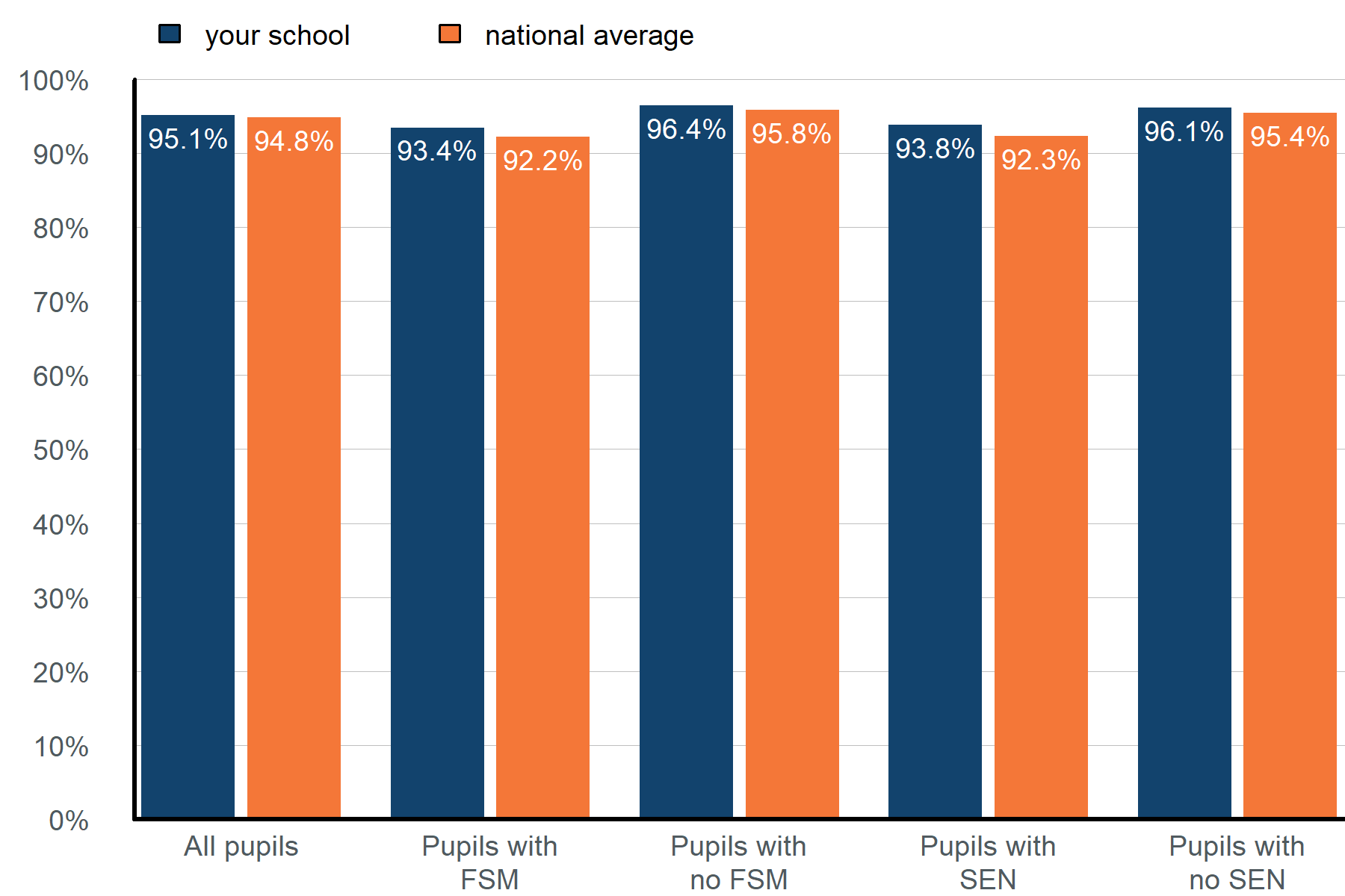

Graph alternative: table of attendance for different pupil groups from the start of the academic year 2024 to 2025, up to Wednesday 13 August 2025.
Pupil group | Attendance | National average
All pupils | 95.1% | 94.8%
Pupils with free school meals (FSM) | 93.4% | 92.2%
Pupils with no FSM | 96.4% | 95.8%
Pupils with special educational needs (SEN) support | 93.8% | 92.3%
Pupils with no SEN | 96.1% | 95.4%
Sources: Monitor your school attendance results for your school and nationally, data from the DfE.
Notes:
Special education needs (SEN) support data is taken from the latest record available in your management information system (MIS). SEN support pupil numbers include those with an education health and care plan (EHCP).
Year-to-date attendance figures for SEN and EHCP pupils are available via the View your school attendance data dashboard.

Previous academic year comparison
Figure 3: Bar chart showing the attendance percentage for pupils with and without free school meals (FSM) and special educational needs (SEN) compared to last year. Results are for pupils in years 1 to 6 from the start of the academic year 2024 to 2025, up to Wednesday 13 August 2025.
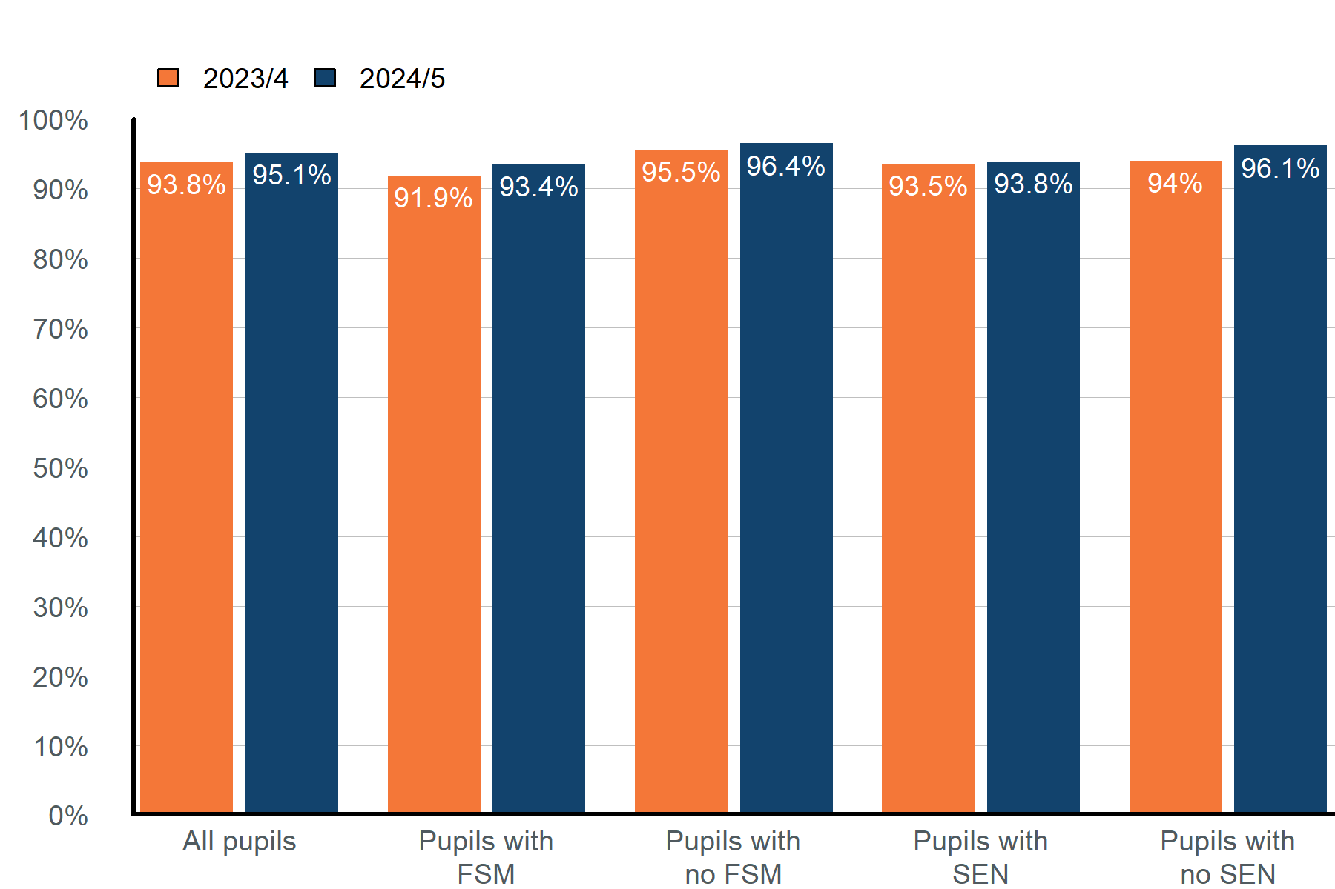

Graph alternative: table of attendance for different pupil groups from the start of the academic year 2024 to 2025, up to Wednesday 13 August 2025, compared to the same period last year.
Pupil group | Attendance 2023/4 | Attendance 2024/5
All pupils | 93.8% | 95.1%
Pupils with free school meals (FSM) | 91.9% | 93.4%
Pupils with no FSM | 95.5% | 96.4%
Pupils with special educational needs (SEN) support | 93.5% | 93.8%
Pupils with no SEN | 94% | 96.1%

Each group shows positive impact and progress – effective use of pupil premium strategy in place.

FSM6 - Attendance
Year | School | National | National distribution banding | Sch trend vs Nat trend | School context
2024/25 | 94.0% | 92.6% | Close to average | Relative improvement | High - FSM, High - SEN
2023/24 | 92.0% | 92.0% | Close to average | Relative improvement | High - FSM, High - SEN
2022/23 | 89.4% | 91.6% | Below | Relative decline | High - FSM, High - SEN

SEN - Attendance
Year | School | National | National distribution banding | Sch trend vs Nat trend | School context
2024/25 | 94.4% | 92.5% | Above | Relative improvement | High - FSM, High - SEN
2023/24 | 92.1% | 92.1% | Close to average | Relative improvement | High - FSM, High - SEN
2022/23 | 89.1% | 91.9% | Below | Relative decline | High - FSM, High - SEN

