

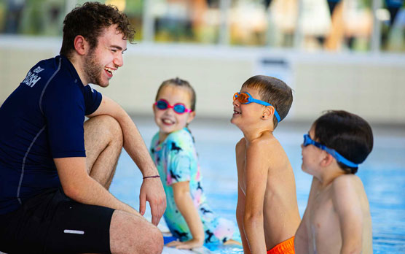
Swim Academy Open Day
WHAT?
Come and try our children’s swimming lessons and baby lessons for FREE!

WHEN?
Sunday 2nd March, 9am-11am

WHERE?
Total Fitness, Aintree, L30 7PT

WHO?
Children and babies aged 0-11 years old.

Book a time slot!
hannah.thomas@totalfitness.co.uk
0151 527 3600

