Design Our St. Oswald’s C of E Primary School Online Safety Mascot!

Safer Internet Day: Tuesday 11th February 2025
Our school is celebrating Safer Internet Day with an exciting challenge! We need YOU to design a creative and fun Online Safety Mascot that will help remind everyone how to stay safe online.

What You Need to Do:
- Think about online safety:
  - How can your mascot teach others to stay safe online?
  - What might your mascot say or do to help?
- Be creative:
  - Draw your mascot on a piece of A4/A3 paper or card.
  - Use lots of colour and make your design eye-catching!
- Give your mascot a name that reflects their role in promoting online safety.
- Include a short description:
  - Write 3-5 sentences on the back of your design explaining how your mascot helps with online safety.

Prizes for the Best Designs:
- 1st Place: Your mascot will become the official school online safety mascot! It will be displayed in every classroom and on the school website. Plus, you’ll win a special prize!
- 2nd Place & 3rd Place: Your designs will be featured on a special Safer Internet Day display, and you’ll receive a prize too!

How to Enter:
- Hand in your completed mascot design to Miss Ledgerton by Friday, 7th February 2025.
- Don’t forget to include your name and class on the back of your paper.

Hints and Tips:
- Think about online safety messages like:
  - Never share your personal information.
  - Be kind online.
  - Tell a trusted adult if something upsets you.
- Your mascot could be an animal, a superhero, a robot, or anything you can imagine!
Let your imagination run wild! We can’t wait to see your amazing ideas.


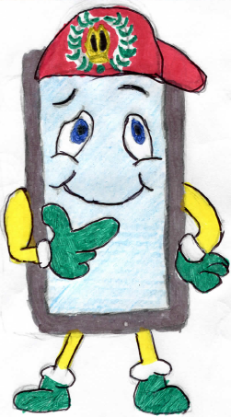
Get designing and help make St. Oswald’s C of E Primary School a safer place online!

