Worship Framework for Planning
Before worship prepare by getting your resources ready, worship table out and music playing. Ensure that children who have a job to do know what they should be doing and are prepared.
Use the worship words powerpoint and the visuals (windows, mirrors, doors) below as a pattern/ structure for your collective worship.
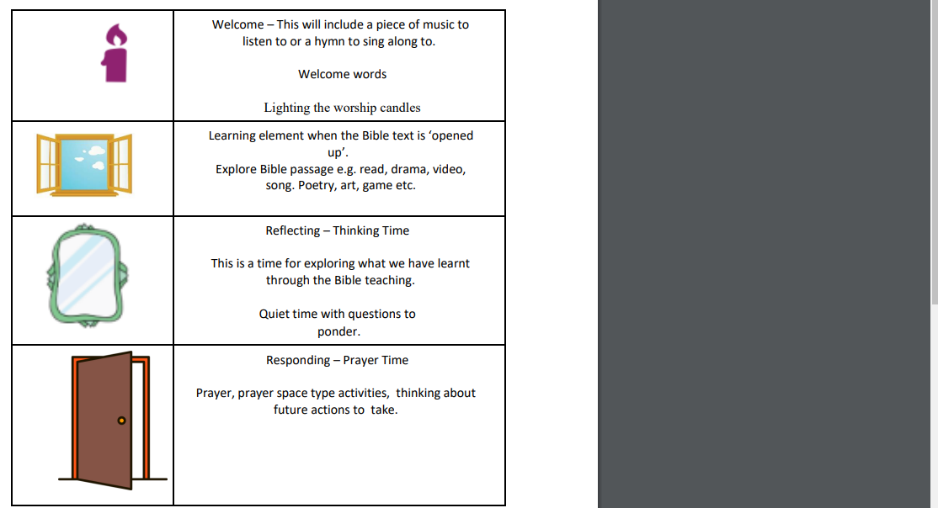

At the end of collective worship give children the opportunity to evaluate (this can be verbally or recorded on post it notes and kept in a box on your worship table.)

