Parent Guidance for applying for the extended entitlement (30 hour offer)

Parents do not need to apply through the digital childcare service if they only want to claim the universal 15 hours entitlement for three and four year olds.
Parents can check eligibility for a range of government childcare offers, including 30 hours, via Childcare Choices at https://www.childcarechoices.gov.uk or the Childcare calculator https://www.gov.uk/childcare-calculator
As part of the application process parents will be asked to enter personal details including their name, address and National Insurance number and the same details for their partner (if applicable) . They will also be asked whether they expect to meet the income requirements over the coming three months and whether they are in receipt of any relevant benefits.
At the start of the application process parents will create a Government Gateway account if they don’t already have one. Any problems or queries during the application please contact the childcare service Customer Interaction Service on 0300 123 4097.
At the end of the application process parents will have a childcare service account. In the ‘secure messages’ section of their account, parents will receive messages regarding their eligibility.
If parents are eligible they will be given an 11 digit ‘eligibility code’ for their children. These codes normally start with ‘5000’. However, there are a small number of cases where parents might have a temporary code starting with ‘11’.
Parents can find their ‘eligibility code’ in the ‘30 hours free childcare’ section of their childcare service account.

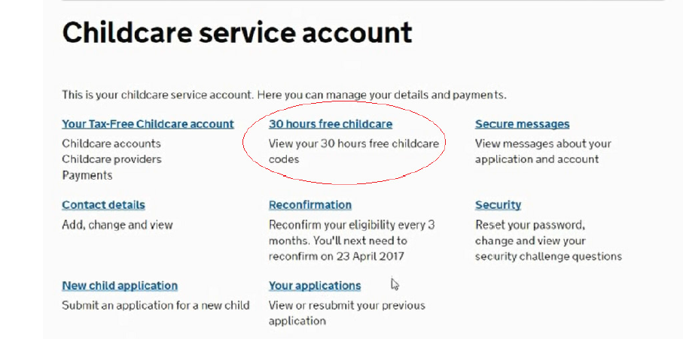
And in their secure messages
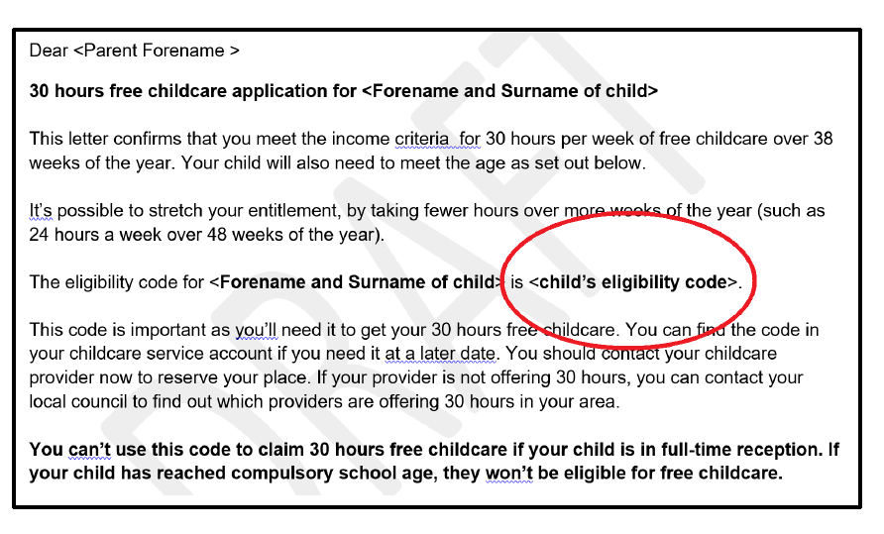

Parents will be prompted every three months to reconfirm the details they entered on their application are still accurate. This is to check they are still eligible. Parents will be prompted, via text messages and/ or email, four weeks before their reconfirmation deadline and again two weeks before the deadline if they still haven’t reconfirmed.
If parents miss the reconfirmation deadline, they will receive a message telling them their eligibility has lapsed. Although they are no longer eligible, they may be able to retain their childcare place for a short period; this is known as a grace period.

