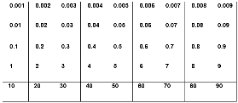
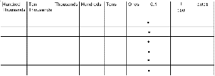
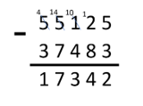
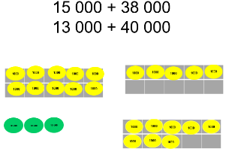
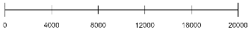
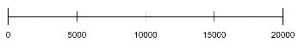
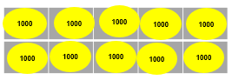
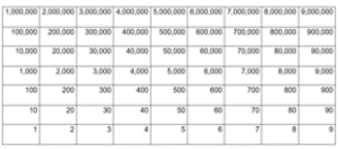
Place value of whole numbers
Count forwards or backwards in steps of powers of 10 for any given number up to 1 000 000

Read, write, order and compare numbers to at least 1 000 000 and determine the value of each digit

Round any number up to 1 000 000 to the nearest 10, 100, 1000, 10 000 and 100 000

Solve number problems and practical problems that involve all of the above

Week 1 Represent order and compare numbers Week 2Partition numbers Week 3 and week 4add and subtract powers of 10 – round numbers to powers of 10 Negative numbers on numb er line
(in place value folder)
.

Ten thousand

Place value of decimals
Read and write decimal numbers as fractions [for example, 0.71 = 71/100

Recognise and use thousandths and relate them to tenths, hundredths and decimal equivalents

Round decimals with two decimal places to the nearest whole number and to one decimal place

Read, write, order and compare numbers with up to three decimal places

Week 5 – Represent, order and compare decimals numbers Week 6 – Round decimals

(in fractions folder)

thousandths

Area
Volume
Calculate and compare the area of rectangles (including squares), and including using standard units, square centimetres (cm2) and square metres (m2) and estimate the area of irregular shapes

Estimate volume [for example, using 1 cm3 blocks to build cuboids (including cubes)] and capacity [for example, using water]

Week 14 and 15 : area of rectangles
(In measurement folder)

Known and related facts
Multiply and divide numbers mentally drawing upon known facts

Week 13 linked facts For example: 3 x 7 leads to 30 x 7, 300 x 7, 30 x 70
(In multiplication and division folder)

Multiply and divide powers of 10

Multiply and divide whole numbers and those involving decimals by 10, 100 and 1000

Week 12 – Multiply and divide numbers by powers of 10
(if you need an extra week, take it from area)
(In multiplication and division folder)
time

Properties of number
Identify multiples and factors, including finding all factor pairs of a number, and common factors of two numbers
Know and use the vocabulary of prime numbers, prime factors, and composite (non-prime) numbers

Establish whether a number up to 100 is prime and recall prime numbers up to 19

Recognise and use square numbers and cube numbers, and the notation for squared (2) and cubed (3)

Week 10 – factors (and multiple)
Week 11 –Properties of number: Prime, square, cube
time

Factor pair

Perimeter
Measure and calculate the perimeter of composite rectilinear shapes in centimetres and metres

Week 9 – Perimeter of rectilinear shapes
(Measurement folder)
Use cubes to make compound rectilinear shapes and explore perimeter

Addition and Subtraction
Add and subtract numbers mentally with increasingly large numbers eg 5-digit – 4-digit multiple of 10
Add and subtract whole numbers with more than 4 digits, including using formal written methods (columnar addition and subtraction)

Use rounding to check answers to calculations and determine, in the context of a problem, levels of accuracy

Solve addition and subtraction multi-step problems in contexts, deciding which operations and methods to use and why. Add and subtract decimals up to 2 decimal places including mixed decimal calculation
Week 7 – Addition of whole numbers Week 8 – Subtraction of whole numbers
(in addition and subtraction folder)

Make links to measurement across every number unit and statistics in place value and addition/subtraction
Include reasoning and problem solving in all units
Green statements are ready to progress, and red are additional information
Year 5 – Autumn Term

