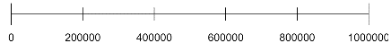
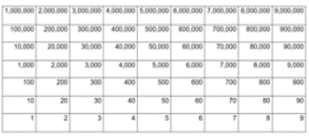
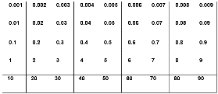
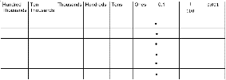
Place value of whole numbers
Read, write, order and compare numbers up to
10 000 000 and determine the value of each digit
Round any whole number to a required degree of accuracy

Use negative numbers in context, and calculate intervals across zero

Solve number and practical problems that involve all of the above.

Week 1 and week 2
Represent order and compare numbers Partitioning numbers
Rounding numbers
Week 3 – Negative numbers

(all in place value folder)

… Ten million

Addition and Subtraction
Perform mental calculations, including with mixed operations and large numbers
Solve addition and subtraction multi-step problems in contexts, deciding which operations and methods to use and why

Solve problems involving addition, subtraction, multiplication, and division

Use estimation to check answers to calculations and determine, in the context of a problem, an appropriate degree of accuracy.

Week 5/6 – addition and subtraction of decimals and mixed whole numbers
(In addition, and subtraction folder)

Place value of decimals

Identify the value of each digit in numbers given to three decimal places

Week 4 – Represent, compare, order to 3 decimal places

(in fractions folder labelled decimals)

Multiplication and Division
Multiply multi-digit numbers up to 4 digits by a two-digit whole number using the formal written method of long multiplication

Divide numbers up to 4 digits by a two-digit whole number using the formal written method of long division, and interpret remainders as whole number remainders, fractions, or by rounding, as appropriate for the context

Divide numbers up to 4 digits by a two-digit number using the formal written method of short division where appropriate, interpreting remainders according to the context
Solve problems involving addition, subtraction, multiplication and division

Use estimation to check answers to calculations and determine, in the context of a problem, an appropriate degree of accuracy.
Week 12/13 – 4d x 2d
Week 14/15 3d ÷ 2d and 4d ÷ 2d
(In calculation folder)

Area and Volume
Recognise when it is possible to use formulae for area and volume of shapes

Recognise that shapes with the same areas can have different perimeters and vice versa

Calculate the area of parallelograms and triangles

Calculate, estimate and compare volume of cubes and cuboids using standard units, including cubic centimetres (cm³) and cubic metres (m³), and extending to other units [for example, mm³ and km³].
Week 10 – area Week 11 – area of triangkles/parellograms (In measures folder)

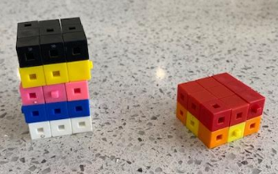
centilitre cubic centimetres(cm3 ), cubic metres (m3 ), cubic millimetres (mm3 ), cubic kilometres (km3 )

Multiplication and division of powers of 10
Multiply and divide numbers by 10, 100 and 1000 giving answers up to three decimal places

Week 9 multiplication and division of powers of 10
(Folder is Calculation – multiplication division powers of 10)

Properties of number
Identify common factors, common multiples and prime numbers

Week 7 – factors
Week 8 prime
(Folder is Calculation – Properties of number and then labelled Factor/prime)

Factorise
prime factor

Make links to measurement across every number unit and statistics in place value and addition/subtraction
Include reasoning and problem solving in all units
Green statements are ready to progress, and red are additional information
Year 6 – Autumn Term

