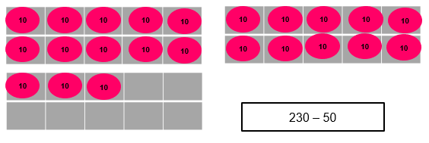
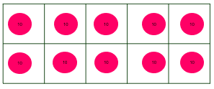
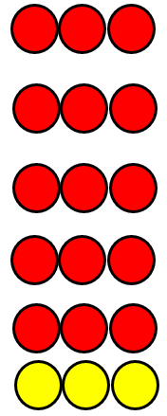
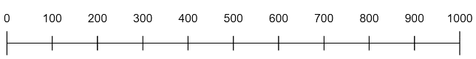
Addition and Subtraction – mental
4 weeks
Secure fluency in addition and subtraction facts that bridge 10, through continued practice.

Calculate complements to 100.

Add and subtract numbers mentally, including:
▪ a three-digit number and ones
▪ a three-digit number and tens
▪ a three-digit number and hundreds
Solve problems, including missing number problems, using number facts, place value, and more complex addition and subtraction.

Manipulate the additive relationship:
Understand the inverse relationship between addition and subtraction, and how both relate to the part–part–whole structure. Understand and use the commutative property of addition, and understand the related property for subtraction

100s +/- 100s
3-digit number +/- ones
3-digit number /- tens (2 weeks)

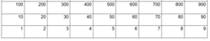
.

hundreds boundary

one hundred more, one hundred less

approximate, approximately
round, nearest, round to the nearest ten, hundred round up, round down

Perimeter

Factor
Product

Place Value within 1000
4 weeks
230
50
?
50
?
50
230
Count from 0 in multiples of 4, 8, 50 and 100; find 10 or 100 more or less than a given number

Recall and use multiplication and division facts for the 3, 4 and 8 multiplication tables
Recall multiplication facts, and corresponding division facts, in the 10, 5, 2, 4 and 8 multiplication tables, and recognise products in these multiplication tables as multiples of the corresponding number.

Apply place-value knowledge to known additive and multiplicative number facts (scaling facts by 10).

X 3 and division by grouping of 3sy
X 4 and division by grouping of 4s
X 8 and division by grouping of 8s

s
Multiplication and Division
4 weeks
Measure the perimeter of simple 2-D shapes j

Perimeter
1 week
Make links to measurement across every number unit and statistics in place value and addition/subtraction
Include reasoning and problem solving in all units
Green statements are ready to progress and red are additional information
Count from 0 in multiples of 4, 8, 50 and 100; find 10 or 100 more or less than a given number

Recognise the place value of each digit in a three-digit number (hundreds, tens, ones)

Compare and order numbers up to 1000

Identify, represent and estimate numbers using different representations

Read and write numbers up to 1000 in numerals and in words

Solve number problems and practical problems involving these ideas.

Represent 3-digit numbers
Order and Compare 3-digit numbers
Partition 3-digit numbers
10, 100 more or less than a number
Identify and estimate numbers using number lines

.

Year 3 – Autumn Term

